SIMPLE STOP WATCH

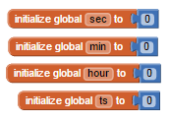**4 variables for ts, hour, min, sec**

**3 events Start, Stop, and Reset**

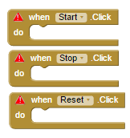

**To make the timer work.**

**Set a variable to 3 events.**



When Start.Click Set Clock 1 (a non visible component) .TimerEnabled to true – changes the property of Clock1

When Stop.Click Set Clock 1 (a non visible component) .TimerEnabled to false – opposite change of the property of Clock1

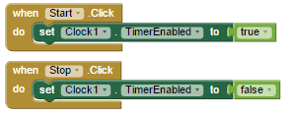

Reset.Click will set all the numbers to 0

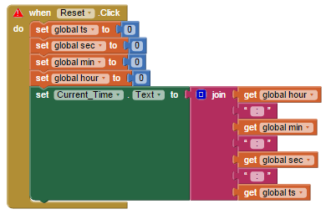

**Clock blocks**

**This is a event called Clock1.timer**



**We will do the tenth to the second called variable “ts”**

**And we will increase the ts variable by 1**



To display it to the counter we need to set Current_Time.Text for variable hour, min, sec, and ts and join to add strings “ : ” it displays on our app like this “00:00:00:00”

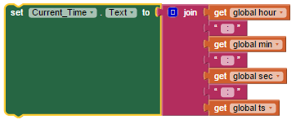

**To make the counter work we will use “if statement”**

If get global ts > 9

Then set global ts to 0

Set global sec to compare get global sec + 1

If get global sec > 59

Then set global sec to 0

Set global min to compare get global mid + 1

If get global min > 59

Then set global min to 0

Set global hour to compare get global hour + 1

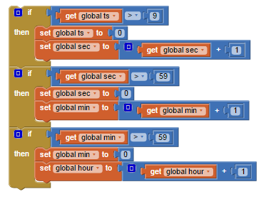

**Complete Blocks**

