How to configure Eclipse environment with source codes downloaded from GitHub

1. Download the source code from GitHub with below commands in Windows PowerShell

git clone <https://github.com/goodyear/tire_hotel_code.git>

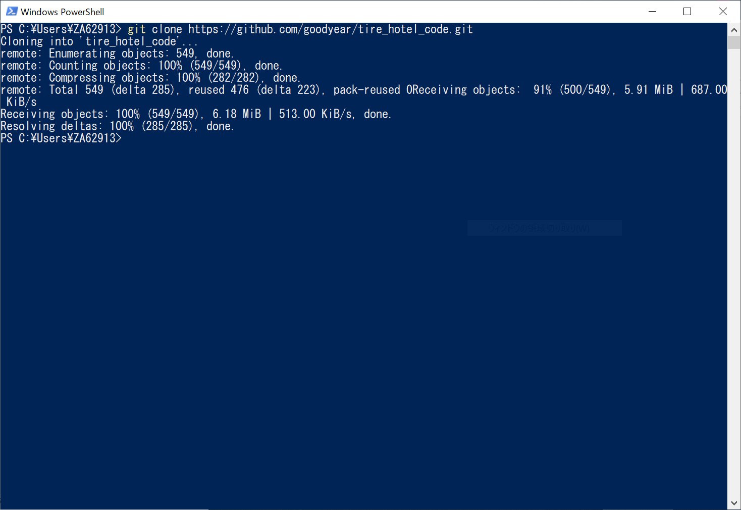

* You may be asked to input your GitHub credentials after you run the above command

After the source code is downloaded, please go to the folder where you run the command, in this case, it is C:\Users\ZA62913

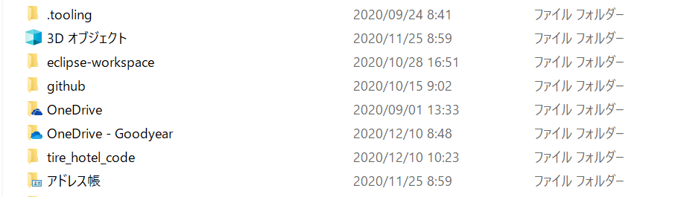

Should you find the source code in there.

1. Install node modules for React.js

Go to tire_hotel_code > app in Windows PowerShell, then run below command

npm install

* make sure you have installed Node.js & npm on your computer

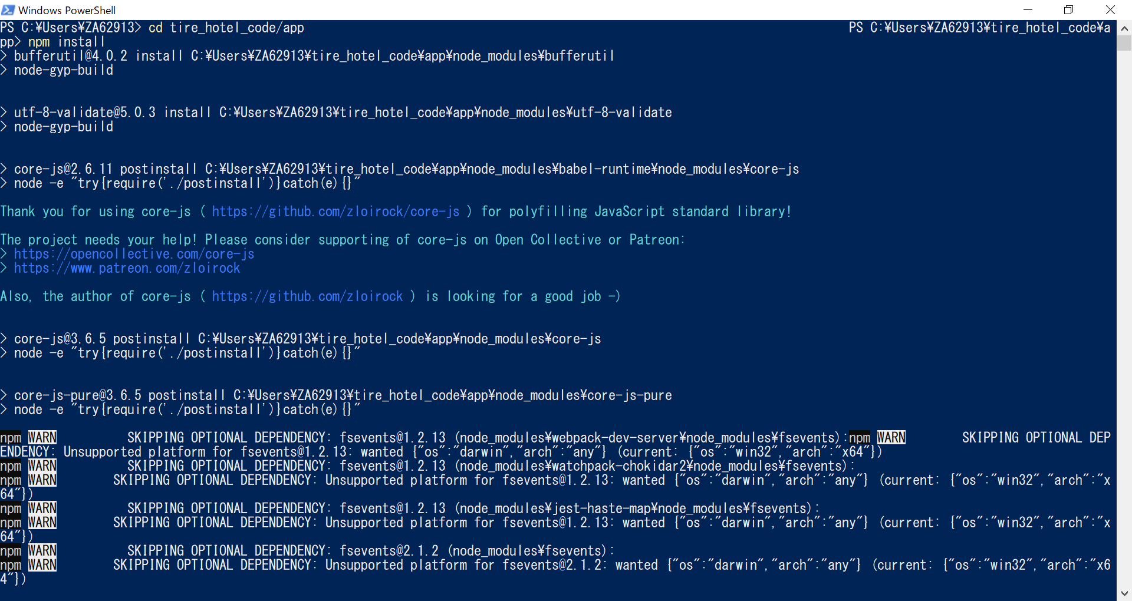

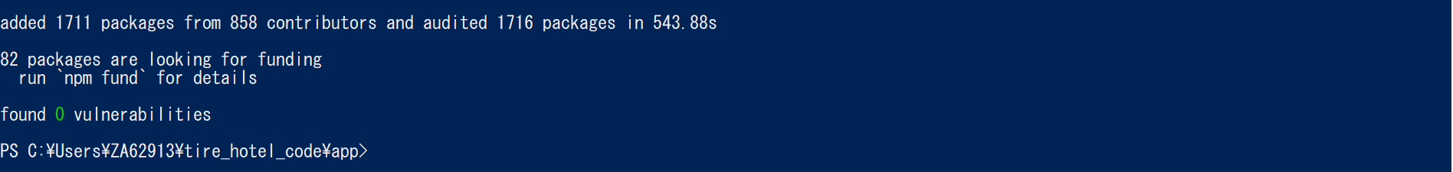

when it’s done, you should see the above screen.

1. Import the source code into Eclipse

in Eclipse, select File > Import, then select the import wizard [Existing Maven Projects] in the pop-up

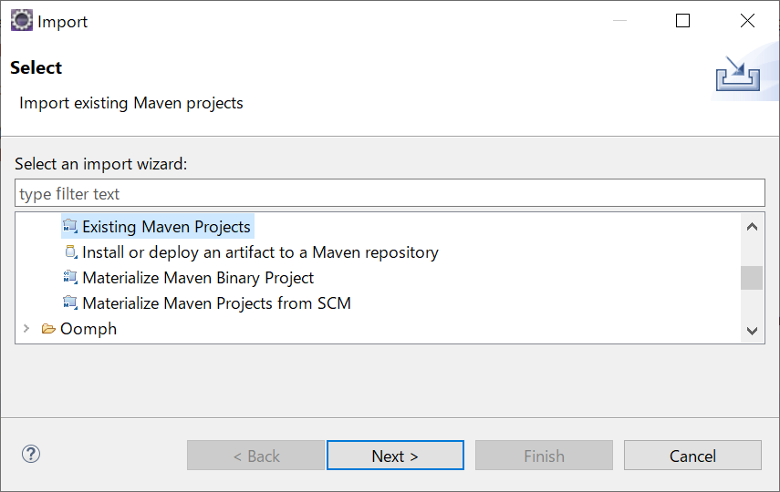

next, select the tire_hotel_code folder you just downloaded as the Root Directory, check the pom.xml, then click the finish button.

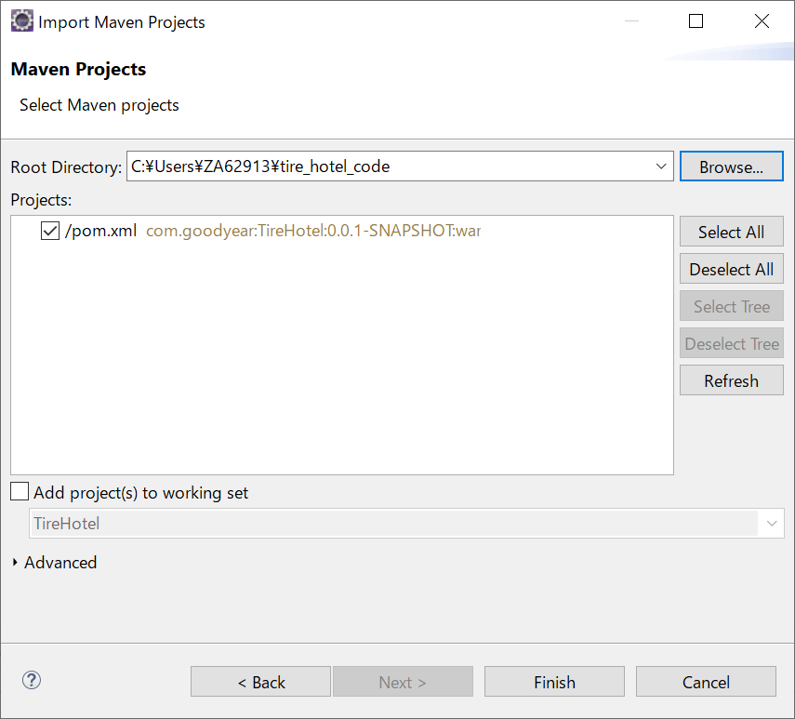

now, you have imported the source code as the TireHotel project in Eclipse.

1. Start the application

run below command under the tire_hotel_code folder in Windows PowerShell

mvn spring-boot:run

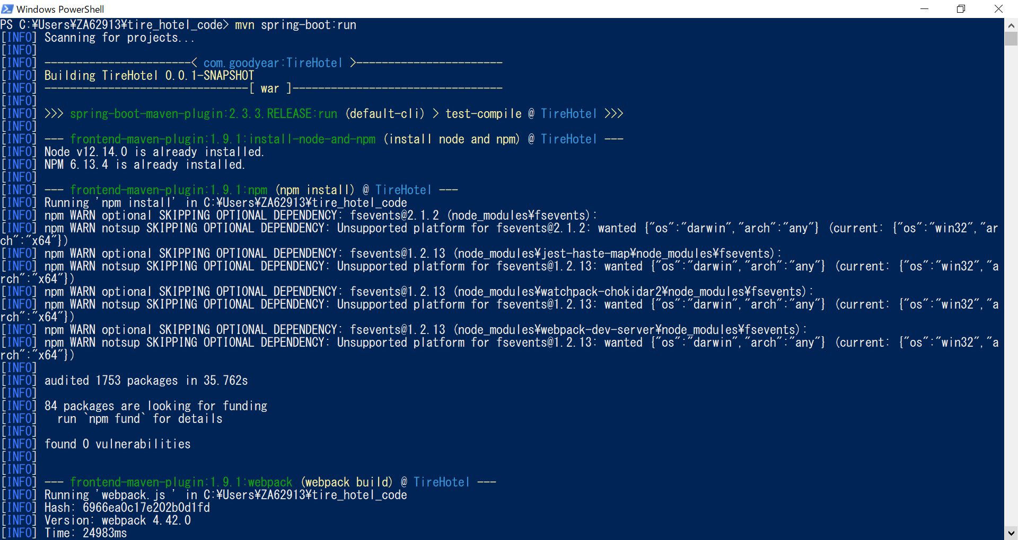

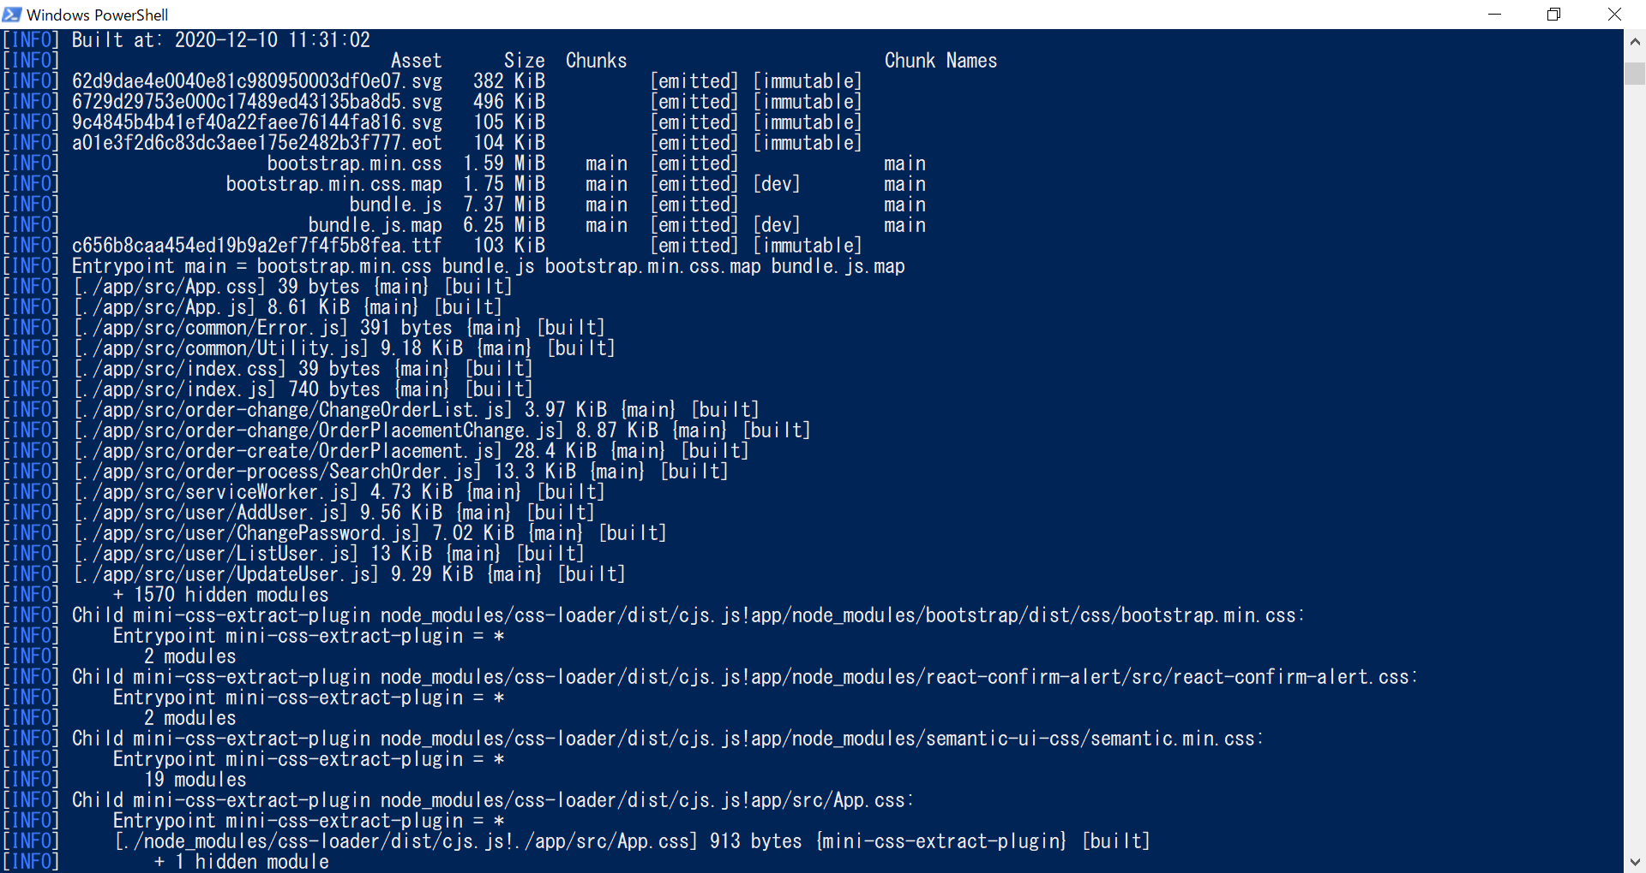

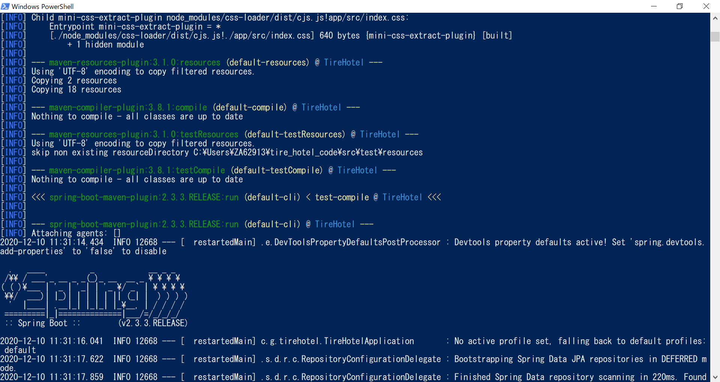

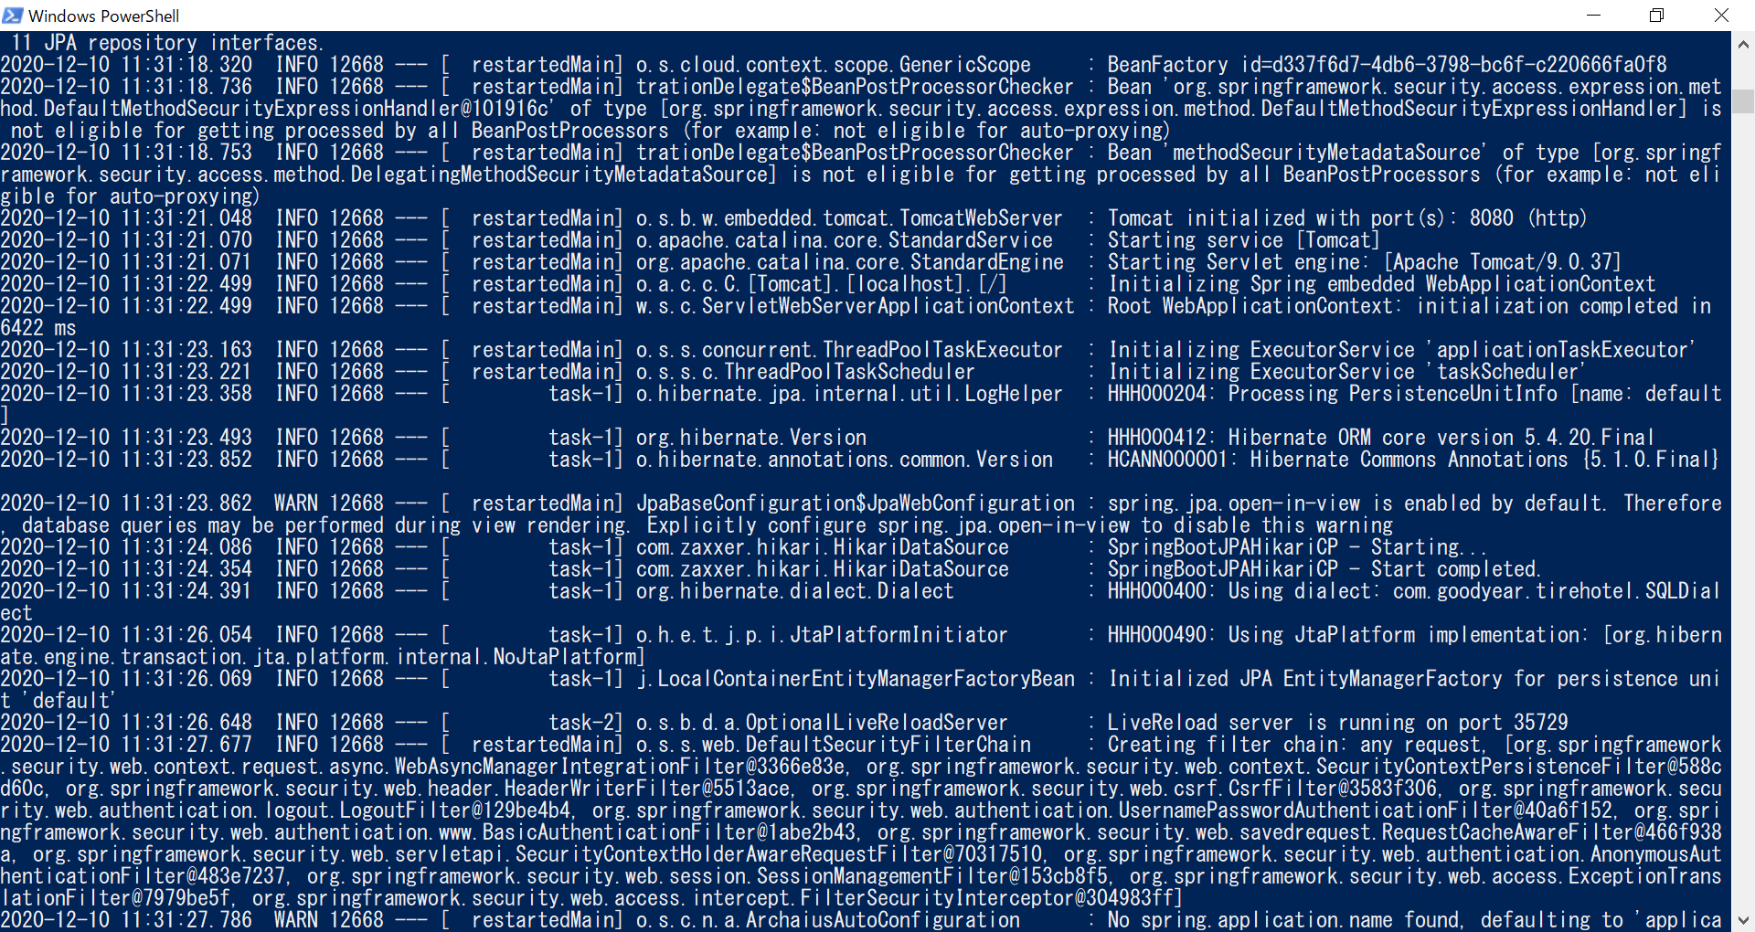

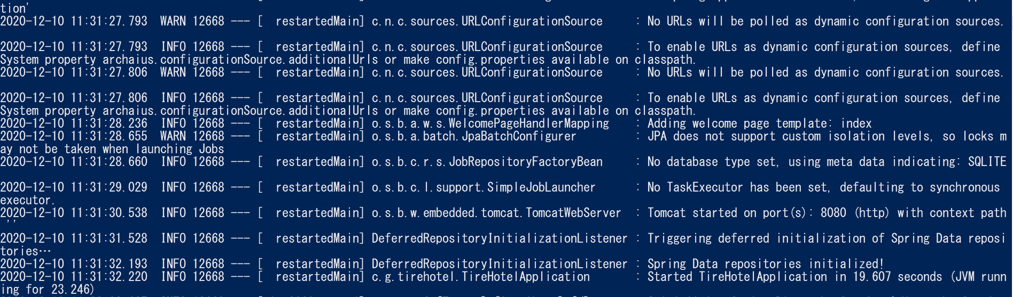

when you see the above screen, the application has been started. now, you type <http://localhost:8080> in browser, you can validate it.

