Cloudera

**User name:** cloudera

**Password**  : cloudera

**Sudo user name** : root

**Password** : cloudera

Start the VM by clicking on start

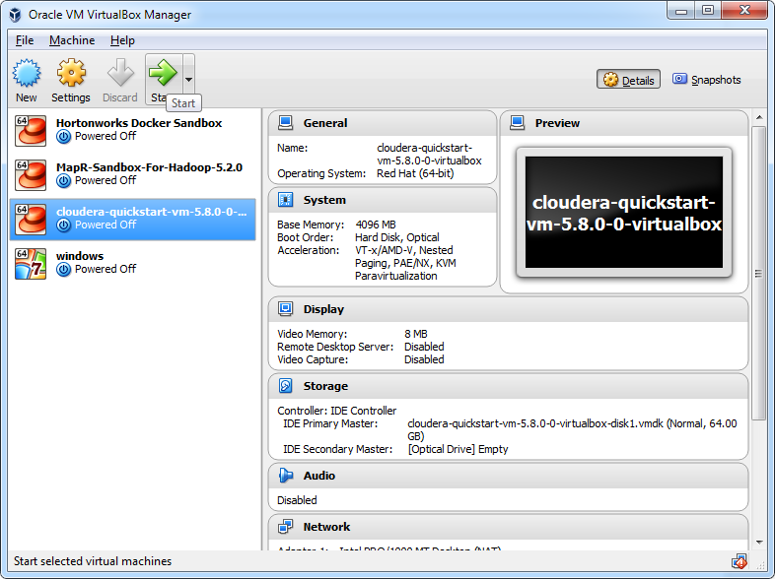

By default it will login to **cloudera** user. Once logged in open the browser and click on HUE.

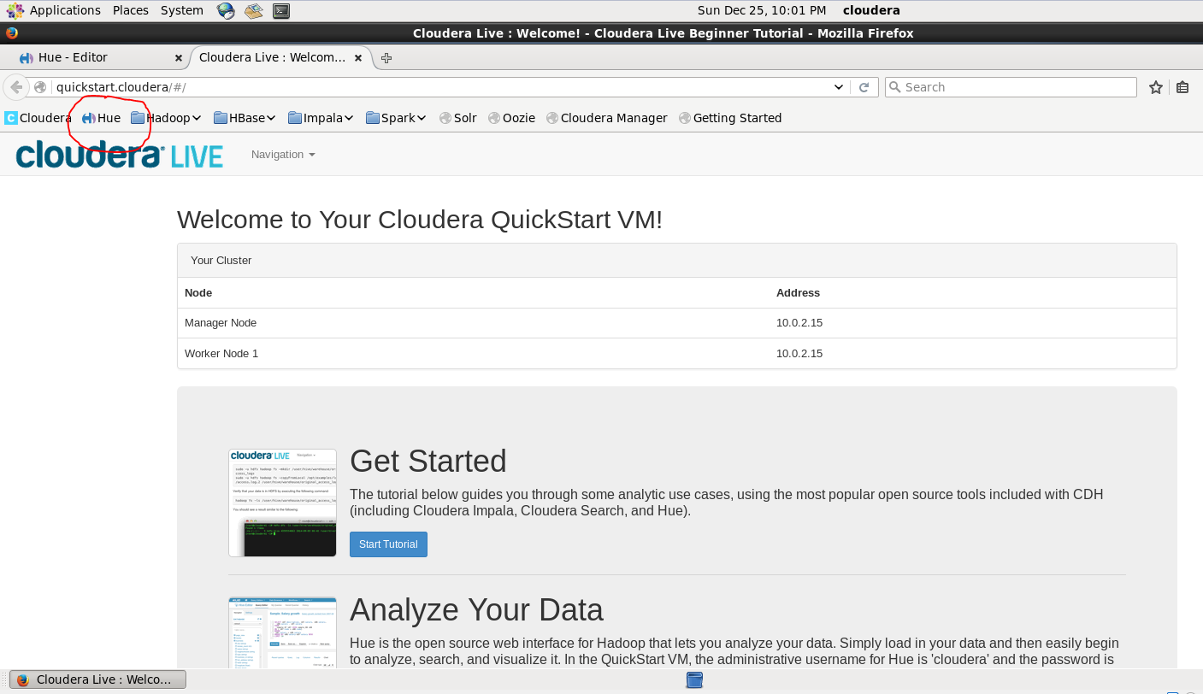

**To copy the file to HDFS find the below procedure:**

Click on File browser and go to HDFS path.

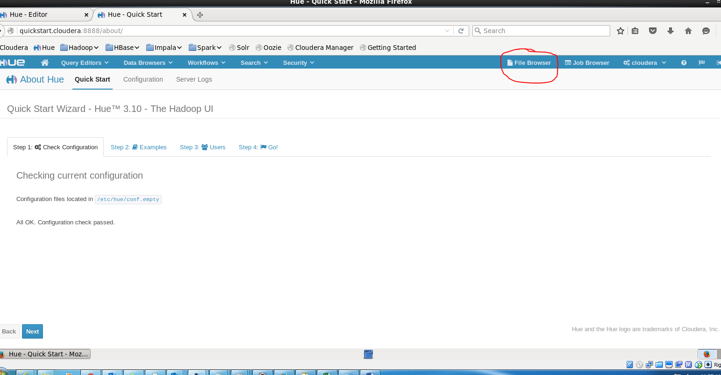

To create new directory in HDFS click on New as shown below.

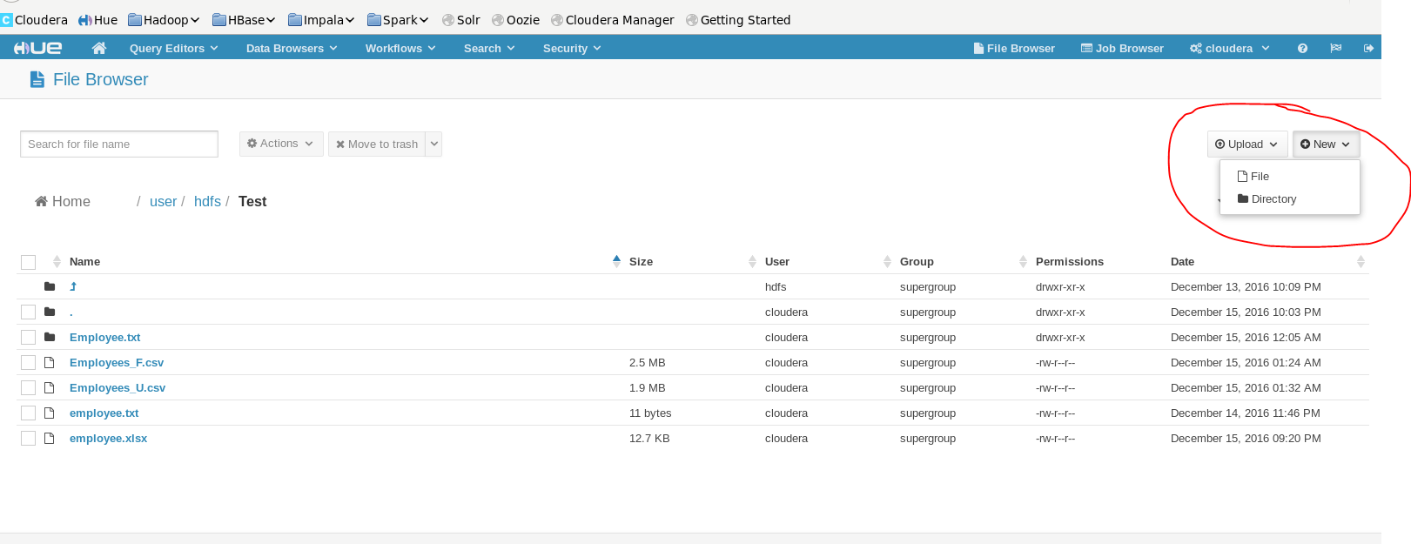

To copy file from local to HDFS click on Upload and select File.

Select the necessary files from local machine and update.

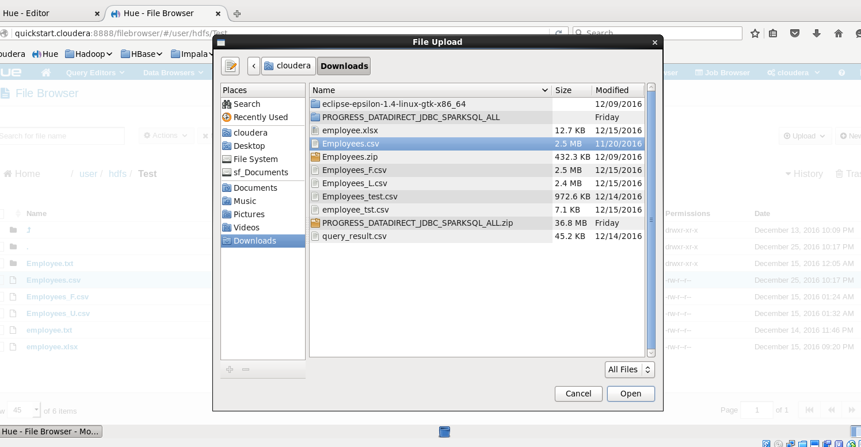

To upload in HIVE database click on Data browser and select Metastore tables

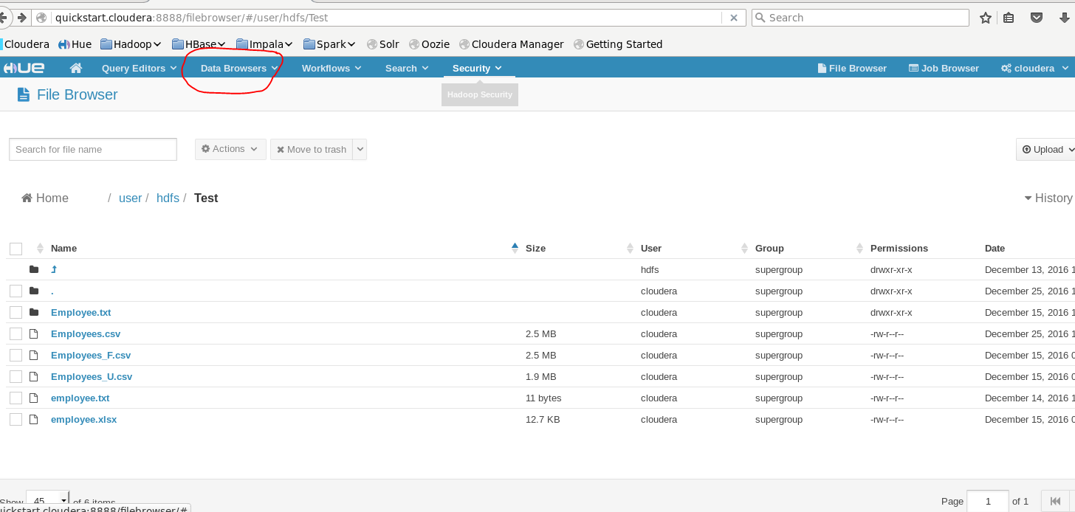

Click on Create a new table from a file

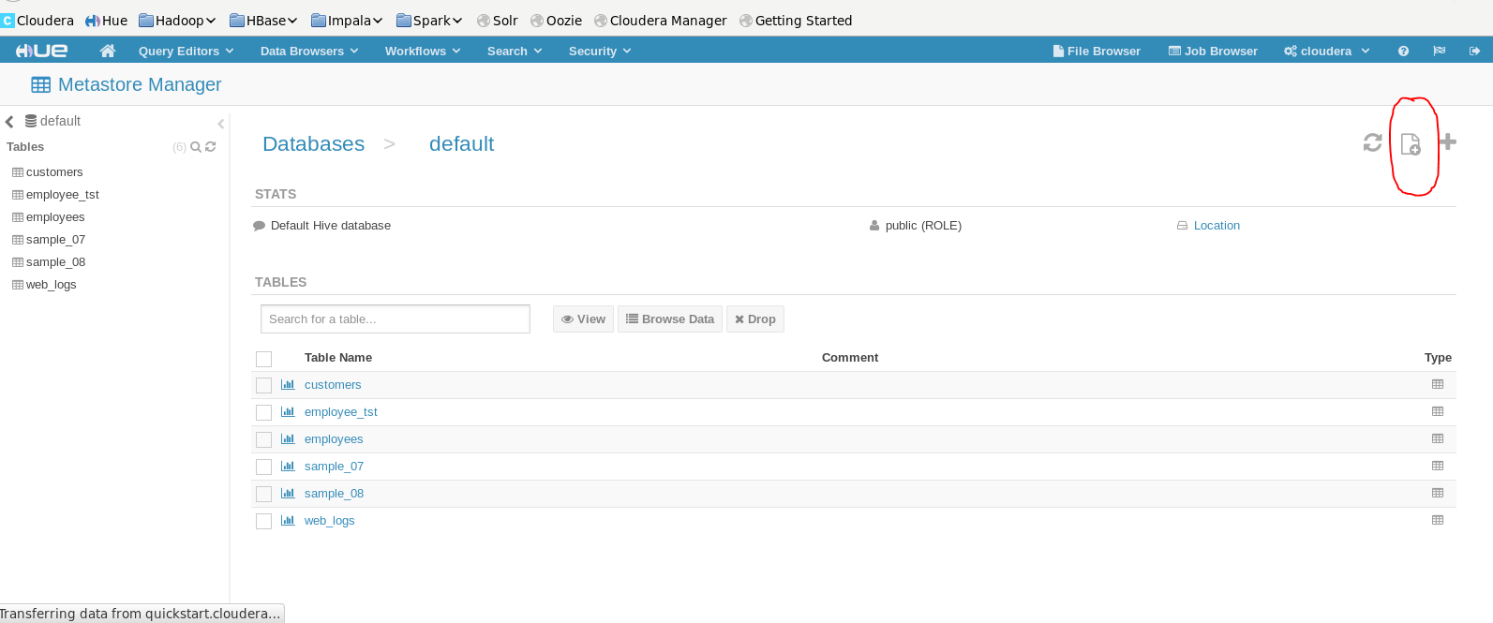

Fill the table name and select input file ( you can select either from HDFS or local) and click next.

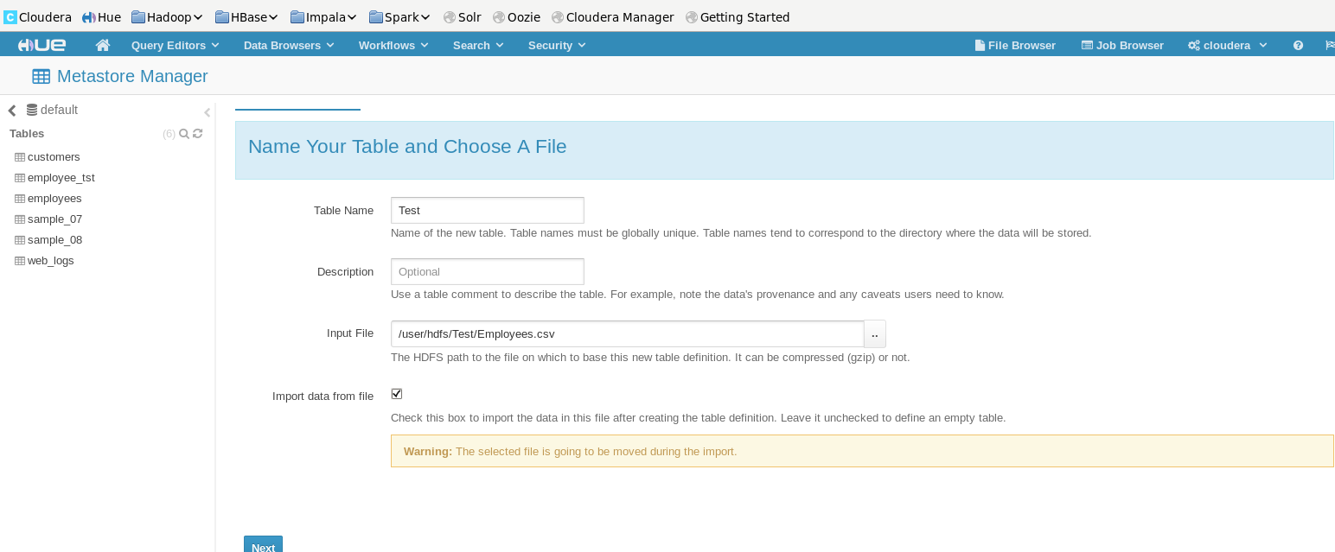

Select the necessary delimiter and click next.

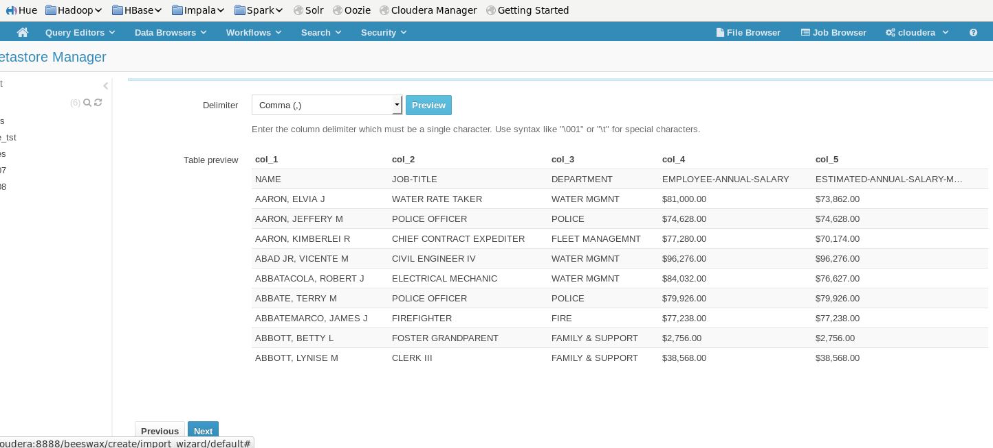

Select the data type if any changes required. (Default it will use first row as column names).

If you want to add column click on Bulk edit column name and add the column name.

And click on create table.

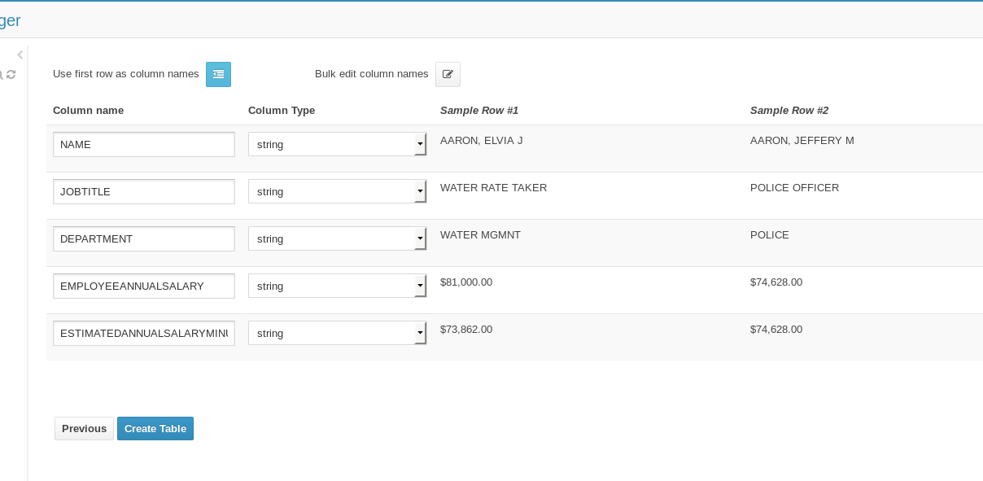

To Query the data in HIVE , click on Query editors select HIVE.

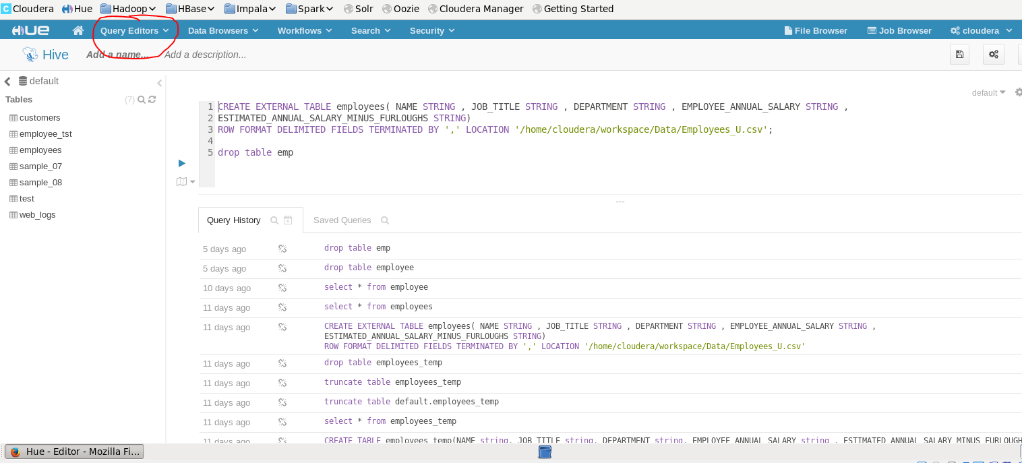

**Transfer file using WINSCP:**

Change the network setting in Virtual box

Go to 🡪 setting 🡪 Network 🡪 change “**attached to**” host only adapter (make sure Promiscuous Mode should be Allow all)

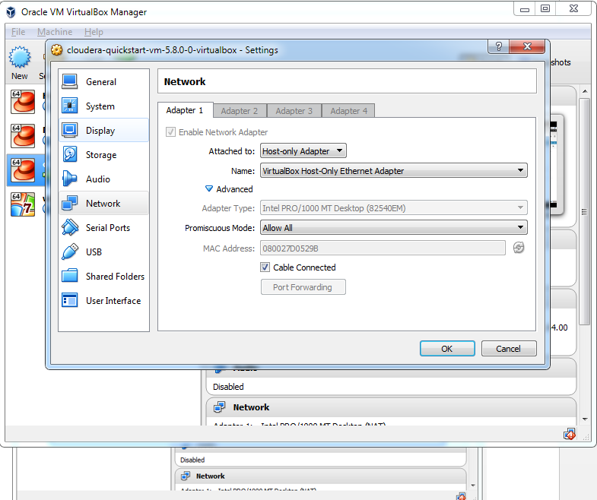

Check ip address in terminal with ipconfig command and login to winscp using either one credential.

( IP address should be starting from 192.168. series, if not reboot the VM image again)

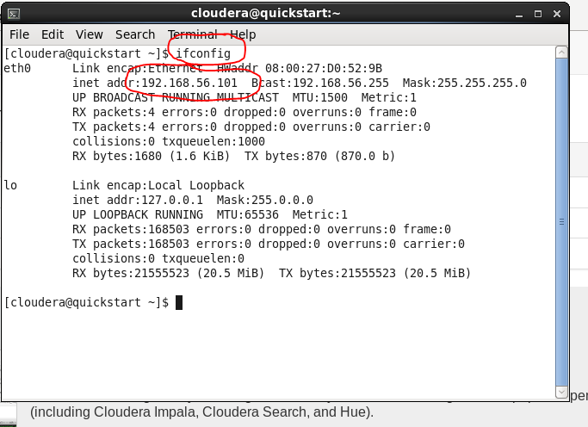

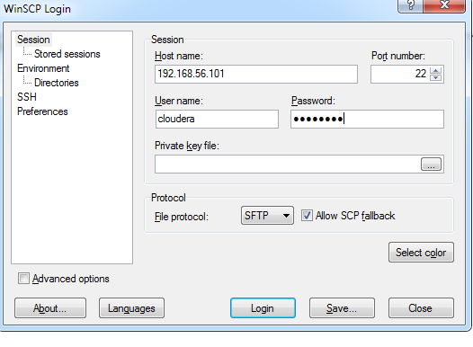

Once file transformation done revert back to the network (NAT) setting, if not done HUE will not work.

**SPARK**

To execute scala we have 3 following ways as below.

1. Through eclipse
2. Through terminal
3. Creating a .scala file

**Through Terminal :**

Open terminal 🡪 type scala enter and execute your program.

**Creating a .scala file :**

Open gedit file and write a scala program and save the file as a **.scala**.

Go to file path in terminal and type scala filename.scala