**1. Intro & User Roles:**

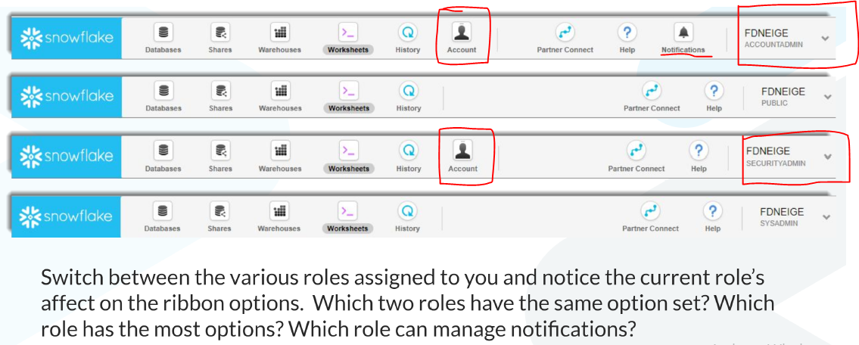

**2. DB Navigation:**

How to navigate different data bases and DB objects across snowflake account.

**3. Data Exploration:**

This is all about navigating through Data base navigation tree to see the DB objects and preview the data.

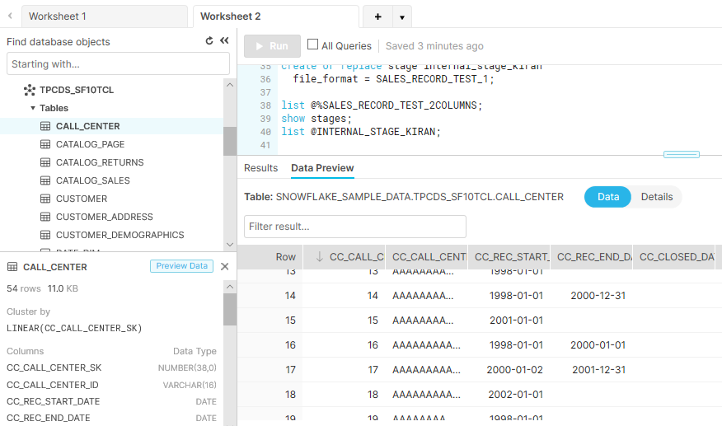

**4. Warehouses:**

Different types of warehouses (Single & Multi) and how to launch single virtual warehouse and multi cluster.

Scale up 🡪 XS -> Medium [Small machine to higher machine]

Scale down 🡪 Medium -> S [Higher machine to Lower Machine]

Scale In 🡪 Spinning up from Single cluster to Multi Cluster.

Scale Out 🡪 Spinning down from Multi Cluster to Single Cluster.

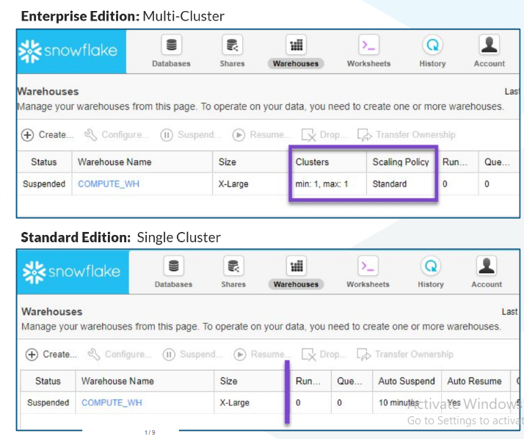

**5. Creating DB Objects:**

In this section learned about creating new database, tables, file format, loading data to tables.

Do this exercise.

**6. Transformations (ETL vs ELT)**

Extracting from one table do transformation and load into another table.

**7. Warehouse Concepts (Virtual warehouse):**

1. Each virtual warehouse is a cluster which has one or more nodes and each node has 8 cores.
2. 1 Node (8 Cores)🡪 1 Virtual Warehouse Cluster (1-128 Nodes) 🡪 Multi Warehouse Cluster (As many as)

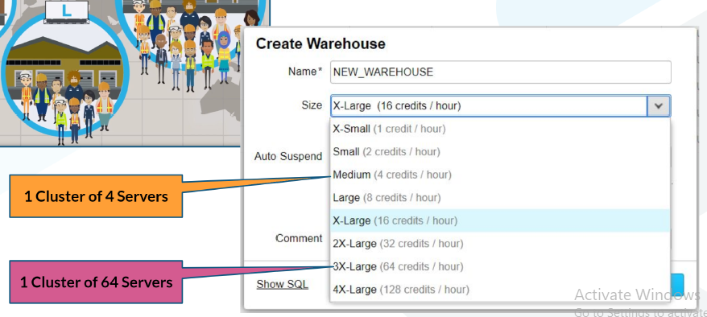

1. Virtual warehouse power/resources are used when -

* Loading and Unloading the data
* Querying the data

1. Virtual warehouse is meant for only computation and not for storage.

**Elastic Data Warehouse (Multi Cluster):**

For heavy load computations we can create a scalable multi cluster (Multiple virtual warehouses)

For multi cluster we must define the scaling policy.

**Scaling Policy:** helps snowflake decide when to move from a single cluster to more than one and snap back to a single cluster.

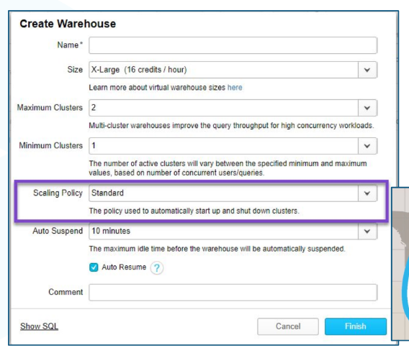

**8. Staging (Different stages in snowflake):**

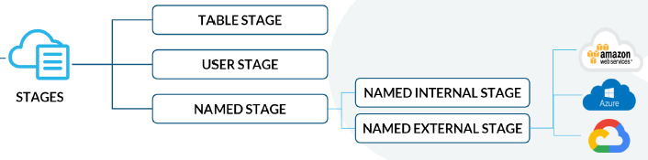

**9.Data Storage Structures (ER Diagrams & Sequences):**

Entities (Tables)

Attributes (Columns)

Values (Row content)

Normalization (Reducing the duplicate data by splitting the table to multiple tables.)

This section talks about ER Diagrams and relationships (one-many or many-one or many-many etc..)

Talks about how to create sequence numbers and call the sequence number.

**10. Intro to Semi Structured Data**

Don’t miss the lab to query on XML and JSON files (10_b_Intro_to_Semi_Structured_Data_Lab)

Different types of data available in the digital world

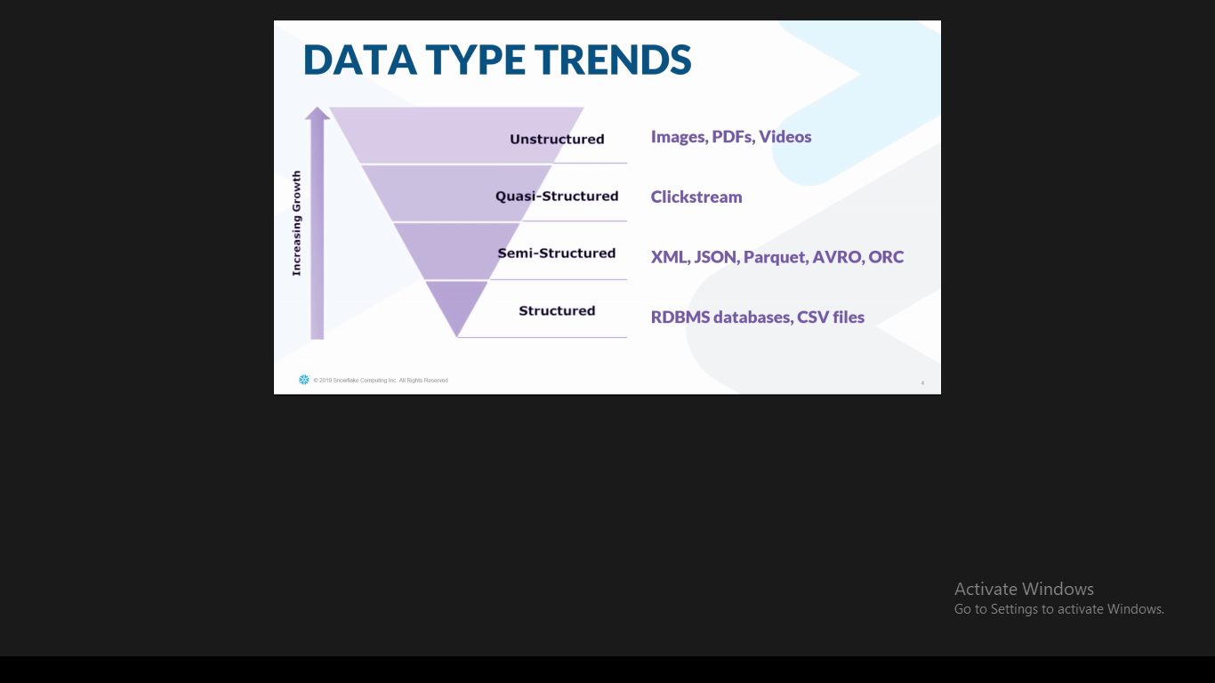

Below are the 5-different semi structured formats currently snowflake is supporting.

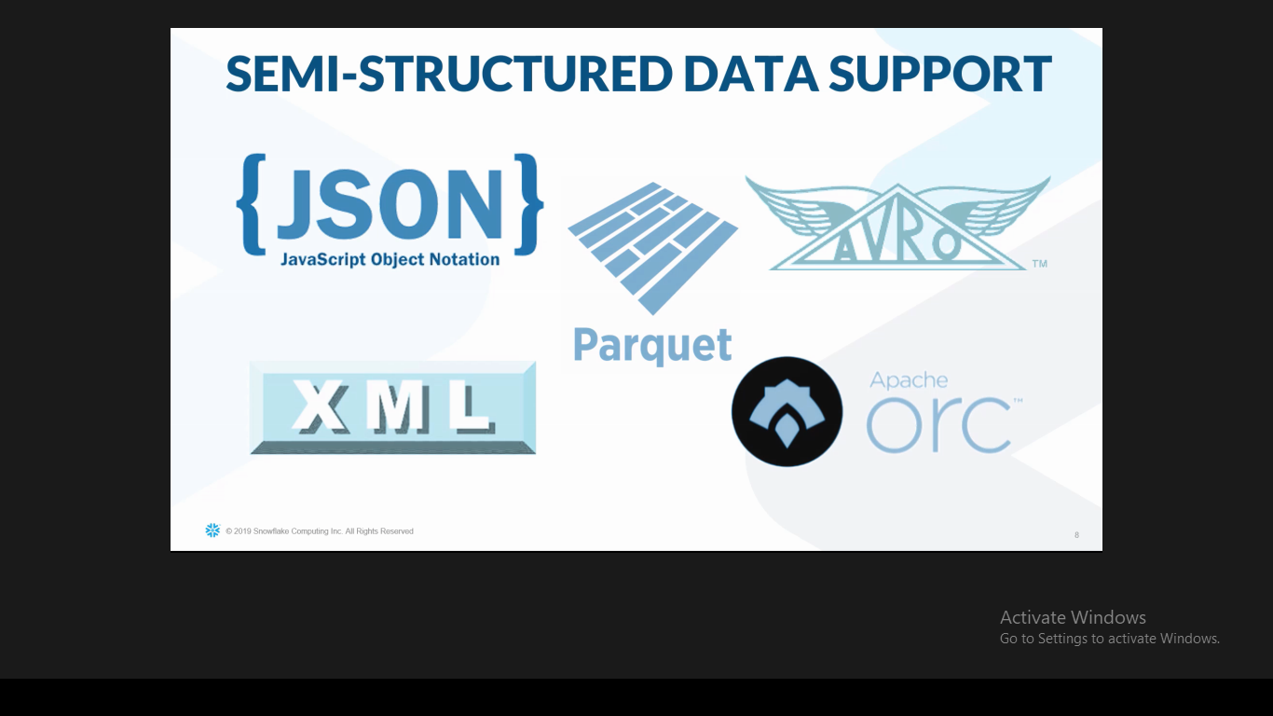

XML file Querying

<https://community.snowflake.com/s/article/Querying-Nested-XML-in-Snowflake>

**11. Semi Structured Nested Data:**

**Query Pruning & Query Execution:**

Query Pruning is a **top down** approach and Query execution is a **bottom up** approach.

**Good Links for reference:**

<https://dataedo.com/kb/query/snowflake/find-queries-executed-in-specific-warehouse>

**Level up Series**

**Step-1: Snowflake Three Layer Design:**

Refer downloaded PDF, no video content.

**Step-2: Snowflake Key Concepts:**

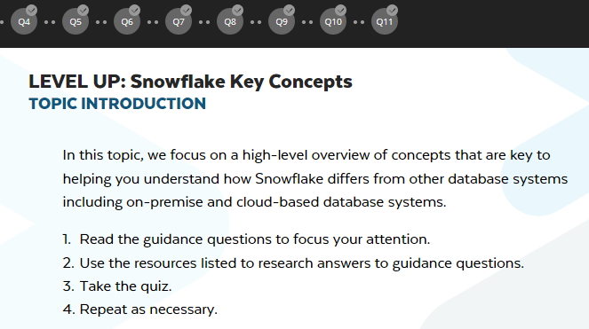

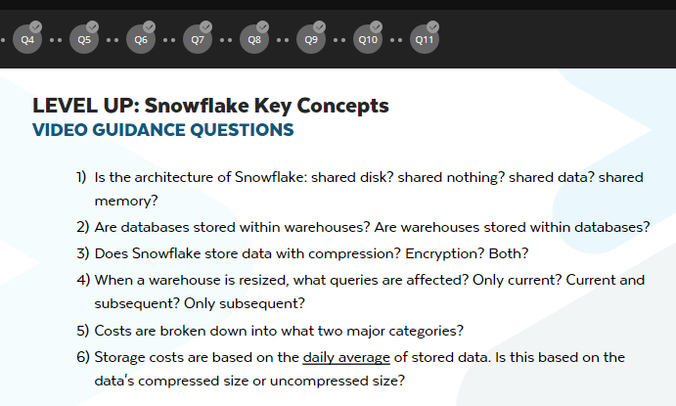

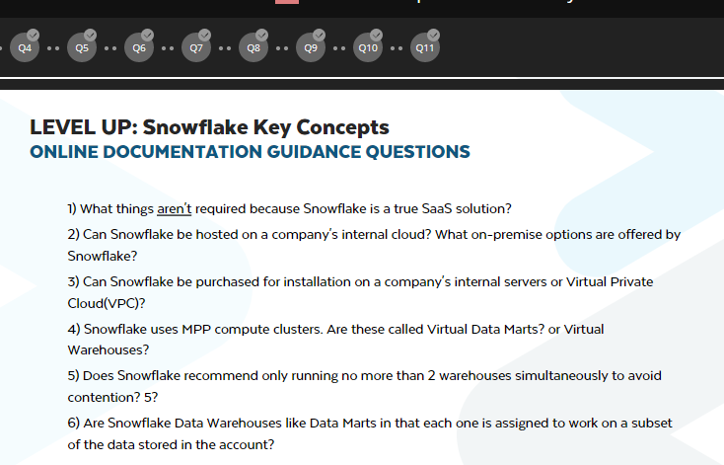

<https://docs.snowflake.net/manuals/user-guide/intro-key-concepts.html>

The data is encrypted to AES-256 encryption method.

**Step-3: Snowflake Ecosystem:**

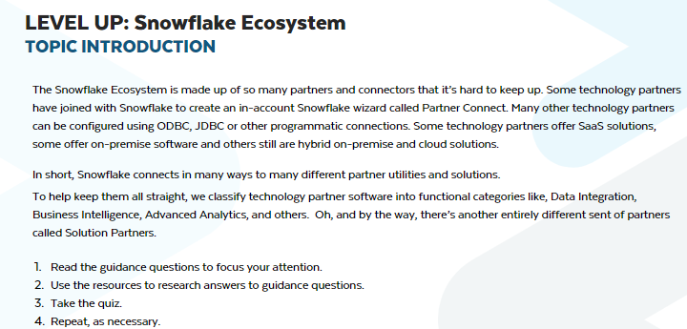

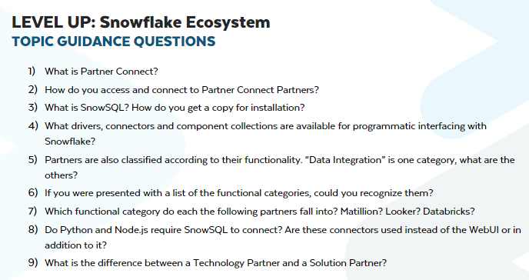

**Step-4: Snowflake Account (Options & Assurances):**

**Step-5: Container (Hierarchy & Details):**

**Step-6: Query and Results History:**

**Step-7: Context:**

**Step-8: Caching:**