**Level up Series**

**Step-1: Snowflake Three Layer Design:**

Refer downloaded PDF, no video content.

**Step-2: Snowflake Key Concepts:**

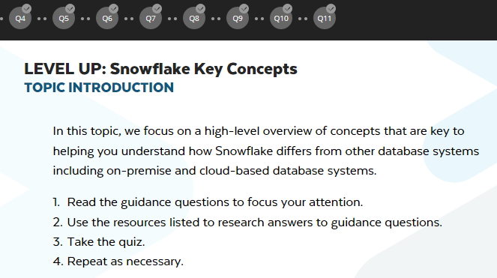

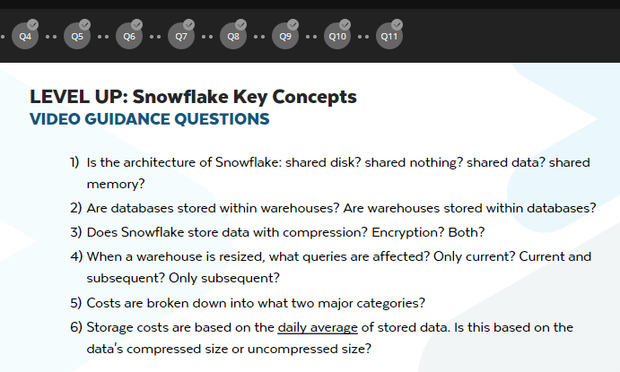

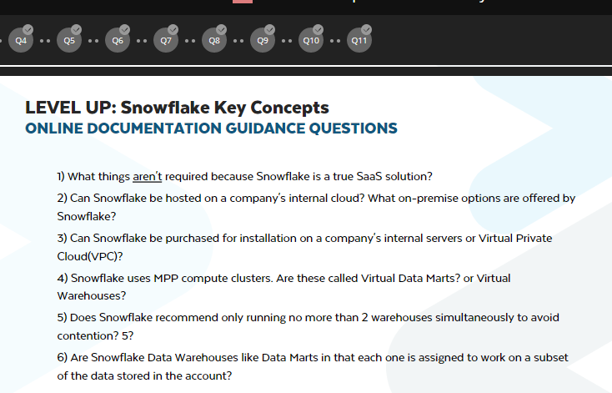

<https://docs.snowflake.net/manuals/user-guide/intro-key-concepts.html>

The data is encrypted to AES-256 encryption method.

**Step-3: Snowflake Ecosystem:**

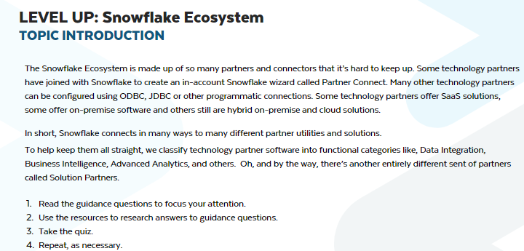

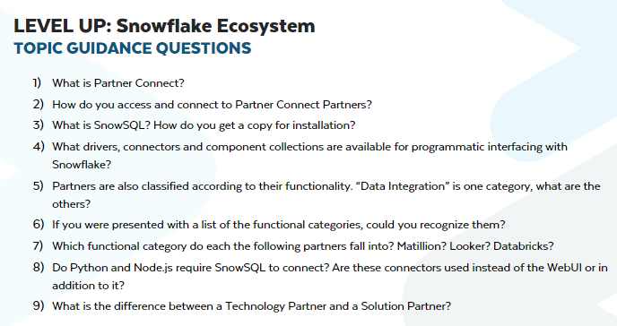

**Step-4: Snowflake Account (Options & Assurances):**

**Compliance:** refers to set of rules, standards and policies.

* For critical data, snowflake is certified with many industry protocols such as **HIPPA, PCI DSS, SOC1 and SOC Type-2, FedRAMP.**
* AWS Regions and corresponding AZ’s

<https://cloudacademy.com/blog/aws-global-infrastructure/>

**Step-5: Container (Hierarchy & Details):**

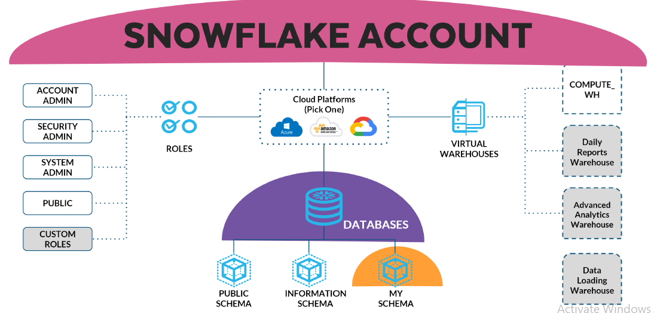

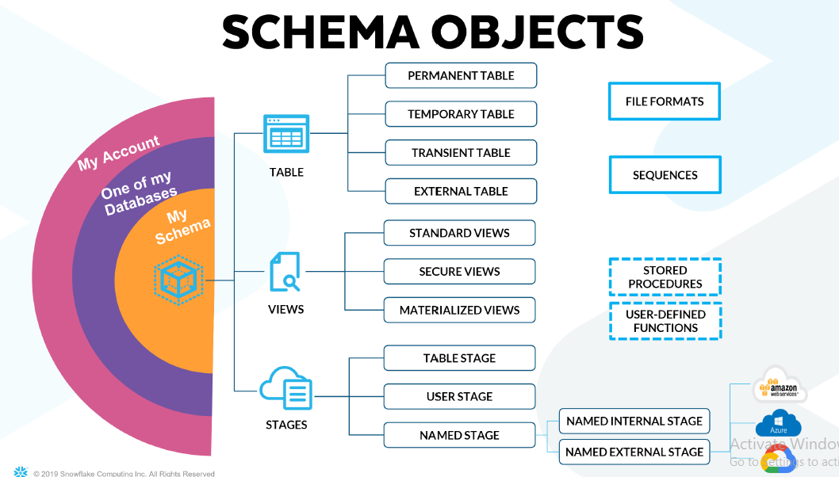

**Step-6: Query and Results History:**

**Step-7: Context:**

**Step-8: Caching:**