**Step-1: Snowflake Three Layer Design:**

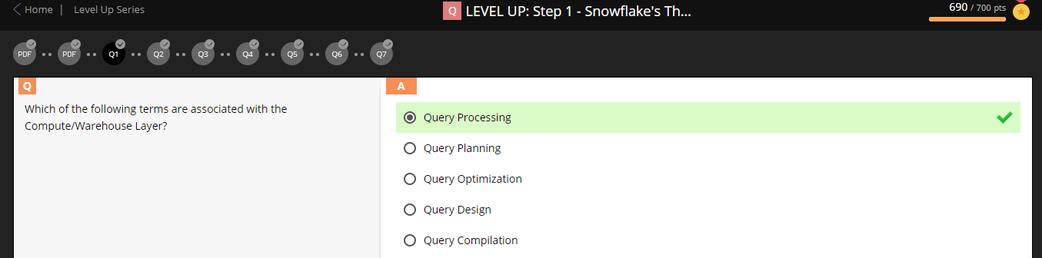

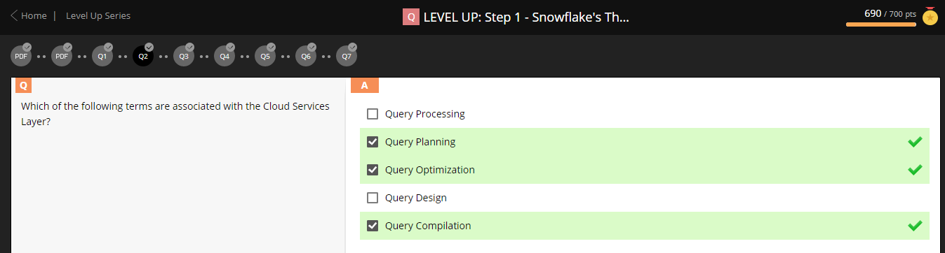

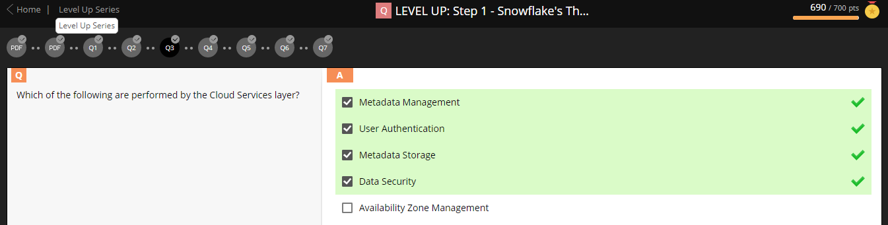

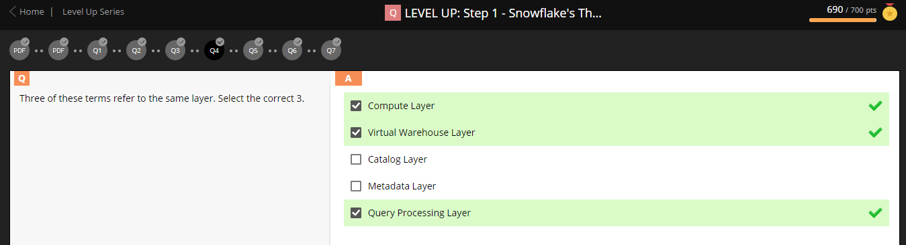

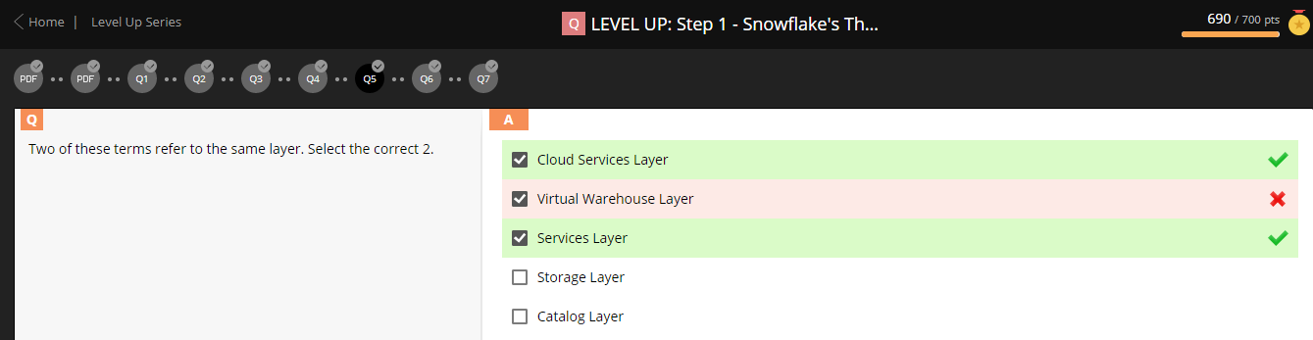

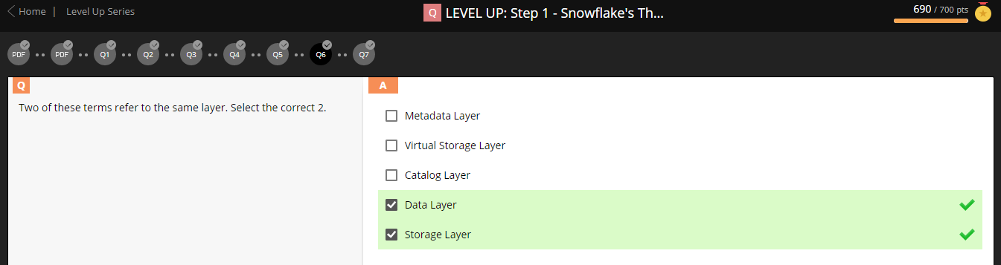

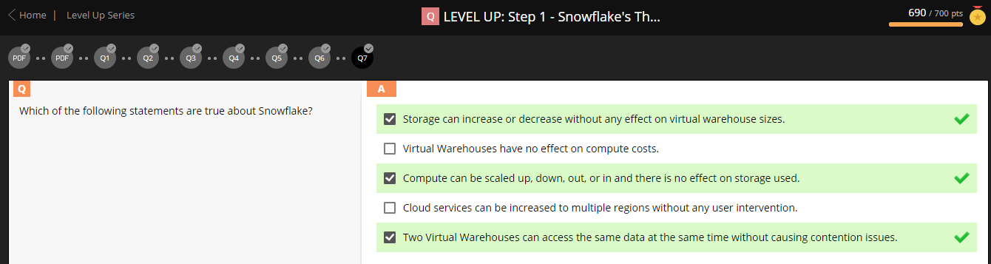

**Step-2: Snowflake Key Concepts:**

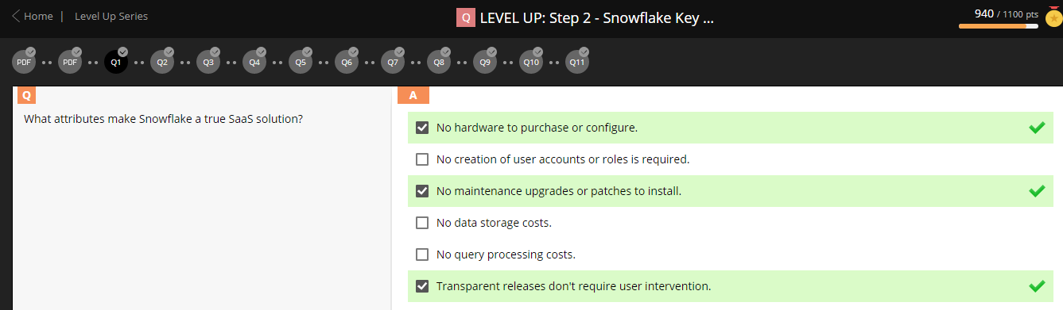

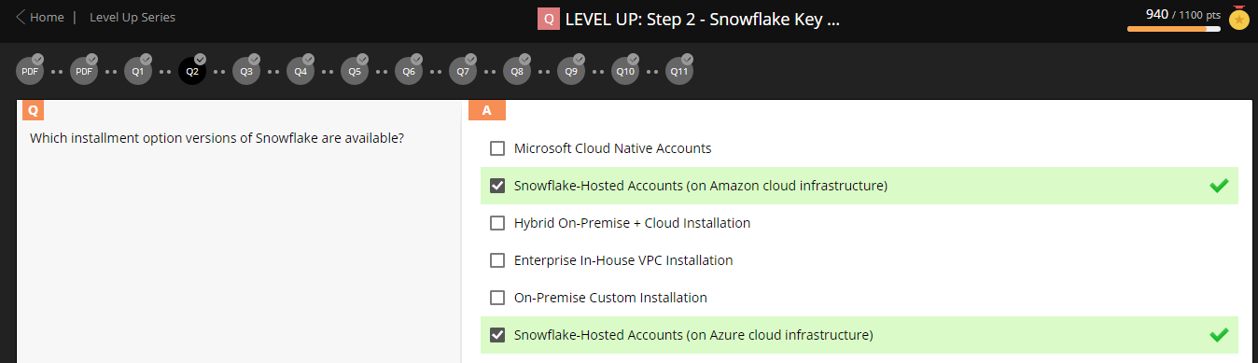

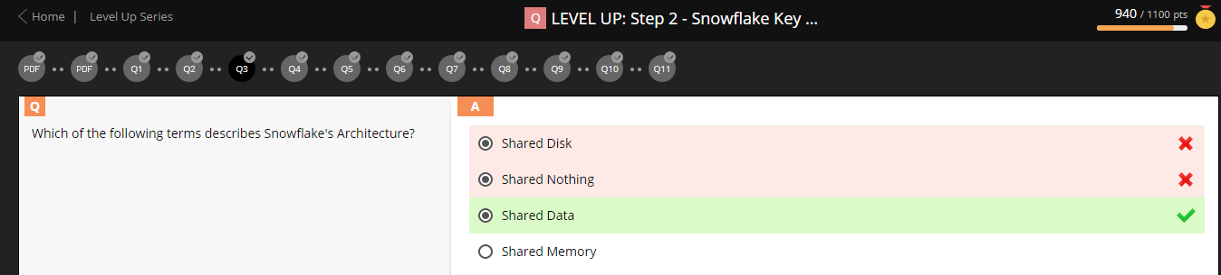

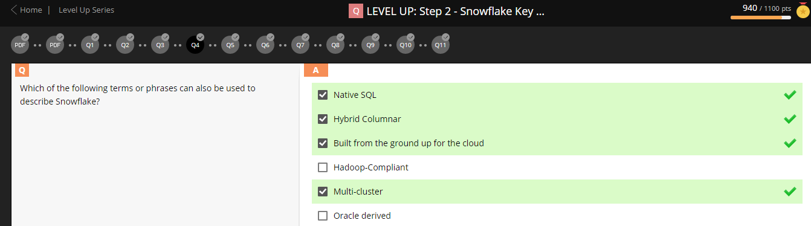

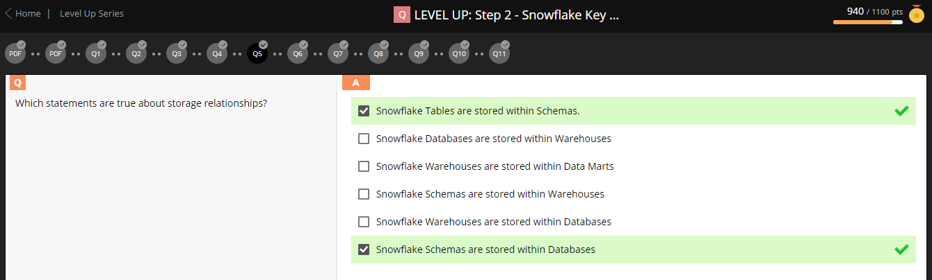

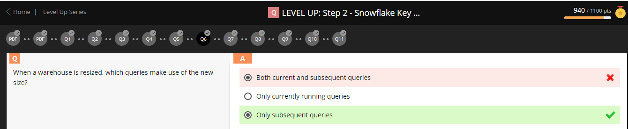

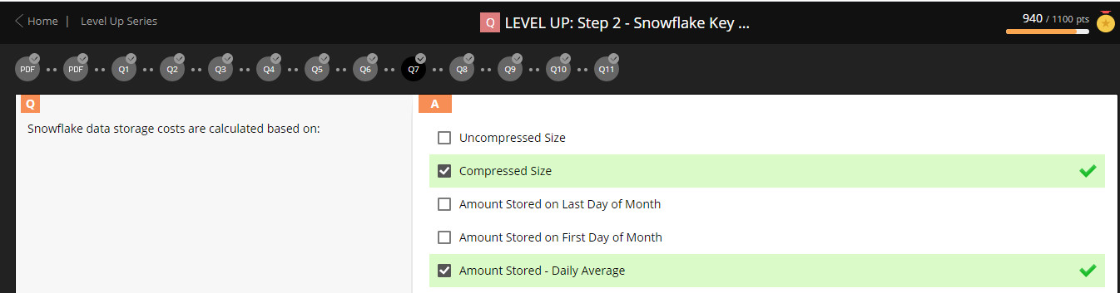

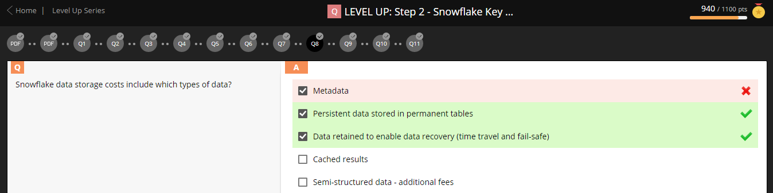

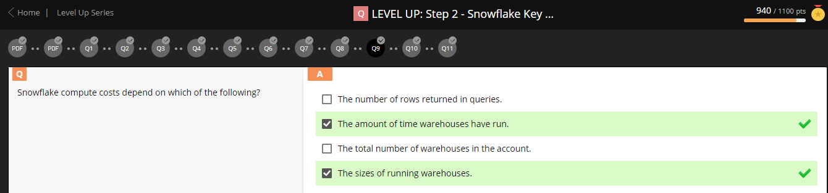

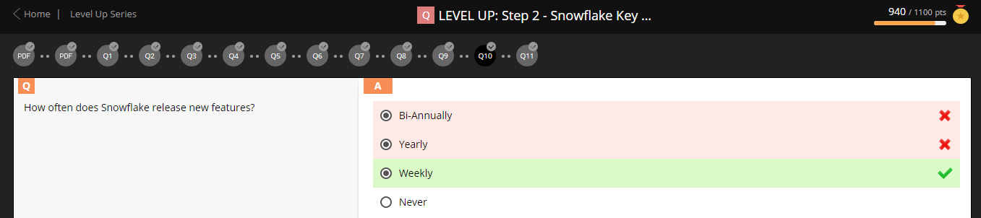

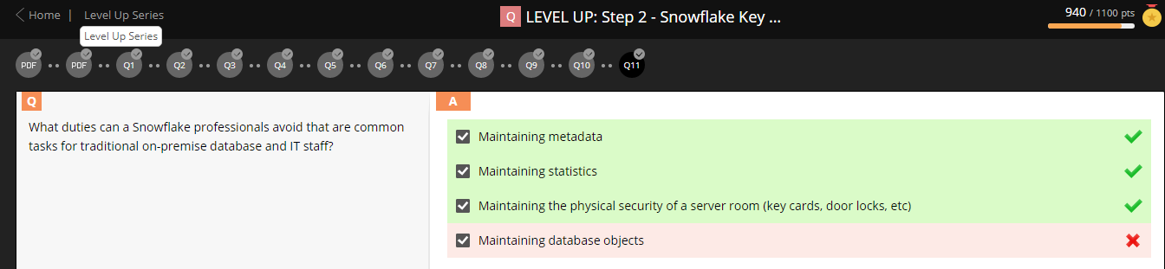

**Step-3: Snowflake Ecosystem (Partner Connects):**

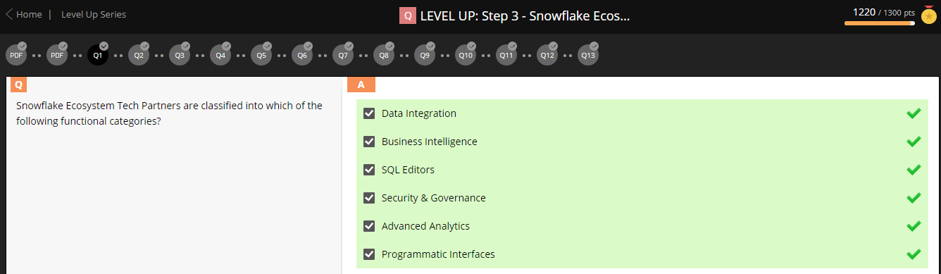

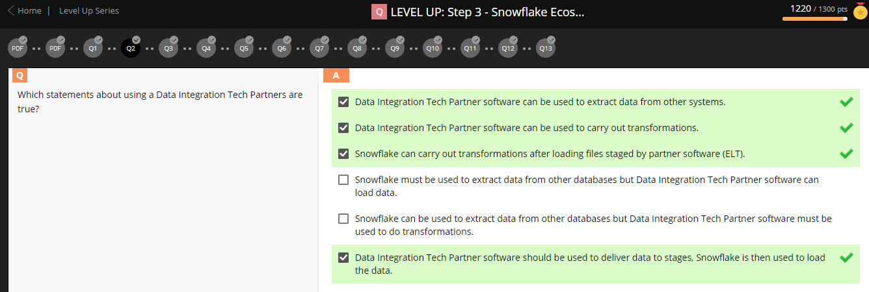

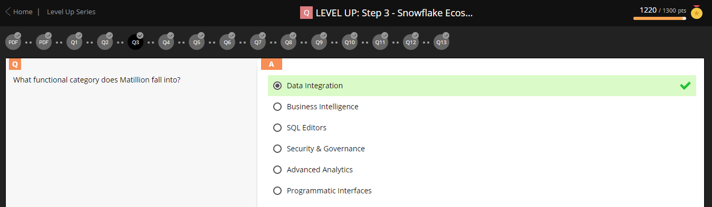

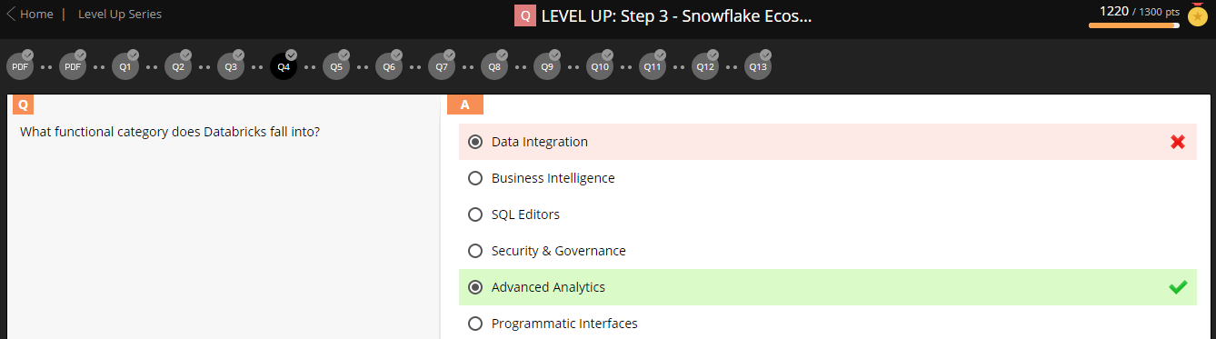

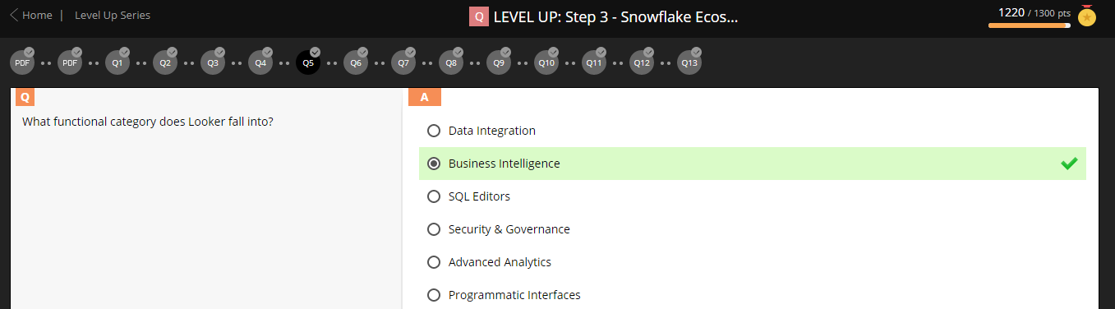

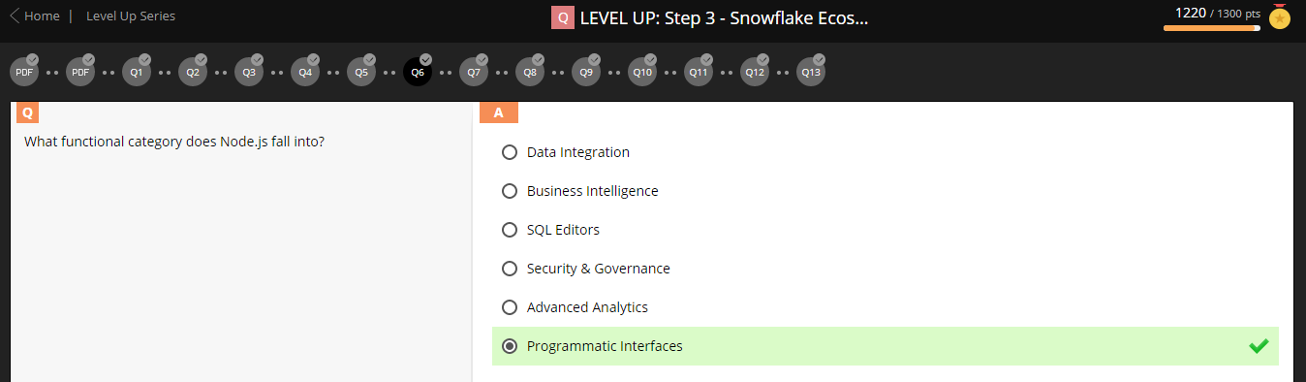

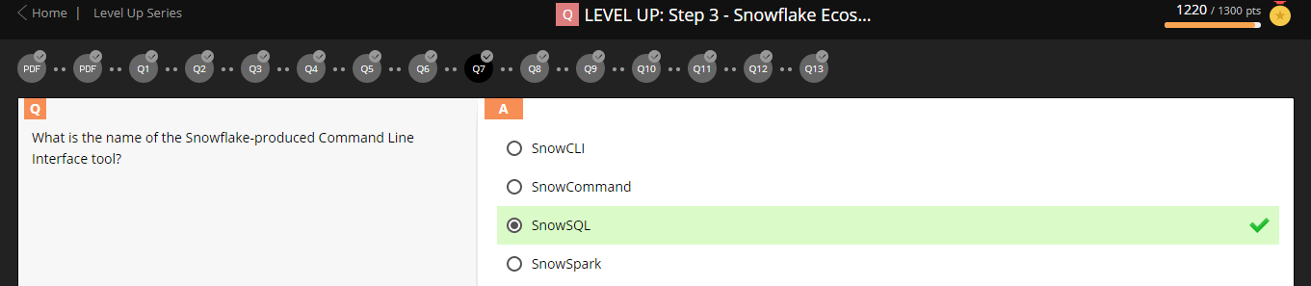

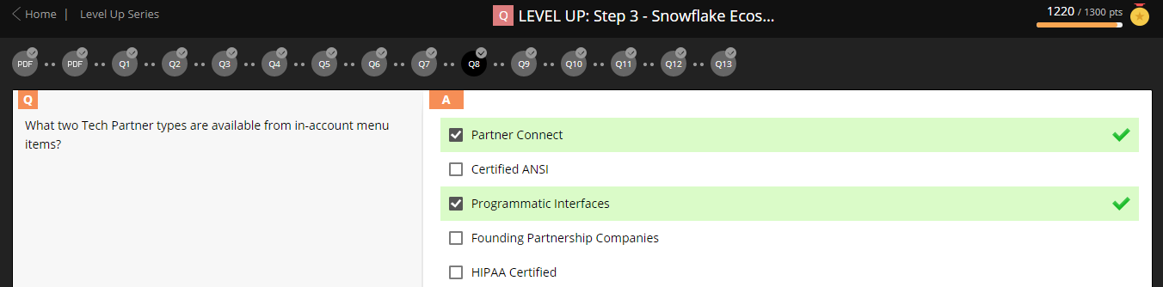



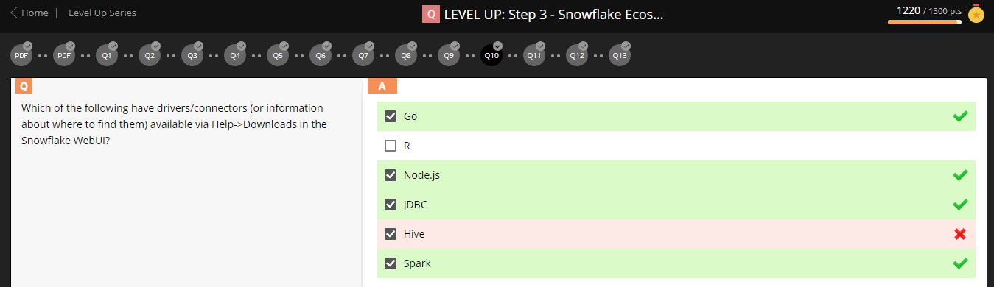

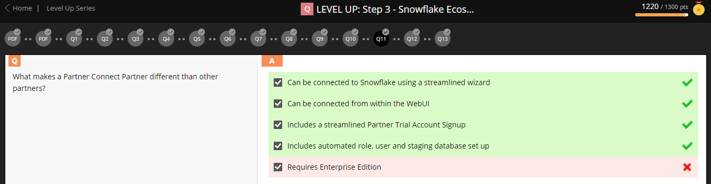

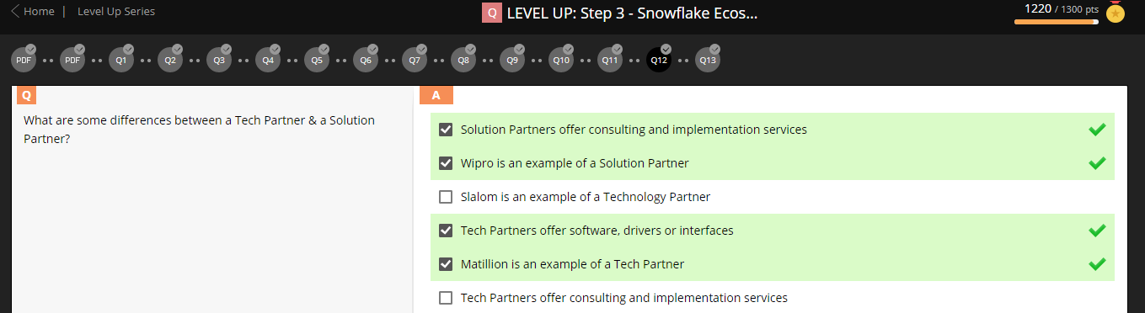

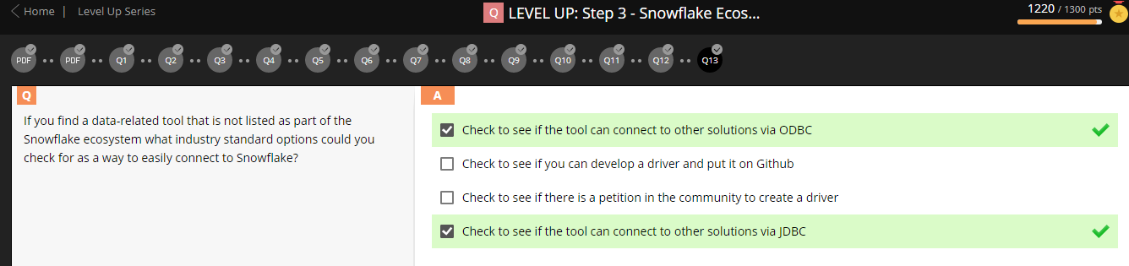

**Step-4: Snowflake Account (Options & Assurances):**



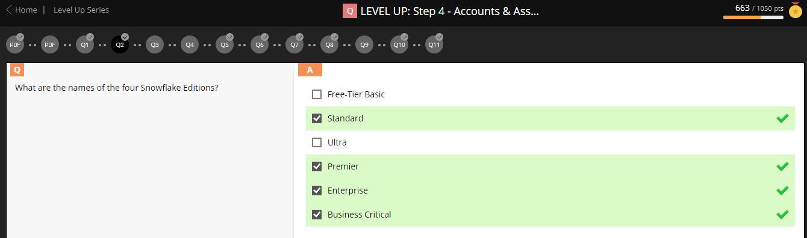

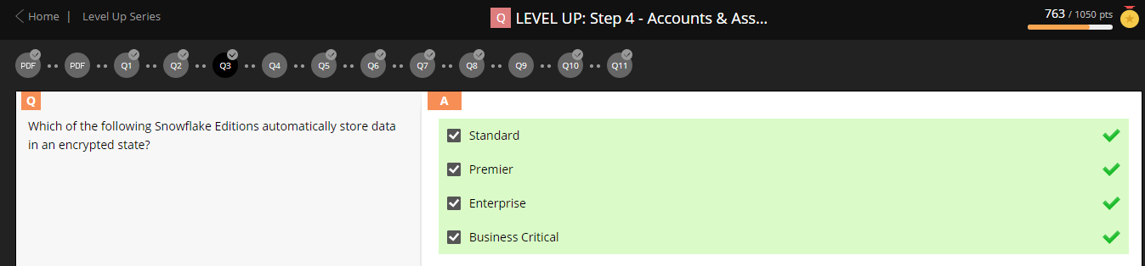

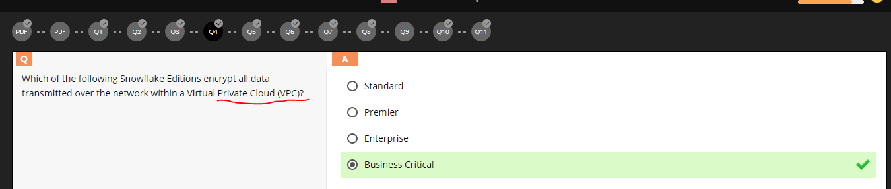

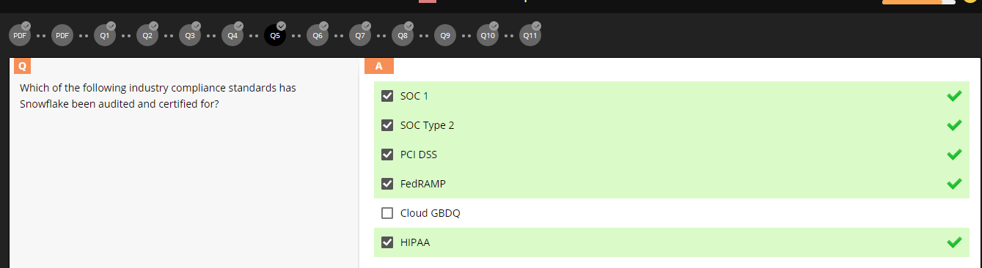

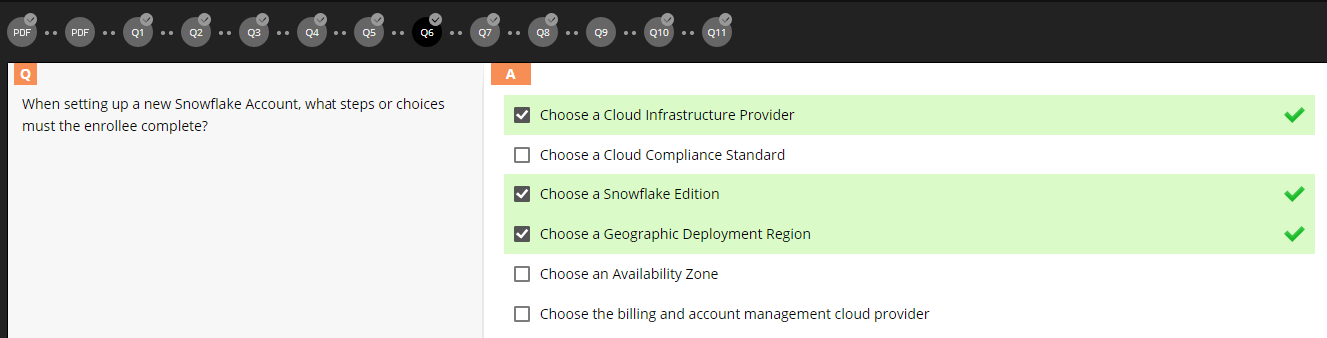

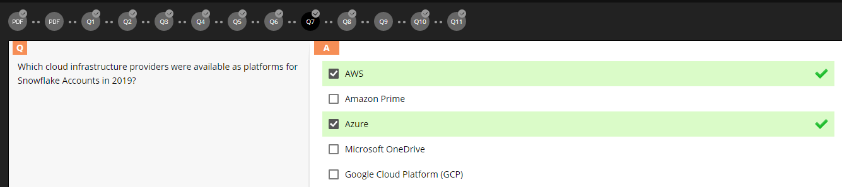

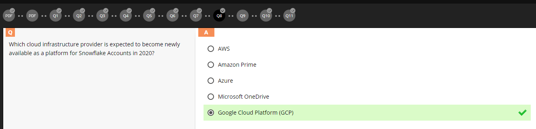

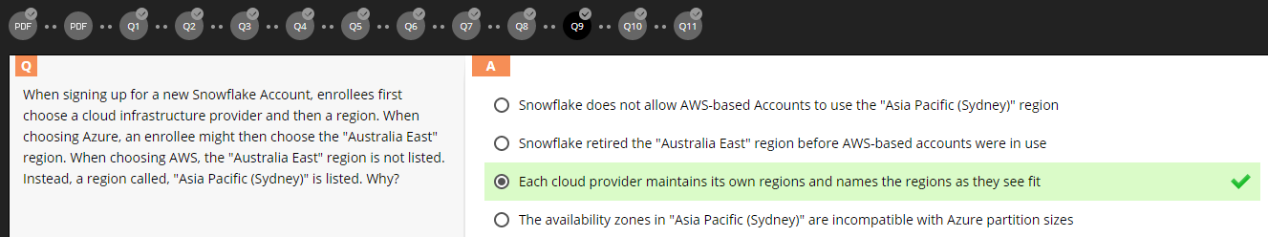

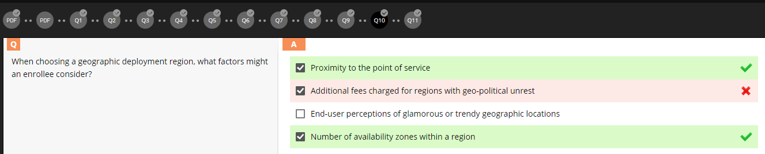

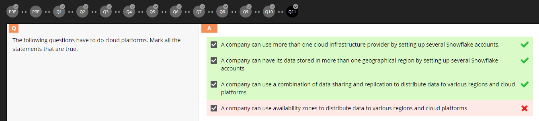

**Step-5: Container (Hierarchy & Details):**

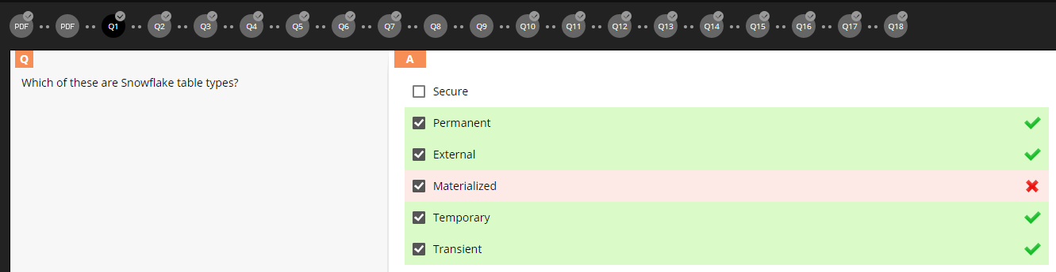

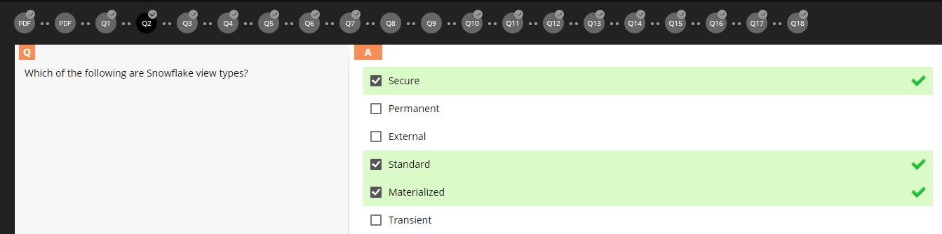

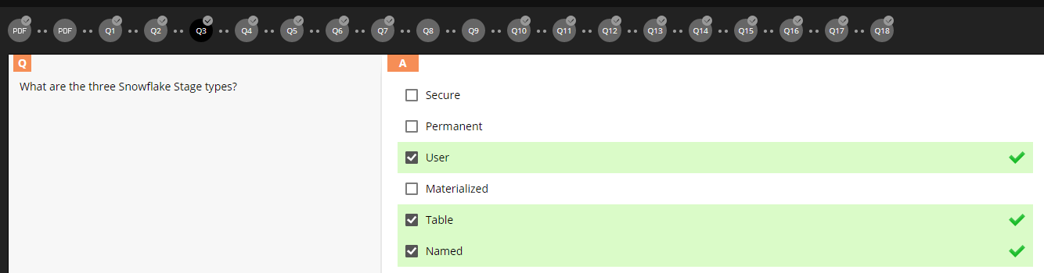

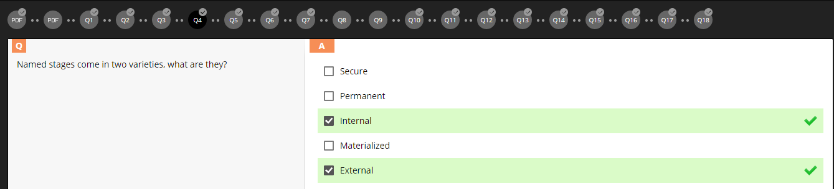

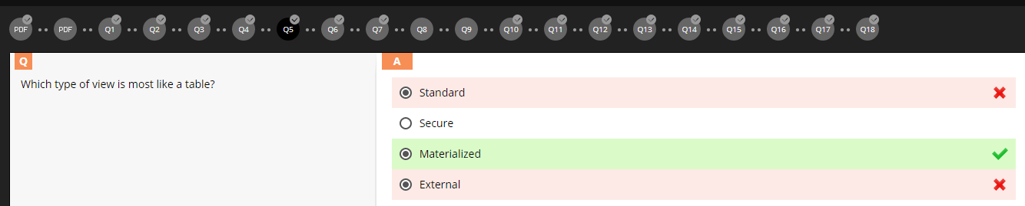

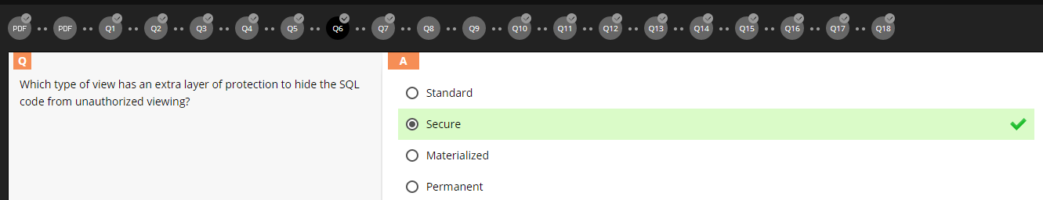

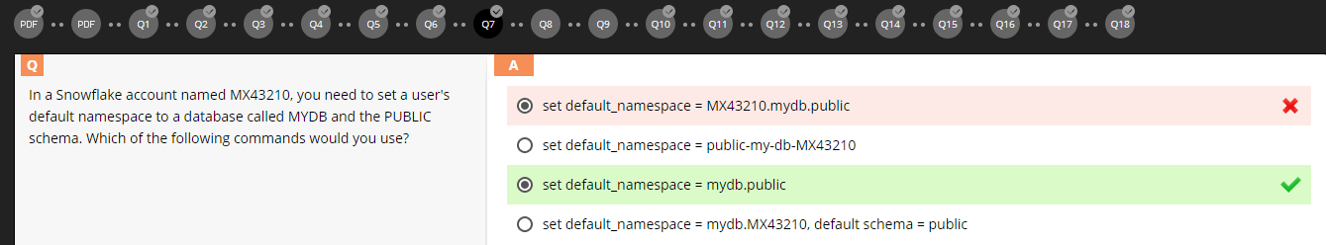

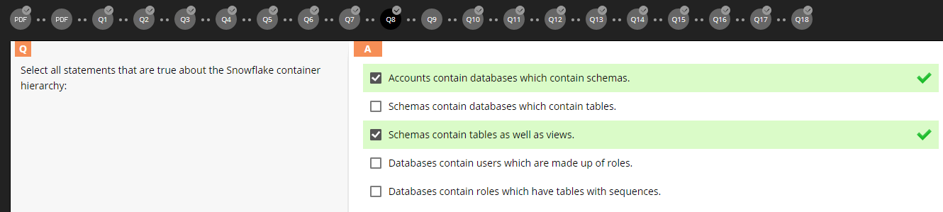

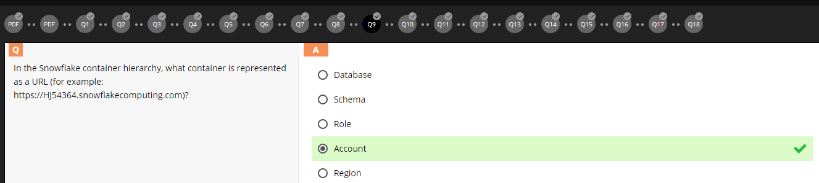



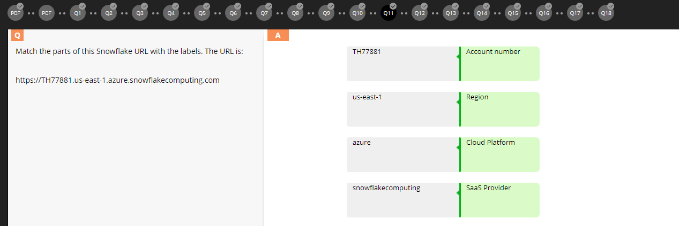

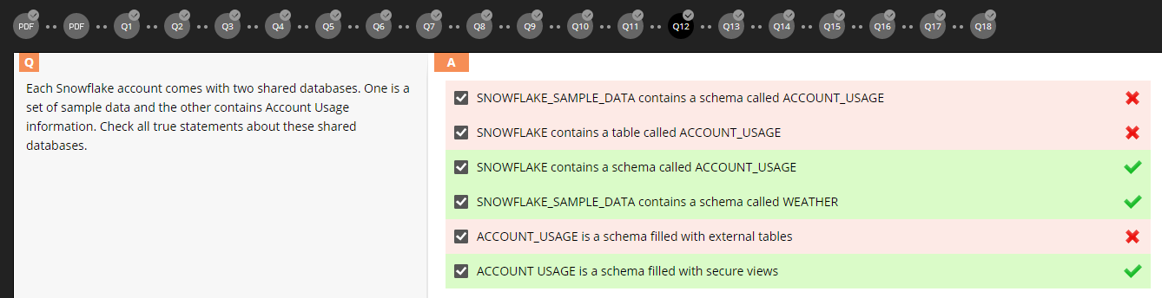

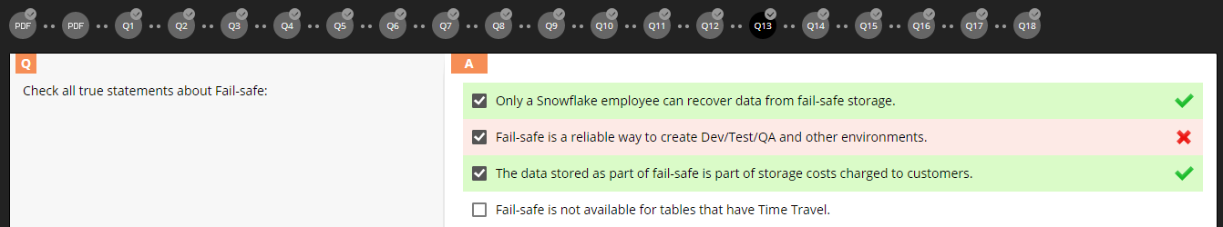

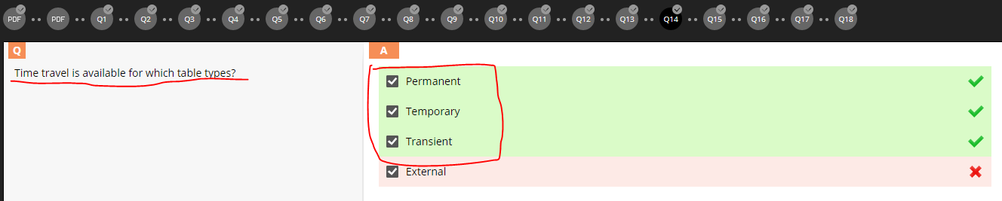

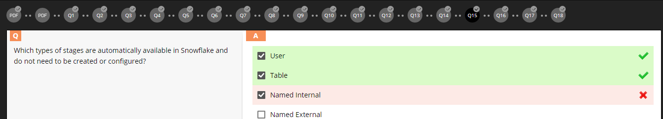

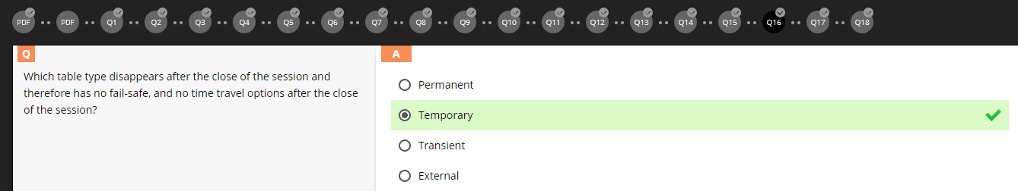

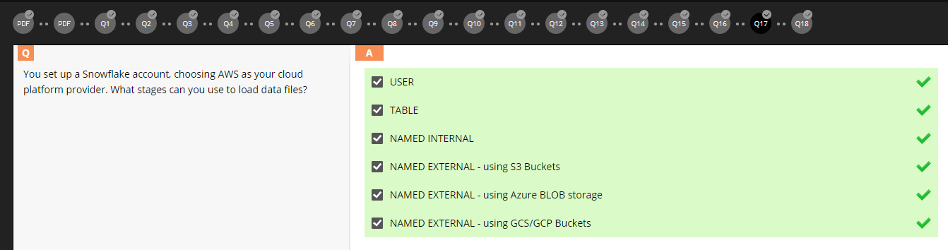

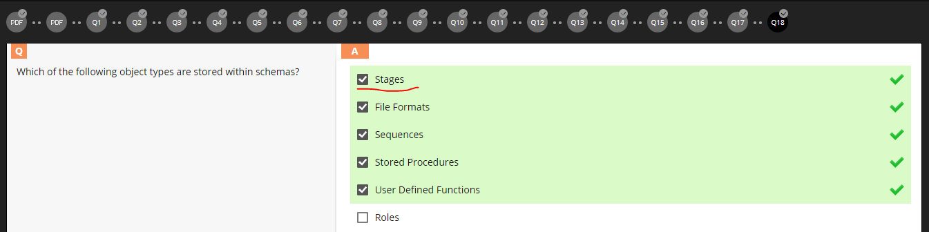

**Step-6: Query and Results History:**

**Step-7: Context:**

**Step-8: Caching:**