Firmware file is ai03_orbit_x_via.hex

Install instructions:

1. If computer does not have drivers for atmega32u4:
   1. Open qmk_toolbox.exe
   2. When QMK toolbox asks to install drivers, select Yes.  
      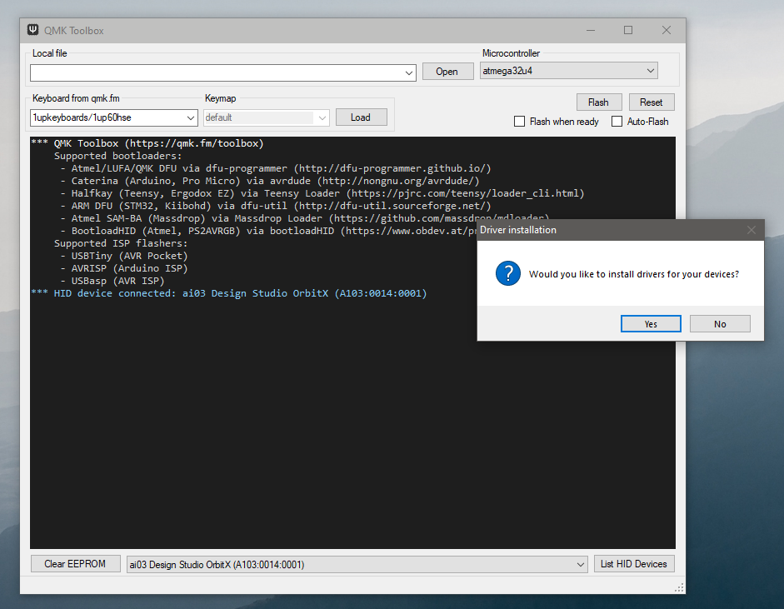
   3. The drivers will install slowly.  
      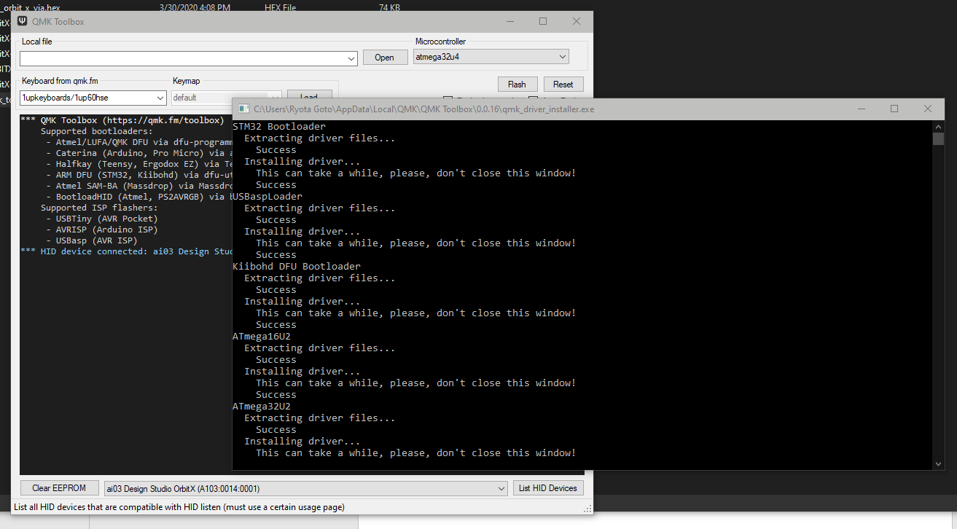
   4. Restart computer to finish driver install.
2. After drivers are installed, open qmk_toolbox.exe.
3. Click the Open button under “Local File”, and select the firmware file ai03_orbit_x_via.hex.  
   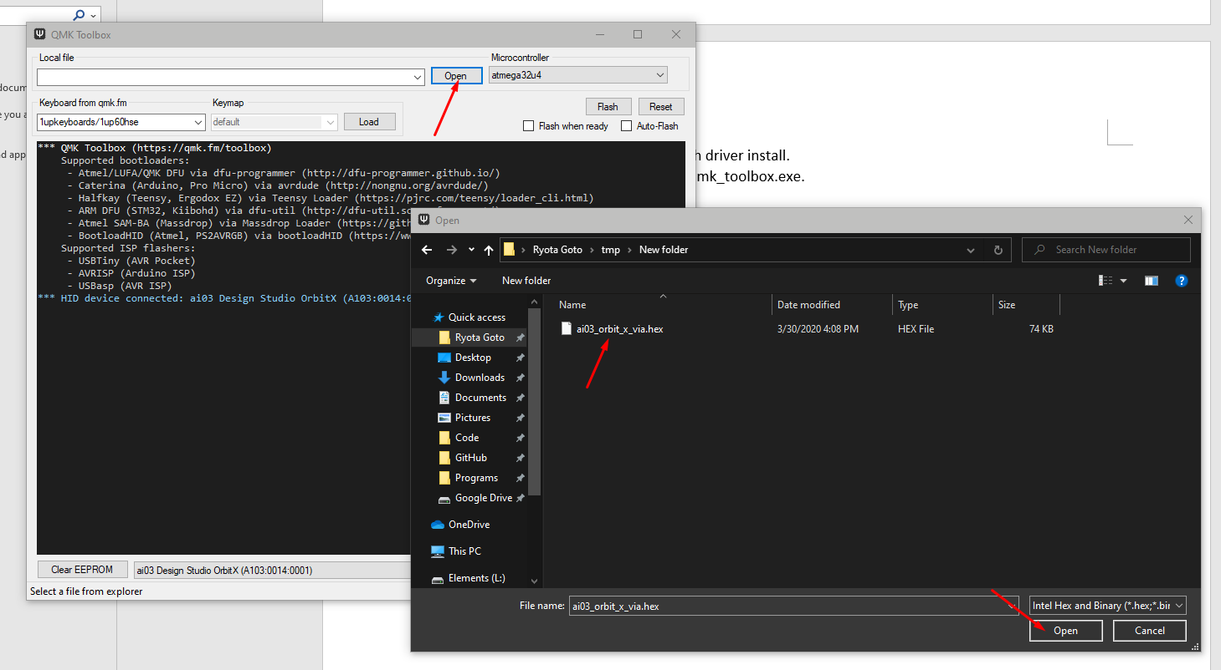/
4. Select atmega32u4 for Microcontroller, and turn on “Flash when ready”.  
   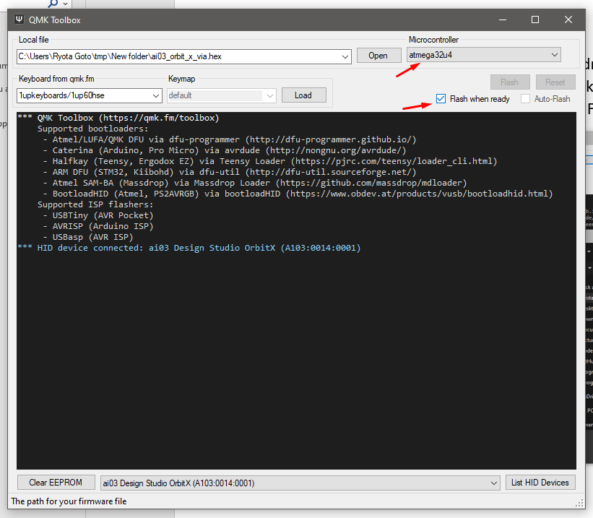
5. Connect the PCB. Firmware will automatically flash, and the device will appear as “ai03 Design Studio OrbitX” after success.