未尽之处：

1线程交互

2

——————————————————————————

1.Thread Creating
public class ThreadCreated implements Runnable {

public void run() {
//@todo Something thread to do
}

2.Start a Thread
public class TestRunnable {

public static void main(String[] args) {
ThreadCreated ThreadCreated1 = new ThreadCreated(); //sth to do

Thread Thread1 = new Thread(ThreadCreated1); // thread

t1.start();
}
Tips:
1.A thread must have a name no matter you give one or JVM does.
2.Have current thread : Thread.currentThread();
3.Whatever order you use to start several threads,the only thing JVM does is to ensure all the threads executing until the run() method comes to the last codes.At a specified time slot,JVM can only run one thread on every CPU,and a serials of threads on the same CPU can run in different orders.
4.The Thread Management in JVM seems like the others in a real Computer Operating System Archetechture.
5.We can't control the order of thread running,but we can use some semantics to affect it.

3.Thread Stack Model
A Thread Stack is a Stack that contains several methods the Thread is executing.Two method in different Thread Stack may execute in a order depends on the JVM.

4.Thread Statement
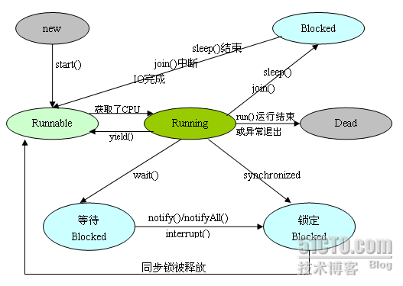
1.ThreadName.sleep(long millis) and ThreadName.sleep(long millis, int nanos) to slow down the thread running.The parameter is the time thread won't running 。
2.Thread Priority and Compromise(让步): Thread.yield() pause the current thread and start to execute another thread.
Tips:The Thread Priority number in JVM is a integer between 1 and 10.We can use ThreadName.setPriority(int Prio) to change it.Note that,JVM can't ensure the executing order by Priority either but it does increase the executing efficient.There's three constant value to present priority:
static int MAX_PRIORITY

static int MIN_PRIORITY

static int NORM_PRIORITY
3.ThreadName.join() makes Thread B can't be runnable until the Thread A it joins has dead.
There's another override method:ThreadName.join(long millis) makes the thread wait for another thread until the timeout is reached.

The three method above have the same effect that make a running thread become blocked.
Also there's four conditions do that:
1.run() method runs until the last line;
2.Reference the wait() method on the object (different from the same action on threads);
3.Thread can't fetch the object lock(对象锁) when trying to run the method of that object;
4.Thread Management Programs change it's statement from running to runnable without any reasons.

5.Sychronization an Lock
Why did so：you have known it well.
There's one built-in lock in every object in JAVA.To make a

6.Thread interaction

ThreadA.class
public class ThreadA {

public static void main(String[] args) {

ThreadB b = new ThreadB();

//启动计算线程

b.start();

//线程 A 拥有 b 对象上的锁。线程为了调用 wait()或 notify()方法,该线程必须是那个

对象锁的拥有者

synchronized (b) {

try {

System.out.println("等待对象 b 完成计算。。。");

//让a等待b算完并唤醒a，不是b等待

b.wait();

} catch (InterruptedException e) {

e.printStackTrace();

}

System.out.println("b 对象计算的总和是:" + b.total);

}

}

}

ThreadB.class
/**

* 计算 1+2+3 ... +100 的和

*

* @author leizhimin 2008-9-15 13:20:49

*/

public class ThreadB extends Thread {

int total;

public void run() {

synchronized (this) {

for (int i = 0; i < 101; i++) {

total += i;

}

//(完成计算了)唤醒在此对象监视器上等待的单个线程,在本例中线程 A 被唤醒

notify();

}

}

}

等待对象 b 完成计算。。。

b 对象计算的总和是:5050

Process finished with exit code 0

7.Thread Scheduling – Sleep

