CSCI3280 Project Report

Team Number: Group 17

Team Member:

HO Chun Kit - 1155034786

Boris Yau - 1155040871

FAN Wai Keung - 1155047303

FAN Sin Tat - 1155047763

TSE Cheung Yuet - 1155049118

P2P Karaoke System

Workload division

| Work | Work description | PIC |
| --- | --- | --- |
| 1. Player implementation |  |  |
| Basic User Interface | Display window, buttons and list control of files | Tse Cheung Yuent |
| Music Management | A database which stores music information (album picture, title, artist, length) | Ho Chun Kit |
| Music information display | Music information display scene according to database | Ho Chun Kit |
| Multi-keyword music searching | Search music in database with multi-keyword | Fan Wai Keung |
| Music decoding and playback | Decoding AVI, MP4 split and combine frames and audio | Fan Sin Tat |
|  |  |  |
| 2. Peer-to-peer network system |  |  |
| Network connection | Connect other PC via the network | Fan Sin Tat |
| Video Searching | Search video in the database which in the PC within the network system | Fan Sin Tat |
| Playing criteria | Criteria for streaming | Fan Wai Keung |
| Real-time video streaming | Streaming video from other PC real-timely | Boris Yau |
| Peer-to-peer playing | Streaming video from more than one PC simultaneously | Boris Yau |
|  |  |  |
| 3. Documentation | Report writing | Ho Chun Kit |

Operation Manual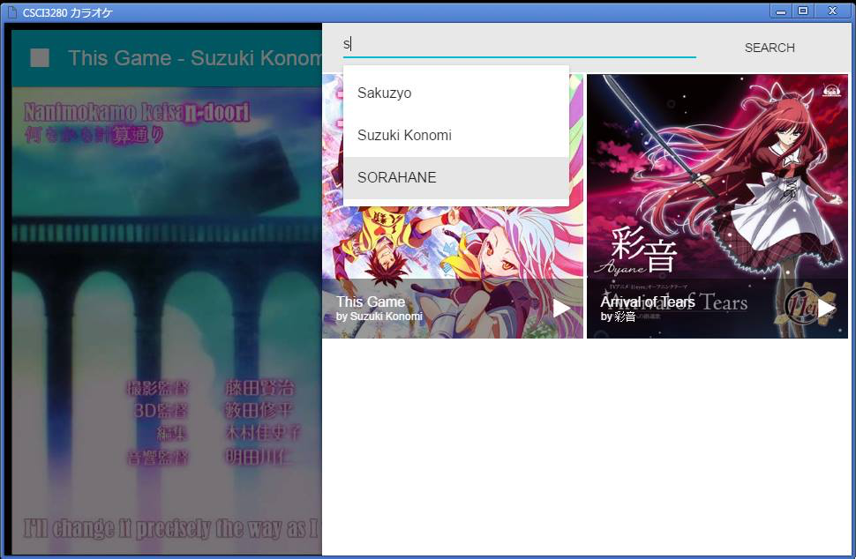

1.Searching Screen

This is the screen which user requested to search. It will search through the databases which joint the network, including local database and other node.

User can simply type in the search keyword. The program will show the existing media in the network. After searching, it will response a list of related media which its information like picture, title, artist and so on.

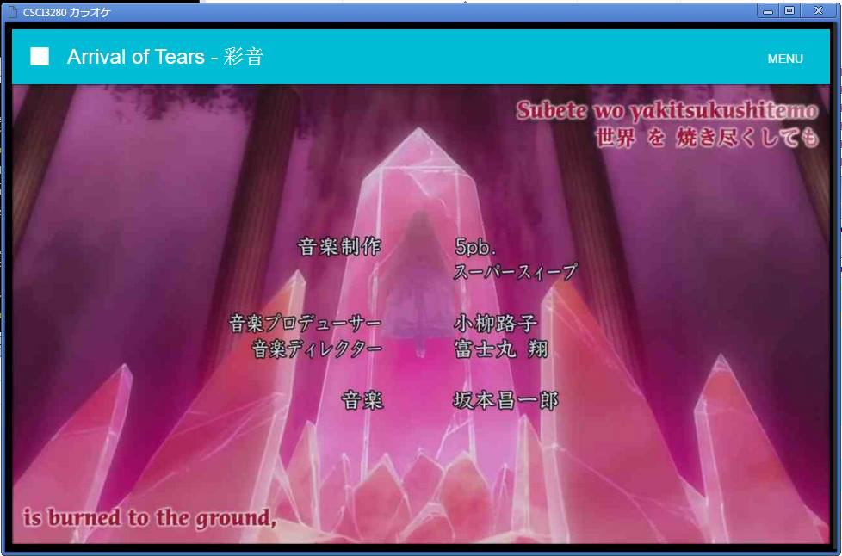

2. Playing Screen

When user chose a media, the program will determent whether the file is in local or in other node, and load to the play like this.

The top bar will show the information of the current playing media and let user go to menu for another search.

Third-party Libraries

|  |  |  |  |
| --- | --- | --- | --- |
| FFMPEG | [A-Forge.NET](http://a-forge.net) | Node-ppm | Node-crc-32 |
| React | Babel | Font-awesome | Material-ui |
| Webpack | Nwjs |  |  |
|  |  |  |  |