**HUMCOM**

## Table of Contents

Table of Contents 2

Phase 1: 30% 3

Phase 2: 50% 9

Phase 3: 75% 14

Phase 4: 90% 19

# Phase 1: 30%

● Create a minimum of one HTML page (index.html).



● Utilize semantic HTML5 elements (e.g., <header>, <nav>, <main>, <footer>, <article>, <section>).

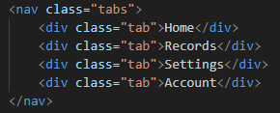

● Implement proper document structure (<!DOCTYPE html>, <html>, <head>, <body>).

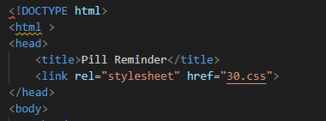

● Include appropriate headings (<h1> to <h6>), paragraphs (<p>), and lists (<ul>, <ol>, <li>).







● Include at least one image.

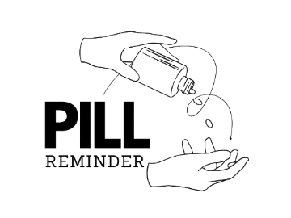

CSS Styling:

● Create an external CSS file (styles.css) and link it to the HTML page.



● Apply basic CSS styles for layout, typography, and colors.

body {

    font-family: 'Segoe UI', Tahoma, Geneva, Verdana, sans-serif;

    margin: 0;

    padding: 0;

    background-color: #f4f4f4;

    display: flex;

    justify-content: center;

    align-items: center;

    height: auto;

    flex-direction: column;

}

.container {

    width: 100%;

    background-color: white;

    padding: 10px;

    border-radius: 10px;

    text-align: center;

}

header {

    display: flex;

    align-items: center;

    justify-content: space-between;

    padding: 10px 20px;

    background-color: #28a745;

}

.header-content {

    display: flex;

    align-items: center;

    justify-content: center;

    width: 100%;

}

h1 {

    margin: 0;

    font-size: 24px;

    color: rgb(0, 0, 0);

}

.logo {

    width: 350px;

    height: auto;

    margin-left: 15px;

}

.tabs {

    display: flex;

    justify-content: space-around;

    background-color: #28a745;

    padding: 15px;

    position: fixed;

    bottom: 0;

    width: 100%;

    border-radius: 10px 10px 0 0;

}

.tab {

    cursor: pointer;

    font-weight: bold;

    flex: 1;

    text-align: center;

    padding: 10px;

    border-right: 2px solid black;

    transition: all 0.3s ease-in-out;

}

.tab:last-child {

    border-right: none;

}

.tab:hover {

    background-color: white;

    transform: scale(1.05);

    box-shadow: 0px 4px 10px rgba(0, 0, 0, 0.2);

}

main {

    padding: 20px;

}

.welcome {

     border: 3px solid #28a745;

     padding: 20px 20px;

}

.welcome h2{

    color: #535252;

}

button {

    background-color: #28a745;

    color: black;

    border: none;

    padding: 12px 24px;

    font-size: 16px;

    font-weight: bold;

    cursor: pointer;

    border-radius: 5px;

    transition: all 0.3s ease-in-out;

}

button:hover {

    background-color: white;

    transform: scale(1.05);

    box-shadow: 0px 4px 10px rgba(0, 0, 0, 0.2);

}

.medication {

    background-color: #e9ecef;

    padding: 10px;

    margin: 10px 0;

    border-radius: 5px;

}

.status {

    padding: 5px 10px;

    border-radius: 3px;

    font-weight: bold;

}

.status.taken {

    background-color: #28a745;

    color: white;

}

.status.missed {

    background-color: #dc3545;

    color: white;

}

footer {

    background-color: #28a745;

    color: white;

    text-align: center;

    padding: 10px;

    width: 100%;

    left: 0;

    height: 50px;

    line-height: 30px;

    position: relative;

    margin-top: auto;

}

Reflection:

I began by structuring the HTML page with semantic elements to ensure clarity and accessibility. The initial design felt plain, so I focused on adding basic styling to improve visual appeal. The header was too large and lacked branding, so I adjusted its size and added a placeholder logo. Navigation links were cramped, and the color scheme was dull. This phase taught me the importance of planning the layout and styling early to avoid rework later. Moving forward, I aim to refine the design and enhance user experience.

# Phase 2: 50%

Requirements (Cumulative):

● Multiple HTML pages with consistent navigation.

● Expanded content across all pages.

● Basic interactive elements.

● Refined CSS styling with advanced techniques.

● Basic responsiveness.

● Basic accessibility considerations.

<img src="logo.png" alt="Medication Reminder Logo" class="logo"><br> <br>

● Validated HTML and CSS

Reflection:

Expanding the project to multiple pages was challenging but rewarding. I ensured navigation consistency by reusing the header and footer across pages. The addition of interactive elements, like buttons with hover effects, made the site more engaging. I experimented with CSS flexbox for layout and added media queries to improve responsiveness. Accessibility was a new focus, and I learned the importance of alt text and semantic HTML. Validating the code helped me catch errors early. However, the mobile layout still needs improvement, and I plan to address this in the next phase.

One memorable moment for me here is that the links I pasted in my code is wrong those limiting the access of other device in the website.

# Phase 3: 75%

● All requirements from Phase 1 and 2 must be met.

● Refined and expanded content.

● Advanced CSS styling and layout.

● Enhanced interactive elements.

● Improved accessibility and performance.

● Thorough testing and validation.

/* Menu Button (Hamburger) */

.menu-toggle {

display: none; /* Hidden on large screens */

background: none;

border: none;

font-size: 24px;

color: white;

cursor: pointer;

margin-left: auto;

Reflection:

This phase involved polishing the design and functionality. I replaced basic layouts with CSS Grid for better control and added subtle animations to enhance interactivity. Forms now include client-side validation, improving user experience. Accessibility improvements, such as ARIA labels and keyboard navigation, were implemented. Performance optimization, like image compression and minified CSS, made the site faster. Testing across browsers revealed minor inconsistencies, which I resolved.

# Phase 4: 90%

All requirements from previous phases must be met.

● Finalized and polished content and design.

● Advanced functionality and interactivity.

● Optimized performance and security.

● Comprehensive cross-browser and device compatibility.

● Deployment readiness.

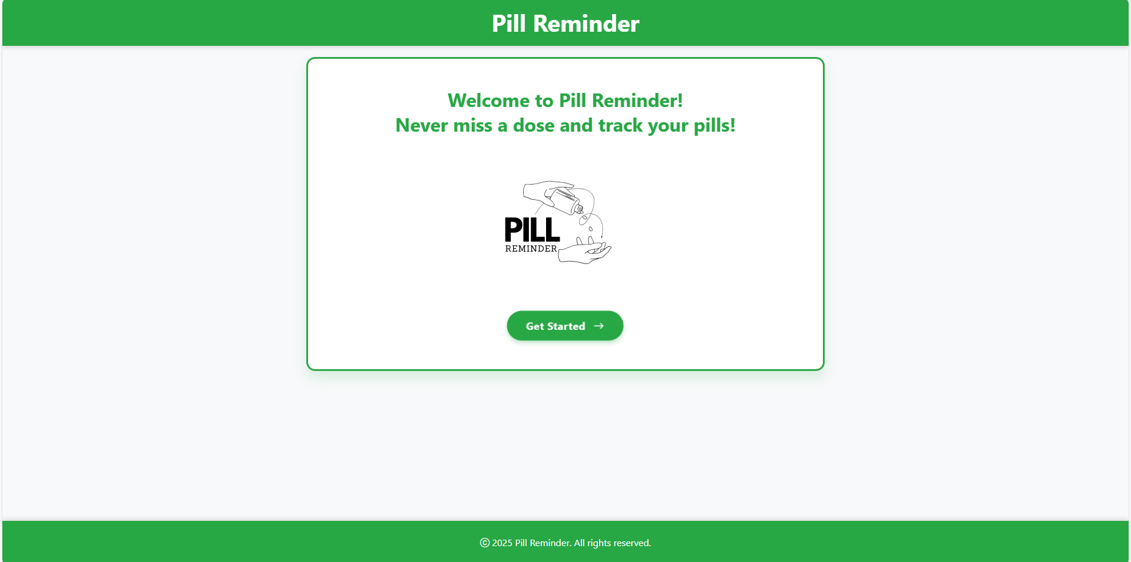

Reflection:

After a conversation with our teacher, I applied some adjustments such as adding footer at the bottom of each page, adding also a logo and making the pages more responsive.

The final phase was about perfection. I audited the design for consistency, ensuring all elements aligned with the branding. Dynamic content, like a medication tracker, was added using JavaScript. I also implemented bootstrap thus lessening my line code in css. Performance optimizations, such as lazy loading and caching, were implemented. Security measures, like sanitizing user inputs, were prioritized. Rigorous testing on various devices and browsers confirmed compatibility. The site is now ready for deployment. This journey taught me the value of iterative development, attention to detail, and the importance of user-centered design.