World Population Analysis
World is facing major scarcity of resources because of over and below birth rate of population so if a country knows about birth and death rate prior then they can make necessary decision to fight with the situation. So we are employing machine learning algorithm for automatic prediction of population growth for any country. Machine learning model get trained on past dataset and then can predict future growth.
Before training Machine Learning Random Forest algorithm we have done extensive research on dataset in visualization format for each understanding of children birth, survive and date rate, gender wise death rate, birth and death rate etc.
To train above ML algorithm we have utilized same world population dataset given by you and to implement this project we have designed following modules
- New User Signup: using this module user can sign up with the application
- User Login: using this module user can login to application
- Load Population Dataset: using this module user can load worldwide population dataset
- Dataset Analysis: using this module user can select desired country from dataset and can get various visualization of dataset analysis
- Predict Growth Rate: this module will predict birth rate for next 10 years (120 months) for selected country.
SCREEN SHOTS
To run project copy content from DB.txt file and then paste in MYSQL to create database and then double click on ‘runServer.bat’ file to start python server and get below page
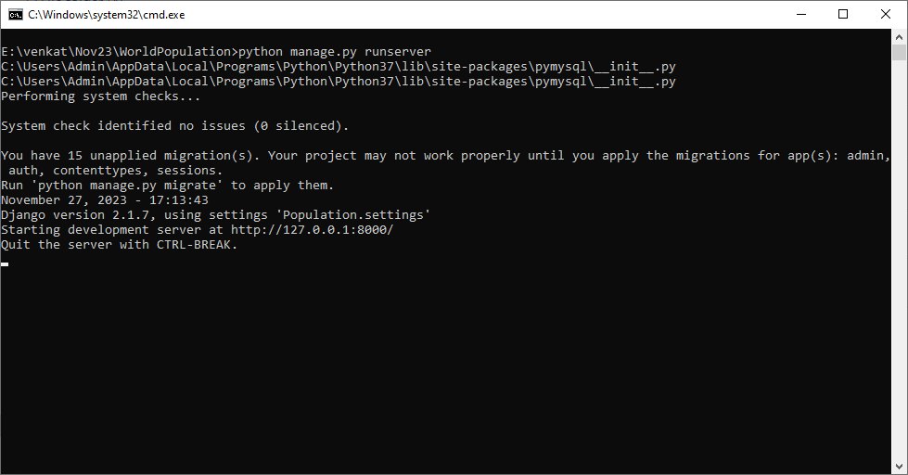
In above screen python server started and now open browser and enter URL a http://127.0.0.1:8000/index.html and press enter key to get below page
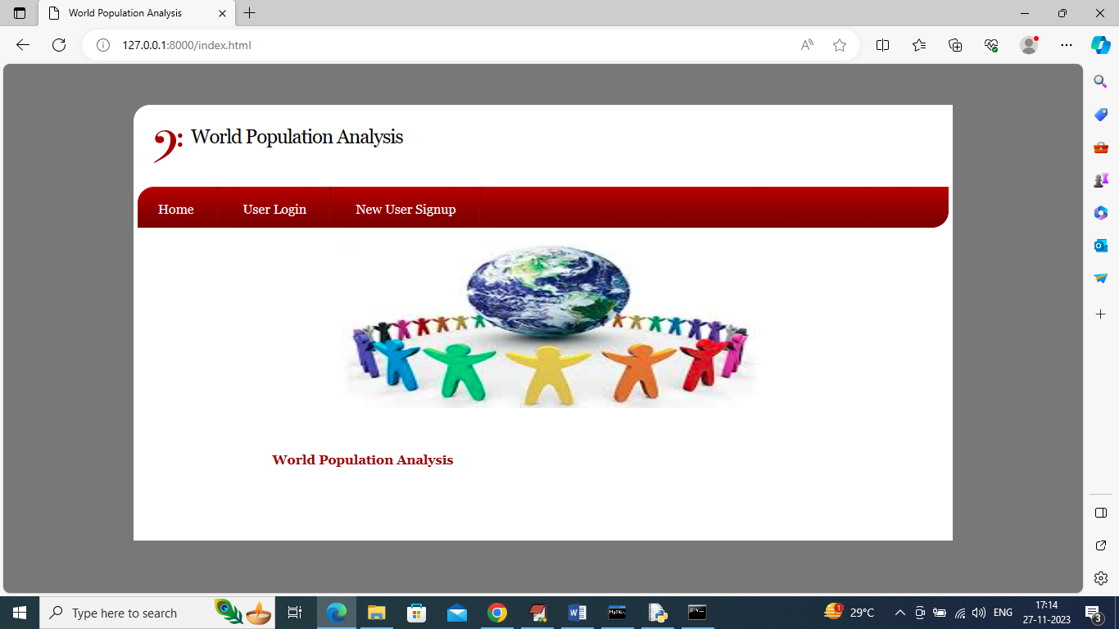
In above screen click on ‘New User Signup’ link to get below page
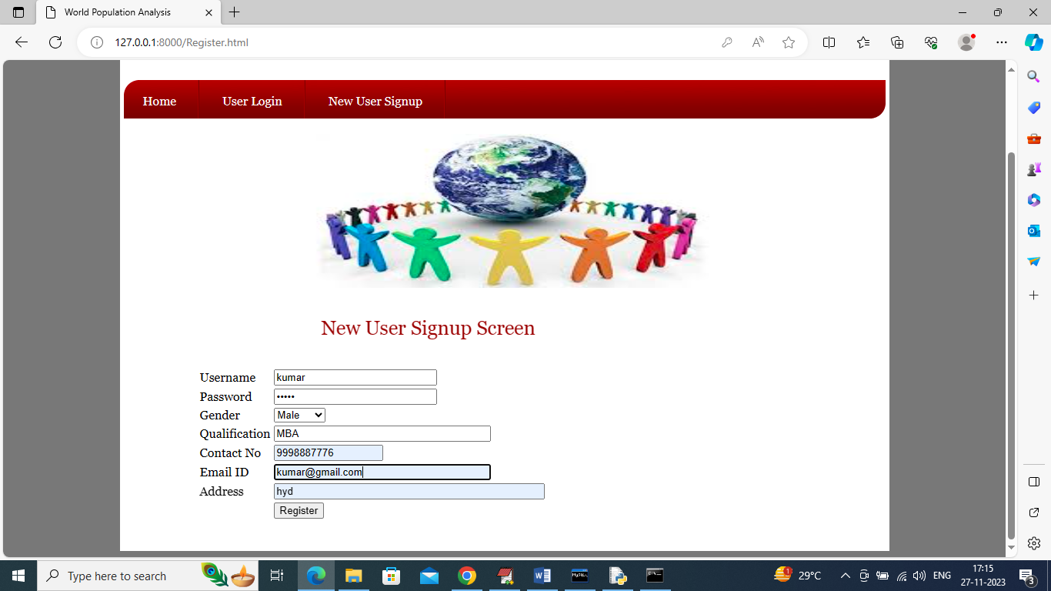
In above screen user is entering sign up details and then press button to get below page
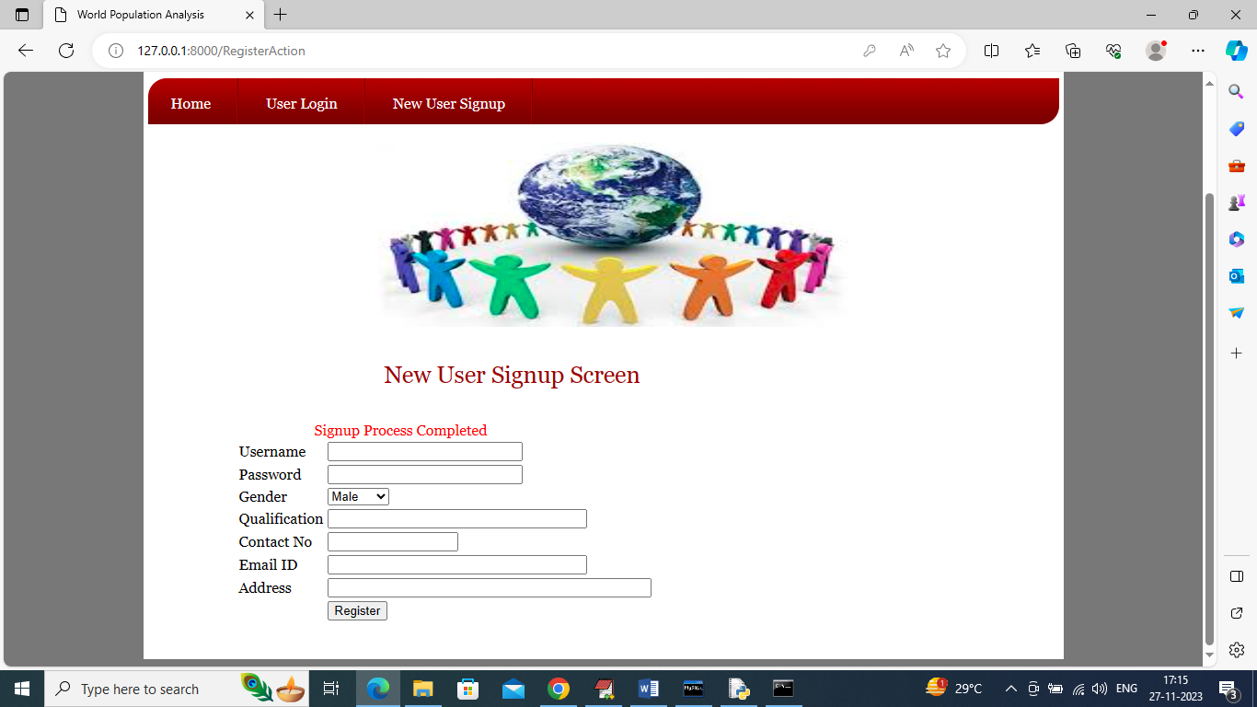
In above screen user signup completed and now click on ‘User Login’ link to get below page
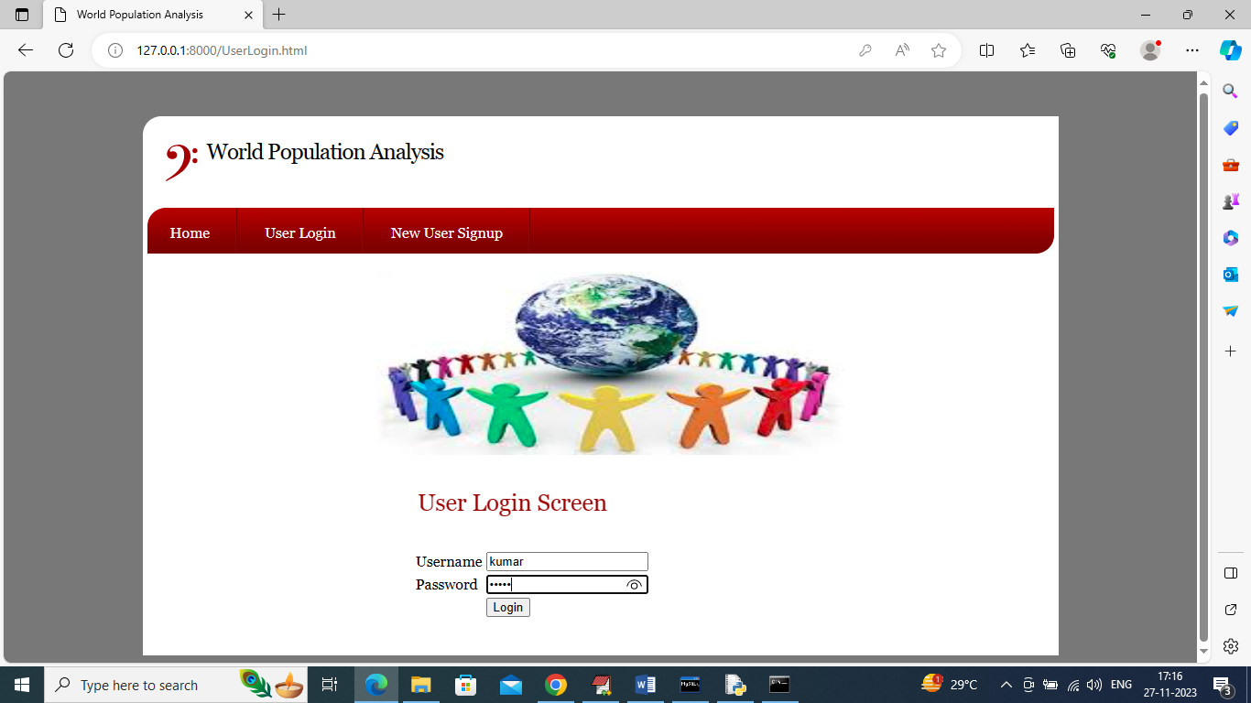
In above screen user is login and after login will get below page
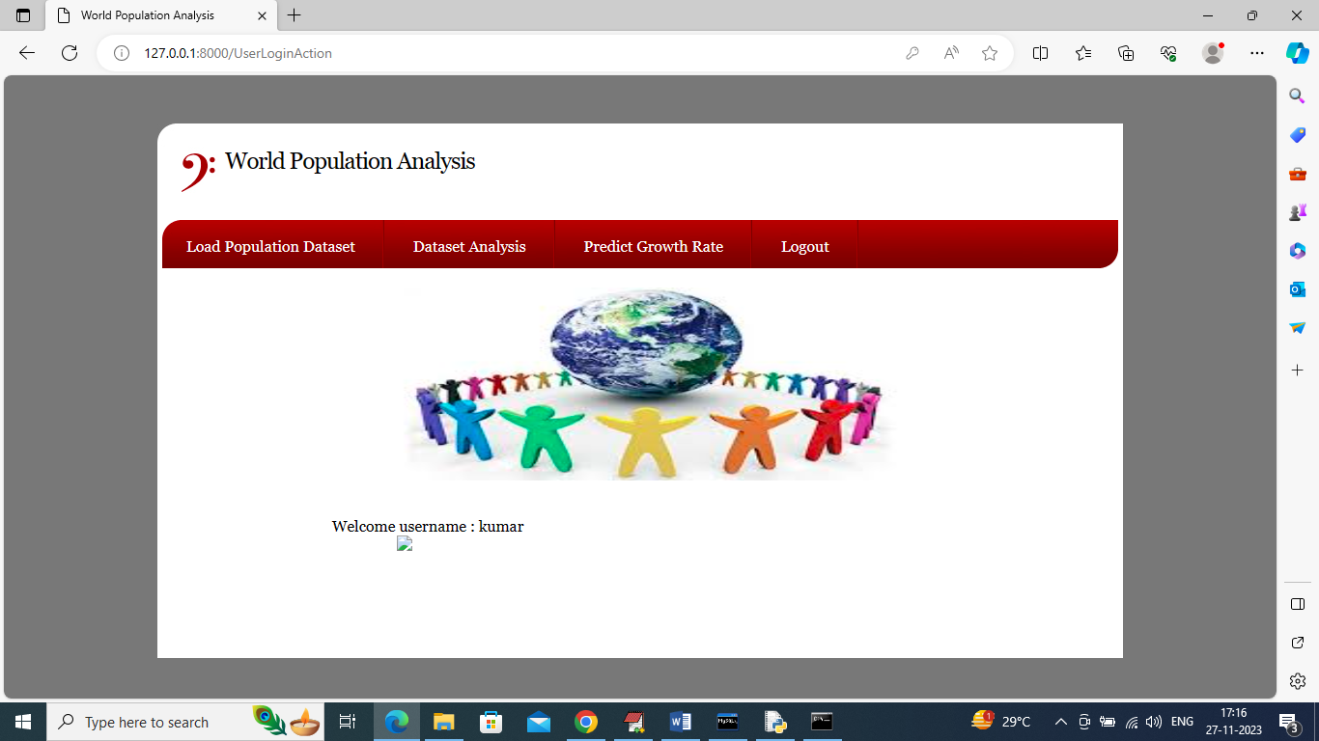
In above screen click on ‘Load Population Dataset’ link to load dataset and get below page
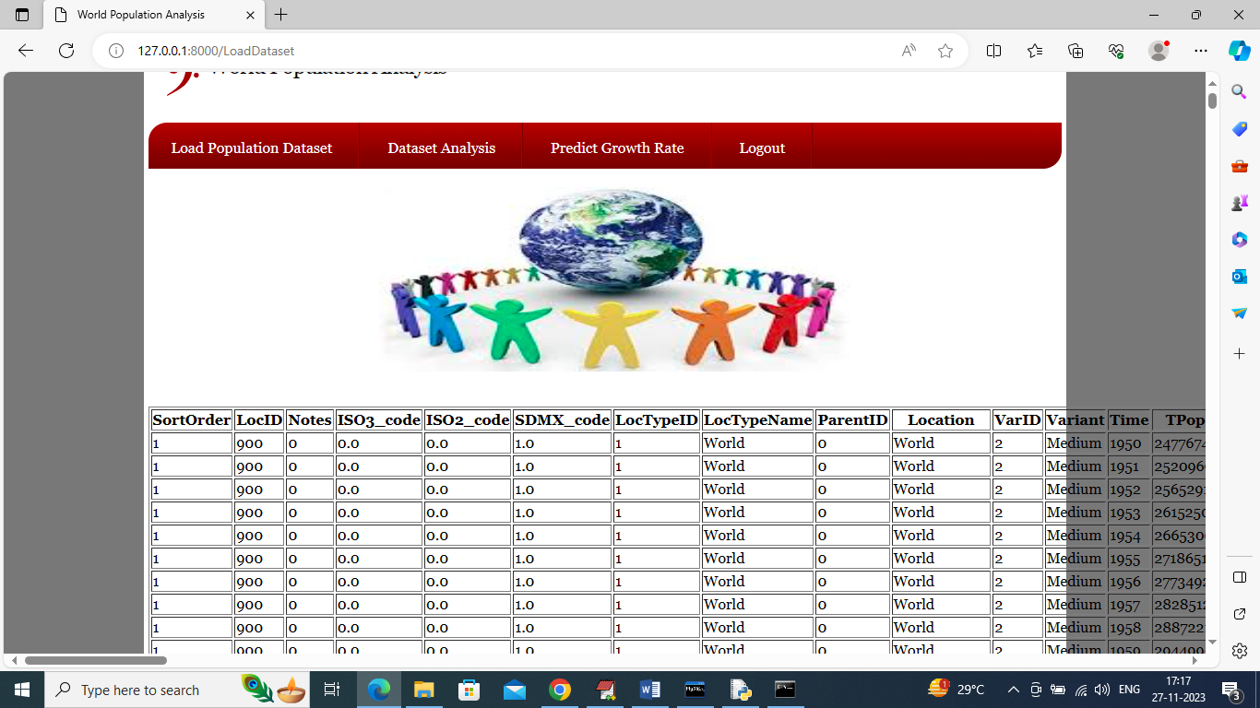
In above screen dataset loaded and now click on ‘Dataset Analysis’ link to get below page
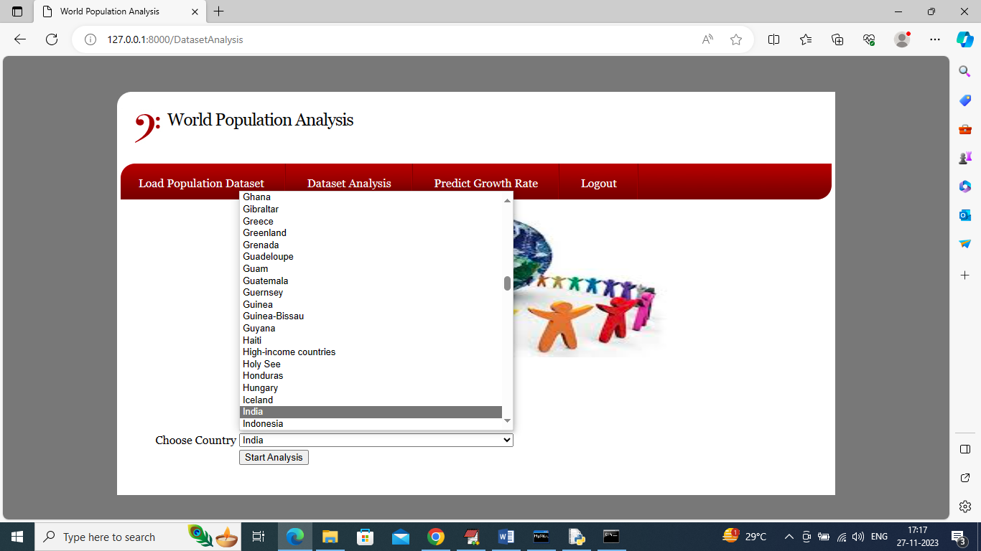
In above screen from drop down box select desired country name to perform analysis and in above screen I selected ‘India’ and then press button to get below graphs
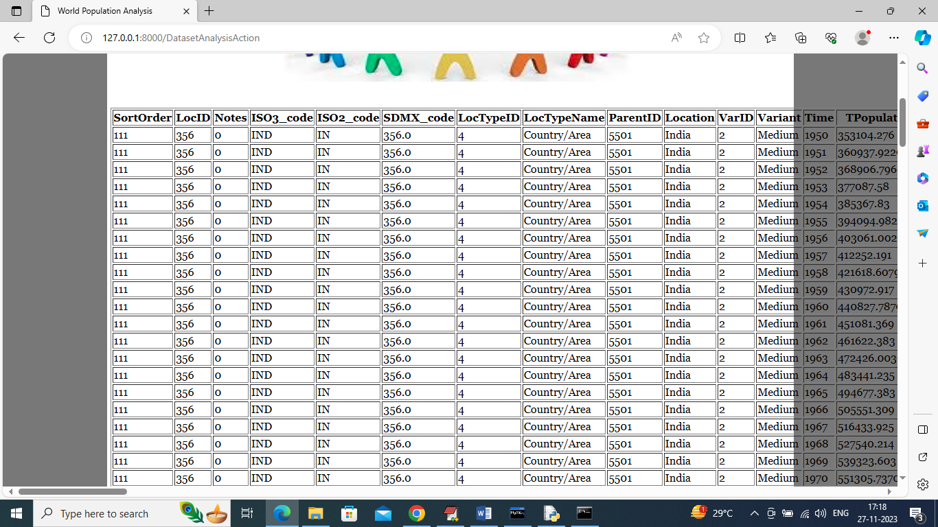
In above screen all data selected from India country and then go below page to see below graphs
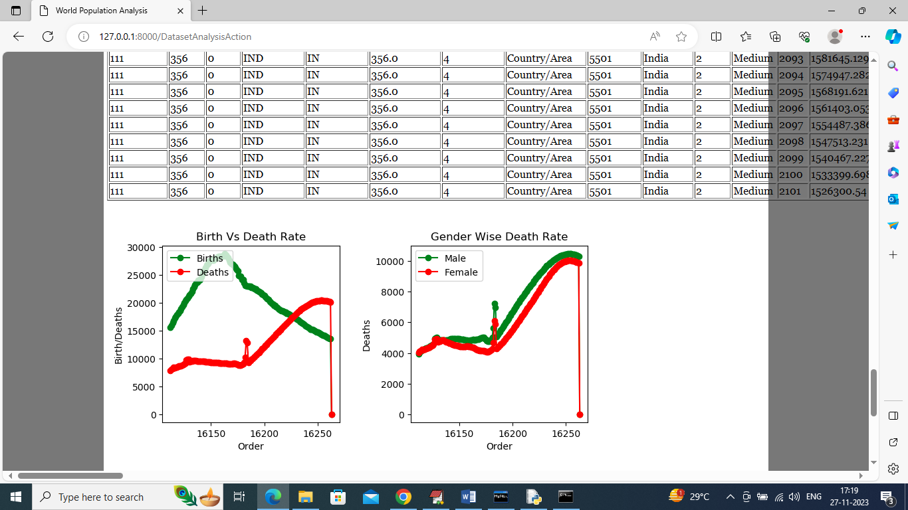
In above screen in first graph can see birth and death rate and in second graph can see gender wise birth and death rate
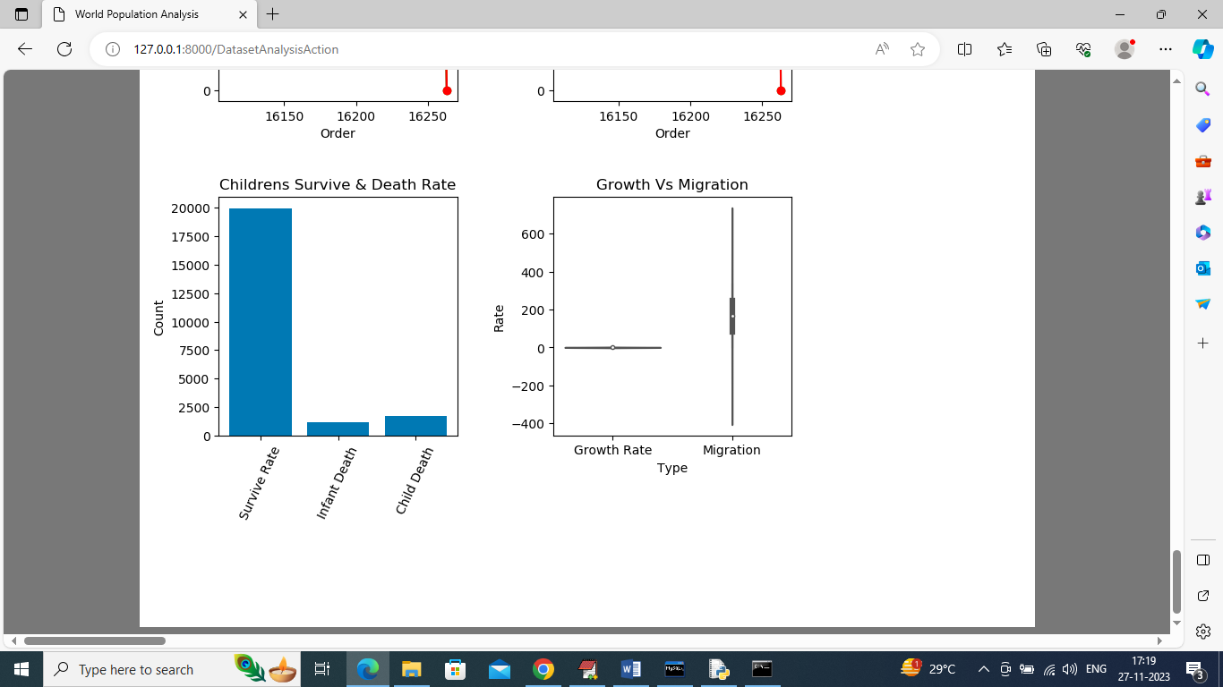
In above screen in first graph we can see children survive rate, infant (new born) death and child (child below 5 year) death. In second graph can see India Growth Rate and Migration rate. In x-axis can see growth and migration and y-axis represents count and from above graph can say migration is more compare to birth rate. Now click on ‘Predict Growth Rate’ link to get below output
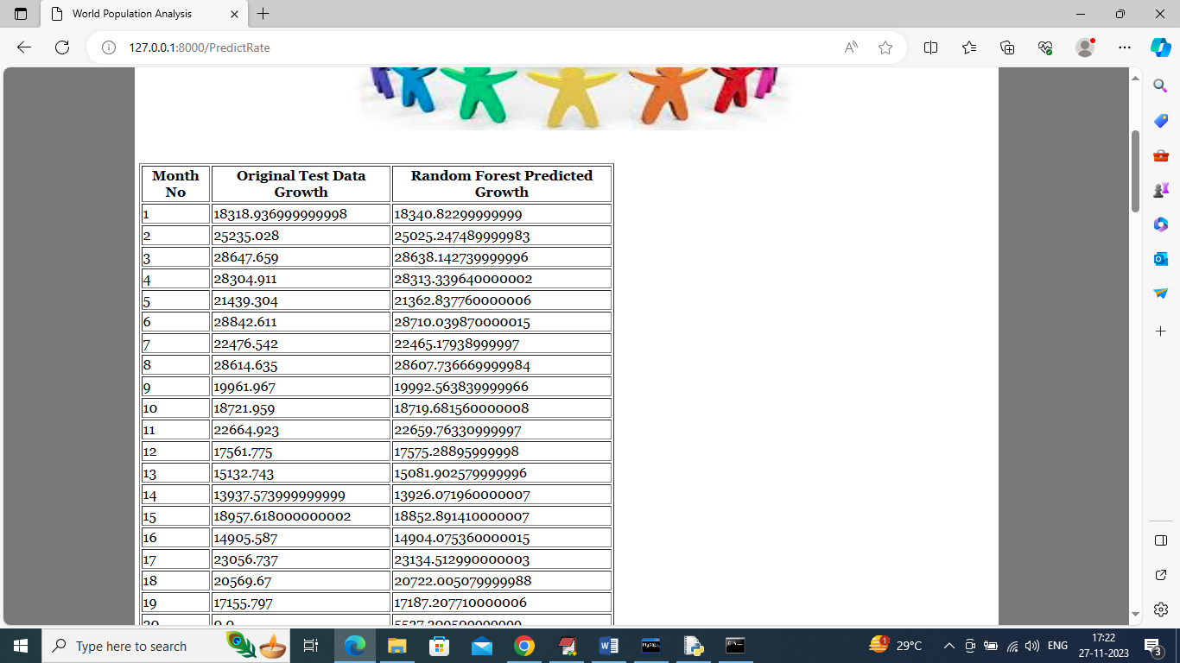
In above screen in first column can see Month Number and in second column contains dataset original birth rate and 3rd column contains Random Forest Predicted rate and can see both dataset and predicted growth values are too close and can say Random Forest is accurate in birth rate prediction and go down to page to view all 120 months data
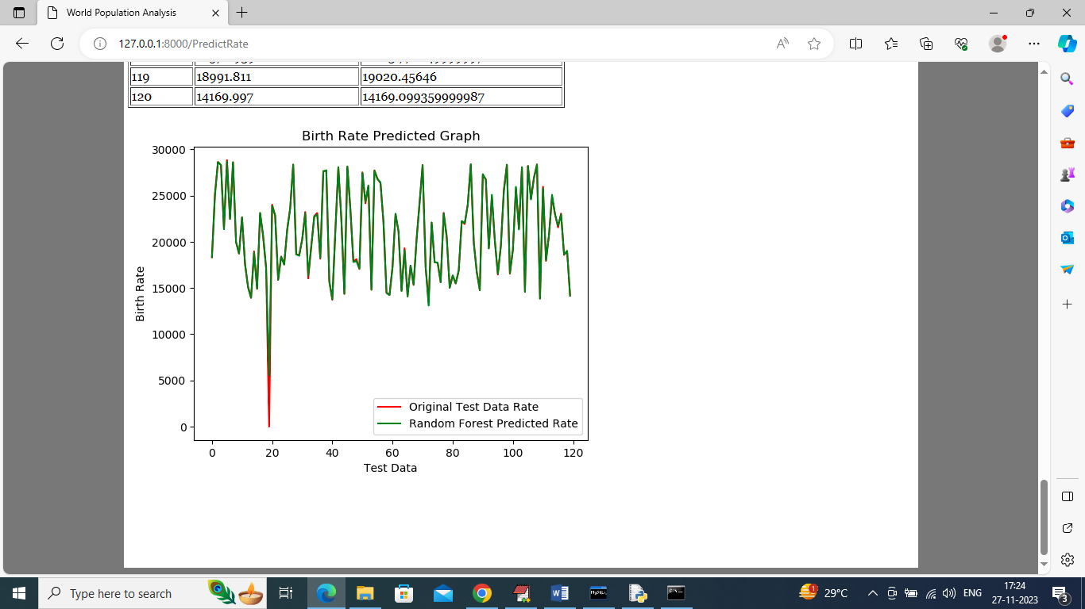
In above graph x-axis represents months from 1 to 120 and y-axis represents Birth Rate and Red line represents original dataset birth rate and green line represents Random Forest predicted birth rate and both lines are fully overlapping with little gap so we can say Random Forest is 99% accurate in prediction

