Initial Dashboard Napkin

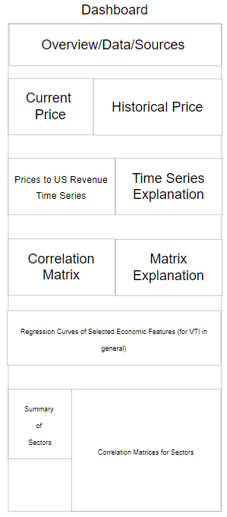

Feedback

AlgoRhythm Group:

* The layout flows well from top to bottom.
* Consider switching order of Correlation Matrix (top) section and Regression Curves section so that the lower section is dedicated to Matrices.

JADR Health Insights Group:

* Make sure to introduce the goal in the dashboard, we need context for what VTI is and what you’re examining.

Post Feedback Dashboard Napkin

