The fifth homework (and last!) assignment will be to create an AI agent that uses MC learning.

This agent will act randomly and as per the guidelines we will discuss / discussed in class.

A simple agent could be written by randomly playing a certain number of games (e.g. 100) for each of the 7 possibilities to create an estimate to the value of a state. A more elegant way, but not required is to remember the different state and update the values as you play more games – and use epsilon greedy to balance exploration / exploitation as per the Youtube video we saw in class: <https://www.youtube.com/watch?v=e8ofon3sg8E>.

Things to consider:

There are three ways to test your agent:

1. Manually (not recommended as RL learning needs many iterations!)
2. Play against a randomly playing agent—that uses MC learning or a simpler strategy
3. Play against your previous agent.

As was the case in the previous homework assignments, you will be grading based on the logic, clarity and documentation of your solution.

The grade breakdown will be:

60% -- creating a solution for that plays the game as per the rules

20% -- documentation about the logic of your solution

20% -- the creativity of your solution

The get the 60% (or 60 points out of 100 of the grade), you need to create a python program that plays the game legally -- i.e. it makes no illegal moves including knowing when a column is full, it registers when one of the players has won the game, etc.

The interface need not be anything fancy. This is what I had imagined and previously implemented myself:

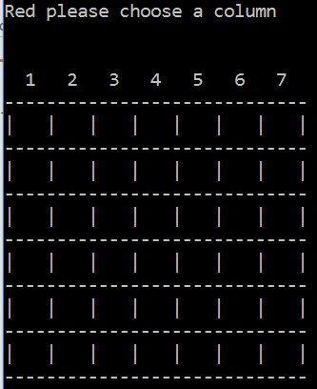

The human player (black) can then chose a column 1-7.

To get the full 20% (20 points) for documentation, there should be both comments in your Python solution and in a separate document (up to one page) of general explanation of your code.

To get the last 20% (20 points) for creativity you will need to always wins when you play against yourself with a perfect game.

Submission will be via Github as is normally done by December 14.

Happy coding!!!