From the East I Will Bring Your Seed

From the East I Will Bring Your Seed
Parshas Chayei Sarah, the sons of Keturah, and the sparks coming home
Akiva Gutnicki
A young man raised as a Muslim in an Arab village in the Galilee came to a talmid chacham in Bnei Brak for Shabbos. He had only recently begun to put on tefillin. When the table began to sing Lecha Dodi, his eyes filled with tears. He asked them to sing it again, and then again, and each time he cried.
Where those tears came from is the story of this week’s parsha.

The sons Avraham sent east
Near the end of Chayei Sarah, after Sarah is buried and Rivkah is brought home, Avraham marries again. Keturah bears him six sons. Then the Torah says: “Avraham gave all that he had to Yitzchak. And to the sons of the concubines Avraham gave gifts, and he sent them away from Yitzchak his son while he was still alive, eastward, to the land of the East” (Bereishis 25:5–6).
What were the gifts? The Gemara answers in a few words: shem tumah masar lahem, “he handed them a name of impurity” (Sanhedrin 91a). Rav Tzadok HaKohen of Lublin will not accept that Avraham taught his sons sorcery. He reads it with the Pa’aneach Raza and Rashi: Avraham gave them a holy Name that would work even in impurity. He knew where his sons were going and that they would not stay pure, and he wanted a root of holiness to survive in them there (Pri Tzaddik, Chayei Sarah 6).
He also sent them far away. The Midrash says he told them to go east as far as they could, “so that you are not burned by the coal of Yitzchak.” Pri Tzaddik explains the coal as the fire of the Oral Torah. Close to Yitzchak, they would have been burned. Far away, they could shine whatever light the Name gave them.
Then the Midrash Tanchuma says something startling. On the pasuk “Though your beginning was small, your latter end will greatly increase” (Iyov 8:7), it says the small beginning is Yitzchak and the great increase is the sons of Keturah. Yitzchak is the father of all Israel, and Keturah’s sons became idol worshippers in the East. How are they the great increase?
Pri Tzaddik answers that from them Israel draws out, in the end, all the depth of the Oral Torah, “the light that comes out of darkness.” When Shlomo’s wisdom “excelled the wisdom of all the Bnei Kedem” (I Melachim 5:10), it grew by drawing those sparks back. As the Zohar says, there is no light except the light that comes out of darkness.

Light out of the darkness
The story did not stop with Shlomo. When the Beis HaMikdash fell, Hashem sent Israel into exile in Bavel, and the Gemara asks why there (Pesachim 87b). Rabbi Yochanan answers that He “sent them back to their mother’s house,” and Rashi explains: Avraham came from Ur Kasdim. Rabbi Elazar answers that Bavel is “deep as She’ol,” and from that depth Hashem redeems. There, in the dark, the Talmud Bavli was made. “He has set me in dark places” (Eichah 3:6), says Rabbi Yirmiyah, “this is the Talmud of Bavel” (Sanhedrin 24a).
Rav Tzadok states the rule plainly. The Oral Torah “resides specifically in an uglier vessel; in proportion to the intensity of the darkness, so does it shine brighter” (Poked Akarim 6). And Pri Tzaddik adds that the “daughters,” the exiles of all the other lands, also “did valiantly” in Torah (Tazria 8).
He traces the first fulfillment back to Keturah’s own family. Yisro was the priest of Midian, and Midian was a son of Keturah. Yisro’s descendants, the Kenites, went to learn the Oral Torah and sat in the Sanhedrin. And by a tradition Pri Tzaddik brings from the Rema of Fano, Rabbi Akiva, the root of the Oral Torah, came through Yael, who came from Yisro (Pri Tzaddik, Yisro 1).

Out of Bavel, Aram and the lands of Yishmael
Look at the last two centuries and the same pattern appears, land by land.

Baghdad
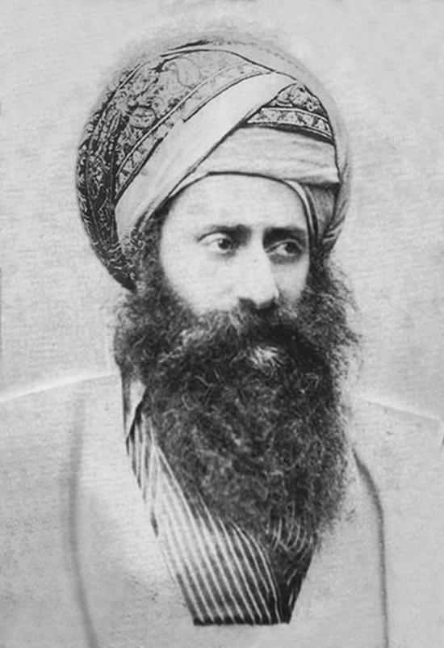
Rabbi Yosef Chaim of Baghdad, the Ben Ish Chai. Public domain, via Wikimedia Commons.
In nineteenth-century Baghdad, Chacham Abdallah Somech taught a generation of scholars, and his student Rabbi Yosef Chaim, the Ben Ish Chai (1835–1909), joined kabbalah and halachah in the book that still sits in Sephardi homes. From his circle came Rabbi Yaakov Chaim Sofer, the Kaf HaChaim, born in Baghdad in 1870, and the kabbalist Rabbi Yehuda Fatiyah, the authority of his day on spirits and gilgulim. In our own time, Baghdad’s sons led Torah in Jerusalem: the kabbalists Rabbi Salman Mutzafi and Rabbi Yitzchak Kaduri, and Rabbi Ovadia Yosef, born in Baghdad in 1920 and brought to Jerusalem as a small child.
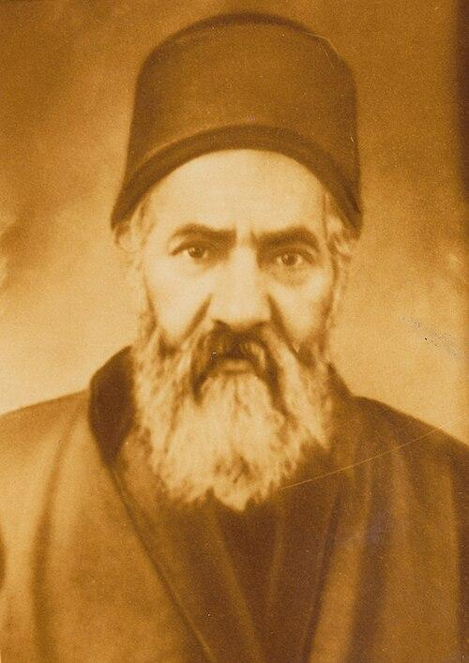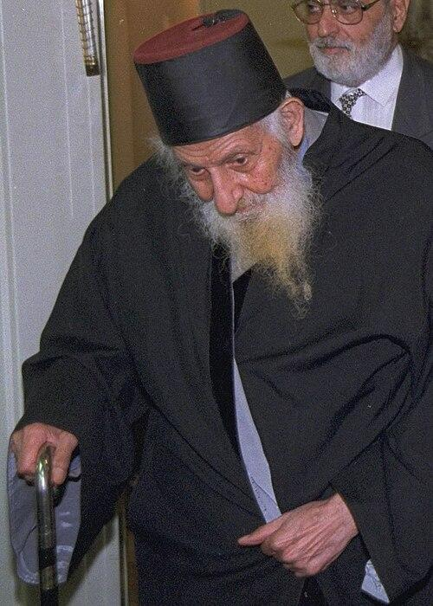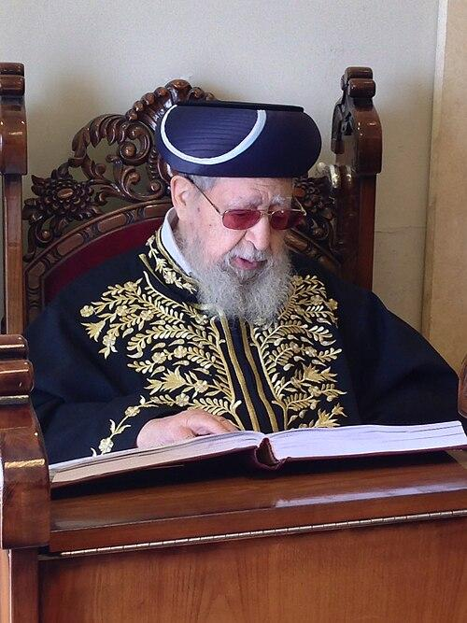
Left to right: Rabbi Yaakov Chaim Sofer, the Kaf HaChaim (public domain); Rabbi Yitzchak Kaduri (Avi Ohayon, Israel GPO, CC BY-SA 3.0); Rabbi Ovadia Yosef in the shul below his home (Alloni, CC BY-SA 3.0). Via Wikimedia Commons.

Aram
Aleppo is Aram Tzova, and Damascus is Aram Dammesek, the land of Lavan and Bilam. For nearly six hundred years the great synagogue of Aleppo guarded the Keter, the codex of Tanach that the Rambam relied on, until the riots of 1947. Out of Aleppo came Rabbi Ezra Attiya, for forty-five years rosh yeshiva of Porat Yosef in Jerusalem, where Rabbi Ovadia Yosef learned.
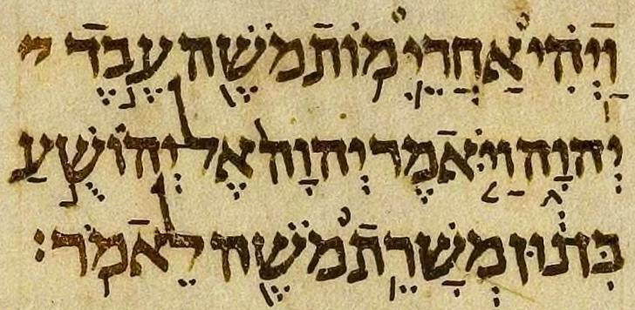
The opening of Yehoshua in the Aleppo Codex, the Keter Aram Tzova. Public domain, via Wikimedia Commons.
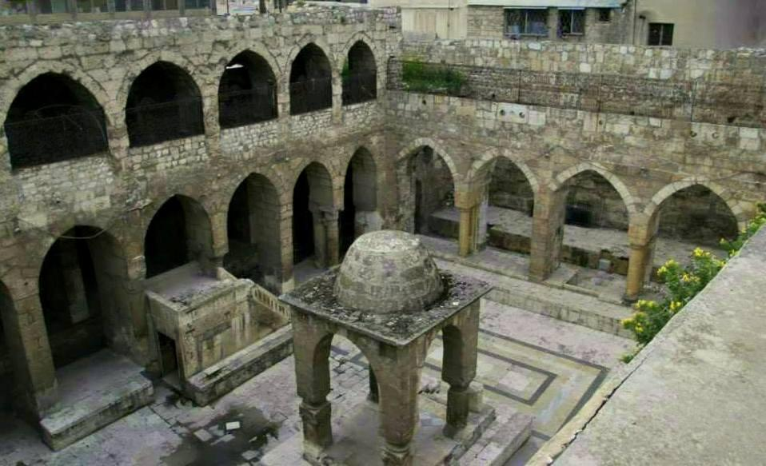
The Central Synagogue of Aleppo, where the Keter was kept. Govorkov, CC BY 2.0, via Wikimedia Commons.
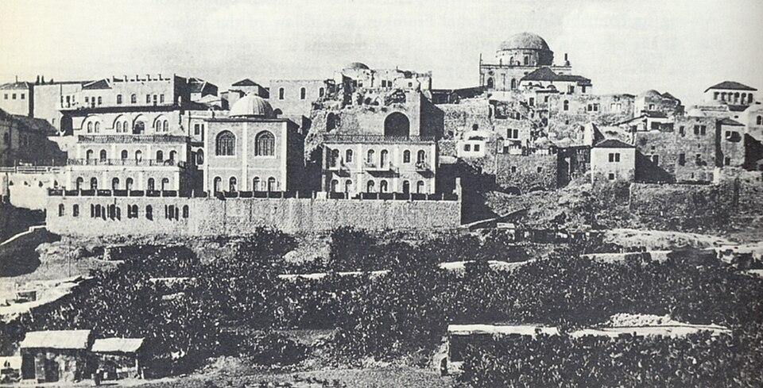
Porat Yosef Yeshiva in the Old City of Jerusalem, as it stood before 1948. Public domain, via Wikimedia Commons.

Charan and Turkey
Charan, where Avraham lived and where Yaakov found Rachel and Leah, lies in today’s Turkey. Under the Ottomans, Turkey became a home of Torah. Rabbi Yosef Karo began the Beis Yosef in Adrianople, Rabbi Yaakov Culi began the Me’am Lo’ez in Constantinople, and Rabbi Chaim Palachi, chief rabbi of Izmir, wrote more than seventy books.

Persia
Persia is where Esther became queen. In 1839 the Jews of Mashhad were forced to accept Islam. For almost a century they went to the mosque in public and kept Shabbos at home. The women hid sifrei Torah and tefillin under their chadors, and Rabbi Mordechai Akalar taught the children in secret, until they could live openly as Jews again.

Yemen and Morocco
From Yemen came Rabbi Shalom Sharabi, the Rashash (1720–1777), who passed through India, Baghdad and Damascus on his way to Jerusalem and became the head of the Beis El kabbalists. The kabbalists of Baghdad, Rabbi Fatiyah and Rabbi Kaduri among them, prayed with his kavanos.
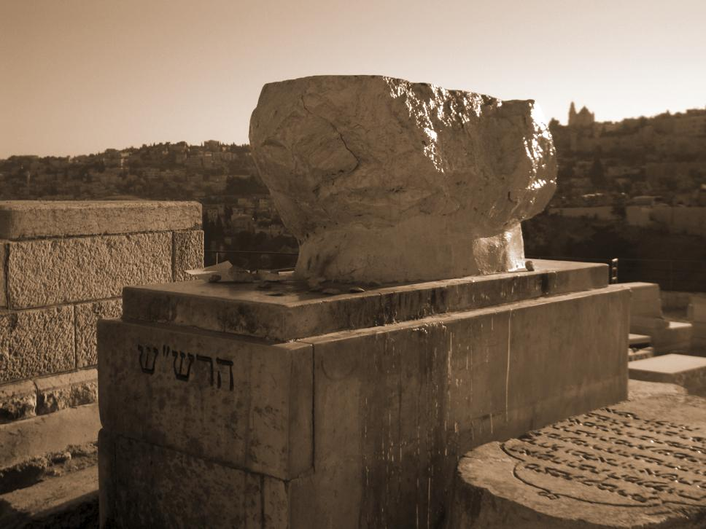
The tomb of the Rashash in Jerusalem. Yirmiyahou, CC BY 3.0, via Wikimedia Commons.
From Morocco, at the far western edge of Yishmael’s lands, came the Baba Sali, Rabbi Yisrael Abuchatzeira (1889–1984). His family line begins with Rabbi Shmuel Elbaz, who learned with Rabbi Chaim Vital in Damascus before his descendants settled in Morocco. And the Chida, Rabbi Chaim Yosef David Azulai, born in Jerusalem in 1724 to a family from Morocco, traveled as an emissary through Egypt, Tunisia and Morocco as well as Europe, and wrote some seventy works.
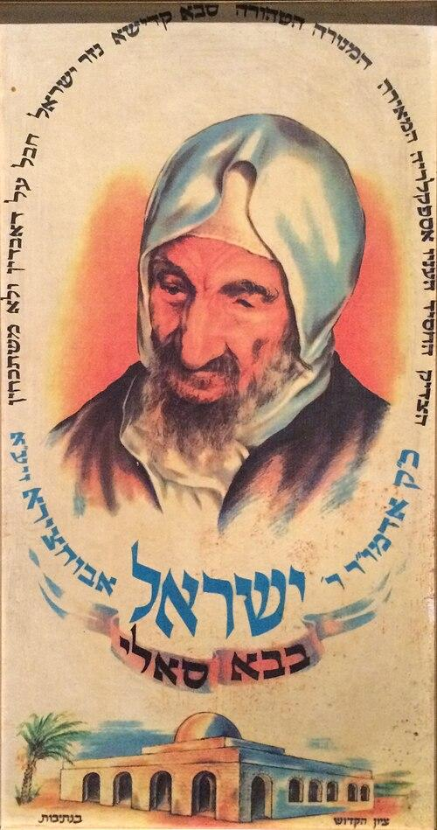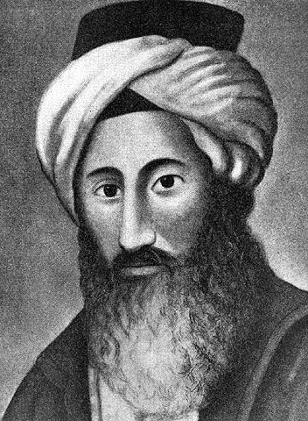
Left: a poster of the Baba Sali in a Paris museum (Joseph Nahan Hirsch, CC BY-SA 4.0). Right: the Chida, portrait by an unknown artist (public domain). Via Wikimedia Commons.
These lands held the Jews for centuries, and out of them came some of the brightest Torah of the last two hundred years. It is the pattern Rav Tzadok described: the darker the vessel, the brighter the light.

Souls hidden in Yishmael’s house
Now back to the young man at the Shabbos table. Rav Yitzchak Zilberstein, who tells the story in Aleinu Leshabe’ach, gives the beginning. After a Yom Kippur in a shul in Kiryat Shemona, the young man spoke to his mother, and she told him: “You are a Jew.” She came from a family rooted in Tzfas. At the Shabbos table in Bnei Brak he showed his host an old photograph of her relatives praying at a grave in Tzfas. The next morning the host went to the old cemetery and found the grave. It was the tomb of Rabbi Shlomo Alkabetz, who wrote Lecha Dodi.
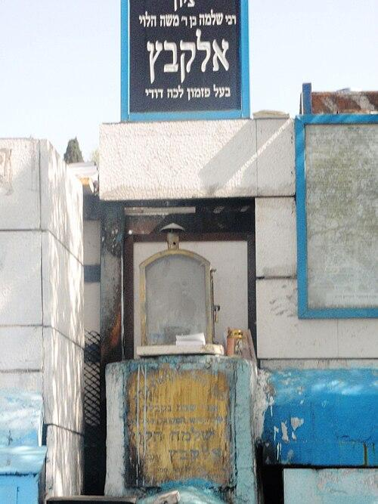
The grave of Rabbi Shlomo Alkabetz in Tzfas. Ariel Palmon, CC BY 3.0, via Wikimedia Commons.
The story is told in several versions, with different names and details, and none of them can be checked. Its heart, though, is plain halachah: the child of a Jewish mother is a Jew wherever he is born. Rav Tzadok says it about the descendants of Haman who taught Torah in Bnei Brak. They came, he explains, from a Jewish woman taken captive, and “Heaven forbid to blot out that holy seed, the son of a Jewish woman, who is a kosher Israelite.” Even from Amalek, he says, something is absorbed into holiness (Likkutei Maamarim, Festivals 16).
Stories like this are reported in our own time. Mark Halawa was born in Kuwait to a Palestinian Muslim family. His mother’s mother had been a Jew in Jerusalem, and he grew up not knowing what that meant, until a Jewish professor in Canada told him it made him Jewish. He now lives in Jerusalem as an observant Jew. In 2019 a young man in Jordan, whose mother and grandmother were Jews from Iraq, learned from a video of the singer Ziv Yechezkel that Jewishness passes through the mother. He is learning about Judaism in secret with the help of Yad L’Achim, which said it had received some 150 such requests from across the Muslim world in a year and a half.

Before our eyes
In the twentieth century the sparks began to come home all at once. Between December 1948 and September 1950, Israel brought some 49,000 Jews out of Yemen in Operation On Wings of Eagles. In 1951 and 1952, between 120,000 and 130,000 Jews of Iraq were airlifted in Operation Ezra and Nehemiah, named for the two who led the Jews home from Bavel. The Jews of Morocco, Syria and Iran followed.
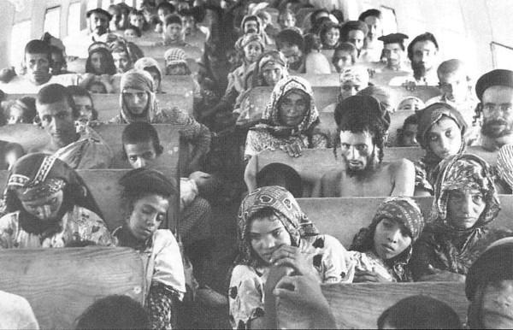
Jews of Yemen on their way to Israel during Operation On Wings of Eagles, 1949–1950. Public domain, via Wikimedia Commons.
Yeshayahu saw it:
אַל תִּירָא כִּי אִתְּךָ אָנִי, מִמִּזְרָח אָבִיא זַרְעֶךָ וּמִמַּעֲרָב אֲקַבְּצֶךָּ. אֹמַר לַצָּפוֹן תֵּנִי וּלְתֵימָן אַל תִּכְלָאִי, הָבִיאִי בָנַי מֵרָחוֹק וּבְנוֹתַי מִקְצֵה הָאָרֶץ.
“Do not fear, for I am with you. From the East I will bring your seed, and from the West I will gather you. I will say to the north, Give; and to the south (Teiman), Do not hold back. Bring My sons from afar and My daughters from the end of the earth” (Yeshayahu 43:5–6).
The Gemara reads “My sons from afar” as the exiles of Bavel and “My daughters from the end of the earth” as the exiles of all the other lands (Menachos 110a). Those are the very words Pri Tzaddik uses for the Torah of the East and the valor of the other lands. And Yeshayahu adds: “On that day a great shofar will be sounded, and those who were lost in the land of Ashur will come” (27:13). Ashur is the East. The lost include those who did not know they were lost: a young man in the Galilee, a student from Kuwait, a Jordanian whose grandmother came from Baghdad.
Avraham sent his sons east with a Name that would still work in the dark, so that something of his would survive there. Pri Tzaddik promised that the end would be greater than the beginning. It is hard not to see that end beginning before our eyes. On Friday night, we sing the words ourselves:
הִתְנַעֲרִי מֵעָפָר קוּמִי, לִבְשִׁי בִּגְדֵי תִפְאַרְתֵּךְ עַמִּי, עַל יַד בֶּן יִשַׁי בֵּית הַלַּחְמִי, קָרְבָה אֶל נַפְשִׁי גְּאָלָהּ.
“Shake off the dust, arise; put on your garments of glory, my people. Through the son of Yishai of Beis Lechem, draw near to my soul and redeem it.”

Sources
Bereishis 25:1–6; Sanhedrin 91a; Midrash Tanchuma, Chayei Sarah; Pri Tzaddik, Chayei Sarah 6 (Kisvei Rav Tzadok reader); Pesachim 87b with Rashi; Sanhedrin 24a; Poked Akarim 6:4; Pri Tzaddik, Tazria 8 and Yisro 1; Likkutei Maamarim, Festivals 16:10; Menachos 110a; Yeshayahu 27:13 and 43:5–6; Lecha Dodi.
The story of the young man and Lecha Dodi: Rav Yitzchak Zilberstein, Aleinu Leshabe’ach (retold by Shema Yisrael, Parshas Shelach); other versions in Zev Roth, Monsey, Kiryat Sefer, and Beyond (Breslev Israel), and Oded Mizrahi, “Yehudi BeDam” (abc770).
Mark Halawa: Jewish Journal, March 28, 2018. The young man in Jordan: World Israel News, July 31, 2019. The Jews of Mashhad: Aish. Biographies: Wikipedia on the Ben Ish Chai, the Kaf HaChaim, Rabbi Yehuda Fatiyah, Rabbi Yitzchak Kaduri, Rabbi Ezra Attiya, the Aleppo Codex, Rabbi Chaim Palachi, the Rashash, the Baba Sali and the Chida; NJOP on Rabbi Yaakov Culi; Daily Zohar on Rabbi Salman Mutzafi; Wikipedia on Operation On Wings of Eagles and Operation Ezra and Nehemiah.

