A YAHRZEIT ESSAY
Faith in the Night

What my mother, Rav Tzadok HaKohen and a dying professor’s last lecture taught me about what really matters, for the thirty-sixth yahrzeit of Yenta Rivka bas Rav Yaakov Halevi
In loving memory of my mother
Yenta Rivka bas Rav Yaakov Halevi · Yetta Gutnicki
8 Mar Cheshvan 5751 – thirty-sixth yahrzeit, 8 Mar Cheshvan 5787
לעילוי נשמת מרת ינטא רבקה בת הרב יעקב הלוי ע״ה
תהא נשמתה צרורה בצרור החיים

AKIVA GUTNICKI
With teachings from Resisei Layla of Rav Tzadok HaKohen of Lublin, Simanim 5, 27, 24 and 21

The Smile
A week before my mother died, she smiled at me.
I was fourteen, and I had only just learned that she was sick. She had been living with ovarian cancer for five and a half years, and for almost all of that time she had not told us children. Somehow, she knew that I knew. And in that moment she smiled at me and did something deeply personal, something only she could have done. It said more than any words could. It told me that everything was going to be okay.
It was not okay. A week later we lost her. Her name was Yenta Rivka bas Rav Yaakov Halevi, Yetta Gutnicki to everyone who knew her, and her yahrzeit, the eighth of Mar Cheshvan, begins next Sunday evening, October 18. It will be thirty-six years.
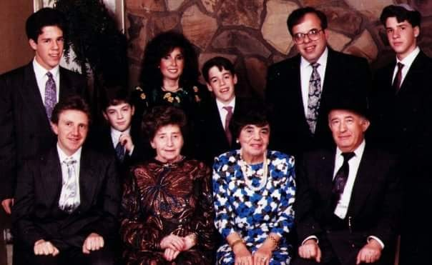
My bar mitzvah, at thirteen, about a year before my mother’s passing.
She was the one who was dying, and she was comforting me.
I have thought about that smile for most of my life, and I understand it differently now than I did then. She was not promising that there would be no pain, or that things would turn out the way I wanted. She was telling me that we would go on, that her love would hold, and that in the end we would be okay. She was the one who was dying, and she was comforting me.
I cannot imagine everything she carried in private: the pain, the uncertainty, the effort of being fully present for her family while fighting something so grave. It must have been extraordinarily hard. Yet her first thought was what knowing would do to us. She wanted us to have the gift of simply being her children for as long as she could give it.
Where does a person find that kind of strength? This year the question led me to three places that have become one story for me: my mother’s own life, a lecture by a dying professor, and the teachings of Rav Tzadok HaKohen of Lublin in Resisei Layla, the book I have been translating.

Fourteen
My mother’s instinct to care for others began long before she had children. As I understand it, she was about fourteen when her own father passed away. She was the eldest, and at an age when most young people are still being looked after, she took responsibility for her mother and her younger brother. Even after her mother remarried, she went on looking after her, including the time they lived under one roof. It was not a response to a crisis. It was who she was.
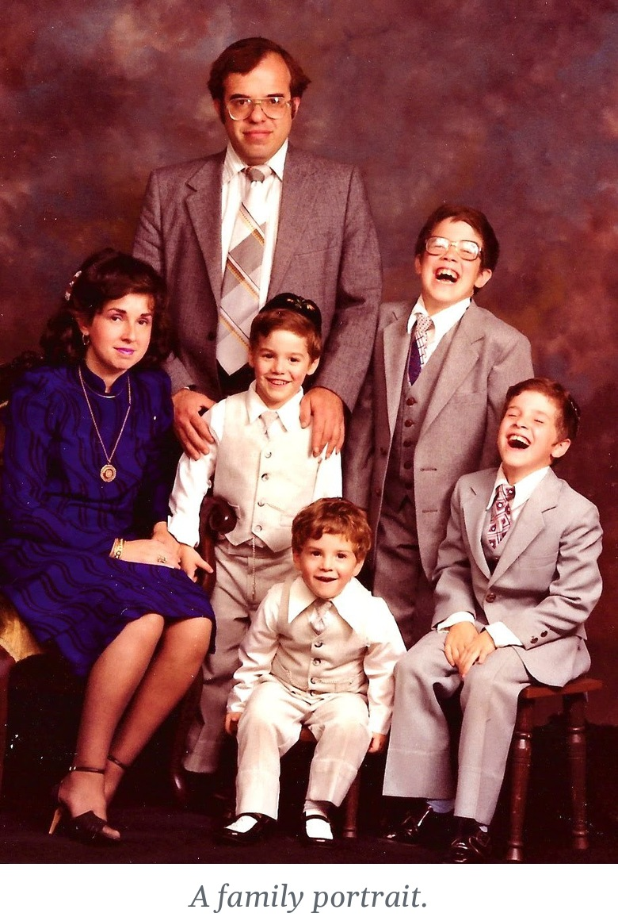
She was fourteen when she lost her father. I was fourteen when I lost her. I did not notice that until I sat down to write this, and I am still sitting with it. What I do know is that a person who learns so young how fragile life is also learns early what actually matters, and she never forgot it.
When she became a mother, she gave every one of us everything she had. Very little of it was material. It was the feeling that we mattered, that she was thinking about us, that we were held. And beneath all of it was one aim: that her children would have a real connection to Hashem, that we would know where life comes from and where it is going. That was the bigger picture she lived by, and she spent herself giving it to us.

A Manual for Three Children
There is a lecture I keep coming back to, and it belongs in this story. On September 18, 2007, Randy Pausch, a forty-six-year-old computer science professor at Carnegie Mellon and the father of three small children, spoke in a series that invited professors to imagine their “last lecture.” For most speakers that was a thought experiment. For him it was not. He had pancreatic cancer, and a month earlier his doctors had told him to expect three to six months of good health. He walked on stage, dropped to the floor for one-handed push-ups, and then talked about how to live.
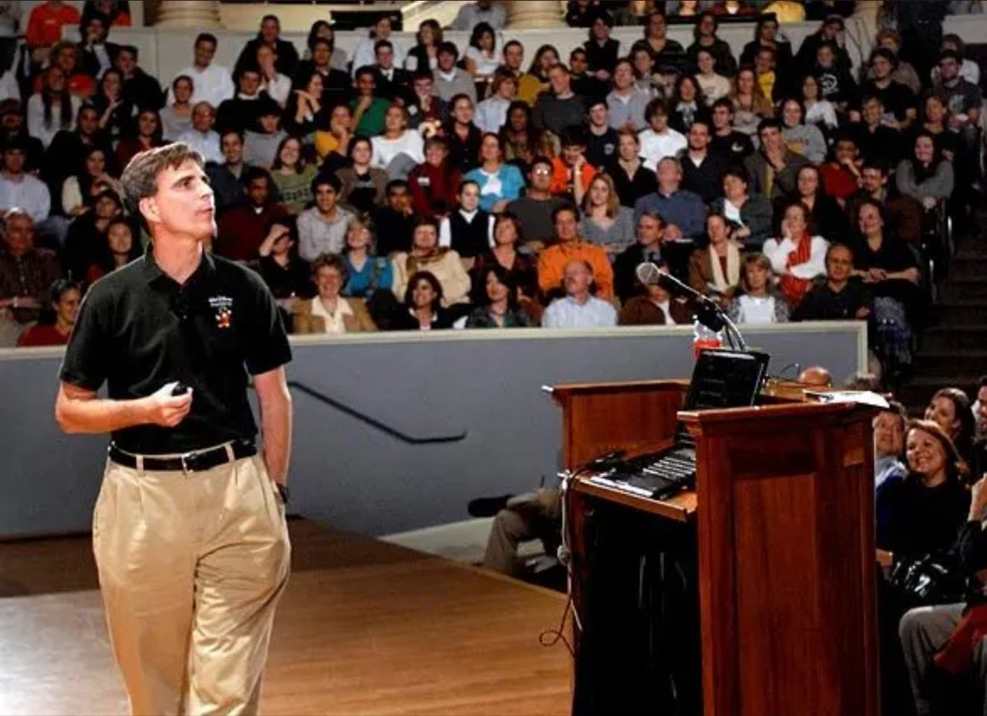  Randy Pausch giving his last lecture at Carnegie Mellon, September 2007. Photo courtesy of Carnegie Mellon University / Randy Pausch. | 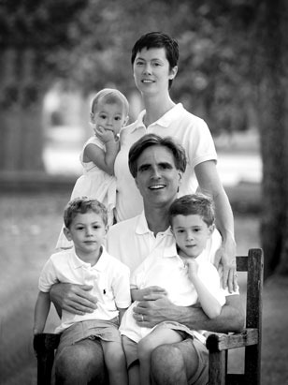  Randy Pausch with his wife, Jai, and their children, Dylan, Logan and Chloe. Image via Wikimedia Commons / Pausch Family Archives.

That lecture spoke to me personally, more than almost anything I have heard. It did what very few things do: it sorted my life. It set aside everything that does not matter and left standing what does: how you treat people, how you meet the walls in your path, how much of yourself you give to the people you love, and what you leave behind. For me it came close to defining the real meaning of life.
Pausch deliberately left religion out of his talk, and I will not put Rav Tzadok’s words in his mouth. But three of his ideas went into me like a key into a lock.
The first is the line everyone remembers: “We cannot change the cards we are dealt, just how we play the hand.” My mother was dealt a hand no one would choose. She played it with warmth, with generosity, and in silence, so that her children would not have to carry it.
The second is about obstacles. The brick walls in our lives, Pausch said, are there to show how badly we want something. My mother did not treat her illness as a reason to give less. It became the measure of how much she wanted to give.
I had seen it given once before, without a stage or a camera.
The third is what he called the head fakes. At the very end he revealed that the lecture had never really been about achieving childhood dreams. It was about how to lead your life. And it had never really been for the more than four hundred people in the room, or for the millions who would watch it later. It was for an audience of three: his children, Dylan, Logan and Chloe. He was leaving them a manual for a life he would not be there to see.
I think that is why the lecture went so deep in me. I had seen it given once before, without a stage or a camera. My mother gave it, in those five and a half years and in that last smile, and it was addressed to her children. I am one of its audience. And it leaves me with the question I want to follow through the rest of this piece: what goes into the manual? What do you hand a child who will have to live without you?
Rav Tzadok answers that question more deeply than anyone I know.

A Man Who Wrote From the Night
Rav Tzadok HaKohen of Lublin (1823–1900) was a Chassidic master and one of the most original Jewish thinkers of his age. His life was not one anyone would have chosen. Some of what follows is documented, and some comes from later biographies and Chassidic tradition, which do not always agree on the details.
He was born in Kreuzburg, in present-day Latvia, where his father was the rabbi. When he was about six his father died, and he was raised in the home of his uncle, Rav Yosef HaKohen Rabinowitz. He threw himself into Torah and became known as the prodigy of Krinik. He married at about fifteen, and within a few years the marriage fell apart. The sources on what happened are painful and uncertain, and it would be wrong to assign blame. But the journeys that grew out of that crisis brought him into the Chassidic world, and to Rav Mordechai Yosef Leiner of Izbica, whose teaching changed the course of his life.
He then married Chana Devorah, and for decades he turned down rabbinic positions so that he could keep learning and writing. They lived in real poverty; according to his biographers, she kept the household going with a small used-clothing shop. He married three times and never had children of his own, though he helped support and raise his wife’s children from an earlier marriage. Only in 1888, at about sixty-five, after the passing of Rav Yehudah Leib Eiger, did he agree to lead the Chassidim of Lublin.
A man with that life could have written books of grief, or bitterness, or complaint. He wrote none of them. What he left is a body of Torah full of hope, dignity and joy. One line from his Tzidkas HaTzadik seems to me to hold the secret of how.
“Just as a person must believe in Hashem, so too must he subsequently believe in himself.”
כְּשֵׁם שֶׁצָּרִיךְ אָדָם לְהַאֲמִין בַּהַשֵּׁם יִתְבָּרַךְ, כָּךְ צָרִיךְ אַחַר כָּךְ לְהַאֲמִין בְּעַצְמוֹ.
— Tzidkas HaTzadik, Siman 154
First you believe in Hashem. Then you believe that your own life matters to Him: that even when it has not turned out as you hoped, it is not wasted, because Hashem has a purpose with you. That is not self-esteem in the usual sense. It grows out of faith. And it is exactly what my mother taught her children, without ever needing to put it into words.
The title of the book I have been translating carries the whole idea. Resisei Layla means “droplets of the night,” from the Song of Songs: “my head is filled with dew, my locks with the drops of the night.” It is a book of small drops of light, gathered in the dark. In it I found four teachings that describe my mother’s life.
RESISEI LAYLA · SIMAN 5

Faith Is the Work
The fifth siman opens with a sentence that is almost startling in how plain it is.
“Man’s primary occupation in this world is faith.”
עִיקַּר עֵסֶק אָדָם בָּעוֹלָם הַזֶּה הוּא הָאֱמוּנָה
— Resisei Layla, Siman 5, Seif 1
Not the main thing we believe, but the main thing we do. Faith is the job. He ties it to the verse in the Psalm for Shabbos: “And Your faithfulness in the nights.” This world, he says, is compared to night. The night is not a punishment. It is where faith is needed, and so it is where faith is made. In daylight you see. At night you trust.
And what does that trust sound like when it is hardest to hold? Rav Tzadok gives a counsel so simple that it is easy to read past.
“During the time of a person’s immersion in this world, let him never let go, at the very least, of the simple faith that everything is from Hashem, blessed be He, and there is none besides Him.”
בְּעֵת שִׁיקּוּעַ הָאָדָם בָּעוֹלָם הַזֶּה … אַל יָזוּז מִמֶּנּוּ עַל כָּל פָּנִים אֱמוּנָה הַפְּשׁוּטָה … דְּהַכֹּל מֵהַשֵּׁם יִתְבָּרַךְ וְאֵין עוֹד מִלְּבַדּוֹ
— Resisei Layla, Siman 5, Seif 1
Everything is from Hashem. He does not say that it will feel good, or that it will be understood. He says to hold on to that one thing, at the very least, while life is at its most absorbing and its darkest. He describes a person who receives his enjoyments from Hashem “even while his work is in darkness,” and to such a person he applies the verse “the righteous shall live by his faith.”
“… and he receives his enjoyments from Hashem, blessed be He, even while his work is in darkness; about this they said: ‘The righteous shall live by his faith.’”
וּמְקַבֵּל הֲנָאוֹתָיו מֵהַשֵּׁם יִתְבָּרַךְ … הֲגַם שֶׁהוּא בְּמַחְשָׁךְ מַעֲשֵׂהוּ … צַדִּיק בֶּאֱמוּנָתוֹ יִחְיֶה
— Resisei Layla, Siman 5, Seif 1, citing Habakkuk 2:4
Rav Tzadok even tells us what the practice looks like in an ordinary day. It is the blessing. When we say Baruch atah, “Blessed are You,” we turn from speaking about God to speaking to Him. Before a person sinks into any pleasure, he stops and addresses the Giver directly.
“Then he says the blessing, ‘Blessed are You, etc.,’ in direct address, and recognizes that all his enjoyments are from Hashem, blessed be He.”
אָז יֹאמַר הַבְּרָכָה … בְּנוֹכָח … וּמַכִּיר שֶׁכָּל הֲנָאוֹתָיו מֵהַשֵּׁם יִתְבָּרַךְ
— Resisei Layla, Siman 5, Seif 1
My mother lived inside that night. She did not treat the hard years as a pause to be endured until real life resumed. She treated them as life, and she never stopped giving. Looking back, I believe her smile at the end was that faith made visible: the simple faith, held on to in the dark, that everything comes from Hashem.
RESISEI LAYLA · SIMAN 27

Not the Doer
Twenty-two simanim later, Rav Tzadok returns to the same idea from a completely different direction. He is explaining why the Torah forbids work on Shabbos, and his answer is not what most of us expect.
“A person must know, regarding all his actions and deeds, that he is not the doer, rather everything is by supernal power, and all his actions are from Hashem, blessed be He, as in ‘for all our works You have wrought for us.’”
הָאָדָם צָרִיךְ לָדַעַת בְּכָל פְּעֻלּוֹתָיו וּמַעֲשָׂיו שֶׁלֹּא הוּא הַפּוֹעֵל … רַק הַכֹּל בְּכֹחַ עֶלְיוֹן וְכָל פְּעֻלּוֹתָיו מֵהַשֵּׁם יִתְבָּרַךְ … גַּם כָּל מַעֲשֵׂינוּ פָּעַלְתָּ לָּנוּ
— Resisei Layla, Siman 27, Seif 1, citing Isaiah 26:12
That is the reason for Shabbos. For six days a person works, plans, builds and worries, and it is very easy to believe that he is the one doing all of it. Then, on Shabbos, he stops, and in the stopping he testifies. The world did not fall apart when his hands rested, because his hands were never the source. Rav Tzadok even reads the phrasing of the verse this way: “six days shall be done” (te’aseh), as if the work gets done on its own.
“… he testifies about himself that all his actions are from Hashem, blessed be He, and that they happen by themselves, without his own strength or the might of his hand at all.”
זֶה מֵעִיד עַל עַצְמוֹ דְּכָל פְּעֻלּוֹתָיו מֵהַשֵּׁם יִתְבָּרַךְ … שֶׁהֵם נַעֲשִׂים מֵעַצְמָם שֶׁלֹּא בְּכֹחוֹ וְעֹצֶם יָדוֹ כְּלָל
— Resisei Layla, Siman 27, Seif 1
And then comes a conclusion that moves me every time. It is not only that Shabbos is permitted despite the work of the week. The work of the six days is permitted only because of Shabbos.
“… specifically through the keeping of Shabbos is the work of the six days permitted, since he knows that he is not the doer or the actor at all.”
דְּעַל יְדֵי שְׁמִירַת שַׁבָּת דַּוְוקָא הוּא שֶׁהוּתְּרָה מְלֶאכֶת שֵׁשֶׁת יָמִים … מֵאַחַר שֶׁיּוֹדֵעַ שֶׁאֵין הוּא הָעוֹשֶׂה וְהַפּוֹעֵל כְּלָל
— Resisei Layla, Siman 27, Seif 1
Here is where Rav Tzadok and the Last Lecture meet, and also where they part. “We cannot change the cards we are dealt, just how we play the hand” is true, and it is a brave and wise way to say it. Rav Tzadok goes one step beyond. The cards are not random. They come from the One who is also the source of the strength to play them. We are told to labor, to strive, to give everything we have. The effort is real, and even commanded. But we are never the final cause, and that is not a burden but a freedom.
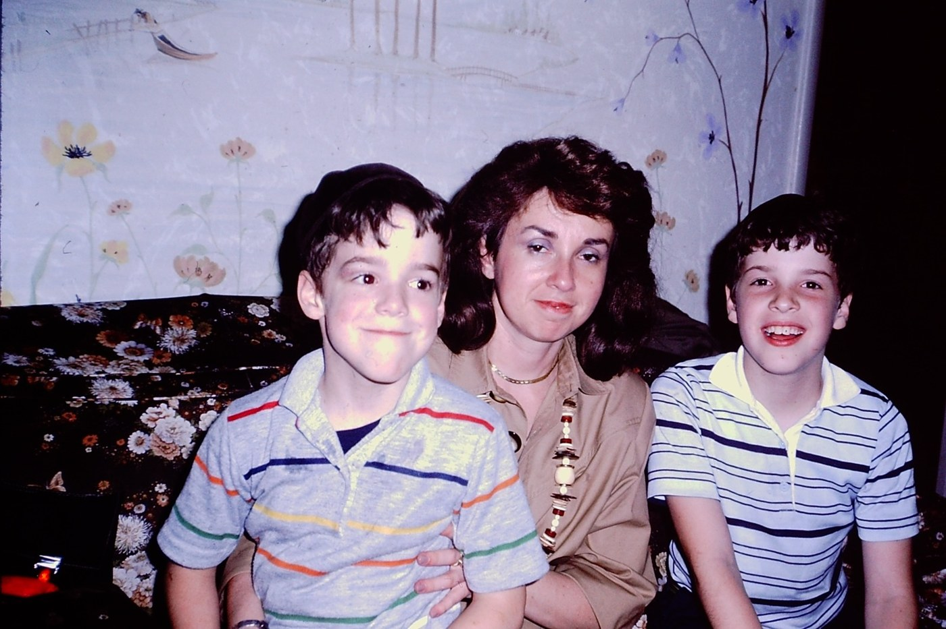  A quiet moment on the couch. | 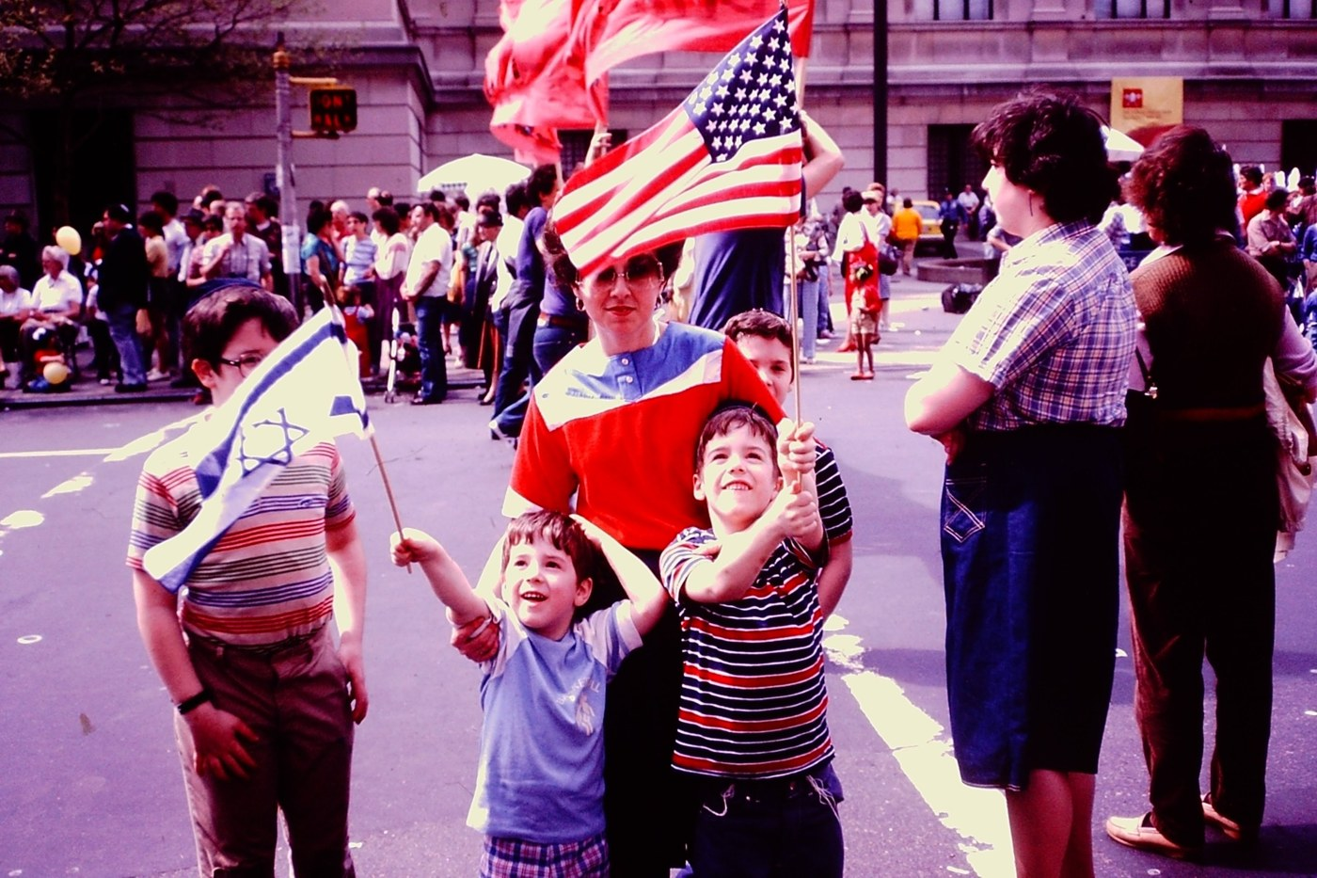  Out together on a parade day.

Nothing strips away the illusion of control faster than a serious illness. My mother lived with that truth for years, at an age when most people have barely begun to face it. I do not say this as a consolation. I say it because Rav Tzadok says it is simply the truth about every one of us, in good years as well. And I believe the people who see it early are not weaker for it. They are freer. They stop spending their strength on the question of control, and they can spend all of it on love.
Rav Tzadok knew it from his own life. Whether a marriage lasts, whether a home has children, whether there is bread on the table: these are exactly the things a person does not control. “For all our works You have wrought for us” was not only a verse for him. I believe it was how he understood his own story.
RESISEI LAYLA · SIMAN 24

Light Only Comes Out of Darkness
The hardest question, and the one I will not hide from, is about the night itself. Why does it have to be there? In Siman 24 Rav Tzadok offers an answer, drawn from the way the world was made. The Talmud says that in Creation, first there was darkness and then light. He takes this as a law of all of life.
“So it is throughout all the days of the world: you have no light revealed except out of the darkness that preceded it.”
כָּךְ הוּא בְּכָל יְמוֹת עוֹלָם … אֵין לְךָ שׁוּם אוֹר מִתְגַּלֶּה אֶלָּא מִתּוֹךְ הַחֹשֶׁךְ הַקָּדוּם לוֹ
— Resisei Layla, Siman 24, Seif 1
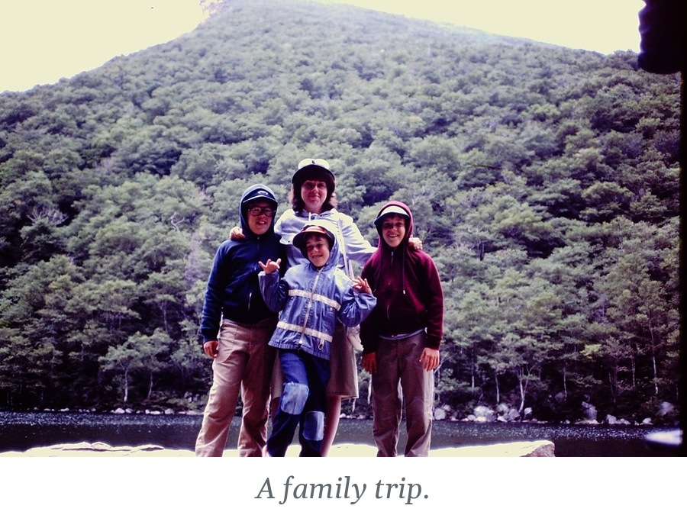
His examples come from the history of our people: the Torah was given only after the Exodus, and the Exodus came only after Israel had sunk to the depths of Egypt. I want to be careful here. Rav Tzadok is not saying that suffering is good, and I would never say it to anyone in pain. He is saying that darkness is not the end of the story, and that a person who is in it need not conclude that his life has lost its meaning. Pausch called it a brick wall. Rav Tzadok calls it the place from which the light will come.
That is what I watched my mother do. Overcoming hardship did not mean that the hardship went away. It meant refusing to let it end her service of Hashem, and refusing to let it end her giving.
RESISEI LAYLA · SIMAN 21

The Joy That Is Given
If everything comes from Hashem, then so does something we usually think of as entirely our own. In Siman 21 Rav Tzadok lists the gifts that Heaven gives a person, and the list begins like this: wisdom in the mind, joy in the heart, and success in action. The Talmud teaches that much of this is decreed at the very beginning of a life.
Look at where he puts joy. It is not an achievement. It is a gift, and he says it is the real meaning of wealth.
“… the joy that is in the heart, which is the essence of wealth.”
הַשִּׂמְחָה שֶׁבַּלֵּב, שֶׁזּוֹ עִיקַּר עֲשִׁירוּת
— Resisei Layla, Siman 21, Seif 1
He cites the Mishnah: “Who is rich? One who rejoices in his portion.” And he adds a line that turns the usual ledger upside down: if a person has silver like the sand of the sea but lacks gladness of heart, he is called poor.
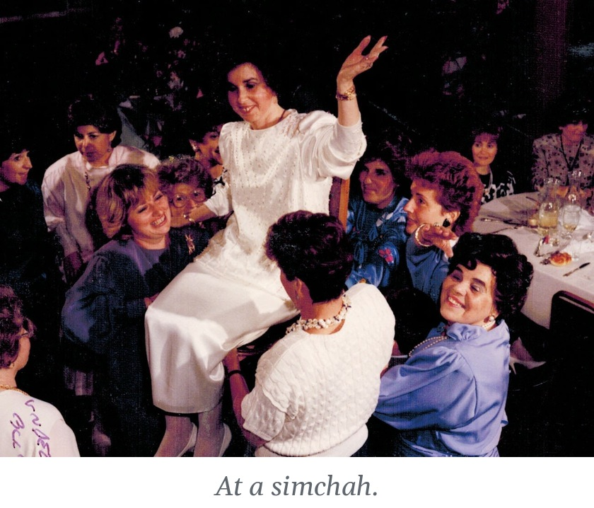
By any ordinary accounting, Rav Tzadok should have been poor, and in the plainest sense of the word he was. Yet everything I have learned about him suggests a person who lived with real simchah, because he knew where everything comes from. He was not rich in what he had. He was rich in how he held it.
My mother was like that. She was not a woman who had a great deal of ease. She had been giving herself away since she was a girl of fourteen. And yet when I look through the photographs from those years, I am struck by how often she is smiling. She made sure that we had a childhood with warmth in it, even while she was living in the night that Rav Tzadok describes. Gladness in the heart, in the middle of the dark, is a way of saying: I know whose world this is.

The Children We Leave
Now I can try to answer the question the Last Lecture left me with. What do you hand a child who will have to live without you? Not advice, and not an explanation. You hand them a way of seeing: that time is precious, that a person can give every fiber of himself to what matters, and that behind all of it Someone is giving us everything we have, including the strength to go on.
Rav Tzadok had no children of his own. Yet today, well over a century after his passing, his books are open on tables in yeshivos and homes around the world, and Jews are learning from them how to live. The Sages teach that “the main offspring of the righteous are their good deeds.” His sefarim became his children, and they are alive. The child who lost his father at six became, through his books, a father to generations.
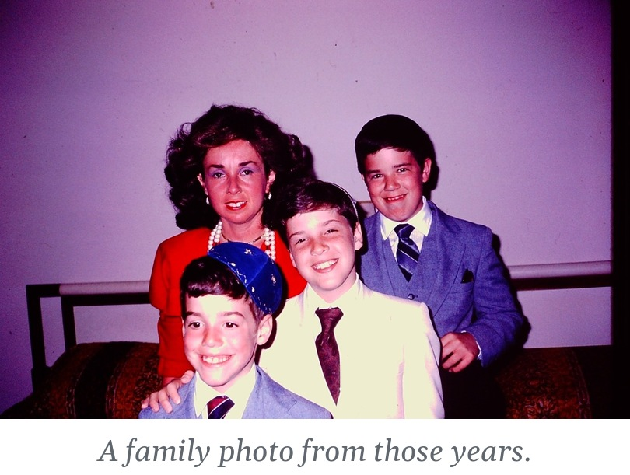
Pausch left his children a recorded lecture and a book. My mother left no lecture and no book. She left children who grew up held by her, and a smile I am still unpacking. I am fifty now, and I am still trying to hand it on. Through my small publishing house I have been translating and annotating Resisei Layla, so that more people can learn what Rav Tzadok teaches. In a real way, it continues what my mother began in me when I was a boy, and I hope every page of it is a good deed in her merit.
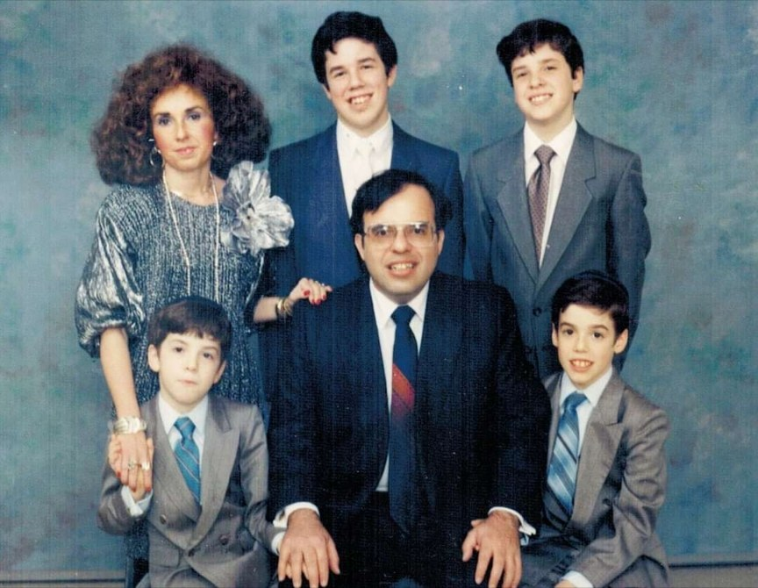
A later family portrait.
I do not want her remembered only for her illness, or even only for the way she faced it. She was an incredible woman who lived life to its fullest, and her love was not one heroic moment. It lived in the ordinary, daily acts of caring that made her who she was.
And I keep coming back to that smile. Everything was not okay; a week later she was gone. But thirty-six years on, with Rav Tzadok’s help, I think I can hear what it was really saying. Not that the night would not come. That the night is not the whole story. That the One who gives the darkness also gives the light that comes out of it. And that we would go on. In that, she was right. In the end, we have been okay. Her mark is on every one of us, and I carry it with me always.
The night is not the whole story.

How to Mark Her Yahrzeit With Me
If you would like to take part in this yahrzeit, here are a few small things, and three questions you are welcome to borrow.
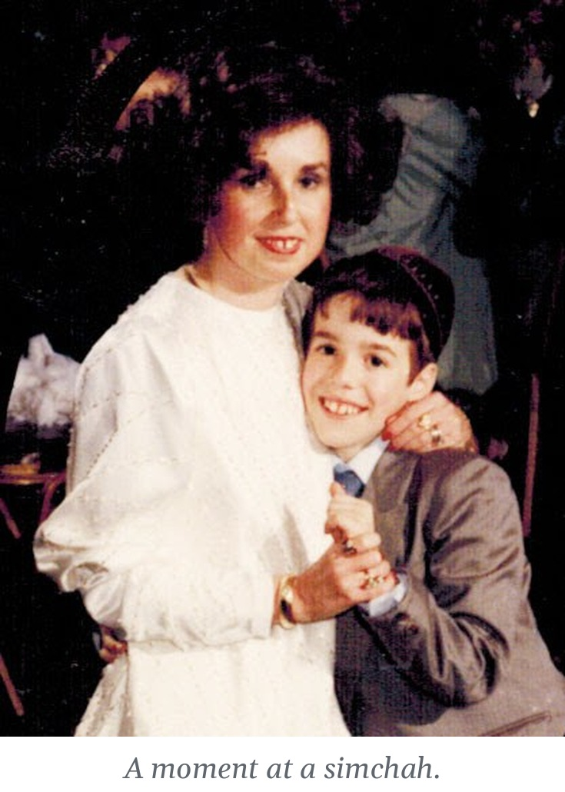
• Learn Siman 5. It is short enough to learn in one sitting. Even a page of it, in my mother’s merit, is enough.
• Say one blessing slowly this week. When you say Baruch atah, stop on the “You.” Remember that you are speaking to the One who gave you what is in your hand.
• Let Shabbos testify. Whatever you are carrying this week, put it down on Shabbos on purpose, and let that be your way of saying that it was never yours alone to carry.
• Light a candle, give tzedakah, and tell a story about someone you miss.
Three questions I am asking myself this week:
— What are the things that truly matter in my life, and does the way I spend this week show it?
— Where am I living as if I were the doer, and what would it change to remember that I am not?
— Where is my night right now, and am I still giving inside it?

May her neshamah have an aliyah, and may her memory be a blessing.
Yehi zichra baruch.

Learn Resisei Layla in My Mother’s Merit
My Hebrew–English interlinear edition of Resisei Layla presents Rav Tzadok’s Hebrew with the English translation set beside each phrase, and translates the sources he cites in the footnotes, so a reader can follow each step of his thought. Every copy that is learned is, I hope, a drop of light in my mother’s merit. It is available in two volumes on Amazon.
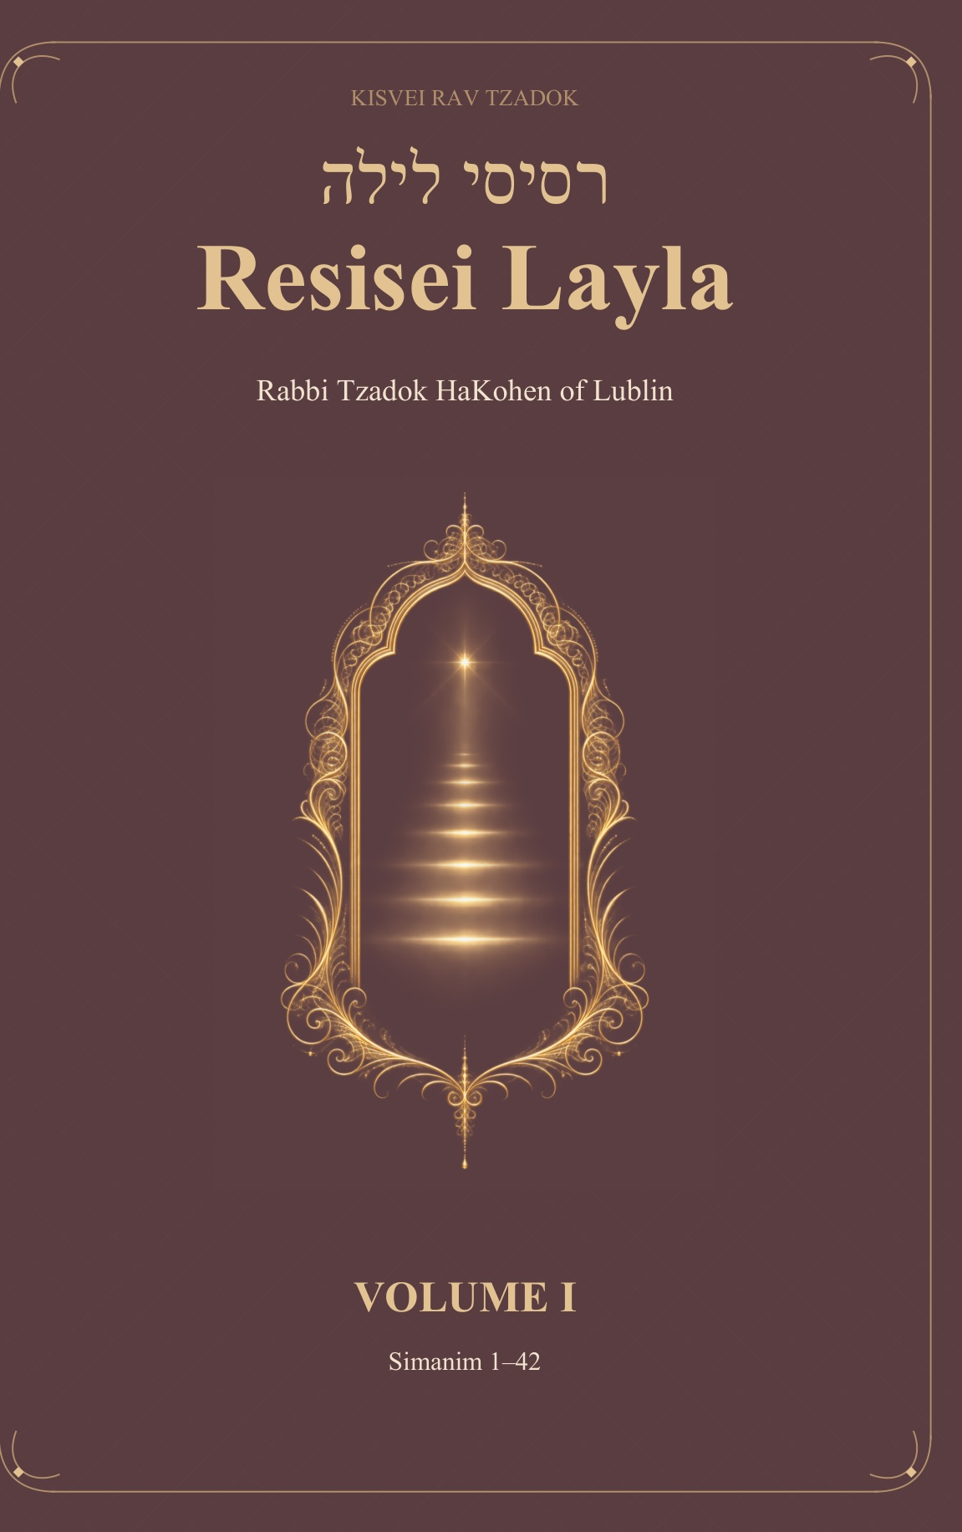  Resisei Layla, Volume I  Simanim 1–42  Buy on Amazon › | 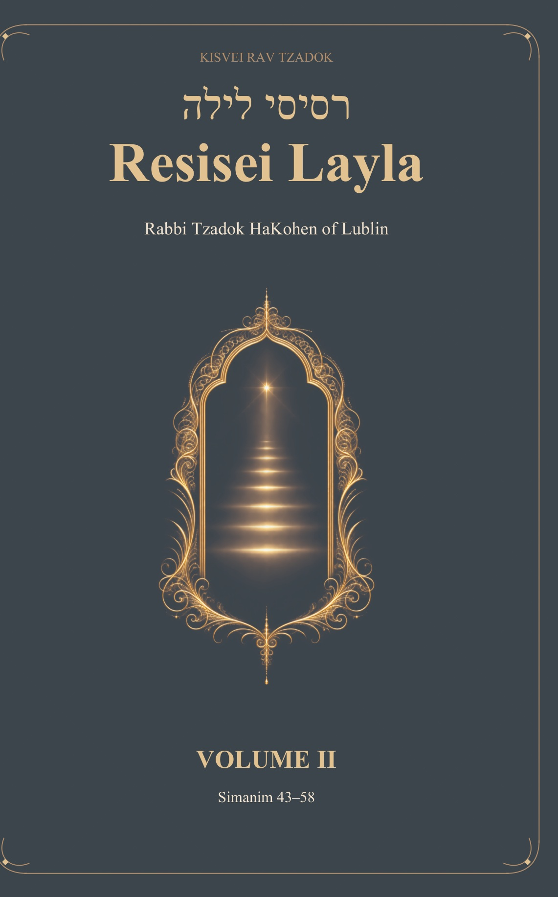  Resisei Layla, Volume II  Simanim 43–58  Buy on Amazon ›

לעילוי נשמת מרת ינטא רבקה בת הרב יעקב הלוי ע״ה
תהא נשמתה צרורה בצרור החיים

Song of Songs 5:2. “I was asleep, but my heart was awake; … my head is filled with dew, my locks with the drops of the night.”
Psalms 92:3, from the Psalm for the Sabbath day. Rav Tzadok connects it with Menachot 29b, “With the letter hei this world was created,” which he reads as the attribute of faith, the final hei of the Divine Name.
Rav Tzadok cites Pesachim 2b for the comparison of this world to night. He adds that the darkness is the evil inclination, which “darkens,” and cites Kiddushin 30b.
Habakkuk 2:4. Rav Tzadok also cites Shabbat 31a, which reads Isaiah 33:6, “And there shall be faith in your times,” as referring to the Order of Zera’im (Seeds), because one who sows has faith in the Life of the Worlds.
Isaiah 26:12: “Hashem, You will establish peace for us, for all our works You have also wrought for us.”
Exodus 35:2: “Six days shall work be done (te’aseh), and on the seventh day shall be holy for you.” Rav Tzadok reads the form te’aseh as work that is “done by itself,” and relates it to Exodus 20:9 (“Six days you shall labor”), and to Isaiah 44:5, “and another shall write on his hand ‘to Hashem.’”
Shabbat 77b: “First darkness, and afterward light.” Rav Tzadok illustrates the principle with the Exodus before the giving of the Torah, and the captivity of the Ark among the Philistines before the building of the Temple.
Niddah 16b: at conception it is decreed whether the drop will become wise or foolish, rich or poor. Rav Tzadok relates “rich” to the joy of the heart.
Pirkei Avot 4:1 (“Who is rich? One who rejoices in his portion”). Rav Tzadok also cites Jerusalem Talmud, Terumot 8:12, “the heart depends on the purse.”
Rashi on Genesis 6:9, quoting Midrash Bereishit Rabbah 30:6: “The main offspring of the righteous are their good deeds.”

