The Sealed Cruse · Chanukah · Weekly Torah
Chanukah 5787 · Weekly Torah · Divrei Chalomos 25

The Sealed Cruse
One against the other: Greek wisdom, the heart of Yisrael, and the light that could not be touched
By Akiva Gutnicki · From Rav Tzadok HaKohen of Lublin, Divrei Chalomos 25
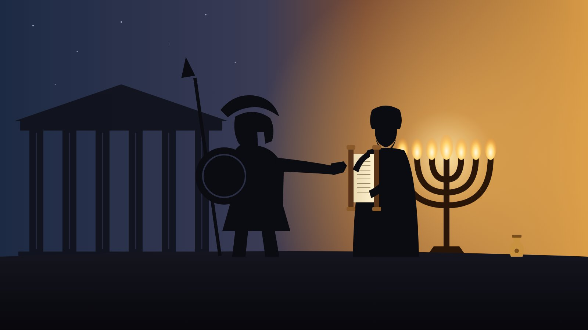
“Hashem has made the one against the other” (Koheles 7:14). The Greeks reached for the Torah; the Kohanim held it to their hearts.

A dream on the fifth night
Rav Tzadok HaKohen of Lublin wrote on almost everything: angels and demons, eating, the recesses of the imagination. One of his smallest and strangest sefarim is Divrei Chalomos, “Words of Dreams,” in which he wrote down Torah that came to him in his sleep and then worked out what it meant once he was awake. Maamar 25 is dated Motzaei Shabbos Mikeitz, the fifth night of Chanukah, and it opens with a line from Mishlei: בִּרְכַּת ה׳ הִיא תַעֲשִׁיר, “The blessing of Hashem is what makes rich.”
What follows is one of the most sweeping pieces he ever wrote. In a few pages it runs from the thirteen tribes to the generation of the Flood, from Avraham and Og to the curses at Har Eival, and it lands at the small sealed cruse of oil the Chashmona’im found in the Beis HaMikdash. Its question is simple and enormous: what exactly did the Greeks want from us, and why was a single jar of oil the answer?

Thirteen tribes, thirteen attributes
He begins with a count. Counting Menashe and Ephraim as two, there are thirteen tribes, and they stand against the thirteen attributes of mercy. Each tribe has its own path of holiness, its own way of fulfilling the command to cleave to Hashem, which the Gemara explains as “cleave to His attributes” (Sotah 14a). And each tribe is made of two sides, because they are the children of Yaakov, the middle line that holds Chesed and Gevurah together.
Everything in the world has two extremes, Rav Tzadok says. The middle line does not erase them. It joins them and knows how to use each one in its proper place, without leaning too far to either side. This is the “middle path” the Rambam describes in Shemoneh Perakim and Hilchos De’os, and it begins with Yaakov.
So thirteen attributes, each with two faces, make twenty-six. And that, he says, is why Tehillim 136, the Great Hallel, says “for His kindness endures forever” exactly twenty-six times. The psalm is a history, from creation to the Land, and every kindness in it is one of those twenty-six forms of holiness entering the world.

A history of souls
Read that way, the psalm becomes a map of how the soul of Yisrael came into being. The tenth verse, “To Him who struck Egypt in their firstborn,” is the beginning of the nation at the Exodus. Rav Tzadok sets it against the generation of the Flood. The Zohar says the Torah should have been given then (Zohar III 216b), and the Gemara finds Moshe hinted in that very generation: בְּשַׁגַּם הוּא בָשָׂר, “beshagam” having the numerical value of Moshe (Chullin 139b). The stirring toward Knesses Yisrael had already begun. Holy sparks were already in the world. But they were still sunk in the shells of impurity, they perished in the Flood, and those same souls came down later into the Egyptian exile.
Next comes “and He brought Yisrael out from their midst.” The name Yisrael begins to appear in Shem, the son of Noach, with whom Hashem joined His Name: “the God of Shem.” Ever, his student, was like him, and Yaakov learned in their beis medrash. A spark of Yisrael was already there, hidden. Ever was even called “a great prophet,” because he named his son Peleg for an event still to come (Bereishis Rabbah 37:7).
Then Avraham Avinu, the father of the nation, and against him, in the psalm, “and Og, king of Bashan.” Og survived the Flood and came to tell Avraham that Lot had been captured (Niddah 61a). The Midrash says his intention was not for Heaven: he hoped Avraham would die in battle so he could take Sarah (Bereishis Rabbah 42:8). Og considered himself Avraham’s equal. He had escaped the Flood, which suggests he did not carry a sin that would have swept him away with the rest, and Moshe himself was afraid of him.
So why was Og not saved in the Ark like Noach? Rav Tzadok’s answer is the key to the whole maamar. Hashem looks first at the heart, at the root of holiness inside it: that a person’s intention is for Heaven, that he turns from evil out of fear of Him and does good out of love of Him, and that everything is for His honor. That holiness of the heart first came out into the open in Avraham, the root of Knesses Yisrael. “Hashem’s portion is His people,” and “the Rock of my heart and my portion.” On “I sleep, but my heart is awake,” the Midrash says Hashem Himself is the heart of Yisrael (Shir HaShirim Rabbah).

The shell comes before the fruit
Og, who desired Sarah, was the kelipah wrapped around the fruit that was Avraham, for גַּם אֶת זֶה לְעֻמַּת זֶה עָשָׂה הָאֱלֹקִים, “Hashem has made the one against the other” (Koheles 7:14). Rav Tzadok suggests Og even possessed some of the outer wisdom that surrounds the wisdom of Torah, the way a shell surrounds the fruit. In everything the shell comes first: first darkness, then light, as the Gemara learns from the order of creation. And Og thought himself righteous. But in his hands everything was like “a price in the hand of a fool to buy wisdom, when he has no heart” (Mishlei 17:16). There was no root of holiness in his heart at all.
Hashem in His kindness sent a soul into the world that was the opposite of that shell and would one day break it. Avraham was the beginning. The final destruction of Og came at the end of the forty years in the desert, through Moshe, and that was something Yisrael accomplished by their own effort: they defeated evil in practice and removed it from the world.
From there the psalm continues. Yitzchak corresponds to “and He gave their land as an inheritance,” because inheriting Eretz Yisrael means bringing holiness down into physical, earthly life. That comes through holding back desire, Yitzchak’s attribute. He lived in the Negev, which the Gemara reads as menugav, dried out from the pull of this world (Temurah 16a). Avraham only “traveled toward the Negev”; it was the goal he worked toward his whole life. Yitzchak was born there, and so he was the first to have a bris on the eighth day, the covenant that sets a boundary around desire. And Yaakov corresponds to “an inheritance to Yisrael His servant.” From Yaakov on, every one of his children was holy. It was not yet revealed until Sinai, but it was known in Heaven.

Every strength has a shadow
Now Rav Tzadok returns to the tribes. Every person has two angels who accompany him, one good and one evil (Chagigah 16a; Shabbos 119b). The evil one is the yetzer hara, which the Midrash calls “very good.” In every trait and every way of acting there is good and evil, and evil is simply the trait used where it does not belong. Walking the middle line, the attribute of “truth to Yaakov,” is what turns the evil back into good.
That is also why each soul, according to its holiness, carries a matching deficiency. Rav Tzadok had a tradition that the eleven curses spoken at Har Eival correspond to the tribes, and that they are the deficiencies built into each one. There are eleven, he explains, because Shimon is included in Yehudah, just as his portion in the Land lay inside Yehudah’s, and Menashe and Ephraim are counted together as Yosef. Because these deficiencies had not yet been repaired, the tribes went down to Egypt, to refine the holiness in them until the evil too returned to good. After the Exodus and Sinai, those forms of holiness came out in their children.

What Greece wanted
And here the dream reaches Chanukah. The wicked kingdom of Greece set out לְהַשְׁכִּיחָם תּוֹרָתֶךָ, “to make them forget Your Torah,” and its aim, Rav Tzadok saw, was to bring the old deficiencies back. Not to destroy the Jews’ strengths, but to wake up the shadows that came with them.
At this point he writes plainly: “No more was revealed to me in the dream.” The rest is his own working out, awake. The Greeks tried to do it with their wisdom. Greek wisdom is the shell around the fruit of the Oral Torah, the wisdom of the Sages of Yisrael, which is the root of Knesses Yisrael and holds every form of holiness.
That wisdom starts in the higher Chochmah, where existence first comes out of nothing. From there Moshe brought down the Torah, which the Midrash calls the unripe fruit, the noveles, of the wisdom above (Bereishis Rabbah 17:5). From it flows the lower wisdom, “Malchus is the mouth, the Oral Torah.” But its feet go down toward death, into outside wisdom, the mirror image of everything holy that flows from holy wisdom. That is where every deficiency is rooted, because it can lead to heresy and to denying the whole Torah.

The seal of the Kohen Gadol
Who defeated them? The Kohanim. They are the root of every form of holiness, which is why Yisrael is called “a kingdom of Kohanim and a holy nation”: a people that contains every level of holiness, joined together as one. And the Kohanim have one Kohen Gadol in whom all those forms of holiness are gathered. He stands in the place of Aharon, set apart “to sanctify him, holy of holies.”
This is the cruse of oil they found sealed with the seal of the Kohen Gadol. With their impure wisdom they could not defile the root of holy wisdom sealed inside the Kohen Gadol’s root of holiness. For no stranger can touch the root of the supernal rose, which is a sealed spring.
Divrei Chalomos 25
Everything else in the Heichal could be touched. The Greeks entered and made all the oil impure. But one jar sat under a seal they could not reach. Rav Tzadok reads that jar as the deepest point of the Jewish soul, the place where holy wisdom begins, sealed like the spring in Shir HaShirim: מַעְיָן חָתוּם.
He shows that the Greeks knew exactly where to aim. All their cleverness went into one decree: every Jewish bride would first be taken by the governor (Rashi on Shabbos 23a). They meant to defile the root of Knesses Yisrael from birth, from the womb, for “a woman makes a covenant only with the one who made her a vessel” (Sanhedrin 22b): she would be bound to him and bear children like him. It did not work. When the decree reached the daughter of the Chashmonai Kohen Gadol, the root of holiness came out into the open and broke the root of impurity.

Wisdom from a pure heart
Why the Kohanim? Because the Oral Torah is rooted in them: “They shall teach Your laws to Yaakov and Your Torah to Yisrael,” and “you shall come to the Kohanim, the Levi’im.” Moshe, root of the Levi’im, brought down the Written Torah from Da’as, the meeting of Chochmah and Binah, the mind and the heart. The Oral Torah lives mainly in the heart. We say a ruling is aliba of a certain Tanna, “according to his heart,” and the Gemara speaks of people who “forget the heart of the reasoning” (Sanhedrin 35a).
The wisdom of the Sanhedrin flows from the heart, from Hashem who is the Rock of their heart: a pure heart. But the yetzer hara lives in the heart too. “Do not stray after your hearts” refers to heresy, for “the fool has said in his heart, there is no God” (Berachos 12b). That is the wisdom of the heretics, “a foolish people and not wise.” For them all wisdom serves the body’s pleasure, and against their desires none of it helps. Bilaam was the wisest of the nations and saw Yisrael’s greatness clearly, yet he advised making them stumble through immorality and tried to curse them against Hashem’s will. All his wisdom was worth nothing against the desire of his heart. “The wicked are in the power of their hearts” (Bereishis Rabbah 34:10), and their wisdom follows. Yisrael aims all its wisdom only at finding the truth and doing Heaven’s will, giving over body and soul to Him.
That is the holiness of Levi, whose name means attachment. When Moshe called out at the Golden Calf, “Whoever is for Hashem, to me!”, all the sons of Levi came. They risked their lives without fearing that all Yisrael would rise against them. Aharon held back, not, Heaven forbid, because he would not give his life, but because of the deeper understanding in his heart: he saw what had been done to Chur and said, better the blame fall on me (Sanhedrin 7a; Vayikra Rabbah 10:3). Out of that love for Yisrael he became the root of the Oral Torah and earned the Kehunah.
And this is Levi’s blessing: “who said of his father and mother, I have not seen them.” Inwardly, Rav Tzadok explains, a person’s father and mother are his own Chochmah and Binah. Levi sets aside his own wisdom and understanding wherever they collide with the will of Hashem, for “there is no wisdom and no understanding against Hashem.” From a heart like that, holy wisdom flows. The opposite is the person who follows evil and scorns holy Chochmah and Binah. That was Greek wisdom.

Eight lights, back to the heart
So the Kohanim, Aharon’s children and the root of the Oral Torah, defeated Greece and set up eight days of Chanukah. Seven days are the days of building, the seven lower sefiros. The eighth is Binah, understanding in the heart, from which all seven flow. Together they hold thirteen: seven coming down from above, and six rising back up from below as Yisrael’s own awakening. And by kindling the lights, Rav Tzadok concludes, we lift the lower, holy wisdom up into the Binah of the heart, so that everything is in holiness.
That is the Torah of the sealed cruse. The Greeks were never really after the Jews’ ignorance. They wanted the Jews’ intelligence, cut loose from the heart. Their wisdom was dazzling, and in their hands it served desire. The answer was not less wisdom but wisdom with a seal on it: Torah that flows from a pure heart and goes back into the heart. Every year the little flames ask each of us the same question. Is my wisdom sealed with the seal of the Kohen Gadol, or is it the shell around the fruit? And they give the same promise: whatever the Greeks managed to touch, there is a jar in every Jewish heart they never reached.
Read Divrei Chalomos 25 in the Kisvei Rav Tzadok reader, in the interlinear study edition with source notes. Sources follow the study edition: Sotah 14a; Tehillim 136; Zohar III 216b; Chullin 139b; Bereishis Rabbah 37:7, 42:8, 17:5, 34:10; Niddah 61a; Koheles 7:14; Mishlei 17:16; Temurah 16a; Chagigah 16a; Shabbos 119b; Rashi on Shabbos 23a; Sanhedrin 22b, 35a, 7a; Berachos 12b; Vayikra Rabbah 10:3.

