LangChain Repo Study Guide + QnA
Simple explanation of the uploaded Langchain.zip repository for learning and interview revision
Generated from repo scan: notebooks, app.py, loaders, splitters, embeddings, FAISS, Chroma, and RAG flow
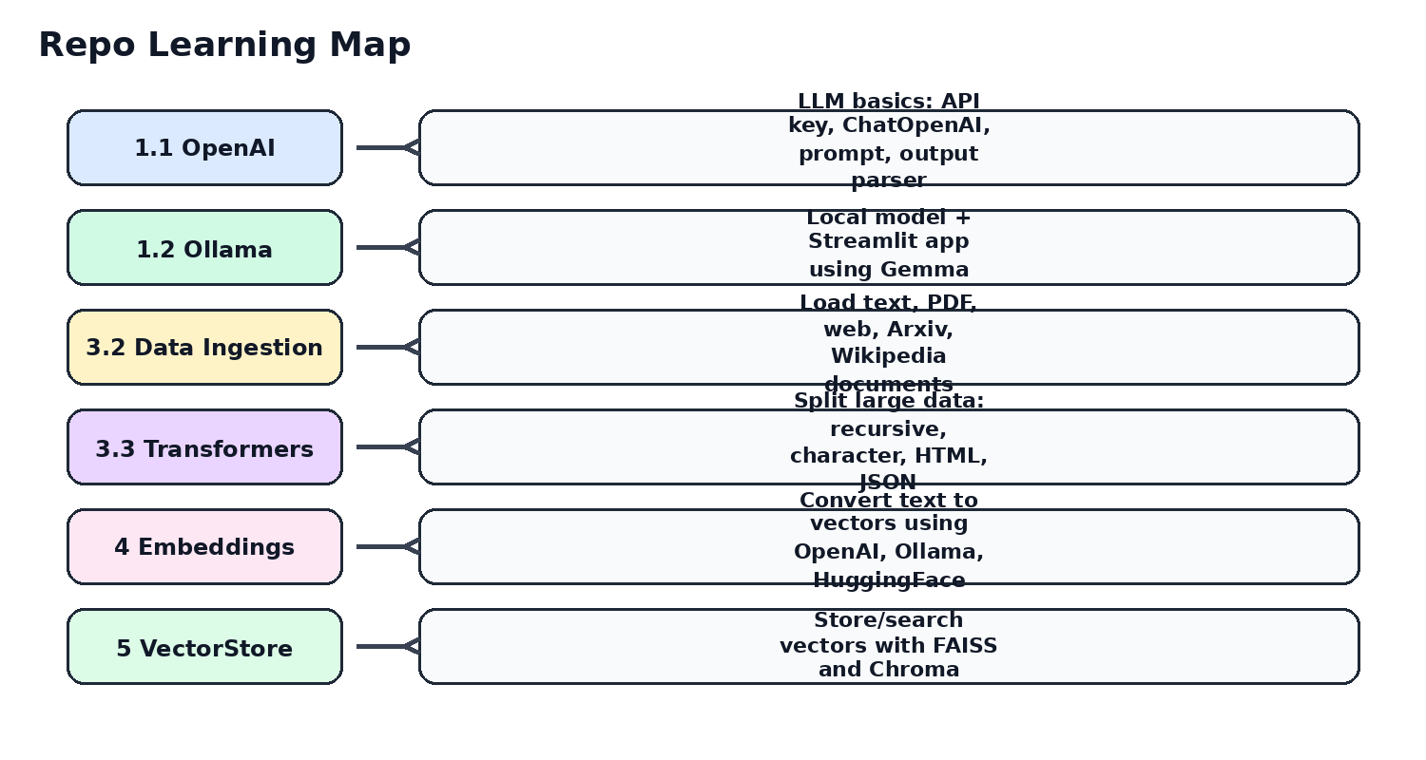

1. What This Repo Teaches
This repository is a beginner-friendly LangChain practice project. It starts with calling an LLM, then builds a simple RAG application, then explains how to load data, split text, create embeddings, store vectors, search similar chunks, and finally use a local Ollama model in a Streamlit UI.
Simple meaning: LangChain helps us connect many small pieces: prompt + LLM + parser + document loader + text splitter + embedding + vector database + retriever + final answer.
- LLM basics using OpenAI ChatOpenAI and local Ollama model.
- Prompt templates using ChatPromptTemplate.
- LCEL chain syntax using the pipe operator: prompt | llm | parser.
- RAG flow using document loading, splitting, embeddings, vector store, retriever, and answer generation.
- Data ingestion from text, PDF, website, Arxiv, and Wikipedia.
- Text transformation using recursive, character, HTML header, and JSON splitters.
- Embeddings using OpenAI, Ollama, and HuggingFace.
- Vector stores using FAISS and Chroma.
- Streamlit app using Ollama Gemma model.

2. Repo Structure Scan
File / Folder | Approx Size
1.1-OpenAi/1.1.1-GettingStarted.ipynb | 11.0 KB
1.1-OpenAi/1.1.2-Simpleapp.ipynb | 36.5 KB
1.2-ollama/1.2.1-Simpleapp.ipynb | 51.9 KB
1.2-ollama/app.py | 1.0 KB
3.2-DataIngestion/3.2-DataIngestion.ipynb | 185.3 KB
3.2-DataIngestion/attention.pdf | 2163.3 KB
3.2-DataIngestion/records.xml | 0.7 KB
3.2-DataIngestion/speech.txt | 3.6 KB
3.3-Data Trnasformer/3.3-RecuriveCharactertextsplitter.ipynb | 99.9 KB
3.3-Data Trnasformer/3.4-CharacterTextsplitter.ipynb | 13.0 KB
3.3-Data Trnasformer/3.5-HTMLtextsplitter.ipynb | 159.8 KB
3.3-Data Trnasformer/3.6-RecursiveJsonSplitter.ipynb | 762.1 KB
3.3-Data Trnasformer/attention.pdf | 2163.3 KB
3.3-Data Trnasformer/speech.txt | 3.6 KB
4-Embeddings/4.1-embedding.ipynb | 85.8 KB
4-Embeddings/4.2-ollamaemnedding.ipynb | 102.9 KB
4-Embeddings/4.3-huggingface.ipynb | 20.6 KB
4-Embeddings/speech.txt | 3.6 KB
5-VectorStore/5.1-Faiss.ipynb | 53.2 KB
5-VectorStore/5.2-Chroma.ipynb | 11.0 KB
5-VectorStore/chroma_db/chroma.sqlite3 | 324.0 KB
5-VectorStore/faiss_index/index.faiss | 80.0 KB
5-VectorStore/faiss_index/index.pkl | 4.2 KB
5-VectorStore/speech.txt | 3.6 KB

3. High-Level Flow You Should Remember
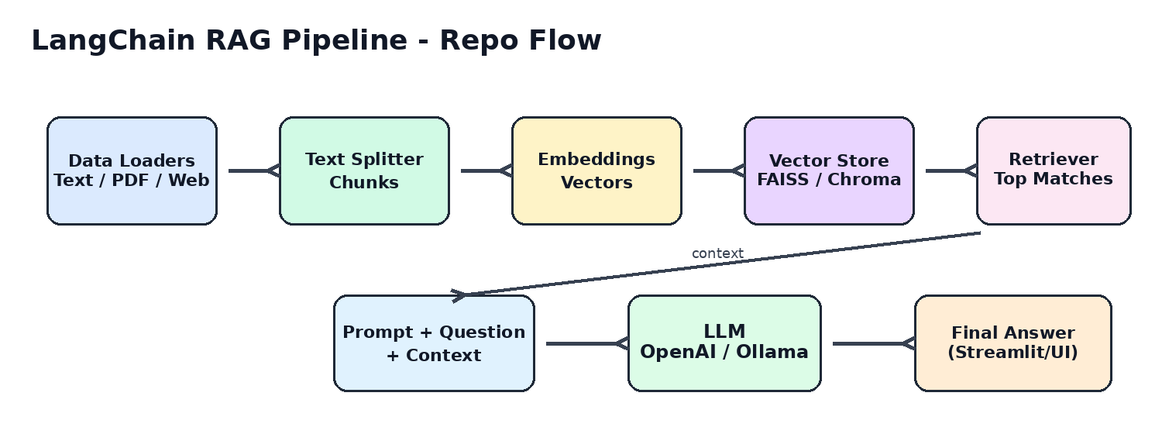
- Load data from text, PDF, website, Wikipedia, Arxiv, or API.
- Split large data into small chunks because LLM cannot read unlimited text at once.
- Convert chunks into vectors using an embedding model.
- Store vectors in FAISS or Chroma vector database.
- When user asks a question, convert the question into a vector also.
- Find the most similar chunks from vector database.
- Send only those relevant chunks to the LLM as context.
- LLM generates answer based on the retrieved context.

4. Chapter-wise Explanation from Repo

4.1 Getting Started with OpenAI and LangChain
Files covered: 1.1-OpenAi/1.1.1-GettingStarted.ipynb
This notebook shows the most basic LangChain flow. First it loads API keys from .env, then creates a ChatOpenAI model, then calls the model using invoke(). After that it creates a prompt template and chains prompt with model. Finally it adds StrOutputParser to return clean string output.
Concept | Simple Explanation | Repo Code Idea
load_dotenv() | Loads secret keys from .env file into the program. | OPENAI_API_KEY, LANGCHAIN_API_KEY
ChatOpenAI | Wrapper class to call OpenAI chat models using LangChain. | llm = ChatOpenAI(model="gpt-4o")
invoke() | Runs the chain or model and returns output. | llm.invoke("What is generative AI?")
ChatPromptTemplate | Creates reusable system and user prompt format. | system + user message
StrOutputParser | Converts LLM message object into plain string. | prompt | llm | parser
from langchain_openai import ChatOpenAI
from langchain_core.prompts import ChatPromptTemplate
from langchain_core.output_parsers import StrOutputParser
llm = ChatOpenAI(model="gpt-4o")
prompt = ChatPromptTemplate.from_messages([
("system", "You are an expert AI Engineer."),
("user", "{input}")
])
chain = prompt | llm | StrOutputParser()
response = chain.invoke({"input": "What is LangChain?"})
Interview line: In LangChain, a chain means connecting components together. Example: prompt creates final input, model generates response, parser converts output into required format.
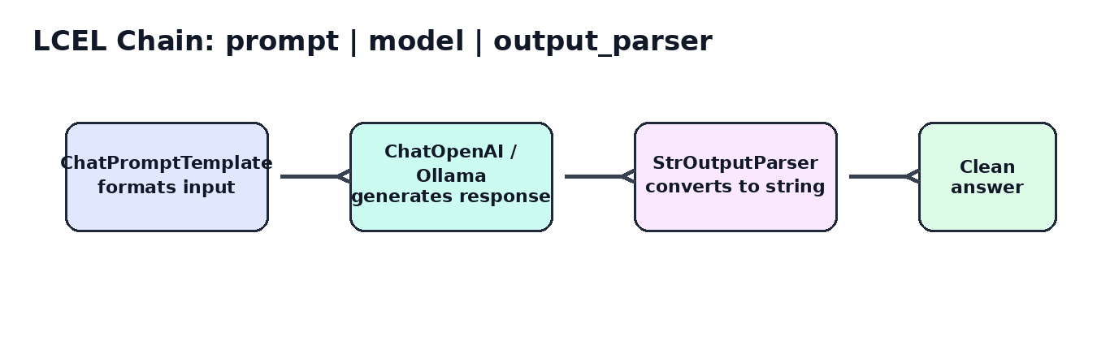

4.2 Simple RAG App using WebBaseLoader, FAISS, Retriever, and Chain
Files covered: 1.1-OpenAi/1.1.2-Simpleapp.ipynb and 1.2-ollama/1.2.1-Simpleapp.ipynb
This notebook builds a basic RAG app. It loads a LangSmith web page, splits it into chunks, creates embeddings, stores them in FAISS, converts FAISS into a retriever, and then creates a retrieval chain.
RAG: RAG means Retrieval Augmented Generation. Instead of asking the LLM from memory only, we first retrieve relevant documents and then ask the LLM to answer using those documents.
Step | Repo Component | Why It Is Used
1 | WebBaseLoader | Scrapes or loads content from a website.
2 | RecursiveCharacterTextSplitter | Splits long web content into smaller chunks.
3 | OpenAIEmbeddings | Converts text chunks into vector numbers.
4 | FAISS.from_documents | Stores vectors for fast similarity search.
5 | as_retriever() | Converts vector store into retriever interface.
6 | create_stuff_documents_chain | Combines retrieved docs into prompt context.
7 | create_retrieval_chain | Connects retriever + document chain for final answer.
loader = WebBaseLoader("https://docs.smith.langchain.com/tutorials/Administrators/manage_spend")
docs = loader.load()
text_splitter = RecursiveCharacterTextSplitter(chunk_size=1000, chunk_overlap=200)
documents = text_splitter.split_documents(docs)
embeddings = OpenAIEmbeddings()
vectorstoredb = FAISS.from_documents(documents, embeddings)
retriever = vectorstoredb.as_retriever()
retrieval_chain = create_retrieval_chain(retriever, document_chain)
response = retrieval_chain.invoke({"input": "What are LangSmith usage limits?"})

4.3 Ollama + Streamlit App
File covered: 1.2-ollama/app.py
This file creates a small Streamlit UI. User enters a question, LangChain formats the prompt, local Ollama Gemma model generates answer, and Streamlit displays it.
Part | Explanation
Streamlit | Creates a simple web UI using st.title(), st.text_input(), st.write().
Ollama | Runs local LLM model like gemma:2b on your machine.
Prompt Template | Formats user question before sending to the model.
Output Parser | Returns clean text output.
llm = Ollama(model="gemma:2b")
output_parser = StrOutputParser()
chain = prompt | llm | output_parser
if input_text:
st.write(chain.invoke({"question": input_text}))
Run command: From the folder containing app.py, run: streamlit run app.py

4.4 Data Ingestion - Document Loaders
File covered: 3.2-DataIngestion/3.2-DataIngestion.ipynb
Data ingestion means bringing external data into LangChain as Document objects. A Document normally contains page_content and metadata. After loading, we can split documents and use them in RAG.
Loader | Used For | Repo Example
TextLoader | Load .txt files. | speech.txt
PyPDFLoader | Load PDF pages as documents. | attention.pdf
WebBaseLoader | Load website content. | Lilian Weng blog / LangSmith docs
ArxivLoader | Load research paper metadata/content. | query="1706.03762"
WikipediaLoader | Load Wikipedia pages. | query="Generative AI"
from langchain_community.document_loaders import TextLoader, PyPDFLoader, WebBaseLoader
text_docs = TextLoader("speech.txt").load()
pdf_docs = PyPDFLoader("attention.pdf").load()
web_docs = WebBaseLoader("https://example.com").load()

4.5 Data Transformation - Text Splitters
Files covered: 3.3-RecuriveCharactertextsplitter.ipynb, 3.4-CharacterTextsplitter.ipynb, 3.5-HTMLtextsplitter.ipynb, 3.6-RecursiveJsonSplitter.ipynb
Text splitters divide big content into smaller chunks. This is important because embeddings and LLM prompts work better with controlled-size chunks. Good chunks improve retrieval quality.
Splitter | Simple Meaning | Best Use
RecursiveCharacterTextSplitter | Tries paragraph, then line, then space based splitting. | General text and PDFs.
CharacterTextSplitter | Splits by a fixed separator/character. | Simple plain text.
HTMLHeaderTextSplitter | Splits HTML based on h1, h2, h3 headings. | Web pages with clear headings.
RecursiveJsonSplitter | Splits nested JSON into smaller JSON chunks. | API/openapi JSON data.
text_splitter = RecursiveCharacterTextSplitter(
chunk_size=1000,
chunk_overlap=200
)
chunks = text_splitter.split_documents(docs)
Chunk size: chunk_size controls maximum chunk length. chunk_overlap repeats some text between chunks, so context is not lost at chunk boundaries.

4.6 Embeddings
Files covered: 4.1-embedding.ipynb, 4.2-ollamaemnedding.ipynb, 4.3-huggingface.ipynb
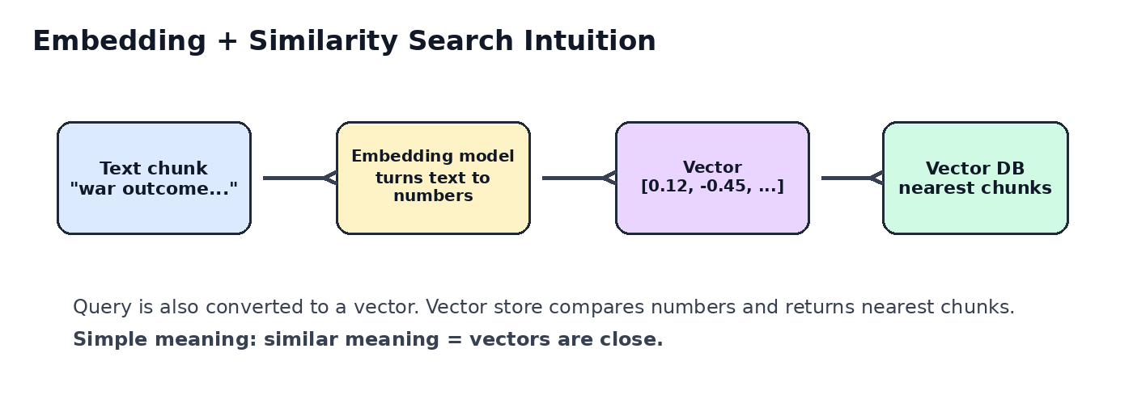
Embeddings convert text into numeric vectors. A vector is just a list of numbers. Similar meaning texts have vectors close to each other. This is the heart of semantic search and RAG.
Embedding Type | Repo Class | When to Use
OpenAI | OpenAIEmbeddings | Good quality cloud embedding. Needs OPENAI_API_KEY.
Ollama | OllamaEmbeddings | Local embedding models. Good for offline/local practice.
HuggingFace | HuggingFaceEmbeddings | Open-source sentence transformer models.
from langchain_openai import OpenAIEmbeddings
embeddings = OpenAIEmbeddings(model="text-embedding-3-large", dimensions=1024)
vector = embeddings.embed_query("This is a tutorial on OpenAI embedding")
print(len(vector))

4.7 Vector Stores - FAISS and Chroma
Files covered: 5.1-Faiss.ipynb and 5.2-Chroma.ipynb
A vector store stores embeddings and allows similarity search. When the user asks a question, vector store returns the closest matching chunks.
Vector Store | Simple Explanation | Repo Features
FAISS | Fast local vector search library from Meta/Facebook AI. | similarity_search, with_score, by_vector, save_local, load_local
Chroma | Developer-friendly open-source vector database. | persist_directory, load from disk, retriever, score search
# FAISS
retriever = db.as_retriever()
docs = retriever.invoke(query)
# Save and load FAISS index
db.save_local("faiss_index")
new_db = FAISS.load_local("faiss_index", embeddings, allow_dangerous_deserialization=True)
# Chroma persistence
vectordb = Chroma.from_documents(splits, embedding, persist_directory="./chroma_db")
db2 = Chroma(persist_directory="./chroma_db", embedding_function=embedding)
Important safety note: allow_dangerous_deserialization=True should be used only when loading FAISS index files you trust, because pickle files can execute unsafe code.

5. Notebook-by-Notebook Quick Notes
Notebook | What to Learn | Cells
1.1-OpenAi/1.1.1-GettingStarted.ipynb | Basic LLM call, prompt template, LCEL chain, output parser. | 9
1.1-OpenAi/1.1.2-Simpleapp.ipynb | RAG flow using web data, FAISS, retriever, and document chain. | 22
1.2-ollama/1.2.1-Simpleapp.ipynb | RAG flow using web data, FAISS, retriever, and document chain. | 22
3.2-DataIngestion/3.2-DataIngestion.ipynb | Load data from text, PDF, web, Arxiv, Wikipedia. | 12
3.3-Data Trnasformer/3.3-RecuriveCharactertextsplitter.ipynb | Recursive text splitting for generic long documents. | 10
3.3-Data Trnasformer/3.4-CharacterTextsplitter.ipynb | Character-based splitting of plain text. | 6
3.3-Data Trnasformer/3.5-HTMLtextsplitter.ipynb | Split HTML by heading hierarchy. | 13
3.3-Data Trnasformer/3.6-RecursiveJsonSplitter.ipynb | Recursive text splitting for generic long documents. | 9
4-Embeddings/4.1-embedding.ipynb | OpenAI embeddings and Chroma vector store. | 15
4-Embeddings/4.2-ollamaemnedding.ipynb | Ollama embeddings/local models. | 13
4-Embeddings/4.3-huggingface.ipynb | HuggingFace sentence transformer embeddings. | 9
5-VectorStore/5.1-Faiss.ipynb | FAISS similarity search, retriever, score, save/load. | 19
5-VectorStore/5.2-Chroma.ipynb | Chroma vector store, persistence, retriever, score. | 11

6. How to Run This Repo Locally
- Create and activate a Python virtual environment.
- Install required packages like langchain, langchain-openai, langchain-community, langchain-text-splitters, langchain-chroma, streamlit, python-dotenv, pypdf, bs4, faiss-cpu, chromadb, langchain-huggingface as needed.
- Create a .env file and add required keys: OPENAI_API_KEY, LANGCHAIN_API_KEY, LANGCHAIN_PROJECT, HF_TOKEN if using HuggingFace API token.
- For Ollama examples, install Ollama and pull the model: ollama pull gemma:2b and optionally embedding models.
- Run notebooks one by one. For Streamlit app, go to 1.2-ollama folder and run streamlit run app.py.
python -m venv .venv
.venv\Scripts\activate # Windows
pip install langchain langchain-openai langchain-community langchain-text-splitters streamlit python-dotenv pypdf bs4 faiss-cpu chromadb langchain-chroma langchain-huggingface
streamlit run app.py

7. Common Errors and Fixes
Error / Problem | Reason | Fix
ModuleNotFoundError | Package not installed in current environment. | Install package using pip in the same venv/kernel.
OPENAI_API_KEY missing | Key not loaded from .env. | Check .env path and variable spelling.
Ollama connection error | Ollama server/model not running locally. | Run Ollama and pull model first.
No relevant answer from RAG | Bad chunks, bad query, or no matching data. | Improve chunk size, overlap, source data, or retriever k.
FAISS load error | Pickle loading restricted. | Use allow_dangerous_deserialization=True only for trusted local index.
Chroma empty result | Persist directory or embedding mismatch. | Use same embedding model when loading stored DB.

8. Practical QnA Based on This Repo
Q1. What is LangChain in simple words?
Answer: LangChain is a framework that helps us build LLM applications by connecting prompts, models, parsers, data loaders, retrievers, and tools together.
Q2. What is the use of ChatOpenAI in this repo?
Answer: ChatOpenAI is used to call OpenAI chat models like gpt-4o through LangChain. It takes input and returns an AI response.
Q3. Why do we use load_dotenv()?
Answer: We use it to load secret keys from the .env file, so we do not hardcode API keys in code.
Q4. What is ChatPromptTemplate?
Answer: It creates a reusable prompt structure. We can define system message and user message with variables like {input} or {question}.
Q5. What does prompt | llm | parser mean?
Answer: This is LangChain Expression Language. First prompt formats input, then LLM generates response, then parser converts output to clean text.
Q6. What is StrOutputParser?
Answer: It converts the LLM output object into a plain string, so it is easier to print or show in UI.
Q7. What is RAG?
Answer: RAG means Retrieval Augmented Generation. We retrieve relevant documents first and then ask the LLM to answer based on those documents.
Q8. Why do we need RAG if LLM already knows many things?
Answer: LLM may not know private or latest data. RAG gives it the right context from our documents, so answers become more accurate and grounded.
Q9. What is WebBaseLoader?
Answer: WebBaseLoader loads content from a website and converts it into LangChain Document objects.
Q10. What is a LangChain Document?
Answer: A Document is a standard object with page_content and metadata. LangChain loaders return data in this format.
Q11. Why do we split documents?
Answer: Large documents cannot be sent fully to the model. Splitting creates small chunks, which are better for embeddings and retrieval.
Q12. What is chunk_size?
Answer: chunk_size decides the maximum size of each text chunk.
Q13. What is chunk_overlap?
Answer: chunk_overlap repeats some text between nearby chunks so important context is not lost at the split point.
Q14. Why is RecursiveCharacterTextSplitter commonly used?
Answer: It tries to keep paragraphs, lines, and words together as much as possible, so chunks remain meaningful.
Q15. What is embedding?
Answer: Embedding means converting text into a list of numbers. These numbers represent the meaning of the text.
Q16. Why embeddings are important in RAG?
Answer: Embeddings help us find text chunks that are semantically similar to the user question.
Q17. What is semantic search?
Answer: Semantic search means searching by meaning, not only exact keyword matching.
Q18. What is FAISS?
Answer: FAISS is a fast vector similarity search library. In this repo it stores document embeddings and finds matching chunks.
Q19. What is Chroma?
Answer: Chroma is an open-source vector database. It can store embeddings and persist them on disk.
Q20. FAISS vs Chroma?
Answer: FAISS is very fast local vector search. Chroma is a vector database with easier persistence and developer-friendly APIs.
Q21. What does similarity_search do?
Answer: It takes a query, converts it to vector, compares it with stored vectors, and returns the most similar documents.
Q22. What is similarity_search_with_score?
Answer: It returns matching documents plus a score. In FAISS L2 distance, lower score generally means better match.
Q23. What is as_retriever()?
Answer: It converts vector store into a retriever interface, so it can be used inside LangChain retrieval chains.
Q24. What is create_stuff_documents_chain?
Answer: It stuffs or inserts retrieved documents into the prompt context and asks the LLM to answer.
Q25. What is create_retrieval_chain?
Answer: It connects retriever and document answering chain. Retriever gets context, document chain generates answer.
Q26. What is the role of Ollama in this repo?
Answer: Ollama runs local models like gemma:2b. It helps test LLM apps without always using cloud model APIs.
Q27. What is Streamlit used for?
Answer: Streamlit is used to quickly create a small web UI where user enters a question and sees the model response.
Q28. What does app.py do?
Answer: It loads environment variables, creates a prompt, starts Streamlit UI, uses Ollama Gemma model, runs the chain, and displays output.
Q29. Why use LangSmith tracing?
Answer: LangSmith tracing helps debug and observe chains, prompts, inputs, outputs, and latency.
Q30. What is TextLoader?
Answer: TextLoader loads a text file like speech.txt into LangChain Documents.
Q31. What is PyPDFLoader?
Answer: PyPDFLoader reads PDF pages and returns them as Document objects.
Q32. What is ArxivLoader?
Answer: ArxivLoader loads research paper data from Arxiv using a query or paper ID.
Q33. What is WikipediaLoader?
Answer: WikipediaLoader loads content from Wikipedia pages based on a search query.
Q34. What is HTMLHeaderTextSplitter?
Answer: It splits HTML based on headings like h1, h2, h3 so section structure is preserved.
Q35. What is RecursiveJsonSplitter?
Answer: It splits nested JSON into smaller chunks while trying to keep objects meaningful.
Q36. What is HuggingFaceEmbeddings?
Answer: It uses HuggingFace sentence-transformer models to create embeddings.
Q37. What is OllamaEmbeddings?
Answer: It uses local Ollama embedding models to convert text into vectors.
Q38. Why model and embedding should match during loading vector DB?
Answer: The same embedding model should be used, otherwise query vectors may not be comparable with stored vectors.
Q39. Why save FAISS index locally?
Answer: Saving avoids creating embeddings again every time. We can load the index and search directly.
Q40. Why is allow_dangerous_deserialization risky?
Answer: FAISS local load may use pickle files. Pickle can run unsafe code if file is not trusted.
Q41. What is persist_directory in Chroma?
Answer: It is the folder where Chroma saves vector database files on disk.
Q42. What is the end-to-end flow in this repo?
Answer: Load data -> split text -> create embeddings -> store vectors -> retrieve relevant chunks -> prompt LLM -> show answer.
Q43. What should you check if RAG answer is wrong?
Answer: Check source data, chunk size, overlap, embedding model, retriever result, prompt, and whether context contains answer.
Q44. How to improve retrieval quality?
Answer: Use better chunking, add overlap, clean data, use good embedding model, increase retriever k, and improve metadata filtering.
Q45. What is the main difference between normal LLM app and RAG app?
Answer: Normal app sends only user question to LLM. RAG app also sends relevant document context to LLM.
Q46. How will you explain this repo in interview?
Answer: This repo demonstrates a simple LangChain RAG pipeline with loaders, splitters, embeddings, vector stores, retriever chains, and Streamlit/Ollama UI.
Q47. What is LCEL?
Answer: LCEL is LangChain Expression Language. It allows us to compose chains using the pipe operator in a readable way.
Q48. Why output parser is added at end of chain?
Answer: Because raw model output can be a message object. Parser converts it into format needed by application, commonly string.
Q49. What is metadata in Document?
Answer: Metadata stores extra information like source URL, page number, file name, or section details.
Q50. Where does LLM answer come from in RAG?
Answer: The final answer comes from LLM, but the knowledge/context comes from retrieved documents.

9. Interview-Style Summary
In this repo, I learned how to build a basic LangChain based LLM and RAG application. First, we call LLMs using ChatOpenAI or Ollama. Then we create prompts using ChatPromptTemplate and connect components using LCEL pipe syntax. For RAG, we load documents using loaders, split them into chunks, convert chunks into embeddings, store them in FAISS or Chroma, retrieve relevant chunks using similarity search, and send those chunks as context to the LLM. Finally, we can integrate the chain with Streamlit to build a small web app.

10. Revision Cheatsheet
Keyword | Remember This
LLM | Generates answer from prompt.
Prompt Template | Reusable prompt with variables.
Parser | Converts output to required format.
Loader | Loads external data into Documents.
Splitter | Breaks large content into chunks.
Embedding | Converts text into vectors.
Vector Store | Stores vectors and searches similar chunks.
Retriever | Fetches relevant documents for a query.
RAG | Retriever + LLM answer generation.
Streamlit | Simple Python web UI.

