NLP, ANN, RNN, LSTM and GRU
Simple Study Guide
Based on course lessons 62 to 95 - explained in simple Indian English
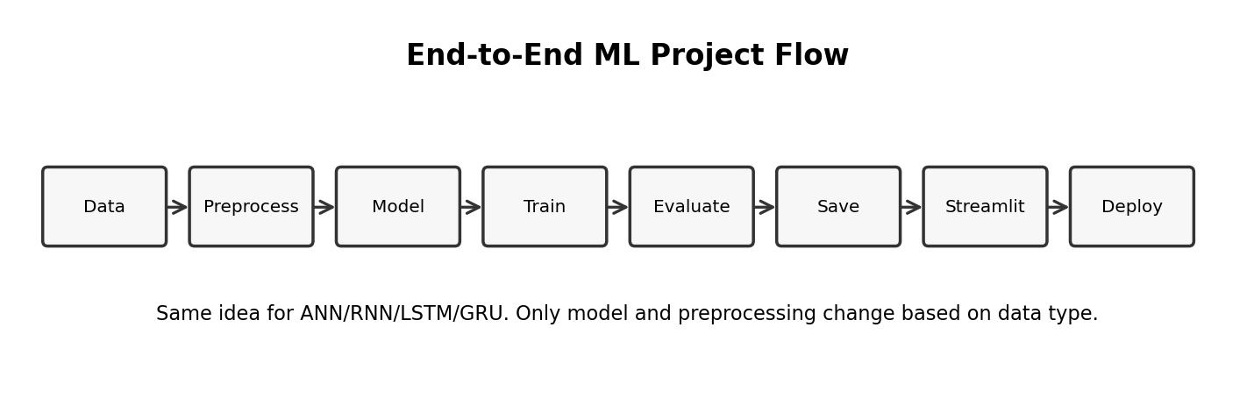
How to use this document: Read in order. First understand why NLP needs numbers, then learn ANN, then RNN, then LSTM and GRU. Practical lessons are explained as project steps.

Table of Contents
- 1. Big picture of NLP in Deep Learning
- 2. ANN basics and ANN vs RNN
- 3. RNN forward propagation through time
- 4. Simple RNN backpropagation through time
- 5. Problems with Simple RNN
- 6. ANN practical project: classification, regression, Streamlit and deployment
- 7. Embedding layers and IMDB dataset
- 8. Simple RNN with embedding layers
- 9. Why LSTM and LSTM architecture
- 10. LSTM gates: forget, input, candidate memory, output
- 11. LSTM training and variants
- 12. GRU intuition and implementation
- 13. End-to-end project checklists
- 14. Revision notes and interview answers

1. Introduction to NLP in Deep Learning
NLP means Natural Language Processing. It is the area where we teach machines to understand human language like English, Hindi, reviews, chat messages, emails, documents, and questions.
- Computer cannot directly understand words. It understands only numbers.
- So first we convert text into numbers using tokenization, padding, one-hot encoding, TF-IDF, or embeddings.
- After conversion, a deep learning model can learn patterns from text.
- In modern LLMs, the basic idea is still the same: text is converted into tokens and vectors before training.
Simple example: Sentence: “movie is good”. First we split into words/tokens. Then each word becomes a number or vector. Then model learns that “good” usually gives positive sentiment.

Term | Simple meaning | Example
Corpus | Full text data collection | All customer reviews
Document | One text record | One review
Token | Small piece of text | word, subword, or character
Vocabulary | All unique tokens known to model | movie, good, bad, acting
Sequence | Ordered list of tokens | I love this movie
Embedding | Dense numeric vector for token | movie -> [0.21, -0.08, ...]

2. ANN vs RNN
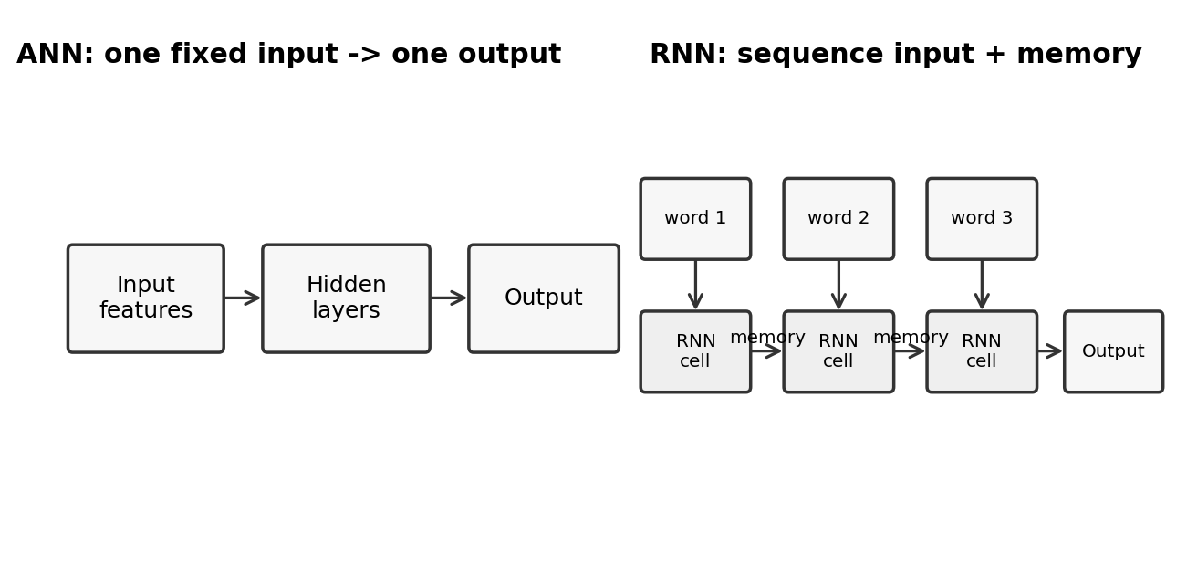
ANN means Artificial Neural Network. RNN means Recurrent Neural Network. Both are neural networks, but they are used for different types of data.
Point | ANN | RNN
Best for | Fixed independent data | Sequence data
Memory | No memory of previous input | Uses previous hidden state as memory
Input example | Age, salary, balance | Words in sentence, stock price by date
Order matters? | Usually no | Yes, order is very important
Use cases | Classification, regression | Text, speech, time-series

Interview answer: ANN is good when each input row is independent. RNN is good when previous values matter. For example, in text, meaning depends on previous words, so RNN keeps a hidden state as memory.

3. RNN Forward Propagation With Time
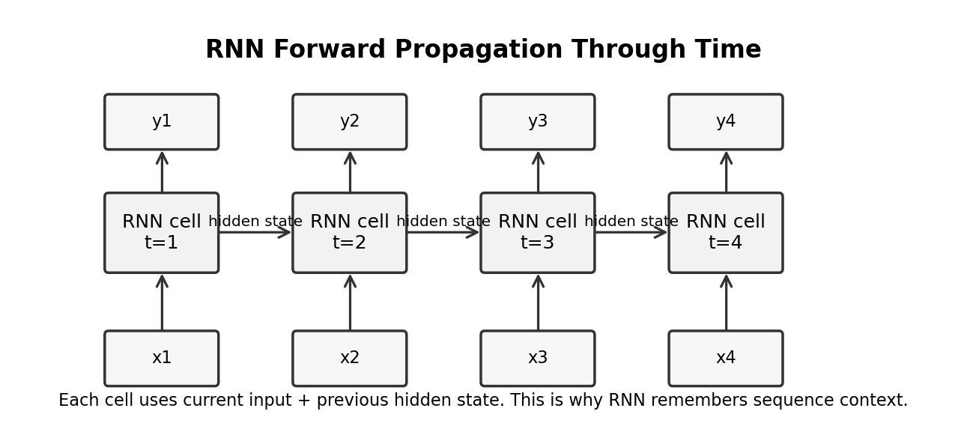
Forward propagation means data moves from input to output. In RNN, data moves step by step through time. At each time step, the cell receives current input and previous hidden state.
h_t = activation(Wx * x_t + Wh * h_(t-1) + b)
y_t = activation(Wy * h_t + by)
- x_t means current input at time t.
- h_(t-1) means previous memory.
- h_t means new memory after reading current input.
- y_t means output at that time step or final output.
Simple understanding: For sentence “I love this movie”, RNN reads “I”, then “love”, then “this”, then “movie”. At each word, it carries some memory from previous words.

4. Simple RNN Backward Propagation
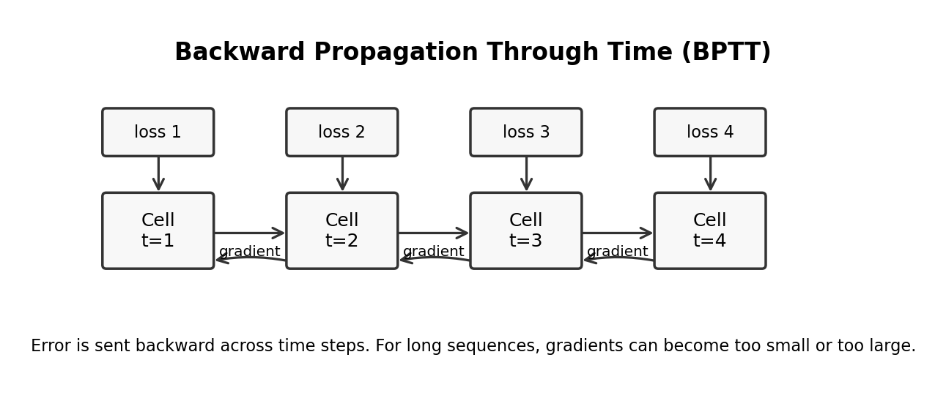
Backward propagation means model learns from error. In RNN, error is sent backward not only through layers, but also through time steps. This is called Backpropagation Through Time, or BPTT.
- First model predicts output.
- Loss function calculates error.
- Gradient is calculated from final step backward to previous steps.
- Weights are updated using optimizer like SGD or Adam.
- Because same RNN cell weights are reused, gradients from multiple time steps affect the same weights.
Key problem: When sequence is long, the gradient must travel through many time steps. It can become very small or very large. This creates vanishing or exploding gradient problem.

5. Problems With Simple RNN
Problem | Meaning | Effect | Common fix
Vanishing gradient | Gradient becomes very small | Model forgets long-term dependency | Use LSTM/GRU, better initialization
Exploding gradient | Gradient becomes very large | Training becomes unstable | Gradient clipping
Slow training | Sequential processing is hard to parallelize | Training takes time | Use better architectures/GPU
Short memory | Simple RNN remembers recent context better than old context | Poor on long text | Use LSTM/GRU/Transformers

Example: In “I grew up in India... I speak Hindi”, the word “India” appears far before “Hindi”. Simple RNN may forget this relation. LSTM is designed to remember important information for longer time.

6. ANN Practical Project: Classification
In lessons 67 to 72, the idea is to build a full ANN classification project, train it, predict from it, integrate it with Streamlit, and deploy it.

Lesson topic | What it means | What you should understand
Problem statement | Define what to predict | Example: customer churn yes/no
VS Code setup | Create project folder and files | Keep model training and app code separate
Feature transformation | Convert raw columns into model-ready numbers | Scaling, encoding, train-test split
Training with optimizer/loss | Model learns by reducing error | Adam optimizer, binary/categorical crossentropy
Prediction | Use saved model on new input | Apply same preprocessing before prediction
Streamlit app | Create simple web UI | User enters input, app shows prediction
Deployment | Host app online | Upload app, model, and requirements file

6.1 Feature Transformation Using Sklearn With ANN
Feature transformation means converting raw data into clean numeric format. Neural networks need numbers in a similar scale.
- Encode categorical columns like Geography or Gender using OneHotEncoder or LabelEncoder.
- Scale numeric columns like Age, Salary, Balance using StandardScaler.
- Split data into train and test set.
- Save the fitted scaler/encoder because same transformation is required during prediction.
from sklearn.preprocessing import StandardScaler
scaler = StandardScaler()
X_train_scaled = scaler.fit_transform(X_train)
X_test_scaled = scaler.transform(X_test)
Common mistake: Do not fit scaler on test data or user input. Fit only on training data, then use transform for test and future prediction.

6.2 Step-by-Step ANN Training With Optimizer and Loss
- Create model layers: input layer, hidden layers, output layer.
- Choose activation: ReLU for hidden layers, sigmoid/softmax/linear for output based on problem.
- Choose loss function: binary_crossentropy for yes/no, categorical_crossentropy for multi-class, mse/mae for regression.
- Choose optimizer: Adam is commonly used.
- Train using model.fit and check validation loss/accuracy.
model = Sequential()
model.add(Dense(64, activation="relu", input_shape=(X_train.shape[1],)))
model.add(Dense(32, activation="relu"))
model.add(Dense(1, activation="sigmoid"))
model.compile(optimizer="adam", loss="binary_crossentropy", metrics=["accuracy"])
model.fit(X_train_scaled, y_train, validation_split=0.2, epochs=50)

6.3 Prediction With Trained ANN Model
Prediction means using the trained model on new unseen data. The most important rule is: apply the same preprocessing used during training.
new_data_scaled = scaler.transform(new_data)
probability = model.predict(new_data_scaled)
prediction = probability > 0.5

6.4 Integrating ANN Model With Streamlit
Streamlit is used to make a simple web app quickly. You load model and preprocessing objects, create input controls, and show prediction result.
import streamlit as st
import pickle
from tensorflow.keras.models import load_model
model = load_model("model.h5")
scaler = pickle.load(open("scaler.pkl", "rb"))
age = st.number_input("Age")
salary = st.number_input("Salary")
if st.button("Predict"):
data = [[age, salary]]
data_scaled = scaler.transform(data)
result = model.predict(data_scaled)
st.write("Prediction:", result)
Deployment checklist: Keep app.py, trained model file, scaler/encoder pickle files, and requirements.txt in the same project repository. Then deploy to Streamlit Community Cloud or another platform.

7. ANN Regression Practical Implementation
Classification predicts a category, like yes/no. Regression predicts a continuous number, like price, salary, rating, or demand.
Point | Classification ANN | Regression ANN
Output | Class or probability | Numeric value
Final activation | Sigmoid or softmax | Linear/no activation
Loss | Binary/categorical crossentropy | MSE, MAE, RMSE
Metric | Accuracy, precision, recall | MAE, MSE, R2 score

model.add(Dense(1)) # linear output for regression
model.compile(optimizer="adam", loss="mse", metrics=["mae"])

8. Finding Optimal Hidden Layers and Hidden Neurons
There is no fixed perfect number of hidden layers or neurons. We try different combinations and select the model that performs best on validation data.
- Start simple. Example: one or two hidden layers.
- Increase neurons if model is underfitting.
- Use dropout/regularization if model is overfitting.
- Use validation loss to compare models.
- Use tools like KerasTuner for systematic search.
Symptom | Meaning | Possible action
Training loss high and validation loss high | Underfitting | Increase model capacity, train more, better features
Training loss low and validation loss high | Overfitting | Dropout, regularization, early stopping, more data
Validation loss stable and good | Good fit | Save model and test on unseen data

9. Getting Started With Embedding Layers
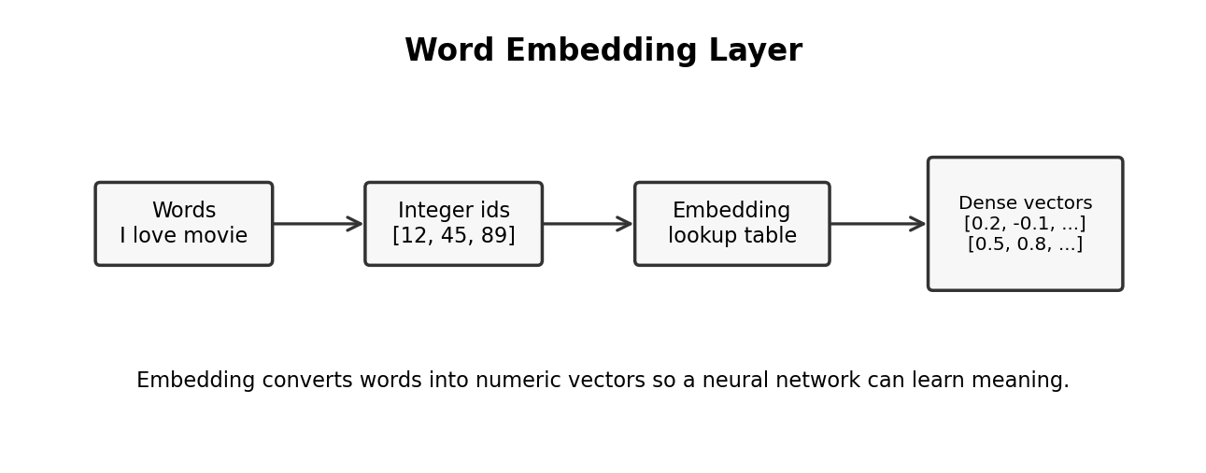
Embedding layer converts word IDs into dense vectors. This is better than simple one-hot encoding because embeddings can learn meaning and relationships between words.
Concept | Simple meaning
Tokenization | Convert sentence into list of words/subwords
Integer encoding | Give each token a numeric ID
Padding | Make all sequences same length
Embedding dimension | Size of vector for each word, like 50 or 100
Embedding matrix | Table where each word ID maps to one vector

model = Sequential()
model.add(Embedding(input_dim=10000, output_dim=64, input_length=200))

10. Implementing Word Embedding With Keras TensorFlow
In Keras, Embedding layer is usually the first layer for text models. It receives integer sequences and returns vector sequences.
from tensorflow.keras.layers import Embedding
embedding = Embedding(input_dim=vocab_size, output_dim=embedding_dim, input_length=max_len)
Remember: Embedding layer does not receive raw text. It receives integer encoded and padded sequences.

11. Loading IMDB Dataset and Feature Engineering
IMDB dataset is commonly used for sentiment classification. Each review is already converted into integer word IDs. Target is usually 1 for positive and 0 for negative.
- Load dataset with limited vocabulary size, like top 10,000 words.
- Pad all reviews to same length.
- Build model using Embedding + RNN/LSTM/GRU.
- Train model to classify review as positive or negative.
from tensorflow.keras.datasets import imdb
from tensorflow.keras.preprocessing.sequence import pad_sequences
(X_train, y_train), (X_test, y_test) = imdb.load_data(num_words=10000)
X_train = pad_sequences(X_train, maxlen=200)
X_test = pad_sequences(X_test, maxlen=200)

12. Training Simple RNN With Embedding Layers
For text classification, the typical flow is: Embedding layer -> SimpleRNN layer -> Dense output layer.
model = Sequential()
model.add(Embedding(input_dim=10000, output_dim=64, input_length=200))
model.add(SimpleRNN(64))
model.add(Dense(1, activation="sigmoid"))
model.compile(optimizer="adam", loss="binary_crossentropy", metrics=["accuracy"])
Limitation: Simple RNN works for small/simple sequences, but for long reviews it can forget older words. That is why LSTM and GRU are important.

13. Prediction From Trained Simple RNN
- Take user review text.
- Convert to sequence using same tokenizer.
- Pad sequence to same max length.
- Call model.predict.
- Convert probability into positive/negative label.
sequence = tokenizer.texts_to_sequences([review])
padded = pad_sequences(sequence, maxlen=200)
score = model.predict(padded)[0][0]
label = "Positive" if score >= 0.5 else "Negative"

14. End-to-End Streamlit App With RNN
RNN Streamlit app is similar to ANN app, but input is text. You must load tokenizer and model, then apply same text preprocessing before prediction.
review = st.text_area("Enter movie review")
if st.button("Predict Sentiment"):
seq = tokenizer.texts_to_sequences([review])
padded = pad_sequences(seq, maxlen=200)
prob = model.predict(padded)[0][0]
st.write("Positive" if prob >= 0.5 else "Negative")

15. Why LSTM RNN?
LSTM means Long Short-Term Memory. It is a special type of RNN designed to solve the short memory problem of Simple RNN.
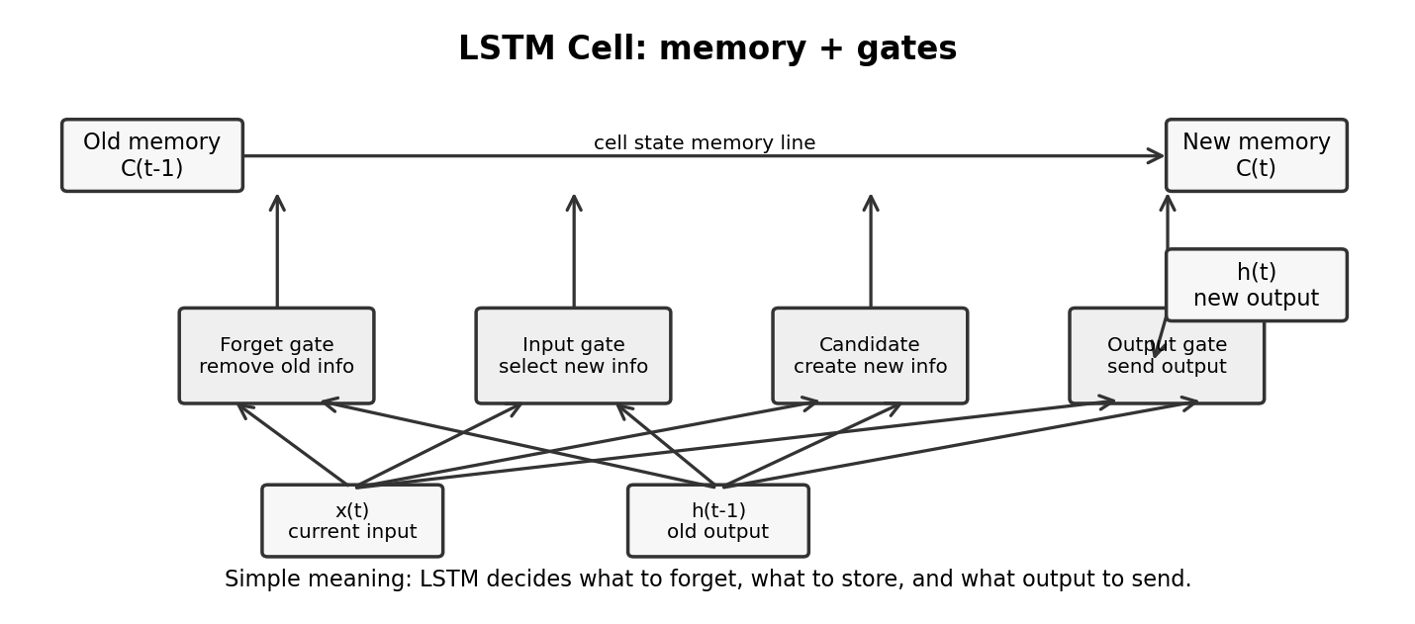
- Simple RNN struggles with long-term dependency.
- LSTM has a cell state, which works like a memory highway.
- LSTM uses gates to control information flow.
- It can decide what to forget, what to add, and what to output.
Interview answer: LSTM is used when sequence has long-term dependency. It solves vanishing gradient problem better than Simple RNN by using gates and cell state.

16. LSTM RNN Architecture
An LSTM cell has two main states: hidden state and cell state. Hidden state is short-term output. Cell state is long-term memory.
Part | Meaning
Cell state C(t) | Long-term memory line
Hidden state h(t) | Output/current short memory
Forget gate | Decides what old memory to remove
Input gate | Decides what new information to store
Candidate memory | Possible new memory content
Output gate | Decides what to send as hidden state

17. Forget Gate in LSTM
Forget gate decides which information from previous cell state should be removed. It gives values between 0 and 1.
- 0 means forget completely.
- 1 means keep completely.
- Values between 0 and 1 mean keep partially.
f_t = sigmoid(W_f * [h_(t-1), x_t] + b_f)
Simple example: In text, when topic changes, forget gate may remove old topic information from memory.

18. Input Gate and Candidate Memory
Input gate decides what new information should be added to memory. Candidate memory creates new possible content.
i_t = sigmoid(W_i * [h_(t-1), x_t] + b_i)
C_candidate = tanh(W_c * [h_(t-1), x_t] + b_c)
C_t = f_t * C_(t-1) + i_t * C_candidate
Simple meaning: Forget gate removes useless old memory. Input gate adds useful new memory. Together they update the cell state.

19. Output Gate in LSTM
Output gate decides what part of updated memory should become output/hidden state.
o_t = sigmoid(W_o * [h_(t-1), x_t] + b_o)
h_t = o_t * tanh(C_t)
Simple meaning: Cell state may store many things, but hidden state sends only required information to next step/output.

20. Training Process in LSTM RNN
Training LSTM is similar to training RNN. Forward pass calculates predictions. Loss calculates error. Backward pass updates weights using optimizer.
- Prepare sequences and labels.
- Pass sequences through Embedding and LSTM layers.
- Calculate loss.
- Backpropagate through time.
- Update LSTM gate weights.
- Repeat for many epochs.
model = Sequential()
model.add(Embedding(10000, 64, input_length=200))
model.add(LSTM(64))
model.add(Dense(1, activation="sigmoid"))
model.compile(optimizer="adam", loss="binary_crossentropy", metrics=["accuracy"])

21. Variants of LSTM RNN
Variant | Simple explanation | Use case
Stacked LSTM | Multiple LSTM layers | Complex sequence patterns
Bidirectional LSTM | Reads sequence forward and backward | Text classification, NLP tasks
Peephole LSTM | Gates also see cell state | Some time-series tasks
Encoder-Decoder LSTM | One LSTM encodes, another decodes | Translation, sequence generation

model.add(Bidirectional(LSTM(64)))

22. GRU RNN In-Depth Intuition
GRU means Gated Recurrent Unit. It is another RNN variant similar to LSTM, but simpler and usually faster.
Point | LSTM | GRU
Gates | Forget, input, output | Update, reset
States | Cell state + hidden state | Only hidden state
Complexity | More parameters | Fewer parameters
Training speed | May be slower | Often faster
Performance | Very strong for long sequences | Often similar to LSTM

Simple answer: Use LSTM when long memory and accuracy are important. Use GRU when you want simpler and faster model with similar performance.

model = Sequential()
model.add(Embedding(10000, 64, input_length=200))
model.add(GRU(64))
model.add(Dense(1, activation="sigmoid"))

23. LSTM Practical Project: Data Collection to Streamlit App
Lesson | Main activity | What to focus on
Problem statement | Define what to predict | Input, output, success metric
Data collection and preprocessing | Clean and prepare text/time-series | Tokenization, padding, train-test split
LSTM model training | Train Embedding + LSTM model | Validation accuracy/loss
Prediction from model | Use same preprocessing | Tokenizer + padding + model.predict
Streamlit integration | Create simple UI | Load model/tokenizer and show result
GRU implementation | Replace LSTM with GRU | Compare speed and accuracy

24. End-to-End Checklist for Any ANN/RNN/LSTM/GRU Project
- Understand problem: classification, regression, or sequence prediction.
- Collect and clean data.
- Split into train/validation/test.
- Apply correct preprocessing.
- Build baseline model first.
- Train with proper loss and optimizer.
- Check overfitting/underfitting.
- Save model and preprocessing objects.
- Build prediction pipeline.
- Create Streamlit app.
- Deploy and test with real examples.
Important production rule: Model file alone is not enough. You must also save tokenizer, scaler, encoder, max sequence length, and label mapping. Without same preprocessing, predictions can be wrong.

25. Quick Revision Notes
Topic | One-line memory
NLP | Make human text understandable to machines.
Tokenization | Split text into smaller units.
Embedding | Convert token IDs into dense meaning vectors.
ANN | Good for fixed independent data.
RNN | Good for sequence data because it has memory.
BPTT | Backpropagation applied across time steps.
Vanishing gradient | Gradient becomes too small, model forgets long history.
LSTM | RNN variant with gates and cell state for long memory.
GRU | Simpler gated RNN, often faster than LSTM.
Streamlit | Quick Python framework to build ML web app.

26. Interview-Style Answers

What is NLP in deep learning?
NLP is used to make machines understand human language. In deep learning, we convert text into numbers using tokenization and embeddings, then train models like RNN, LSTM, GRU, or Transformers.

What is the difference between ANN and RNN?
ANN works on fixed independent data and does not remember previous input. RNN is used for sequence data and uses hidden state to remember previous steps.

Why do we need RNN for text?
Text has order. Meaning of a word depends on previous words. RNN reads words step by step and keeps context using hidden state.

What is BPTT?
BPTT means Backpropagation Through Time. It is the training method for RNN where error is sent backward across all time steps.

What is vanishing gradient?
Vanishing gradient happens when gradients become very small while going backward through many time steps. Because of this, simple RNN cannot learn long-term dependency properly.

Why LSTM is better than Simple RNN?
LSTM has gates and cell state, so it can keep useful information for longer time and forget unnecessary information. It handles long-term dependency better.

What are LSTM gates?
LSTM mainly has forget gate, input gate, candidate memory, and output gate. These gates control what to remove, what to add, and what to output.

What is GRU?
GRU is a simpler gated RNN. It has update and reset gates and usually trains faster than LSTM with similar performance in many cases.

What is embedding layer?
Embedding layer converts word IDs into dense vectors. These vectors help model learn meaning and relationship between words.

What should be saved with trained model?
We should save the model plus preprocessing objects like scaler, encoder, tokenizer, max length, and label mapping. Same preprocessing is needed during prediction.

27. Suggested Learning Order
- First revise NLP basics: tokenization, vocabulary, padding, embedding.
- Then understand ANN basics: layers, activation, optimizer, loss.
- Then learn RNN forward pass and why hidden state acts like memory.
- Then learn BPTT and problems of Simple RNN.
- Then learn LSTM gates using simple examples.
- Then learn GRU as a simplified LSTM.
- Finally implement one project end-to-end and deploy with Streamlit.

