Seq2Seq, Attention and Transformer Architecture
Simple Study Guide
Based on course lessons 97 to 113 - explained in simple Indian English
Goal: understand Encoder-Decoder, Attention, Transformer Encoder, Decoder, Self-Attention, Multi-Head Attention, Positional Encoding, Layer Normalization, Linear and Softmax.
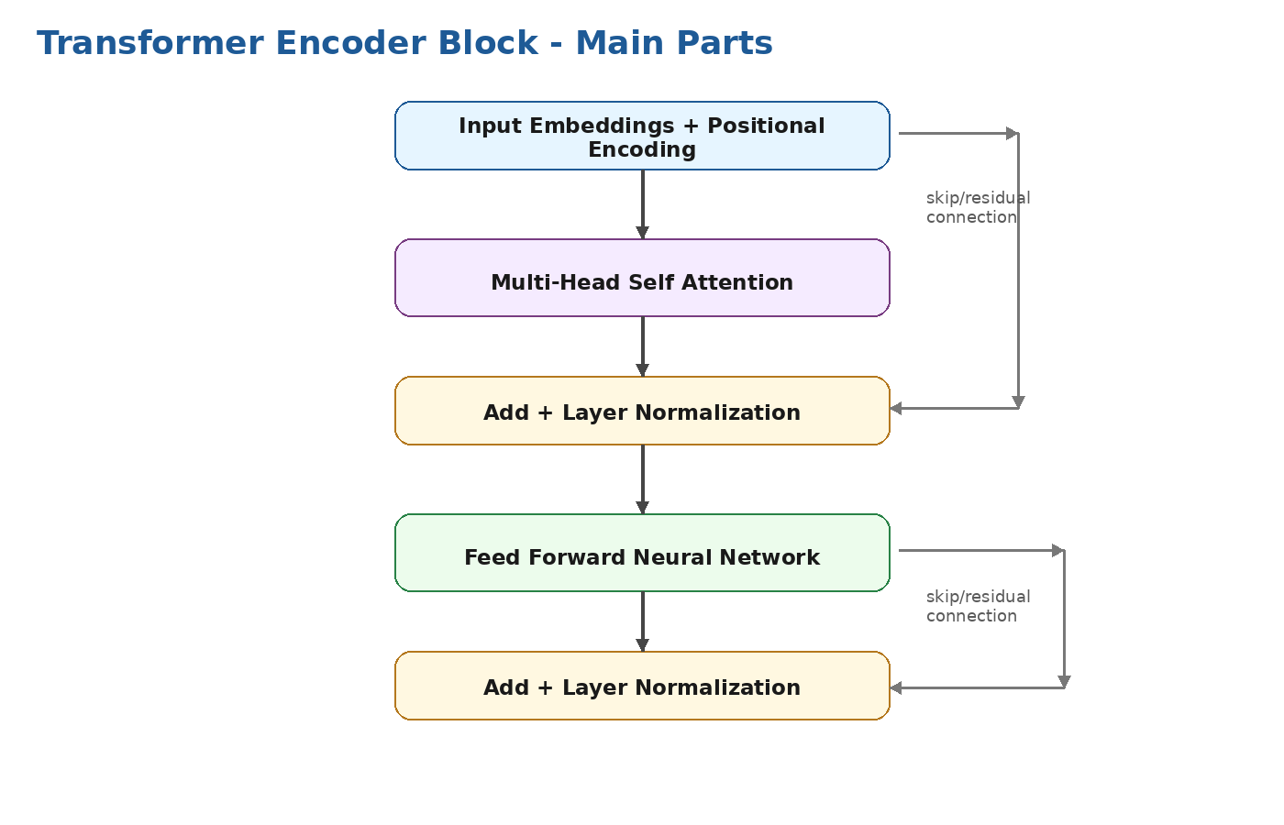

Table of Contents
- 1. How to study these lessons
- 2. Encoder-Decoder / Sequence to Sequence architecture
- 3. Problems with basic Encoder-Decoder
- 4. Attention mechanism intuition and architecture
- 5. Why Transformers are used
- 6. Transformer encoder basic architecture
- 7. Self-attention layer working
- 8. Multi-head attention
- 9. Feed Forward Neural Network in Transformer
- 10. Positional Encoding intuition
- 11. Layer Normalization and examples
- 12. Complete Transformer Encoder architecture
- 13. Transformer Decoder plan
- 14. Masked Multi-Head Attention
- 15. Encoder-Decoder Attention
- 16. Decoder Linear and Softmax layer
- 17. End-to-end flow and revision map
- 18. Interview answers and quick revision notes

1. How to study these lessons
These topics are the bridge between old RNN/LSTM models and modern LLMs like GPT-style models. Do not try to memorize formulas first. First understand the data flow: words become numbers, the model understands relation between words, then it predicts the next word or translated word.
Old idea | New idea | Why it matters
RNN reads words one by one | Transformer can look at all words together | Training is faster and context understanding is better
Encoder-Decoder uses one context vector | Attention uses many encoder states | Long sentences are handled better
One attention view | Multi-head attention uses many views | Model can learn grammar, meaning, position, relation together
No natural word order in attention | Positional encoding adds order information | The model knows token position in sentence

Simple roadmap
First learn Encoder-Decoder. Then learn why it fails. Then learn Attention. Then Transformer is basically Attention + Feed Forward + Positional Encoding + Layer Normalization + Residual connections.

2. Encoder-Decoder / Sequence to Sequence Architecture
Sequence to Sequence means input is a sequence and output is also a sequence. Example: English sentence to Hindi sentence, speech to text, chatbot reply, summarization, question answering.
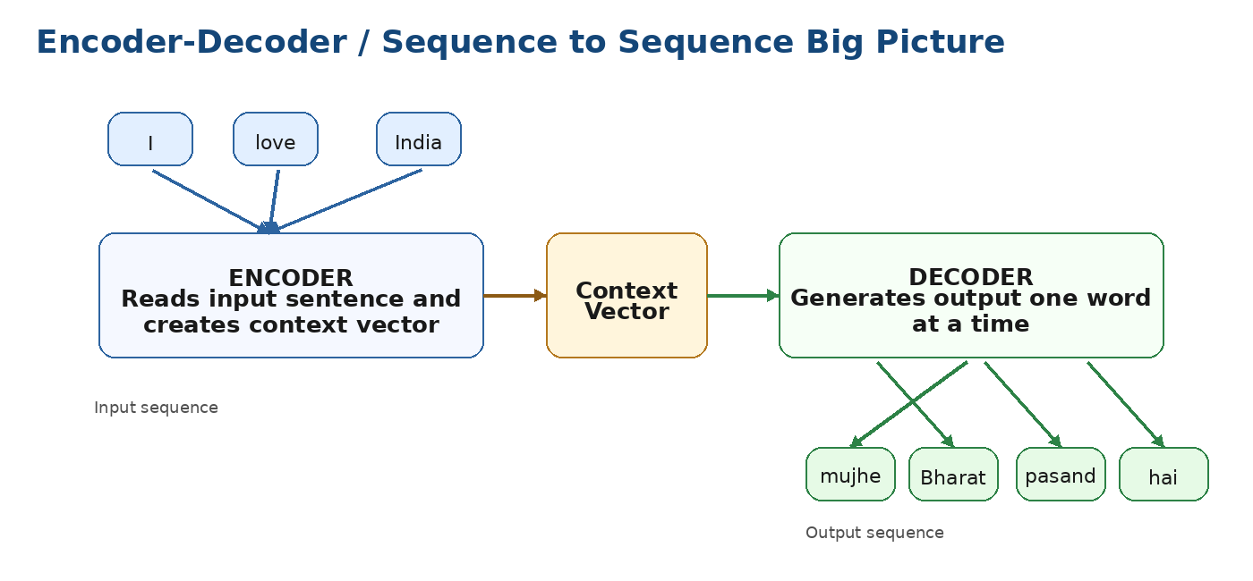

2.1 What is Encoder?
- Encoder reads the full input sentence token by token or as embeddings.
- It converts the input sentence into hidden representations.
- In older Seq2Seq RNN models, the final hidden state is called context vector.
- This context vector is like a summary of the input sentence.

2.2 What is Decoder?
- Decoder takes the context vector and starts generating output sequence.
- It predicts one token at a time.
- For translation, decoder generates words in target language.
- During training it often receives previous correct token; during prediction it uses its own previous output.
Term | Simple meaning | Example
Sequence | Ordered data | Words in a sentence
Encoder | Reads input and creates meaning | English sentence reader
Context vector | Compressed summary of input | One vector containing sentence meaning
Decoder | Generates output sequence | Hindi sentence generator
Teacher forcing | During training, provide correct previous word to decoder | Use correct word instead of model guess

Interview answer
Encoder-Decoder architecture is used when input and output both are sequences. Encoder understands the input sequence and creates a context representation. Decoder uses this representation to generate output sequence step by step, like translation or summarization.

3. Problems With Basic Encoder and Decoder
The basic Encoder-Decoder architecture works, but it has important limitations. These limitations are the reason Attention was introduced.
Problem | Simple explanation | Impact
Fixed-size context vector | Entire input sentence is compressed into one vector | Long sentence information can be lost
Long-range dependency issue | Important word at the start may be forgotten by the end | Bad translation for long sentences
RNN sequential processing | Words are processed one after another | Training is slow, hard to parallelize
Same context for every decoder step | Decoder sees only one summary for all output words | It cannot focus on different input words for different output words
Vanishing gradient | Earlier information gets weak during training | Model struggles with long context

Easy example
For translating a long paragraph, one small context vector is like asking a person to remember a full paragraph in one small note. Some details will be missed.

4. Attention Mechanism Intuition and Architecture
Attention solves the fixed context problem. Instead of using only one final context vector, the decoder can look at all encoder hidden states and decide which input word is important for the current output word.
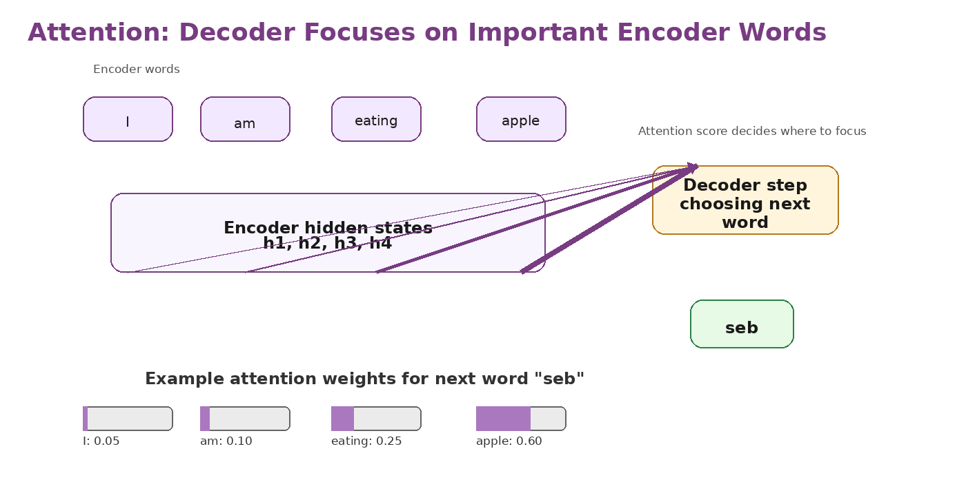
Attention step | What happens | Simple example
Score | Compare decoder current state with each encoder state | Which English word is useful now?
Softmax | Convert scores into probabilities | Important words get higher weight
Context vector | Weighted sum of encoder hidden states | Focused meaning for current output word
Predict word | Use focused context to generate next token | Generate correct translated word

4.1 Why Attention is powerful
- Decoder can focus on different input words at different output steps.
- Long sentences become easier than one-vector Seq2Seq.
- Attention weights also give some explainability: we can see which words model focused on.
- Attention is the base idea behind Transformers and modern LLMs.
Interview answer
Attention mechanism allows the decoder to dynamically focus on important encoder hidden states while generating each output token. It solves the bottleneck of fixed context vector and improves performance on long sequences.

5. What and Why To Use Transformers
Transformer is an architecture that uses attention heavily and removes recurrence. It does not read words strictly one by one like RNN. It can process tokens in parallel during training, so it is faster and handles long context better.
RNN/LSTM | Transformer
Sequential processing | Parallel processing during training
Hard to train on very long sequences | Better long-context handling with attention
Uses hidden state memory | Uses self-attention to connect tokens
Slower for large datasets | Scales better for large data and GPUs
Good for sequence tasks but older style | Foundation of BERT, GPT, T5 and modern LLMs

Simple line
Transformer means: every word can directly look at other words using attention, and this is repeated through many layers to learn deeper meaning.

6. Understanding the Basic Architecture of Transformer Encoder
Transformer encoder takes input tokens and creates rich contextual embeddings. Each token output contains information from other related tokens in the sentence.

Part | Role in simple words
Input Embedding | Converts token ID into vector
Positional Encoding | Adds word order information
Multi-Head Self Attention | Each token looks at other tokens
Add and Norm | Keeps training stable and preserves original input through residual connection
Feed Forward Network | Applies deeper transformation to each token
Stacking layers | Repeats this process many times for better understanding

7. Self Attention Layer Working
Self-attention means attention inside the same sentence. Each token checks how much it should focus on other tokens in the same input.
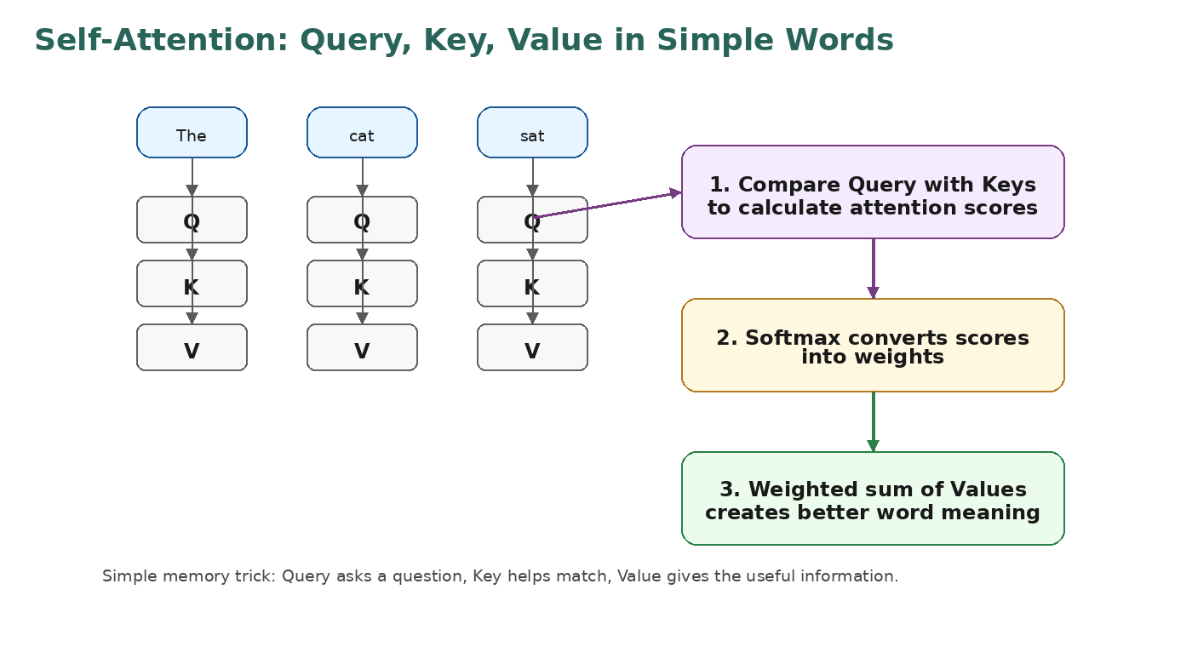

7.1 Query, Key, Value intuition
Term | Simple meaning | Memory trick
Query (Q) | What this token is looking for | Question
Key (K) | What each token offers for matching | Index / label
Value (V) | Actual information taken from token | Answer / content

7.2 Self-attention formula intuition
The common formula is: Attention(Q, K, V) = softmax(QK^T / sqrt(dk)) V
- QK^T calculates similarity between queries and keys.
- Divide by sqrt(dk) keeps values controlled and training stable.
- Softmax converts similarity scores into weights.
- Multiply by V creates final weighted information.
Simple pseudo flow:
1. Create Q, K, V vectors from embeddings
2. score = Q dot K
3. weights = softmax(score)
4. output = weights multiplied by V
Important
Self-attention does not automatically know word order. That is why positional encoding is added before attention.

8. Multi Head Attention
One attention head gives one way of looking at sentence relation. Multi-head attention creates multiple attention heads, so the model can learn different types of relationships at the same time.
Head can learn | Example
Grammar relation | Subject connected to verb
Meaning relation | Apple connected to fruit/eating
Position relation | Nearby words are strongly related
Long-distance relation | Pronoun connected to earlier noun
Task-specific relation | Question word connected to answer span

- Input is projected into Q, K, V for each head.
- Each head performs attention separately.
- All head outputs are concatenated.
- A final linear layer combines them into one output vector.
Interview answer
Multi-head attention runs multiple attention operations in parallel. Each head can capture different relationships in the sequence. Their outputs are concatenated and linearly transformed, which gives richer contextual representation.

9. Feed Forward Neural Network With Multi Head Attention
After attention mixes information between tokens, Feed Forward Network processes each token independently. It is like improving each token representation after it has collected context from other tokens.
Step | Purpose
Multi-head attention | Share information between tokens
Add + LayerNorm | Stable training and residual connection
Feed Forward Network | Apply non-linear transformation to each token
Add + LayerNorm again | Stability and preserve useful signal

Usually FFN has two linear layers with activation in between. The first layer expands dimension, activation adds non-linearity, second layer brings it back to model dimension.
FFN(x) = Linear2(Activation(Linear1(x)))
Common activation: ReLU or GELU

10. Positional Encoding Indepth Intuition
Attention can see all words together, but by itself it does not know which word came first, second, third, etc. Positional encoding adds position information into token embeddings.
Why needed? | Simple explanation
Order matters | "Dog bites man" and "Man bites dog" use same words but different meaning
Attention is permutation-friendly | Without position, shuffled words may look similar
Position is added to embedding | Token meaning + token position = better input representation
Sin/Cos patterns | Original Transformer used sine and cosine waves for unique positions

Simple formula idea
Final input to encoder = word embedding + positional encoding. Word embedding says what the word means. Positional encoding says where the word is placed.

embedding("cat") + position_encoding(position=2) = input vector for token "cat" at position 2

11. Layer Normalization
Layer normalization keeps the values inside neural network in a stable range. It normalizes features inside each token representation. This helps training become more stable and faster.
Concept | Simple explanation
Normalization | Bring values into controlled range
LayerNorm | Normalize across features of one sample/token
Why needed | Avoid unstable activations and gradients
Where used | After attention and after feed forward, normally with residual connection

11.1 Layer Normalization Example
Suppose token vector values are [10, 20, 30]. LayerNorm calculates mean and variance for that vector and scales values into a stable distribution. The exact math is less important in the beginning; remember the purpose: stable training.
Before LayerNorm | After LayerNorm idea
[10, 20, 30] | values centered and scaled
Very high/low activations | controlled activations
Training may become unstable | training becomes smoother

Interview answer
Layer normalization normalizes the features of each token representation. In Transformers it is used with residual connections after attention and feed forward layers to make training stable.

12. Complete Encoder Transformer Architecture
A complete encoder is made by stacking multiple encoder blocks. Each block has self-attention, feed forward network, layer normalization and residual connections. The final encoder output is a contextual representation for every input token.
- Input tokens are converted into embeddings.
- Positional encoding is added.
- Embeddings go through multiple encoder blocks.
- Each block updates token meaning using self-attention and FFN.
- Final output can be used for classification, translation, question answering, or passed to decoder.
Component | One-line role
Embedding | Convert token ID to vector
Positional Encoding | Add order information
Self Attention | Let tokens communicate
Multi Head | Learn multiple relation types
FFN | Improve token representation
Residual Connection | Preserve signal and help gradients
LayerNorm | Stabilize training

13. Decoder - Plan of Action
Transformer decoder generates output tokens one by one. It uses previous output tokens, applies masked self-attention, attends to encoder output, then predicts the next token using linear and softmax.
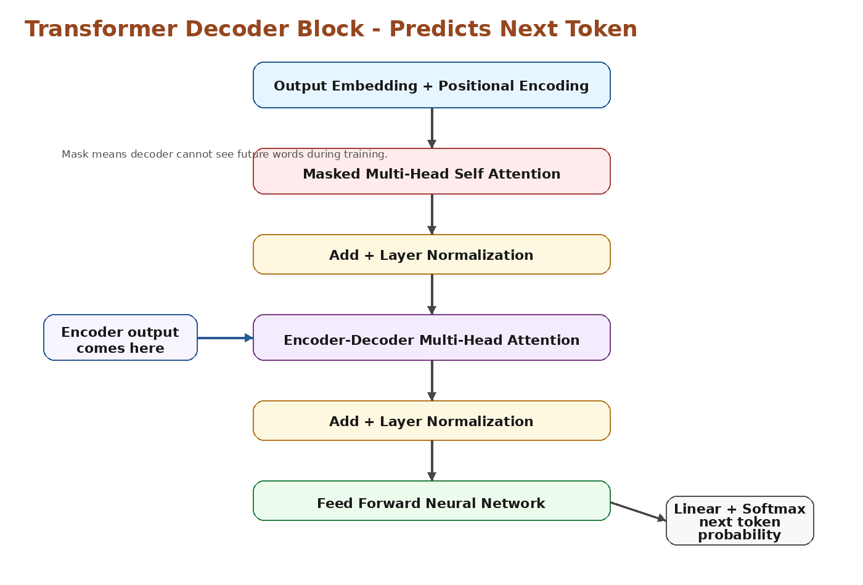
- Decoder receives already generated tokens or shifted target tokens during training.
- Masked self-attention prevents looking at future tokens.
- Encoder-decoder attention uses encoder output as knowledge source.
- FFN processes decoder representation.
- Linear and softmax convert final vector into probability over vocabulary.

14. Decoder - Masked Multi Head Attention
In normal self-attention, token can look at all tokens. But decoder predicts future words, so during training it should not cheat by looking at future target tokens. Masked attention hides future tokens.
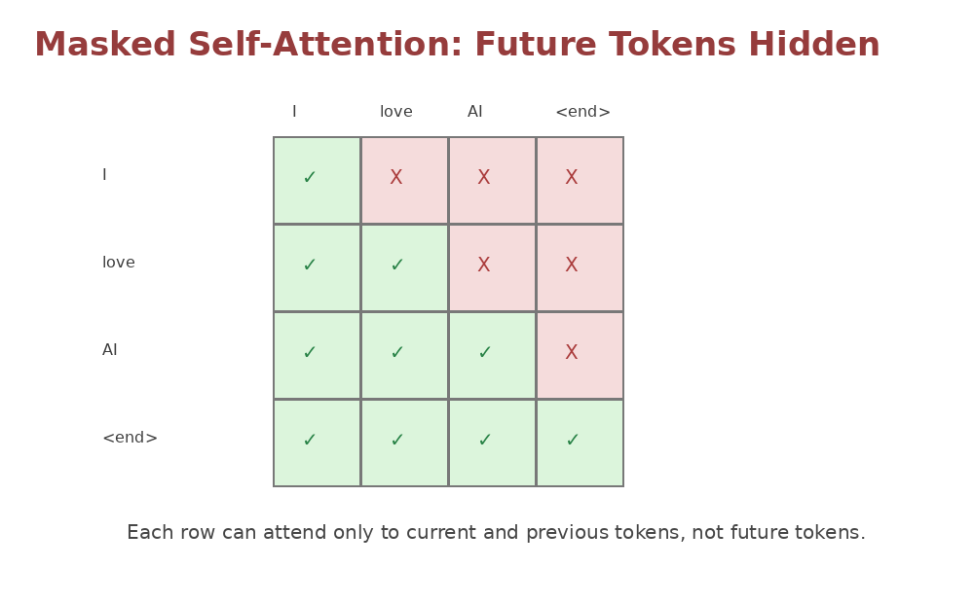
Without mask | With mask
Model can see future correct words | Model sees only previous/current words
Training becomes cheating | Training matches real prediction behavior
Not suitable for generation | Suitable for autoregressive generation

Simple example
When predicting word 3, decoder can look at word 1 and word 2, but not word 4 or word 5.

15. Encoder and Decoder Multi Head Attention
This layer connects decoder with encoder output. Decoder uses its current state as Query, while encoder output provides Key and Value. This helps decoder focus on relevant input tokens while generating output.
Q comes from | K comes from | V comes from | Meaning
Decoder previous layer | Encoder output | Encoder output | Decoder asks: which input tokens should I focus on now?

- In translation, this layer connects target language generation to source language meaning.
- It is different from self-attention because Query is from decoder and Key/Value are from encoder.
- It is also multi-head, so it can focus on multiple relations at once.
Interview answer
Encoder-decoder attention allows decoder to attend over encoder outputs. Decoder states act as queries, and encoder outputs act as keys and values. This helps generate target tokens based on relevant input tokens.

16. Decoder Final Linear and Softmax Layer
After decoder block, we get a vector for the next token. But vector is not a word. Final linear layer maps this vector to vocabulary size, and softmax converts scores into probabilities.
Layer | Purpose | Example
Decoder output vector | Rich meaning for next token | [0.2, -1.1, 0.8, ...]
Linear layer | Convert vector to vocabulary scores/logits | score for each word in vocabulary
Softmax | Convert logits into probabilities | apple: 0.65, mango: 0.12
Argmax / sampling | Choose next token | apple

logits = Linear(decoder_output)
probabilities = softmax(logits)
next_token = token with highest probability or sampled token
Remember
Training usually uses cross entropy loss between predicted probability and actual next token.

17. End-to-End Flow and Revision Map
Stage | What happens
Tokenization | Sentence is split into tokens and token IDs
Embedding | Token IDs become vectors
Positional Encoding | Position/order info is added
Encoder | Input sentence becomes contextual vectors
Decoder input | Previous output tokens are given to decoder
Masked self-attention | Decoder cannot see future tokens
Encoder-decoder attention | Decoder looks at encoder output
FFN + Norm | Representations are refined
Linear + Softmax | Next token probability is generated
Repeat | Generated token is fed back until end token

17.1 Full Transformer training intuition
- During training, target sentence is shifted right. Example decoder input: <start> I love; expected output: I love AI.
- Mask is applied so model predicts only using past target tokens.
- Loss is calculated for each predicted token.
- Backpropagation updates all weights: embeddings, attention, FFN, layer norm parameters, linear layer.

17.2 Prediction / inference intuition
- Start with <start> token.
- Decoder predicts next token.
- Add predicted token to decoder input.
- Repeat until <end> token or max length.
- Token IDs are converted back into words.

18. Interview Answers and Quick Revision Notes
What is Seq2Seq architecture?
- Seq2Seq is used when input and output both are sequences. Encoder reads the input sequence and decoder generates output sequence step by step, like translation or summarization.
What is the main problem with basic Encoder-Decoder?
- The main problem is fixed-size context vector. Long input sentence is compressed into one vector, so important details can be lost.
What is Attention mechanism?
- Attention allows decoder to focus on important encoder hidden states while generating each token. It solves the fixed context bottleneck.
Why are Transformers better than RNN for many NLP tasks?
- Transformers use self-attention and can process tokens in parallel during training. They handle long-range relations better and scale well on large datasets.
What is Self-Attention?
- Self-attention lets each token look at other tokens in the same sentence and create a context-aware representation.
What are Q, K and V?
- Query means what a token is looking for, Key is used for matching, and Value contains the actual information used in the final output.
Why Multi-Head Attention?
- Multiple heads learn different relations in parallel, like grammar, meaning, long-distance dependency and position-based relation.
Why Positional Encoding?
- Self-attention does not know word order by itself. Positional encoding adds position information to embeddings.
What is Layer Normalization?
- Layer normalization normalizes token features to keep training stable. It is used with residual connections in Transformer blocks.
What is Masked Self-Attention?
- Masked self-attention hides future tokens in decoder so the model cannot cheat while predicting next token.
What is Encoder-Decoder Attention?
- Decoder uses queries from decoder states and keys/values from encoder output to focus on relevant input tokens.
What is final Linear and Softmax layer?
- Linear layer converts decoder output vector into vocabulary logits, and softmax converts logits into probabilities for next token.
Final one-minute summary
Encoder-Decoder converts input sequence to output sequence. Basic version has context bottleneck. Attention allows focusing on important input parts. Transformer uses self-attention instead of recurrence. Encoder understands input. Decoder uses masked attention and encoder-decoder attention to generate output token by token. Linear + softmax gives next-token probability.

