**MCEME ROBOTHON PROJECT**

**1.               DETAILS OF TEAM MEMBERS**

|  |  |  |
| --- | --- | --- |
| NAME | ID | YEAR OF JOINING |
| AKSHAT JOHAR | 2020A3PS1793H | 2020 |
| ROHIT ARYAN | 2020AAPS0293H | 2020 |
| L SHIVA RUDRA | 2020A8PS1246H | 2020 |

**2.               DETAILS OF TEAM LEADER:**

a.  Name: Akshat Johar

b.  BITS ID: 2020A3PS1793H

c.  Department: EEE

d. Email ID: f20201793@hyderabad.bits-pilani.ac.in

e. Phone Number: 9896111979

**3. Professor Guide**: - Mrs. Ponnalagu R N

**4*.*              TITLE OF THE PROJECT**: **SPHERICAL SURVEILLANCE BOT**

**5.               PROBLEM STATEMENT/BACKGROUND OF THE PROBLEM:**

Among diverse types of robots, spherical robots have become increasingly attractive in the last decade. They are believed that it has several benefits.

* They have only a single contact point with the ground with minimal friction for locomotion. Therefore, they would be able to save energy for movement.
* The Spherical Structure makes it possible to move even in tightly constrained spaces.
* The spherical exoskeleton can protect the inner structure against external shocks or dust.

**6.             SCOPE OF THE PROJECT:**

The scope of the robot will be as under: -

* The rolling bot has an inherent dynamic balancing capability that will automatically orient itself in the right opposition when thrown by the user.
* Battery backup of a minimum of 90 minutes.
* It is equipped with a camera and microphone for AV recording during surveillance and providing a live feed to the user.
* The spherical body must be transparent to get a clear picture from the installed camera.
* Rugged, easy to operate, and man-packed.

**7.               OBJECTIVE OF THE PROJECT**:

The Surveillance bot should be able to do the following tasks:-

* The spherical bot would be able to traverse long paths while saving a lot of battery due to the minimal amount of friction on any type of surface.
* The user would control its movement. Hence, it would play a vital role in gathering information (both live and recorded camera feed) by going deep inside the enemy territory and unnoticed because of its minute structure.
* Further objectives are listed in the future prototypes section.

**8.                INNOVATION:**

The Spherical Bot has a lot of advantages when compared to the other surveillance bot like snake bot, etc., the reason primarily being because of its shape and size, it would be able to traverse from Point A to Point B in the shortest time possible, and with this, it would save a lot of energy which would be needed for long hours for surveillance.

As far as its Structure and Design are concerned, The bot would be powered by the Arduino Uno, connected with the 100 RPM DC geared motors for forward/backward translation. The user would control the bot’s motion with the help of two axis joystick.

For the surveillance part, an ESP32 WIFI module would be connected to the Arduino, which would provide the live camera feed on the laptop/mobile by accessing its IP address and port.

Further Innovation is mentioned under the future prototypes section.

**9.         METHODOLOGY:**

**A.   Components Used:**

* Arduino Uno R3
* ESP32 Wi-Fi Camera module
* NRF24L01 radio modules
* 100 RPM DC geared motor (BO motors)
* 2 Axis Joystick
* L298N motor driver
* Robot wheel for BO motor
* Transparent Ball

**B.   Detailed Procedure**

From the **Controlling Node**, the data from the dual-axis joystick is sent to the analog pins of the Arduino and is sent to the **Locomotion Unit**through NRF24L01 radio modules. The data received can be used to control the BO motors to run forward and backward. The Y data sent from the NRF module is processed by Slave 1 Arduino and sends appropriate data to the L298N motor driver, which runs the motors.

For **Video Feed Node**

We use the ESP32 CAM Wi-Fi module for the video transmission. We connect the ESP to the mobile hotspot and upload the live video feed code in it. Simultaneously we connect our laptop to the internet via the mobile hotspot. When code uploaded on ESP, its static IP is obtained on the serial monitor and through this IP we can access the Live Video Feed on our computer .

***Fig. 1- Controlling Node***

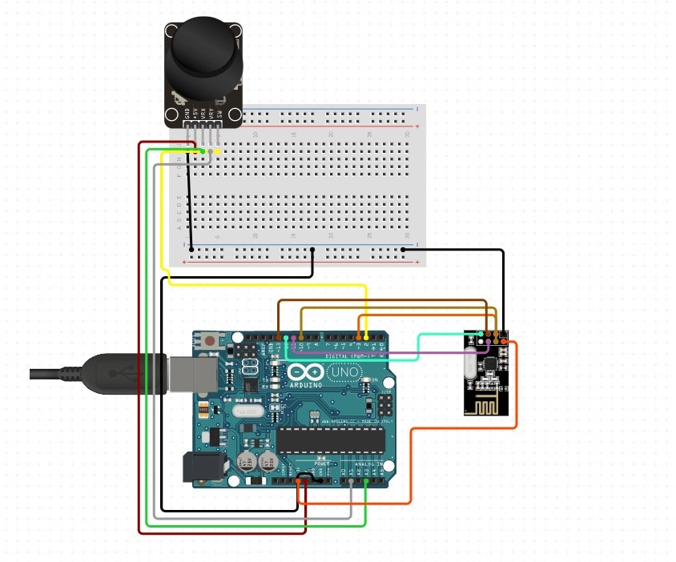

***Fig. 2- Locomotion unit* 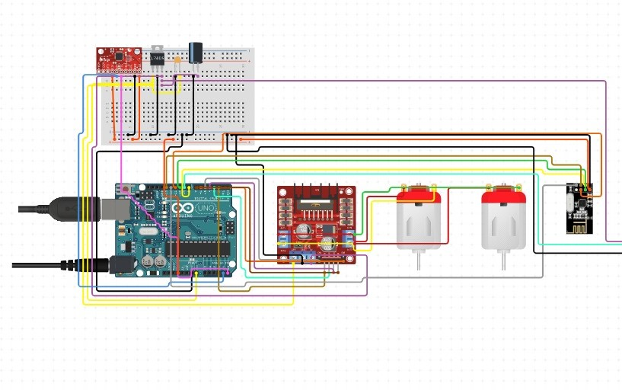**

***Fig.3 - Audio and Video Unit***

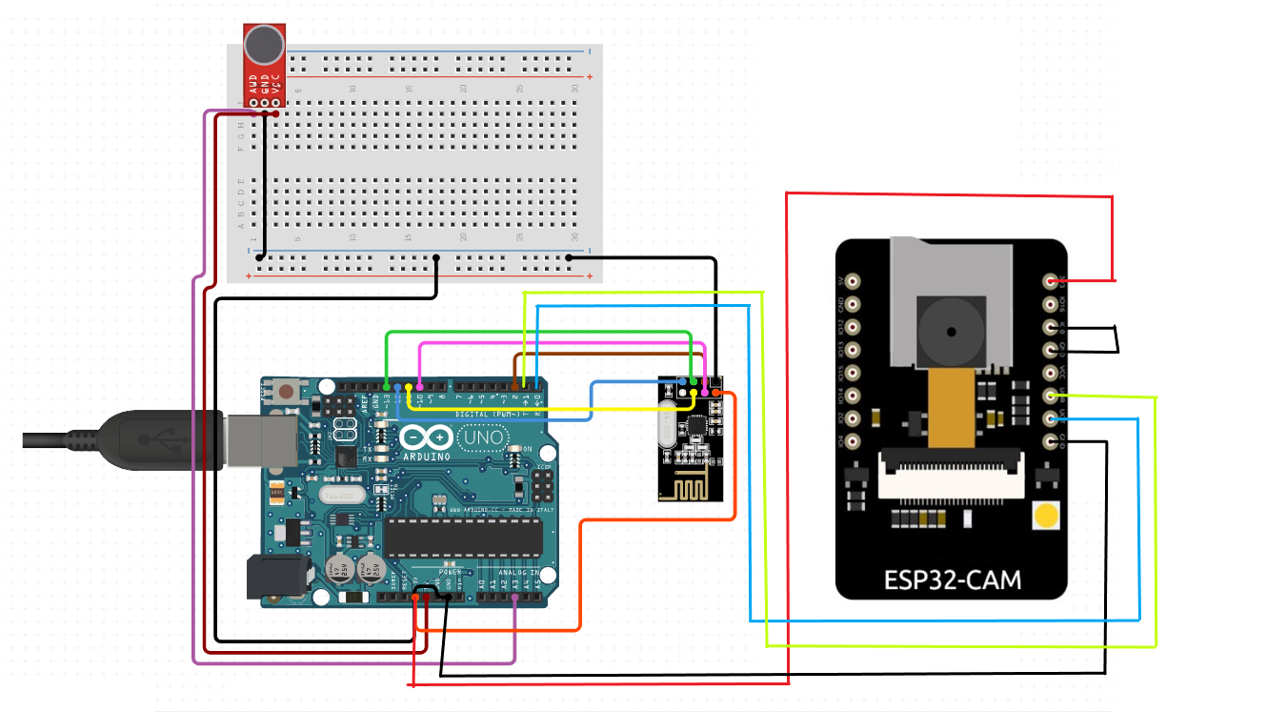

**C.   Risks Involved**

The bot might not withstand an unwanted external jerk, e.g., dropping it from a great height which could damage the outer surface of the bot and the components and the connections inside it since we are not using military-grade equipment.

As far as the surveillance part is considered, the bot can’t camouflage itself when it is not taking the input from outside. This is essential because gathering information from the enemy territory is quite challenging due to tight security.

***Conclusion:***

The modifications required to overcome these risks are mentioned under the future prototypes section.

**D.   Further Development / Future Prototypes**

A lot of modifications and developments can be taken into consideration: -

* The bot can be made even more rugged by using military-grade components to directly be inserted in the enemy territory from the high altitude to make its descent trajectory unnoticed.
* The bot’s stability can be increased by using an accelerometer which is quite beneficial when it is at standstill situation
* The bot’s outer surface can be camouflaged by using a network of microchannels inside its mold. These channels would carry colored fluid. The appropriate pre-selected fluid is pumped in to match the surface when the robot walks over a surface. The color of the surroundings is detected by using CV, which enables the bot to adjust the RGB values of the fluid accordingly and change its appearance. For example, suppose the bot is moving around in the daytime on open ground. In that case, it’s better to turn transparent, which can be achieved by using any red, green, and blue (from 0-255), setting the opacity factor(alpha) as ‘0’. And if the bot is on grass, the green color can be set higher than the red and the blue ones and adjust the opacity accordingly.
* The robot’s path can be mapped, which plays an essential in conducting military operations. For this, SLAM and ROS can be used.
* With the help of Computer Vision, the surveillance task can be upgraded by using image processing techniques for small target detection and tracking, automated and aided target recognition, etc.
* The Face Detection interface used can be upgraded by using Computer Vision and Machine Learning Data Model. Objects like faces, license plates, etc., can be detected/recognized in the best way possible.

    DURATION OF THE PROJECT: **2 months**

**TOTAL COST – 3500 Rs**