Aura Smart Headset V2 - Sample Customer Brochure & Product Guide
Intelligent Neural Noise Cancellation, Lossless Spatial Sound & All-Day Ergonomic Mastery

About this Document
This document is a speculative sample created exclusively for portfolio demonstration purposes to showcase accessible document creation. “Aura Smart Headset V2” and “Aura Audio Labs” are fictional concepts and do not represent a commercial product.

Product Image
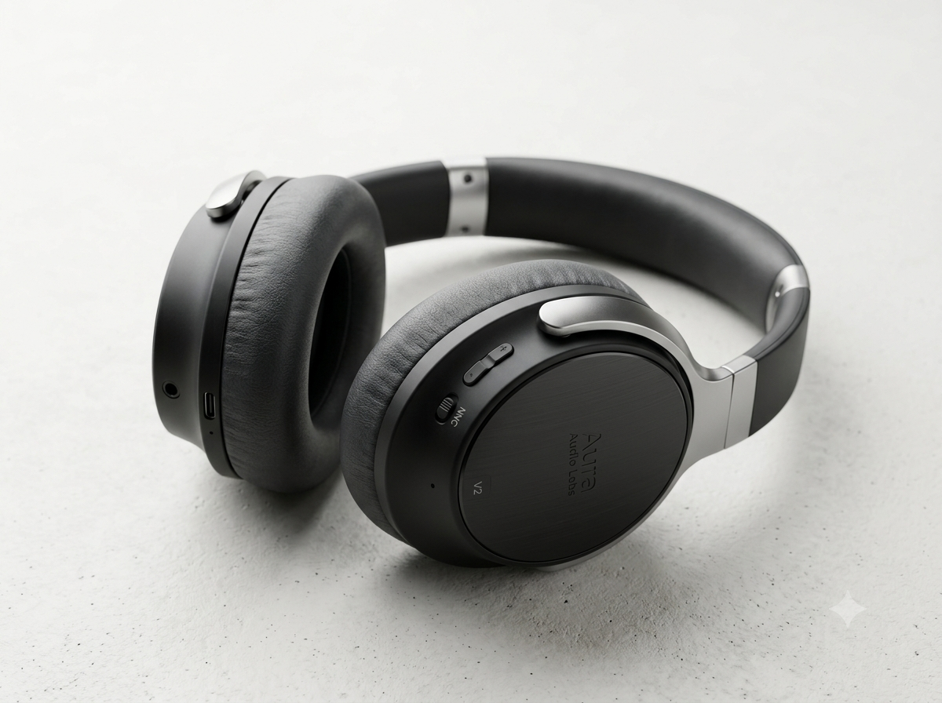
Figure 1: Aura Smart Headset V2 Sample Product Image. The image is created by Nano Banana 2.

WHY CHOOSE AURA SMART HEADSET V2?
Engineered for modern professionals, remote workers, and audiophiles, the Aura Smart Headset V2 combines adaptive Neural Noise Cancellation 3.0 with custom-tuned 40mm Beryllium acoustic drivers. Whether participating in high-stakes video conferences or immersing yourself in hi-res audio, Aura V2 delivers crystal-clear sound, 40-hour battery stamina, and multi-device connection switching.

1. Product Overview & Key Innovations
In today’s hybrid work and lifestyle environment, audio clarity is no longer a luxury—it is an essential tool.
The Aura Smart Headset V2 is built from the ground up to solve the three most common acoustic pain points: background noise distraction during virtual meetings, ear fatigue during extended wear, and constant battery anxiety.

1.1 Neural Noise Cancellation 3.0 (NNC)
Powered by an onboard dual-core AI DSP chip, Aura V2 continuously analyses environmental noise at 48,000 samples per second. NNC 3.0 adaptively cancels up to 42dB of ambient noise —from airplane engine hums to bustling coffee shop chatter —while sparing speech frequencies so you remain aware when colleagues speak directly to you.

1.2 Acoustic Excellence
Equipped with custom 40mm Beryllium-coated dynamic drivers, the Aura V2 produces tight, impactful bass, smooth mids, and crystalline highs up to 40kHz.

1.3 Smart Multi-Point Connectivity
Never miss an urgent call again. Bluetooth 5.4 multi-point technology enables seamless connection to your laptop and smartphone simultaneously. When a phone call arrives while you are listening to music on your computer, Aura V2 automatically switches audio sources without requiring manual pairing.

2. Technical Specifications
The complete technical specifications of the Aura Smart Headset V2 are outlined below:
Category | Technical Specification | Customer Benefit
Acoustic Drivers | 40mm Beryllium Dynamic Transducers | Ultra-low distortion and extended high-  frequency response.
Active Noise Cancellation | Hybrid Quad-Mic NNC 3.0 (up to -42dB) | Eliminates workplace background noise instantly.
Microphone Array | 6-Mic Beamforming with AI Noise Suppression | Crystal-clear voice pickup during calls in windy or noisy rooms.
Battery & Charging | 40 hrs (ANC On) / 60 hrs (ANC Off) / Fast USB-C | 10-minute quick charge delivers 4 hours of playback time.
Wireless & Range | Bluetooth 5.4 + 2.4GHz Low-Latency Dongle | 30-meter (100ft) range with sub-20ms audio latency for gaming/video.
Weight & Build | 235 grams / Memory Foam Ear Cushions | Featherlight comfort for all-day 8+ hour wear without head pressure.

3. Feature Comparison & Upgrade Guide
See how the Aura Smart Headset V2 outperforms its predecessor and competing market flagships:
Key Metric / Feature | Aura Headset V1 | Aura Headset V2 | Industry Competitor Average
ANC Reduction Level | -30 dB (Standard) | -42 dB (Adaptive NNC 3.0) | -35 dB
Battery Life | 24 Hours | 40 Hours (+66% Increase) | 28 Hours
Voice Isolation Mics | 2 Beamforming Mics | 6 AI-Enhanced Mics | 4 Standard Mics

4. Software Ecosystem: AuraConnect App
Unlock the full power of your Aura Smart Headset V2 with the free AuraConnect app available on iOS, Android, macOS, and Windows.
- Smart Hearing Protection & Sound Meter: Monitors decibel exposure levels in real-time to safeguard long-term hearing health during long workdays.
- Over-The-Air (OTA) Firmware Updates: Receive continuous AI algorithm improvements, new sound profiles, and feature upgrades automatically.
- Find My Aura Location Tracking: Locate misplaced headphones using built-in Bluetooth proximity alerts and last-known GPS mapping.

5. Unboxing & Accessories Included
Every Aura Smart Headset V2 package comes in eco-friendly 100% recyclable packaging and includes:
- Aura Smart Headset V2 (Choice of Midnight Black, Stellar Silver, or Navy Blue)
- Premium Hard-Shell Travel Carrying Case with Magnetic Cable Storage
- USB-C to USB-C Braided Fast-Charging Cable (1.2 meters)
- 3.5mm Gold-Plated Audio Cable for Passive Wired Listening
- Ultra-Low Latency USB-C Wireless Transceiver Dongle (with USB-A Adapter)
- Flight Dual-Plug Adapter & Quick Start User Guide

6. Warranty, Customer Support & Ordering
Aura Audio Labs stands behind every product with an industry-leading customer guarantee:

2-Year International Warranty:
Covers all manufacturing defects, hardware failures, and battery degradation under normal use.

30-Day Risk-Free Trial:
Experience Aura V2 in your home or office. If you are not completely satisfied, return it for a full refund with no hassle.

Global Customer Support:
Access 24/7 technical assistance via live chat at support.auraaudio.com or call toll-free at +XX (XXX) XXX-AURA.

