SMART TASMAC CONSUMER REGULATION SYSTEM
System Design Document
Tables • ER Diagram • DFD • Use Case Design
2025 – 2026

Table of Contents
1. Project Overview 3
2. Database Design — Entity Tables 4
2.1 Users 4
2.2 Roles 4
2.3 Consumers 4
2.4 Shops 5
2.5 Products 5
2.6 Purchases 5
2.7 Restrictions 6
2.8 QR Codes 6
2.9 Notifications 6
2.10 Summary of Relationships 7
3. Entity-Relationship (ER) Diagram 8
4. Data Flow Diagrams (DFD) 9
4.1 Context-Level DFD (Level 0) 9
4.2 Level-1 DFD 10
4.3 Processes 11
4.4 Data Stores 11
5. Use Case Design 12
5.1 Actors 12
5.2 Use Case Descriptions 13

1. Project Overview
The Smart TASMAC Consumer Regulation System is a security-hardened web application that promotes responsible alcohol consumption through consumer profiles, purchase tracking, self-imposed limits, and administrative dashboards. It serves five distinct roles: Consumer, Shop Operator, Government Administrator, Doctor, and Caretaker. All identity verification uses simulated (synthetic) data — no real Aadhaar or UIDAI integration.

2. Database Design — Entity Tables

2.1 users
Central authentication identity store for every user.
Column | Data Type | Constraints / Notes
id | UUID | PRIMARY KEY
email | VARCHAR(255) | UNIQUE, NOT NULL
password_hash | TEXT | Argon2id hash — NOT NULL
role_id | UUID | FK → roles.id
mfa_enabled | BOOLEAN | DEFAULT FALSE
is_active | BOOLEAN | DEFAULT TRUE
created_at | TIMESTAMPTZ | DEFAULT now()

2.2 roles
Five RBAC role definitions.
Column | Data Type | Constraints / Notes
id | UUID | PRIMARY KEY
name | VARCHAR(50) | UNIQUE — consumer | shop_operator | gov_admin | doctor | caretaker

2.3 consumers
Extended profile for Consumer users. mock_id_number is AES-GCM encrypted.
Column | Data Type | Constraints / Notes
id | UUID | PRIMARY KEY
user_id | UUID | FK → users.id, UNIQUE
mock_id_number_enc | TEXT | AES-GCM encrypted simulated ID
dob | DATE | NOT NULL
gender | VARCHAR(10) | CHECK IN ('M','F','Other')
district | VARCHAR(100) | NOT NULL
teetotaler_flag | BOOLEAN | DEFAULT FALSE

2.4 shops
TASMAC retail outlet records.
Column | Data Type | Constraints / Notes
id | UUID | PRIMARY KEY
name | VARCHAR(200) | NOT NULL
district | VARCHAR(100) | NOT NULL
license_no | VARCHAR(50) | UNIQUE, NOT NULL
operator_user_id | UUID | FK → users.id

2.5 products
Alcohol product catalogue.
Column | Data Type | Constraints / Notes
id | UUID | PRIMARY KEY
name | VARCHAR(200) | NOT NULL
category | VARCHAR(50) | Beer | Spirits | Wine
volume_ml | INTEGER | NOT NULL
standard_drink_equiv | NUMERIC(5,2) | Calculated
price | NUMERIC(10,2) | NOT NULL

2.6 purchases
Immutable purchase ledger. Idempotency key prevents double-recording.
Column | Data Type | Constraints / Notes
id | UUID | PRIMARY KEY
consumer_id | UUID | FK → consumers.id
shop_id | UUID | FK → shops.id
product_id | UUID | FK → products.id
quantity | INTEGER | CHECK > 0
timestamp | TIMESTAMPTZ | DEFAULT now()
idempotency_key | VARCHAR(64) | UNIQUE, NOT NULL

2.7 restrictions
Consumer-set consumption limits per time window.
Column | Data Type | Constraints / Notes
id | UUID | PRIMARY KEY
consumer_id | UUID | FK → consumers.id
daily_limit | NUMERIC(5,2) | Standard drinks / day
weekly_limit | NUMERIC(5,2) | Standard drinks / week
monthly_limit | NUMERIC(5,2) | Standard drinks / month
self_restricted | BOOLEAN | DEFAULT FALSE
effective_from | DATE | NOT NULL

2.8 qr_codes
Signed, time-limited, single-use QR tokens.
Column | Data Type | Constraints / Notes
id | UUID | PRIMARY KEY
consumer_id | UUID | FK → consumers.id
signed_token | TEXT | HMAC-SHA256 opaque token, UNIQUE
issued_at | TIMESTAMPTZ | DEFAULT now()
expires_at | TIMESTAMPTZ | 15-minute TTL
used_flag | BOOLEAN | DEFAULT FALSE — single-use enforcement

2.9 notifications
In-app notification messages.
Column | Data Type | Constraints / Notes
id | UUID | PRIMARY KEY
user_id | UUID | FK → users.id
type | VARCHAR(50) | LIMIT_ALERT | CONSENT_REQUEST | SYSTEM
message | TEXT | NOT NULL
read_flag | BOOLEAN | DEFAULT FALSE
created_at | TIMESTAMPTZ | DEFAULT now()

2.10 Summary of Relationships
From Entity | Cardinality | To Entity
ROLES | 1 : N | → USERS
USERS | 1 : 1 | → CONSUMERS
USERS | 1 : N | → SHOPS (as operator)
CONSUMERS | 1 : N | → PURCHASES
CONSUMERS | 1 : N | → RESTRICTIONS
CONSUMERS | 1 : N | → QR_CODES
CONSUMERS | N : M | → USERS (caretaker) via CONSENTS
SHOPS | 1 : N | → PURCHASES
PRODUCTS | 1 : N | → PURCHASES
USERS | 1 : N | → AUDIT_LOGS
USERS | 1 : N | → REPORTS

3. Entity-Relationship (ER) Diagram
The ER diagram shows all 12 entities with primary keys (PK), foreign keys (FK), and relationship cardinality.
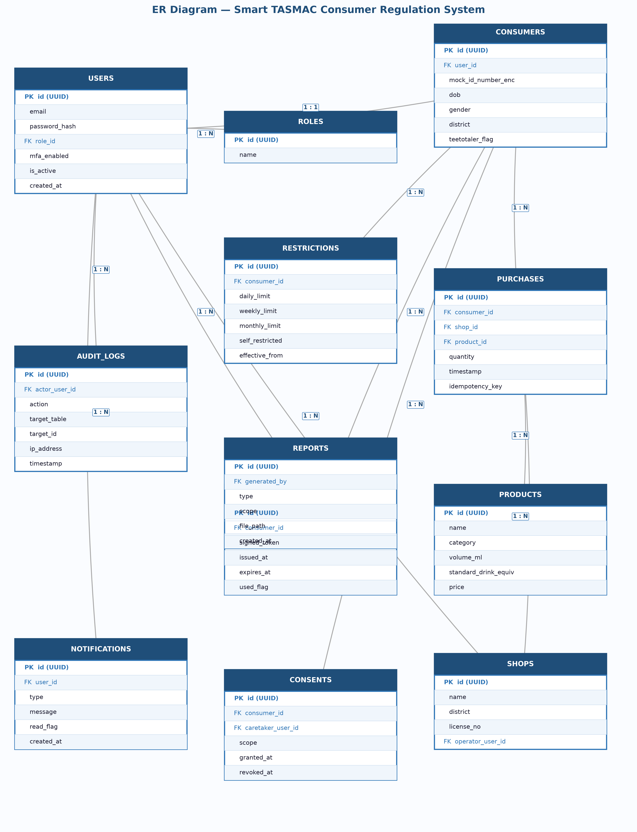
Figure 3.1 — ER Diagram

4. Data Flow Diagrams (DFD)

4.1 Context-Level DFD (Level 0)
The context diagram treats the Smart TASMAC Consumer Regulation System as a single process interacting with five external entities. Each entity supplies inputs and receives system outputs.
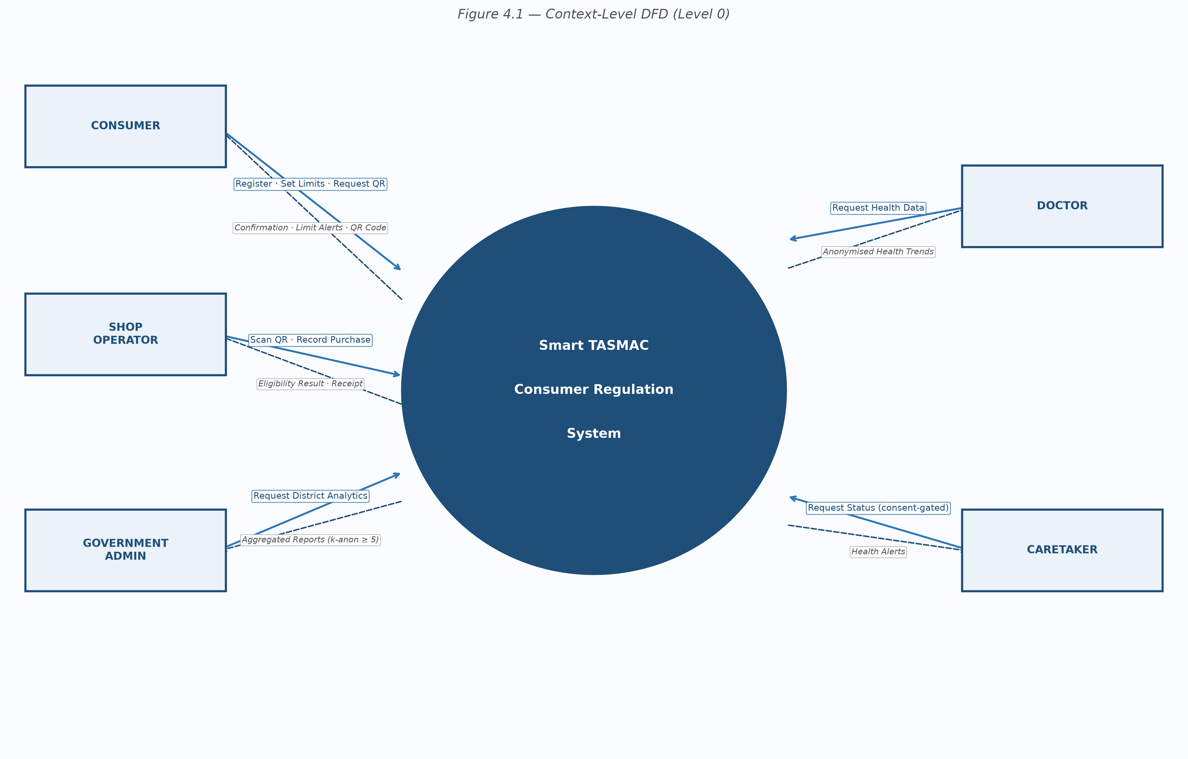
Figure 4.1 — Context-Level DFD (Level 0)

4.2 Level-1 DFD
The Level-1 DFD decomposes the system into six processes and shows bidirectional data flows with data stores.
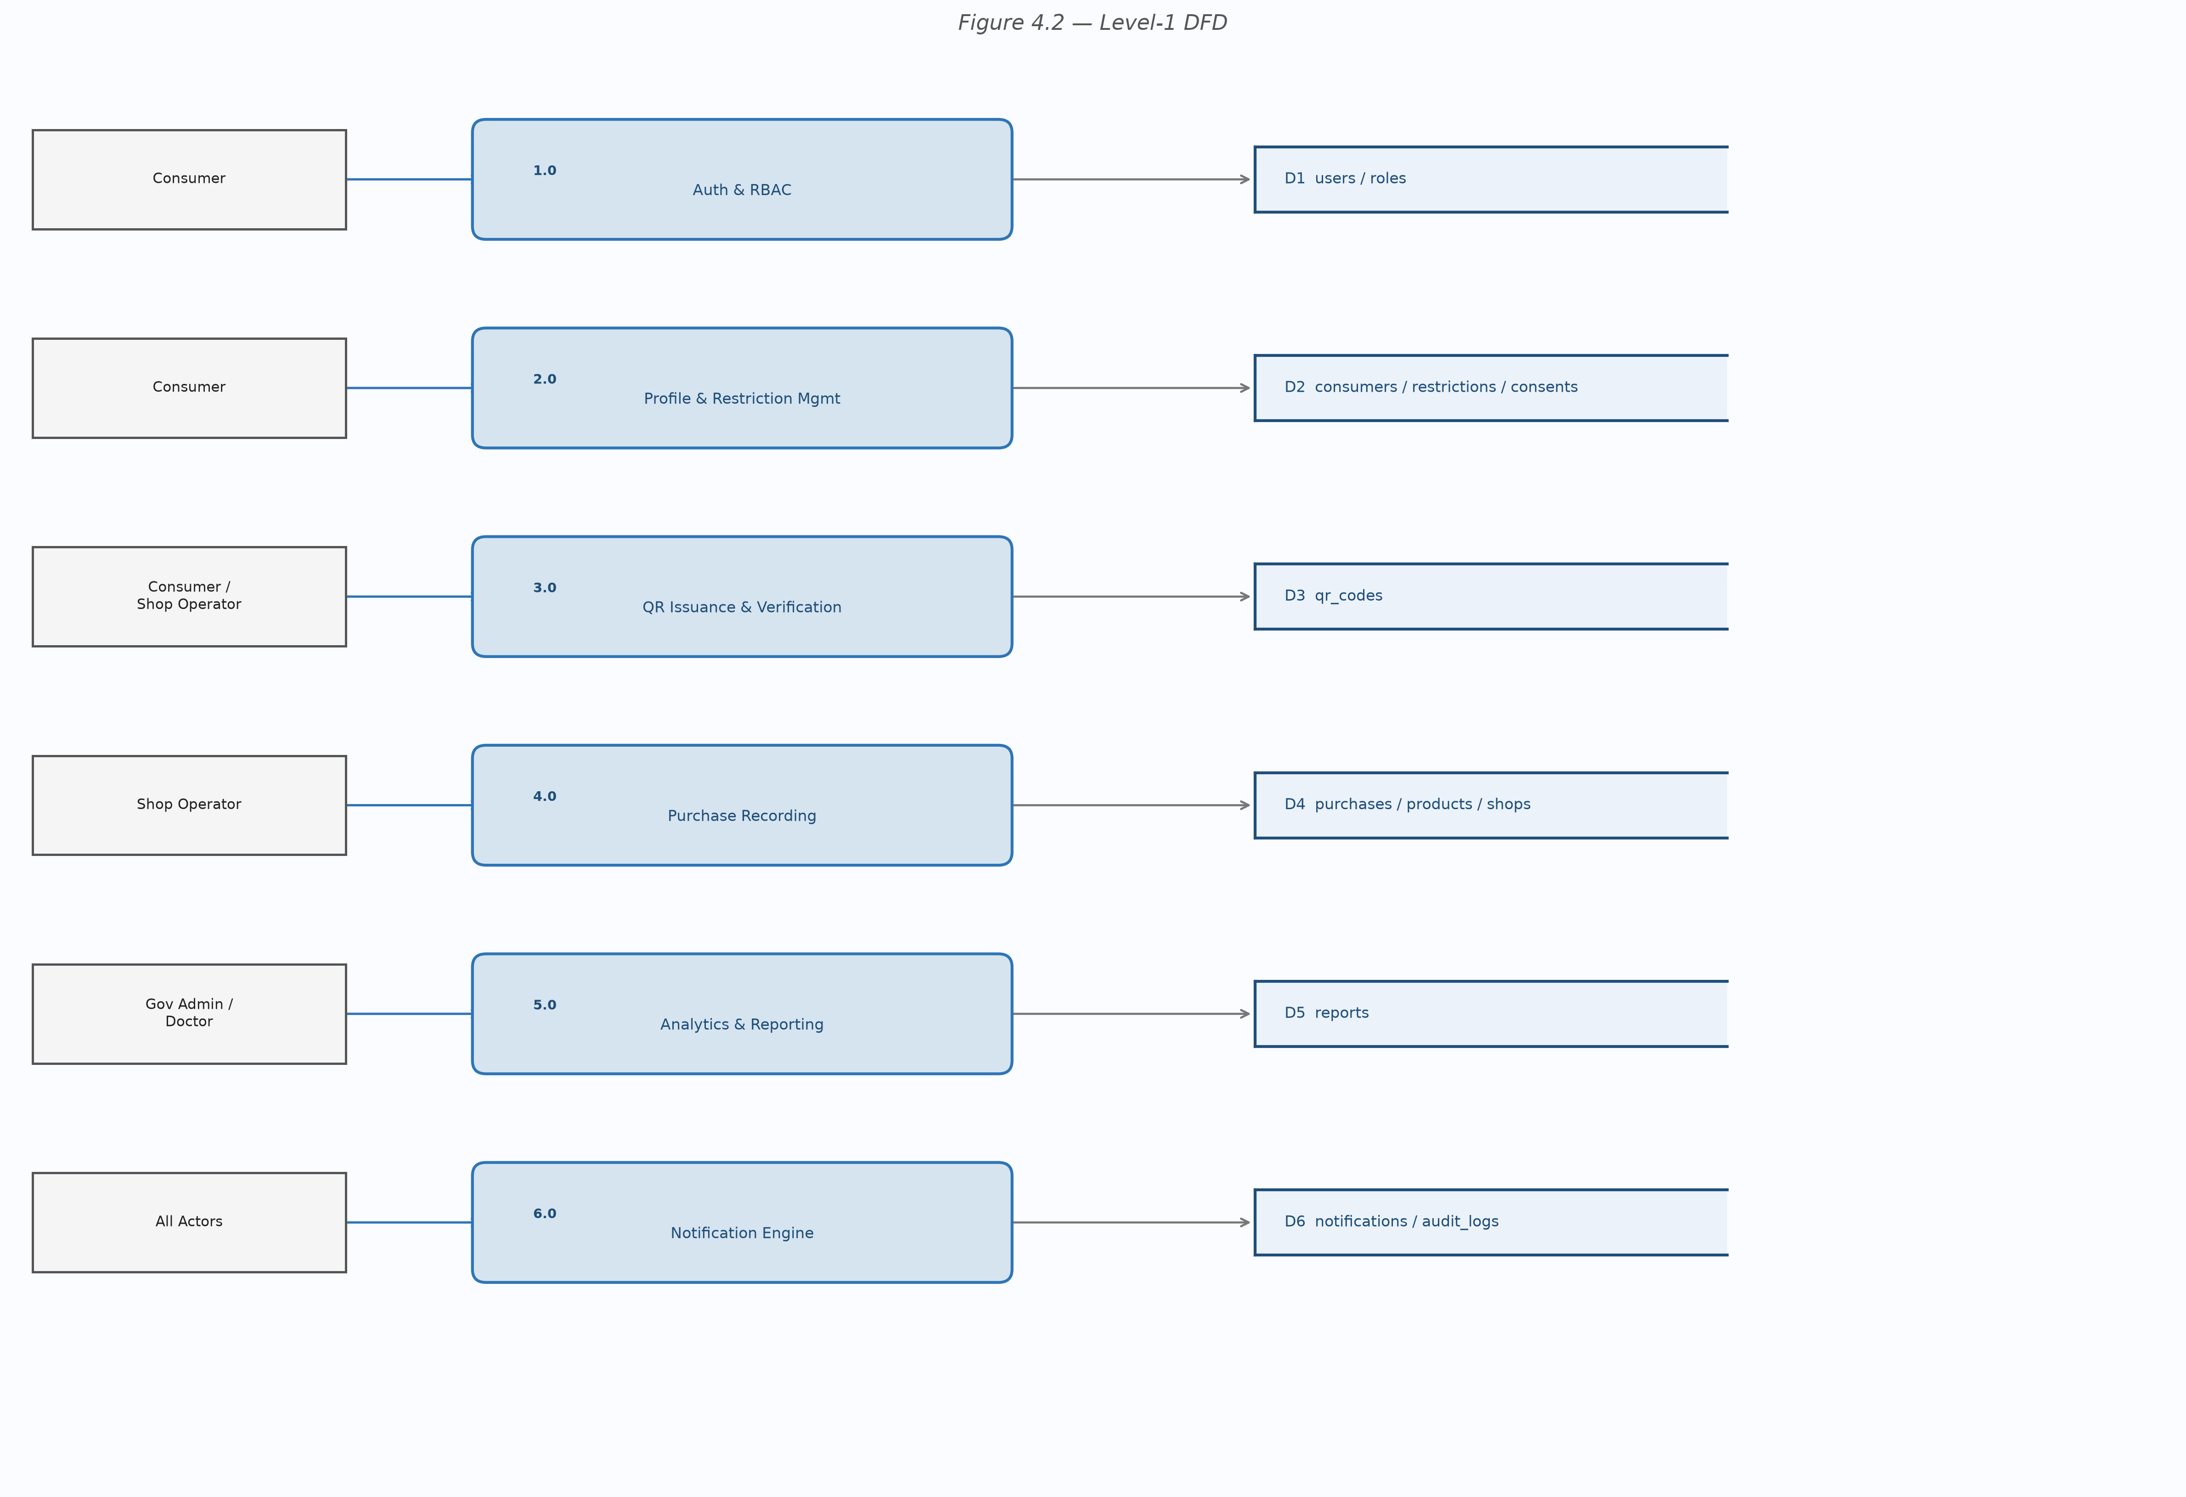
Figure 4.2 — Level-1 DFD

4.3 Processes
ID | Process Name | Data Stores
1.0 | Auth & RBAC | users, roles
2.0 | Profile & Restriction Mgmt | consumers, restrictions, consents
3.0 | QR Issuance & Verification | qr_codes, consumers
4.0 | Purchase Recording | purchases, products, shops
5.0 | Analytics & Reporting | reports, purchases
6.0 | Notification Engine | notifications, audit_logs

4.4 Data Stores
Store | Table(s) | Description
D1 | users, roles | Auth & role data
D2 | consumers, restrictions | Consumer profiles & limits
D3 | qr_codes | Signed, time-limited QR tokens
D4 | purchases, products, shops | Transaction ledger & catalogue
D5 | reports | Generated report metadata
D6 | notifications, audit_logs | Alerts & security event trail

5. Use Case Design

5.1 Actors
Actor | Description
Consumer | Manages profile, limits, QR, purchase history
Shop Operator | Scans QR, records purchases, prints receipts
Government Admin | Views aggregated analytics, exports reports
Doctor | Views anonymised health trends & risk data
Caretaker | Views consent-gated status, receives alerts

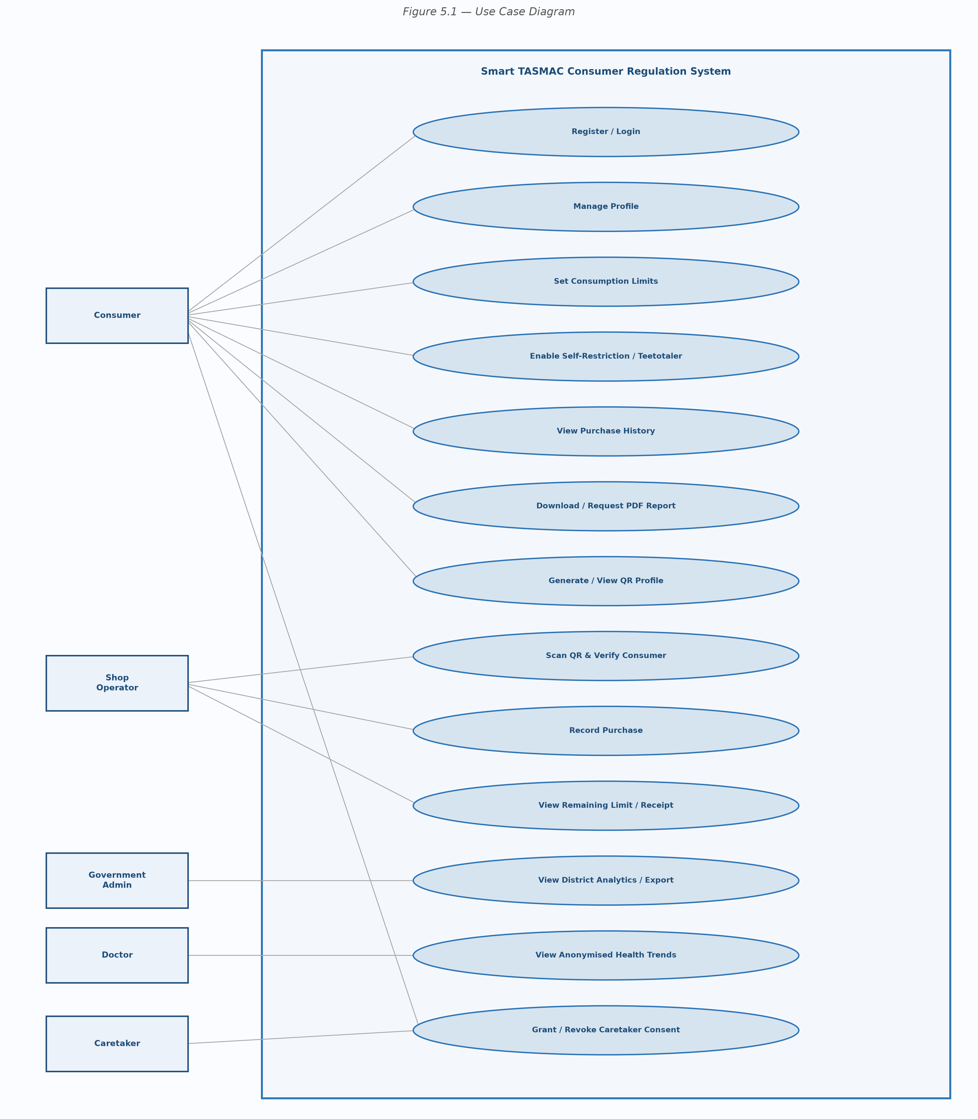
Figure 5.1 — Use Case Diagram

5.2 Use Case Descriptions
ID | Use Case | Actor | Description
UC-01 | Register Account | Consumer | Email, password (Argon2id), DOB, district, mock-ID
UC-02 | Login | Consumer | JWT (15 min) + httpOnly refresh cookie
UC-03 | Set Consumption Limits | Consumer | Daily/weekly/monthly standard-drink limits
UC-04 | Enable Self-Restriction | Consumer | Block all future purchases; teetotaler toggle
UC-05 | View Purchase History | Consumer | Paginated, filterable purchase list
UC-06 | Download PDF Report | Consumer | Personal consumption report as PDF
UC-07 | Generate / View QR Profile | Consumer | HMAC-signed 15-min single-use QR code
UC-08 | Grant / Revoke Consent | Consumer | Create or revoke caretaker access consent
UC-09 | Scan QR & Verify Consumer | Shop Operator | Validate QR signature, TTL, used_flag
UC-10 | Record Purchase | Shop Operator | Idempotency check + limit enforcement
UC-11 | View Remaining Limit | Shop Operator | Live limit status after purchase
UC-12 | View District Analytics | Gov Admin | Aggregated stats — k-anonymity ≥ 5
UC-13 | Export Report | Gov Admin | PDF / Excel / JSON — rate-limited
UC-14 | View Health Trends | Doctor | Anonymous age-group consumption charts
UC-15 | View Addiction Risk Data | Doctor | Risk-tier aggregates, no PII
UC-16 | View Consumer Status | Caretaker | Consent-gated — 403 if no active consent
UC-17 | Receive Health Alerts | Caretaker | Notifications on limit breach

