SMART TASMAC CONSUMER REGULATION SYSTEM
System Design Document
Tables · ER Diagram · DFD · Use Case Design
2025 – 2026

Table of Contents

⚠ Press Ctrl+A then F9 in Word to update the Table of Contents.

1. Project Overview
The Smart TASMAC Consumer Regulation System is a security-hardened web application that promotes responsible alcohol consumption through consumer profiles, purchase tracking, self-imposed limits, and administrative dashboards. The system serves five distinct roles: Consumer, Shop Operator, Government Administrator, Doctor, and Caretaker. All identity verification uses simulated (synthetic) data — no real Aadhaar or UIDAI integration.

2. Database Design — Entity Tables

2.1 users
Central authentication identity store for every user in the system.
Column | Data Type | Constraints / Notes
id | UUID | PRIMARY KEY
email | VARCHAR(255) | UNIQUE, NOT NULL
password_hash | TEXT | Argon2id hash, NOT NULL
role_id | UUID | FK → roles.id
mfa_enabled | BOOLEAN | DEFAULT FALSE
is_active | BOOLEAN | DEFAULT TRUE
created_at | TIMESTAMPTZ | DEFAULT now()

2.2 roles
Lookup table for the five RBAC roles.
Column | Data Type | Constraints / Notes
id | UUID | PRIMARY KEY
name | VARCHAR(50) | UNIQUE — consumer | shop_operator | gov_admin | doctor | caretaker

2.3 consumers
Extended profile for Consumer role users. mock_id_number is encrypted at app layer.
Column | Data Type | Constraints / Notes
id | UUID | PRIMARY KEY
user_id | UUID | FK → users.id, UNIQUE
mock_id_number_enc | TEXT | AES-GCM encrypted (simulated Aadhaar)
dob | DATE | NOT NULL
gender | VARCHAR(10) | CHECK IN ('M','F','Other')
district | VARCHAR(100) | NOT NULL
teetotaler_flag | BOOLEAN | DEFAULT FALSE

2.4 shops
TASMAC retail shop records.
Column | Data Type | Constraints / Notes
id | UUID | PRIMARY KEY
name | VARCHAR(200) | NOT NULL
district | VARCHAR(100) | NOT NULL
license_no | VARCHAR(50) | UNIQUE, NOT NULL
operator_user_id | UUID | FK → users.id

2.5 products
Alcohol product catalogue.
Column | Data Type | Constraints / Notes
id | UUID | PRIMARY KEY
name | VARCHAR(200) | NOT NULL
category | VARCHAR(50) | Beer | Spirits | Wine
volume_ml | INTEGER | NOT NULL
standard_drink_equiv | NUMERIC(5,2) | Calculated
price | NUMERIC(10,2) | NOT NULL

2.6 purchases
Immutable purchase ledger — idempotency key prevents double recording.
Column | Data Type | Constraints / Notes
id | UUID | PRIMARY KEY
consumer_id | UUID | FK → consumers.id
shop_id | UUID | FK → shops.id
product_id | UUID | FK → products.id
quantity | INTEGER | CHECK > 0
timestamp | TIMESTAMPTZ | DEFAULT now()
idempotency_key | VARCHAR(64) | UNIQUE, NOT NULL

2.7 restrictions
Consumer-set consumption limits per time window.
Column | Data Type | Constraints / Notes
id | UUID | PRIMARY KEY
consumer_id | UUID | FK → consumers.id
daily_limit | NUMERIC(5,2) | Standard drinks / day
weekly_limit | NUMERIC(5,2) | Standard drinks / week
monthly_limit | NUMERIC(5,2) | Standard drinks / month
self_restricted | BOOLEAN | DEFAULT FALSE
effective_from | DATE | NOT NULL

2.8 qr_codes
Signed, time-limited QR tokens for consumer identity verification.
Column | Data Type | Constraints / Notes
id | UUID | PRIMARY KEY
consumer_id | UUID | FK → consumers.id
signed_token | TEXT | HMAC-SHA256 opaque token, UNIQUE
issued_at | TIMESTAMPTZ | DEFAULT now()
expires_at | TIMESTAMPTZ | 15-minute TTL
used_flag | BOOLEAN | DEFAULT FALSE — single-use enforcement

2.9 notifications
In-app notification messages.
Column | Data Type | Constraints / Notes
id | UUID | PRIMARY KEY
user_id | UUID | FK → users.id
type | VARCHAR(50) | LIMIT_ALERT | CONSENT_REQUEST | SYSTEM
message | TEXT | NOT NULL
read_flag | BOOLEAN | DEFAULT FALSE
created_at | TIMESTAMPTZ | DEFAULT now()

2.10 Summary of Relationships
From Entity | Cardinality | To Entity
ROLES | 1:N | → USERS
USERS | 1:1 | → CONSUMERS
USERS | 1:N | → SHOPS (as operator)
CONSUMERS | 1:N | → PURCHASES
CONSUMERS | 1:N | → RESTRICTIONS
CONSUMERS | 1:N | → QR_CODES
CONSUMERS | N:M | → USERS (caretaker) via CONSENTS
SHOPS | 1:N | → PURCHASES
PRODUCTS | 1:N | → PURCHASES
USERS | 1:N | → AUDIT_LOGS
USERS | 1:N | → REPORTS

3. Entity-Relationship (ER) Diagram
The ER diagram below shows all 12 entities with their primary keys (PK) and foreign keys (FK) and the cardinality of each relationship.

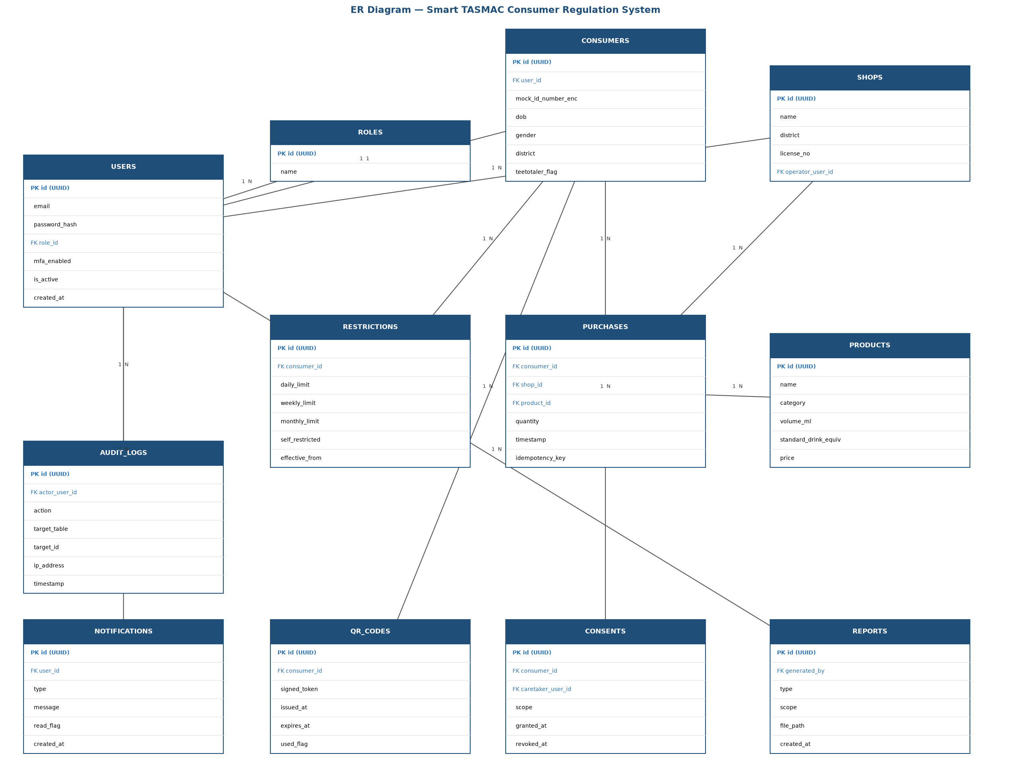
Figure 3.1 — ER Diagram

4. Data Flow Diagrams (DFD)

4.1 Context-Level DFD (Level 0)
The context diagram treats the Smart TASMAC Consumer Regulation System as a single process interacting with five external entities. Each entity supplies inputs and receives outputs.
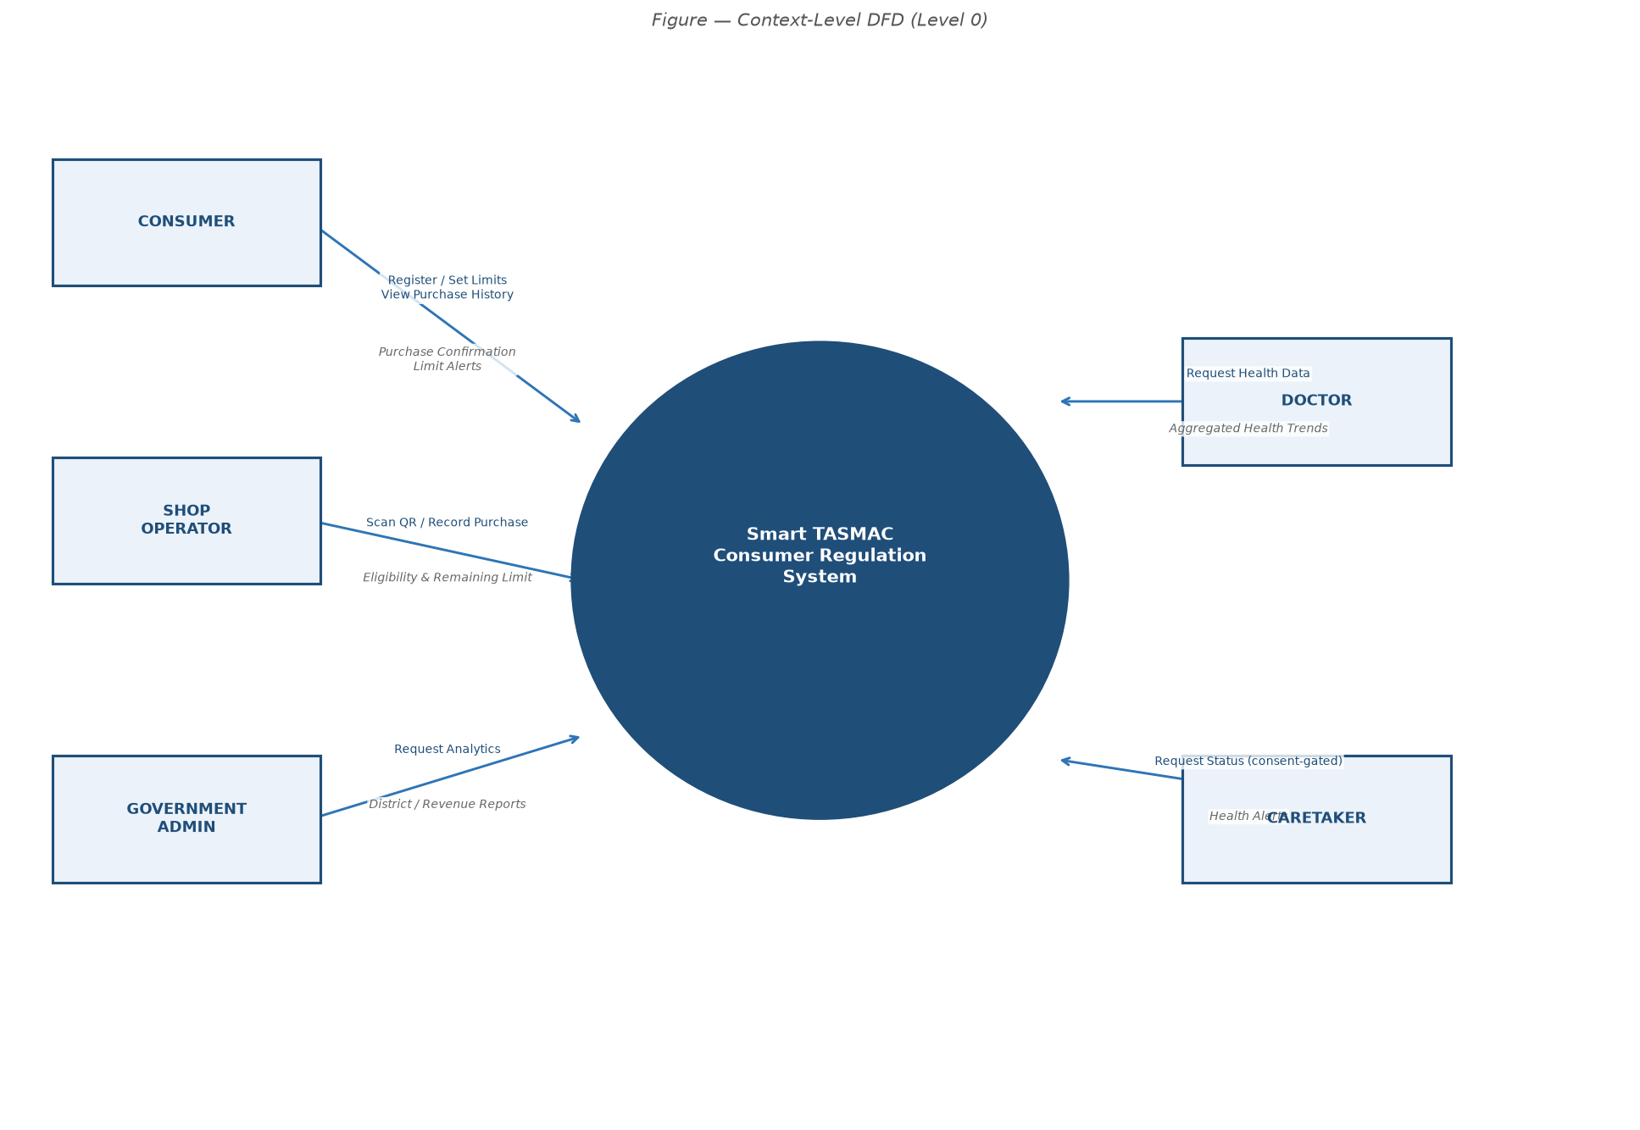
Figure 4.1 — Context-Level DFD (Level 0)

4.2 Level-1 DFD
The Level-1 DFD decomposes the system into seven major processes and shows data flows to and from the data stores.
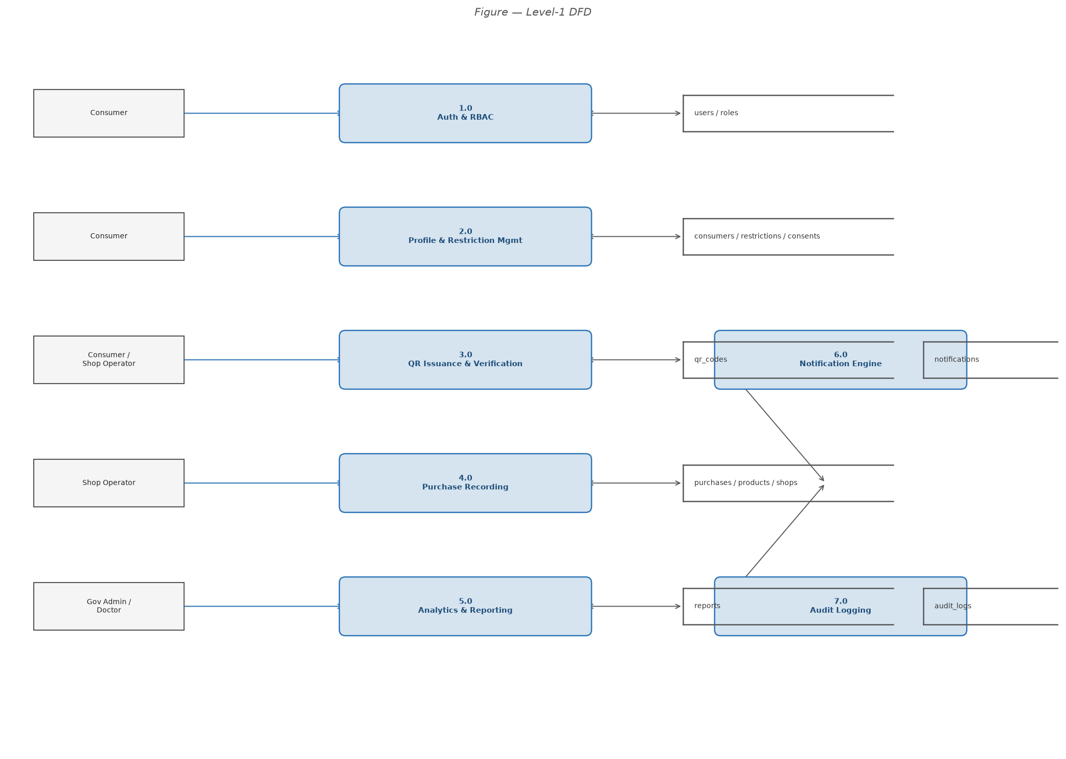
Figure 4.2 — Level-1 DFD

4.3 Processes
Process | Name | Data Stores
1.0 | Auth & RBAC | users, roles
2.0 | Profile & Restriction Mgmt | consumers, restrictions, consents
3.0 | QR Issuance & Verification | qr_codes, consumers
4.0 | Purchase Recording | purchases, products, shops
5.0 | Analytics & Reporting | reports, purchases
6.0 | Notification Engine | notifications, users
7.0 | Audit Logging | audit_logs

4.4 Data Stores
Data Store | Table(s) | Description
D1 | users, roles | Authentication and role data
D2 | consumers, restrictions | Consumer profiles and purchase limits
D3 | qr_codes | Signed, time-limited QR tokens
D4 | purchases, products, shops | Transaction ledger and product catalogue
D5 | reports | Generated report file metadata
D6 | notifications | In-app alerts and messages
D7 | audit_logs | Append-only security event trail
D8 | consents | Caretaker access consent records

5. Use Case Design

5.1 Actors
Actor | Description
Consumer | Registered alcohol consumer — manages profile, limits, QR, and purchase history
Shop Operator | TASMAC outlet staff — scans QR, records purchases, prints receipts
Government Admin | District/state official — views aggregated analytics and exports reports
Doctor | Healthcare provider — views anonymised health trends and addiction-risk data
Caretaker | Family member / guardian — views consent-gated consumer status and receives alerts

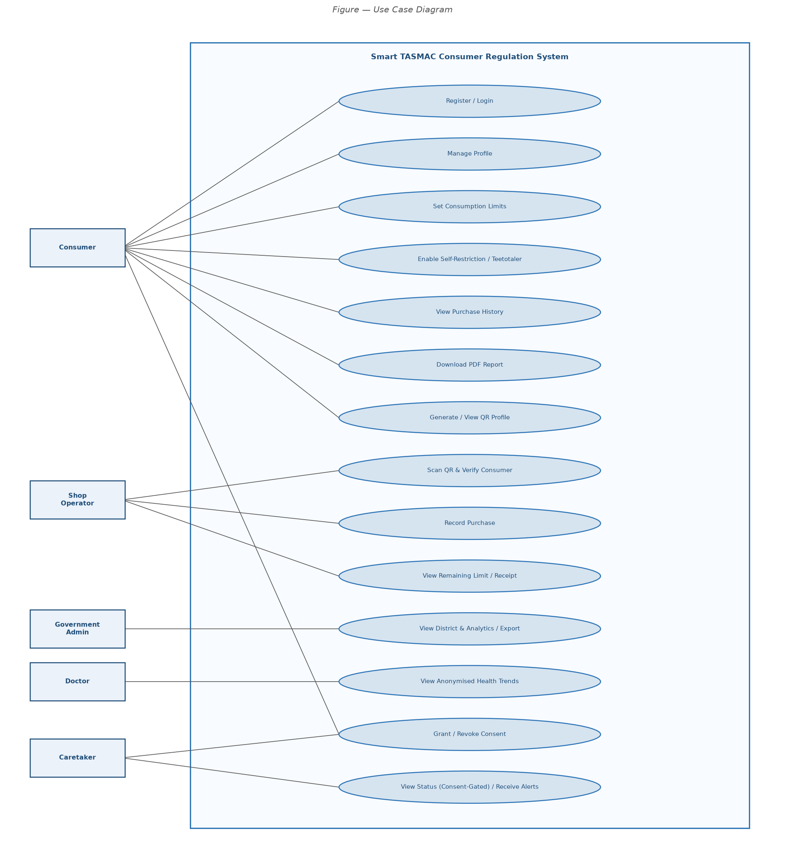
Figure 5.1 — Use Case Diagram

5.2 Use Case Descriptions
ID | Use Case | Primary Actor | Brief Description
UC-01 | Register Account | Consumer | Submit email, password (Argon2id hashed), DOB, district, mock-ID
UC-02 | Login | Consumer | Authenticate; receive JWT (15 min) + httpOnly refresh cookie
UC-03 | Set Consumption Limits | Consumer | Set daily/weekly/monthly standard-drink limits
UC-04 | Enable Self-Restriction | Consumer | Block all future purchases; teetotaler mode toggle
UC-05 | View Purchase History | Consumer | Paginated list of past purchases with date/product filters
UC-06 | Download PDF Report | Consumer | Generate personal consumption report as PDF
UC-07 | Generate / View QR Profile | Consumer | Issue HMAC-signed 15-min single-use QR code
UC-08 | Grant / Revoke Caretaker Consent | Consumer | Create or revoke consent record for a caretaker
UC-09 | Scan QR & Verify Consumer | Shop Operator | Validate QR signature, TTL, and used_flag
UC-10 | Record Purchase | Shop Operator | Record purchase with idempotency check and limit enforcement
UC-11 | Print / Download Receipt | Shop Operator | Generate PDF receipt after successful purchase
UC-12 | View District Analytics | Government Admin | Aggregated purchase stats (k-anonymity ≥ 5 enforced)
UC-13 | Export Report | Government Admin | Export PDF/Excel/JSON — rate-limited
UC-14 | View Health Trends | Doctor | Anonymous age-group consumption charts
UC-15 | View Addiction Risk Analytics | Doctor | Risk-tier aggregates — no individual PII
UC-16 | View Consumer Status | Caretaker | Consent-gated status view — 403 if no active consent
UC-17 | Receive Health Alerts | Caretaker | Notifications on limit breach if RECEIVE_ALERTS consent active

