Bektur Akkabakov
CS 4412
Advanced Algorithms
Project 4: Gene Sequencing

Time and Space Complexity Analysis
Unrestricted Edit Distance Algorithm
- Function: NeedlemanWunsch
Time Complexity: O(n * m)
Space Complexity: O(n * m)

table = [[0] * (len(seq2) + 1) for i in range(len(seq1) + 1)] # O(n * m) time, O(n * m) space
back = [[None] * (len(seq2) + 1) for i in range(len(seq1) + 1)] # O(n * m) time, O(n * m) space
for j in range(len(seq2)+1): # m iterations
table[0][j] = j * INDEL # O(1)
for i in range(len(seq1)+1): # n iterations
table[i][0] = i * INDEL # O(1)
for i in range(1, len(seq1)+1): # n iterations
for j in range(1, len(seq2)+1): # m iterations
diag = table[i-1][j-1] + (MATCH if seq1[i-1] == seq2[j-1] else SUB) # O(1)
top = table[i-1][j] + INDEL # O(1)
left = table[i][j-1] + INDEL # O(1)
table[i][j] = min(left, top, diag) # O(1)
if table[i][j] == left: # O(1)
back[i][j] = "l" # O(1)
elif table[i][j] == top: # O(1)
back[i][j] = "t" # O(1)
else:
back[i][j] = "d" # O(1)
# total: n * m iterations * O(1) = O(n * m)
i = len(seq1) # O(1)
j = len(seq2) # O(1)
alignment1 = "" # O(1)
alignment2 = "" # O(1)
while i > 0 or j > 0: # at most n + m iterations
direction = back[i][j] # O(1)
if direction == "l":
alignment1 = "-" + alignment1 # O(1)
alignment2 = seq2[j-1] + alignment2 # O(1)
j -= 1 # O(1)
elif direction == "t":
alignment1 = seq1[i-1] + alignment1 # O(1)
alignment2 = "-" + alignment2 # O(1)
i -= 1 # O(1)
else:
alignment1 = seq1[i-1] + alignment1 # O(1)
alignment2 = seq2[j-1] + alignment2 # O(1)
i -= 1 # O(1)
j -= 1 # O(1)
# total: O(n + m)

Time complexity:
Initialization: O(n * m)
DP fill: n * m * O(1) = O(n * m)
Backtracking: O(n + m)
Total:
T(n, m) = O(n * m) + O(n * m) + O(n + m) = O(n * m)
Space complexity:
table : O(n * m)
back pointers table : O(n * m)
alignment strings: O(n + m)
Total:
S(n, m) = O(n * m)
- Function: NeedlemanWunschBanded
Time Complexity: O(k * n)
Space Complexity: O(k * n)

if abs(len(seq1) - len(seq2)) > MAXINDELS: # O(1)
return math.inf, "", "" # O(1)
table = [[float('inf')] * (2*MAXINDELS+1) for i in range(len(seq1) + 1)] # O(n * k) time, O(n * k) space
back = [[None] * (2*MAXINDELS+1) for i in range(len(seq1) + 1)] # O(n * k) time, O(n * k) space
table[0][MAXINDELS] = 0 # O(1)
for i in range(len(seq1) + 1): # n iterations
for banded_j in range(2 * MAXINDELS + 1): # k iterations
j = i + (banded_j - MAXINDELS) # O(1)
if j < 0 or j > len(seq2): # O(1)
continue # O(1)
if i == 0 and j == 0: # O(1)
continue # O(1)
diag = float('inf') # O(1)
top = float('inf') # O(1)
left = float('inf') # O(1)
if i > 0 and j > 0: # O(1)
cost = MATCH if seq1[i-1] == seq2[j-1] else SUB # O(1)
diag = table[i-1][banded_j] + cost # O(1)
if i > 0 and banded_j + 1 < 2 * MAXINDELS + 1: # O(1)
top = table[i-1][banded_j+1] + INDEL # O(1)
if j > 0 and banded_j - 1 >= 0: # O(1)
left = table[i][banded_j-1] + INDEL # O(1)
table[i][banded_j] = min(left, top, diag) # O(1)
if table[i][banded_j] == left: # O(1)
back[i][banded_j] = "l" # O(1)
elif table[i][banded_j] == top: # O(1)
back[i][banded_j] = "t" # O(1)
else:
back[i][banded_j] = "d" # O(1)
# total: n * k iterations * O(1) = O(n * k)
i = len(seq1) # O(1)
j = len(seq2) # O(1)
banded_j = MAXINDELS + (j - i) # O(1)
alignment1 = "" # O(1)
alignment2 = "" # O(1)
while i > 0 or j > 0: # at most n + m iterations
direction = back[i][banded_j] # O(1)
if direction == "d":
alignment1 = seq1[i-1] + alignment1 # O(1)
alignment2 = seq2[j-1] + alignment2 # O(1)
i -= 1 # O(1)
j -= 1 # O(1)
banded_j = MAXINDELS + (j - i) # O(1)
elif direction == "t":
alignment1 = seq1[i-1] + alignment1 # O(1)
alignment2 = "-" + alignment2 # O(1)
i -= 1 # O(1)
banded_j += 1 # O(1)
elif direction == "l":
alignment1 = "-" + alignment1 # O(1)
alignment2 = seq2[j-1] + alignment2 # O(1)
j -= 1 # O(1)
banded_j -= 1 # O(1)
# total: O(n + m)

Time complexity:
Initialization:
O(n * k)
DP band computation:
n * k * O(1) = O(n * k)
Backtracking:
O(n + m)
Total:
T(n) = O(n * k) + O(n * k) + O(n + m) = O(n * k)

Space complexity:
table : O(n * k)
back pointers: O(n * k)
alignment strings : O(n + m)
Total:
S(n) = O(n * k)
Alignment Extraction and Backtrace Explanation
The alignment extraction algorithm reconstructs an optimal alignment by performing a backtrace through the back pointer table generated during dynamic programming. After the scoring table is fully computed, the algorithm begins at the bottom-right cell, which represents the optimal alignment cost for the full sequences. At each step, the algorithm consults the corresponding entry in the back pointer table to determine the direction of the optimal move: left (“l”), top (“t”), or diagonal (“d”). A diagonal move indicates either a match or substitution, so both characters from the sequences are added to the alignment. A left move represents an insertion (gap in the first sequence), so a “-” is added to the first alignment and the corresponding character from the second sequence is added. A top move represents a deletion (gap in the second sequence), so a character from the first sequence is added and a “-” is added to the second alignment. The indices are updated accordingly after each step, and the process continues until both indices reach zero. Since the alignment is constructed in reverse order, characters are appended to the beginning at each step to produce the final aligned sequences. The same backtrace procedure is used for both the unrestricted and banded algorithms, with the only difference being that the banded version maps indices within a restricted diagonal band of width k.
Results
Unrestricted results:
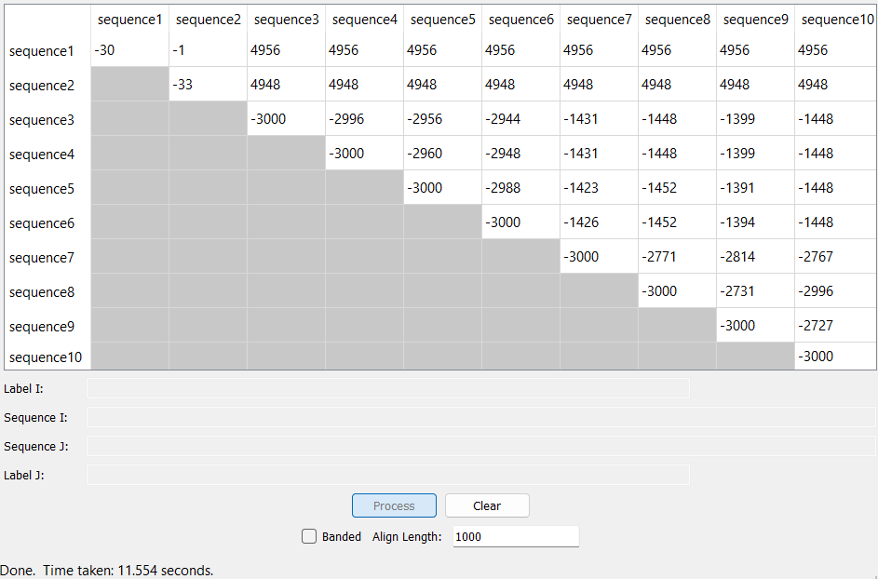
Banded results:
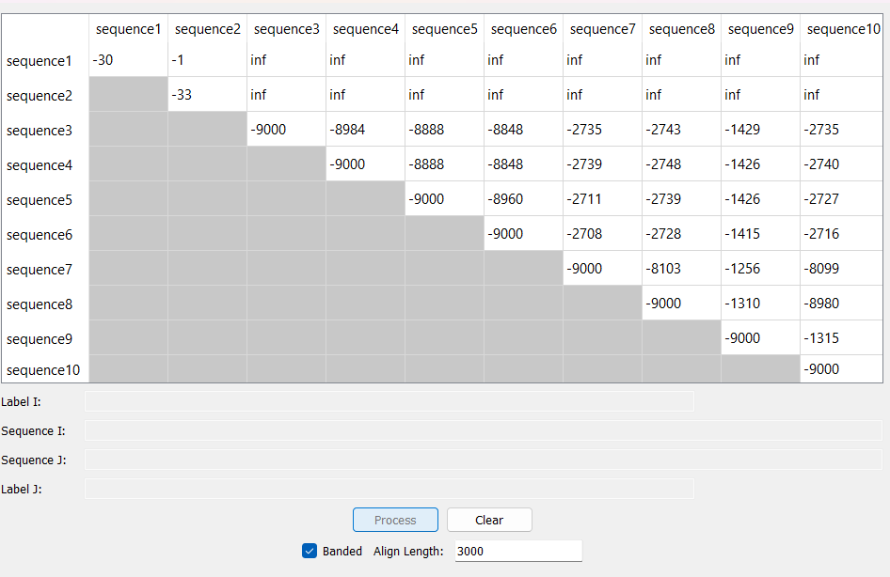
Unrestricted algorithm:
gattgcgagcgatttgcgtgcgtgcatcccgcttc-actg--at-ctcttgttagatcttttcataatctaaactttataaaaacatccactccctgta-
gataa-gagtgattggcgtccgtacgtaccctttctactctcaaactcttgttagtttaaatc-taatctaaactttataaa--cggc-acttcctgtgt
Banded algorithm:
gattgcgagcgatttgcgtgcgtgcatcccgcttc-actg--at-ctcttgttagatcttttcataatctaaactttataaaaacatccactccctgta-
-ataa-gagtgattggcgtccgtacgtaccctttctactctcaaactcttgttagtttaaatc-taatctaaactttataaa--cggc-acttcctgtgt
GitHub link:

