Bektur Akkabakov
CS4412: Advanced Algorithms
Project 2: Convex Hull
Report

procedure ConvexHull(Q):
Input: Q is a set of points in 2D space.
Output: H is a set of points of computed convex hull.
// base case
if(len(Q)<=1): return Q
// recursive calls recursion depth: $\log_{2}{(n})$ where n = |Q|
leftSH = ConvexHull(Q[0,$⌊|Q|/2⌋$])
rightSH = ConvexHull(Q[$\left\lfloor \frac{|Q|}{2}\right\rfloor , |Q|$)
// variables preparation O(n)
rPoint = find rightmost point of leftSH
lPoint = find leftmost point of rightSH
rNext = find next to the rightmost point of leftSH in counterclockwise direction
lNext = find next to the leftmost point of rightSH in clockwise direction
// upper common tangent computation
// O(n) - at the worst-case loops together will iterate over each point in two sub-hulls, i.e. 2*n/2 = n
while slope(rPoint, lPoint)> slope(rNext, lPoint) or slope(rPoint, lPoint)< slope(rPoint, lNext):
while slope(rPoint, lPoint)> slope(rNext, lPoint):
rPoint = rNext
rNext = find next to the rightmost point of leftSH in counterclockwise direction
while slope(rPoint, lPoint)< slope(rPoint, lNext):
lPoint = lNext
lNext = find next to the leftmost point of rightSH in clockwise direction
// saving vertices of upper common tangent
upperR = rPoint
upperL = lPoint
// variables preparation O(n)
rPoint = find rightmost point of leftSH
lPoint = find leftmost point of rightSH
rNext = find next to the rightmost point of leftSH in clockwise direction
lNext = find next to the leftmost point of rightSH in counterclockwise direction
// lower common tangent computation O(n)
while slope(lPoint, rPoint)< slope(lPoint, rNext) or slope(lPoint, rPoint)> slope(lNext, rPoint):
while slope(lPoint, rPoint)< slope(lPoint, rNext):
rPoint = rNext
rNext = find next to the rightmost point of leftSH in clockwise direction
while slope(lPoint, rPoint)> slope(lNext, rPoint):
lPoint = lNext
lNext = find next to the leftmost point of rightSH in counterclockwise direction
// saving vertices of lower common tangent
lowerR = rPoint
lowerL = lPoint
H = []
// construct merged hull in clockwise order
// O(n) algorithm needs to iterate over all n points of merged hull
Add to H all points of rightSH from upperL to lowerL in clockwise order.
Add to H all points of leftSH from lowerR to upperR in clockwise order.
return H

ConvexHull is divide and conquer algorithm which breaks down the problem into 2 subproblems of size n/2 with combining complexity of O(n), where n is the number of points. Thus, the Master Theorem can be utilized to compute total complexity of the algorithm:
Since a = 2, b = 2, and d = 1, this is case 2 of the Master Theorem
$$T\left(n\right)=O(n* log⁡(n))$$
Each recursive call uses constant extra space. So, recursion stack space is O(log n). During merge, algorithm creates a new hull list H. In the worst case (all points on hull) ∣H∣=n. Note that at lower recursion levels, the temporary hull lists are reused as the recursion returns, so we do not multiply n by the recursion depth. Thus, merging requires O(n) space. Overall total space complexity will be:
T(n) = n + log n = O(n)

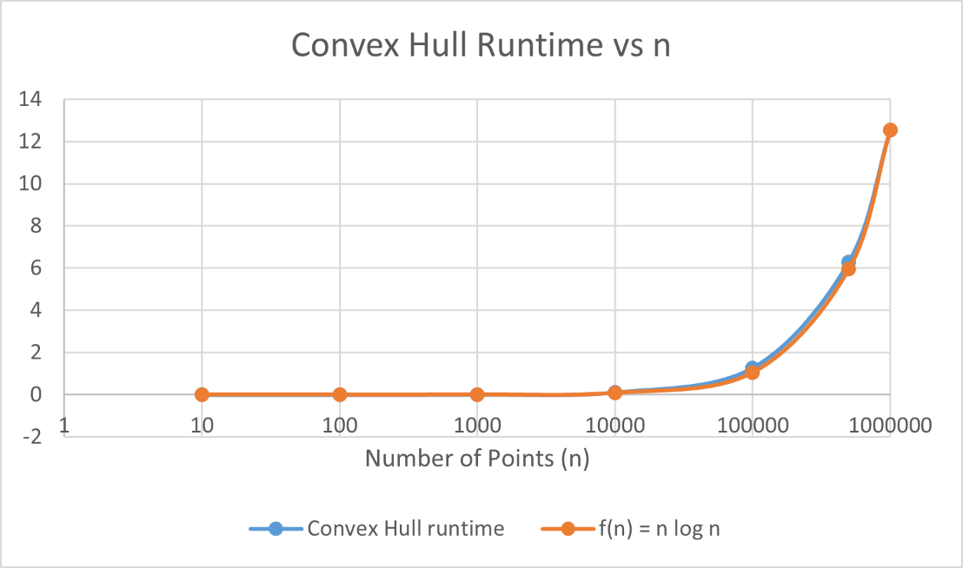
*The x-axis was plotted on a logarithmic scale to better visualize growth across multiple orders of magnitude (from 10 to 1,000,000). Using a logarithmic scale compresses large values of n and spreads out smaller values, preventing the smaller input sizes from being visually negligible.

Theoretically from point 2, my Convex Hull algorithm should have runtime that grows proportionally to $n log n$. After scaling $n log n$. by a constant factor k≈6.29×10−7 the fitted curve closely matches the measured mean runtime values. This confirms the theoretical complexity O(n log n).
The value of k, constant of proportionality, was obtained by measuring the factor by which n log n function is bigger for input size of 1M: $\frac{12.5281}{19931568.57} ≈6.29*{10}^{-7}$.

From the plotted curves, we observe that for n=100,000 and n=500,000, the measured mean runtime is slightly higher than the predicted k * n log n values. This difference is likely due to system overhead such as memory allocation, cache effects, recursion overhead, and other factors. Since Big-O describes asymptotic behavior, small deviations at finite input sizes are expected. Overall, the growth trend still follows n log n which supports the theoretical analysis.

