
Kaunas University of Technology
Faculty of Informatics
Image Synthesis and Translation Report

Kamil Alakbarov
Project author
Assoc. Prof. Dr. Dalia Čalnerytė
Assoc. Prof. Dr. Andrius Kriščiūnas
Professors
Kaunas, 2026
Table of contents

Introduction 3
1. Image Generation and Synthetic Data Performance 4
1.1. Problem 4
1.2. Dataset Description 4
2. Algorithms 5
2.1. Deep Convolutional Generative Adversarial Network (DCGAN) 5
2.2. CNN Classifier 5
3. Experiment Setup 6
4. Results 7
4.1. Visual and Quantitative Analysis 7
5. Part 2: Pix2Pix (Supervised Approach) 8
6. CycleGAN (Unsupervised Approach) 9
7. Results: Map to Satellite Translation 10
7.1. Visual Analysis 10
7.2. Training Stability 10
7.3. Quantitative Evaluation 12
7.4. Comparative Analysis and Discussion 12
Conclusions 13
List of references 14

Introduction
The objective of this work is to explore the capabilities of Generative Adversarial Networks (GANs) and evaluate the utility of synthesized data in machine learning workflows. The project is divided into two distinct tasks: the first focuses on synthesizing new image data to evaluate its impact on classification accuracy, while the second explores image-to-image translation techniques for transforming between satellite imagery and administrative maps. By comparing supervised and unsupervised generative approaches, this project seeks to determine how well these models can capture structural and semantic features of complex datasets under limited computational resources.

Image Generation and Synthetic Data Performance

Problem
The problem is to evaluate how well a generative model can simulate a training distribution for a classification task. We aim to compare the performance of a Convolutional Neural Network (CNN) trained on real data versus a CNN trained on purely synthetic data generated by a DCGAN. Furthermore, we must analyze the "Data Amount vs. Accuracy" relationship to determine the impact of dataset size on model robustness.

Dataset Description
The data was sourced from the CIFAR-10 dataset. The task was restricted to three specific image classes:
- Cat (Class 3)
- Dog (Class 5)
- Bird (Class 2)
Preprocessing: As per the instructions to reduce resolution and optimize size, images were maintained at 32 x 32 pixels. Redundant classes were removed, resulting in a balanced dataset of 15,000 original images (5,000 per class).
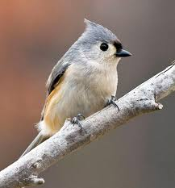
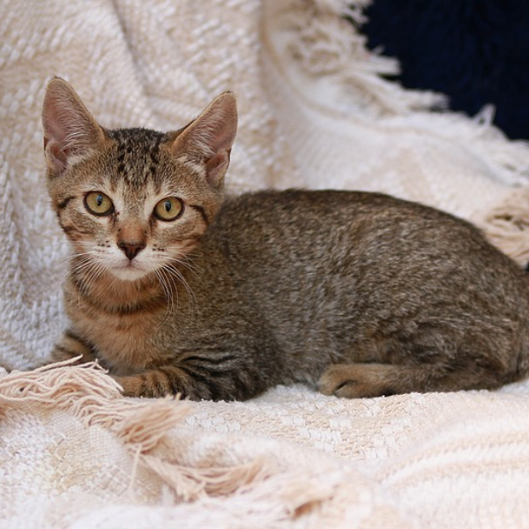
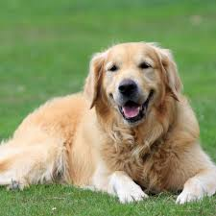

Algorithms
This task utilizes two distinct neural network architectures.

Deep Convolutional Generative Adversarial Network (DCGAN)
A DCGAN architecture was implemented without the use of transfer learning.
- Generator (G): Takes 100-dimensional random noise and applies transposed convolutions with Batch Normalization and ReLU activations to synthesize an image.
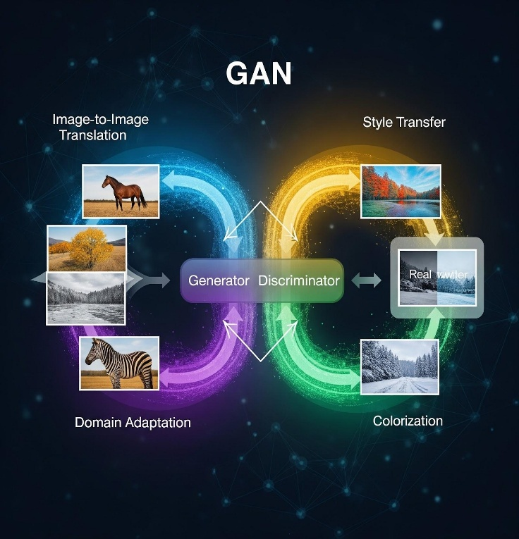
- Discriminator (D): A convolutional network that predicts the probability of an image being real or fake.

CNN Classifier
A custom Convolutional Neural Network was developed for evaluation. It consists of:
- Two convolutional blocks (Conv2D -> ReLU -> MaxPool).
- A dense head with a Dropout layer (0.5) to prevent overfitting.
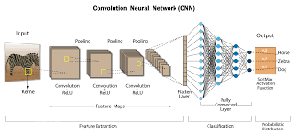
- A final softmax layer for 3-class classification.

Experiment Setup
To evaluate the strategies, we conducted a "Data Amount Analysis" using specific subsets of the real data:
- Data Fractions: 20% (3,000 images), 50% (7,500 images), and 100% (15,000 images).
- Metric: Classification Accuracy (%) and Computational Training Time (s).
- Synthetic Test: A classifier was also trained on 15,000 synthetic images generated after 50 epochs of GAN training
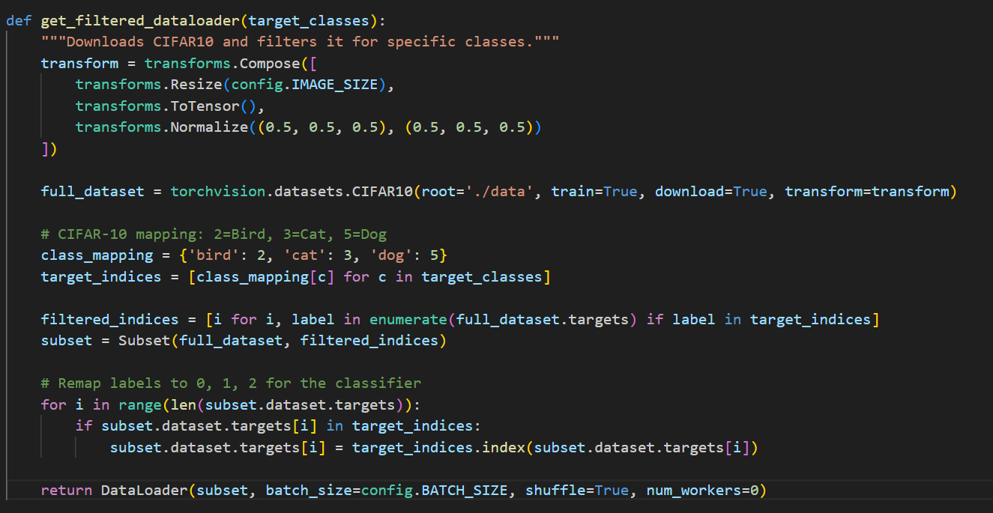
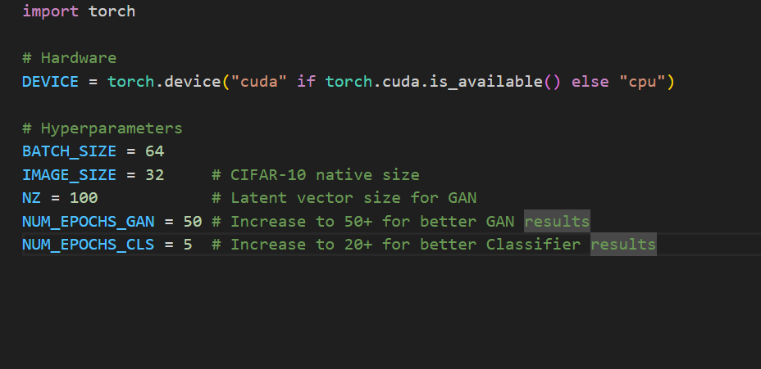
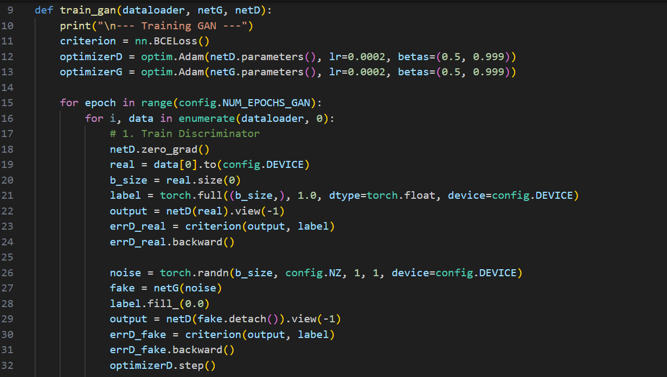

Results
The experiments yielded clear performance differences between the real and synthesized datasets.
Table 1: Classification Results and Training Time
Dataset Fraction | Accuracy (%) | Training Time (s)
20% Real Data | 67.90% | 2.26s
50% Real Data | 71.24% | 5.48s
100% Real Data | 75.13% | 11.00s
100% Synthetic | 36.27% | 0.73s

Visual and Quantitative Analysis
- GAN Performance: The loss curves for the Discriminator and Generator stabilized, but visual inspection of synthetic samples shows that while the GAN captured the general color distribution (e.g., green for bird backgrounds), it lacked the fine structural detail needed for high accuracy.
- Data Amount Trend: There is a direct positive correlation between the amount of real data and classification accuracy. Reducing the dataset size from 100% to 20% resulted in a ~7% drop in accuracy.
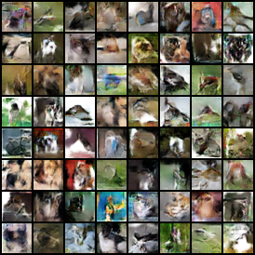
- Synthetic Quality: The synthetic accuracy (36.27%) is only slightly above random guessing (33.3%). This confirms that for complex animal classes, a basic DCGAN requires more training or a more complex architecture to be a viable replacement for real data.
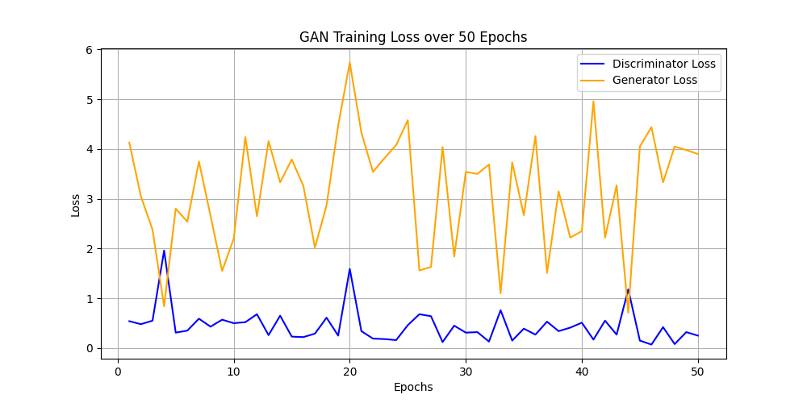

Part 2: Pix2Pix (Supervised Approach)
For the supervised translation of administrative maps to satellite imagery, a Pix2Pix architecture was implemented. Pix2Pix operates as a Conditional Generative Adversarial Network (cGAN), where the generator learns a deterministic mapping conditioned on a paired input image rather than a random noise vector.
- Generator (U-Net): The generator utilizes a U-Net architecture. By employing skip connections between the downsampling (encoder) and upsampling (decoder) layers, the network directly bypasses the bottleneck. This is critical for geographical translation, as it preserves the exact spatial coordinates of high-frequency map features, such as road networks and coastlines, in the generated satellite output.
- Discriminator (PatchGAN): Instead of evaluating the image globally, the PatchGAN discriminator penalizes structure at the scale of local image patches ($70 \times 70$ pixels). This approach encourages the generator to produce highly realistic, localized high-frequency textures (e.g., the visual difference between foliage and asphalt) while relying on the U-Net's skip connections to maintain global consistency.
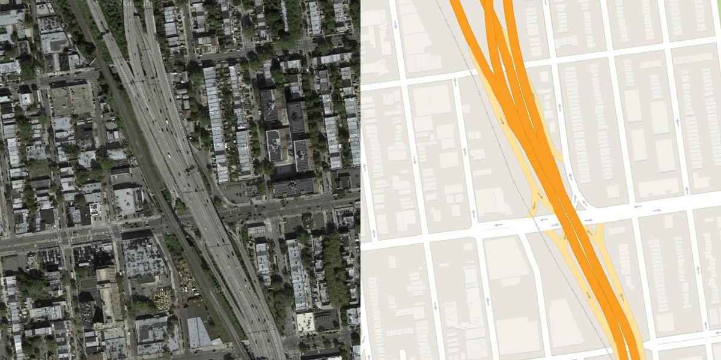
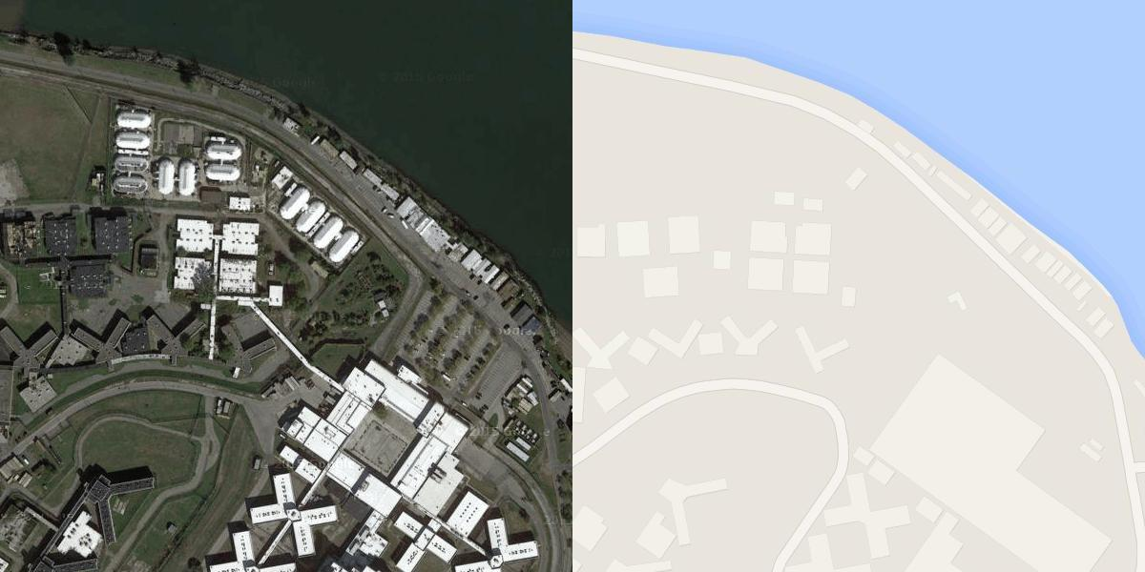
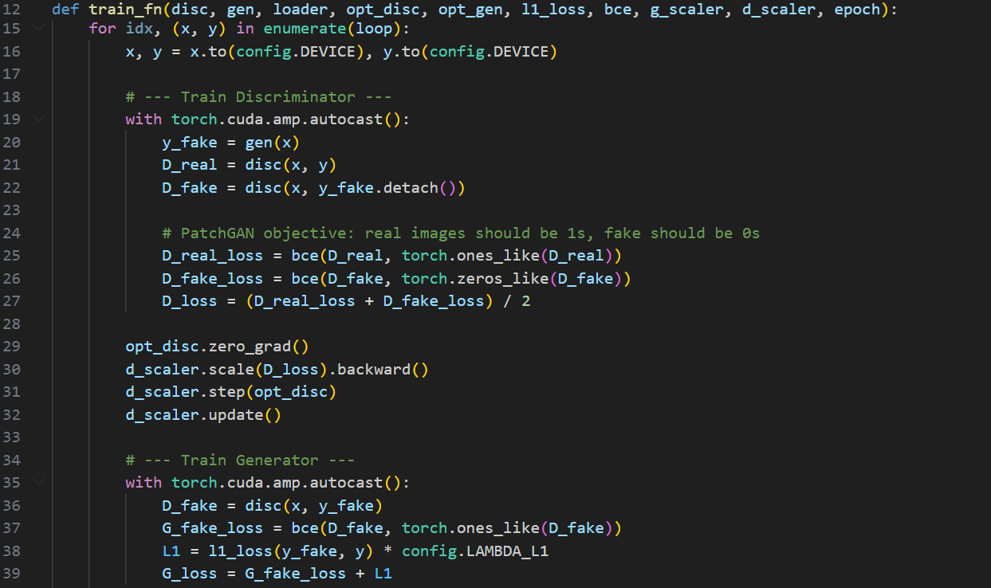

CycleGAN (Unsupervised Approach)
To provide a comparative unsupervised baseline, a CycleGAN architecture was constructed. Unlike Pix2Pix, CycleGAN does not rely on paired training data (exact pixel-to-pixel matches of maps and satellite photos).
- Architecture: It utilizes two distinct generators (incorporating Residual Blocks rather than U-Net skip connections to focus on style transfer over strict spatial alignment) and two discriminators.
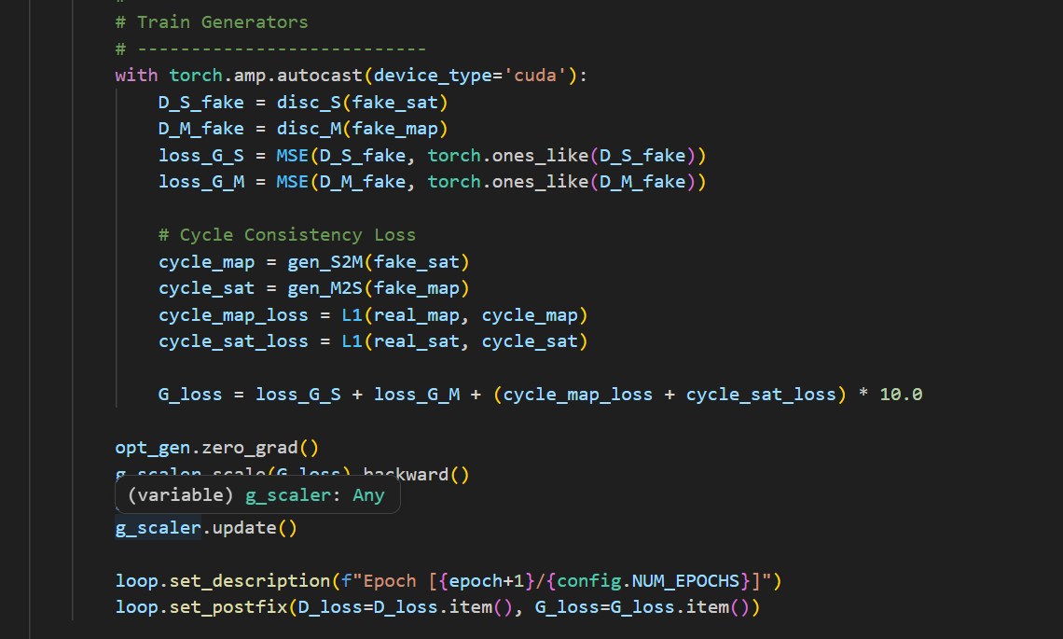
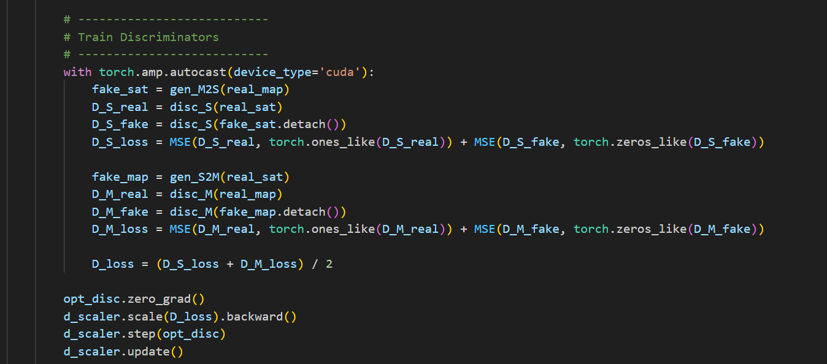
- Cycle-Consistency Loss: The network is optimized using a cycle-consistency loss function. This enforces the constraint that an image translated from Domain A (Map) to Domain B (Satellite), and then back to Domain A, must be identical to the original input. This allows the model to learn the generalized "texture" of satellite imagery without supervised spatial alignment.

Results: Map to Satellite Translation

Visual Analysis
The Pix2Pix model successfully translated abstract mapping colors into complex urban textures over a 100-epoch training period.
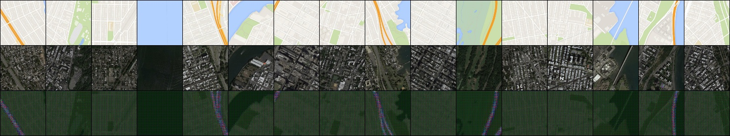
- Initial State (Epoch 1): Early generations exhibited high-entropy, muddy textures. The model failed to differentiate between urban blocks, water, and vegetation, producing dark, low-contrast outputs.
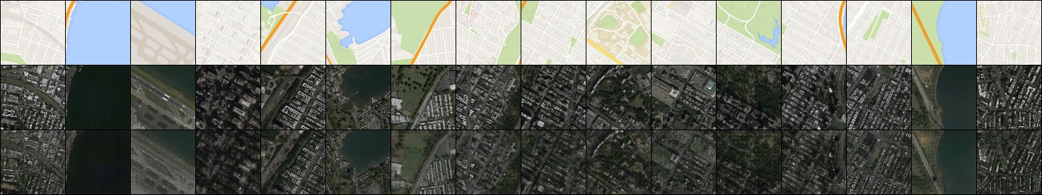
- Final State (Epoch 100): The generator successfully achieved high structural fidelity. The final images clearly differentiate between complex environmental features, rendering distinct road grids, varied building densities, and localized green spaces that align precisely with the input map's geometry.

Training Stability
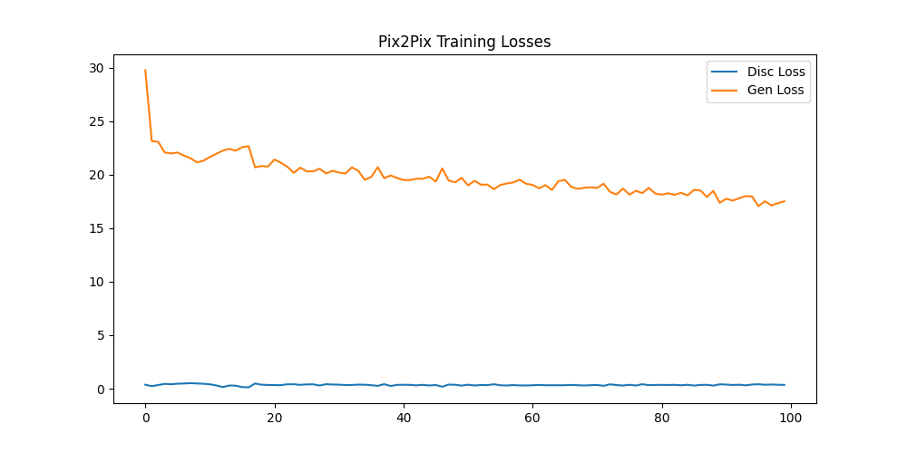
The adversarial training environment remained highly stable. The Discriminator loss maintained a consistently low profile, which effectively challenged the Generator to continuously refine its high-frequency outputs to avoid detection. The Generator loss successfully plateaued without experiencing mode collapse.

Unsupervised Visual Analysis (CycleGAN)
To validate the unsupervised approach, the CycleGAN architecture was trained for 5 epochs to establish a baseline of cycle-consistency learning.
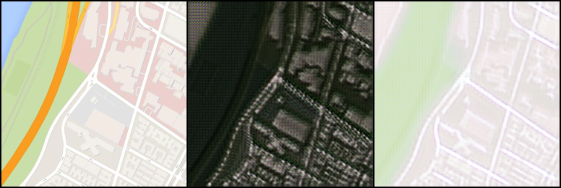
- Epoch 1: The generator struggled to map the domains, resulting in severe checkerboard artifacts in the synthesized satellite imagery and a highly degraded, blurry reconstruction of the original map.

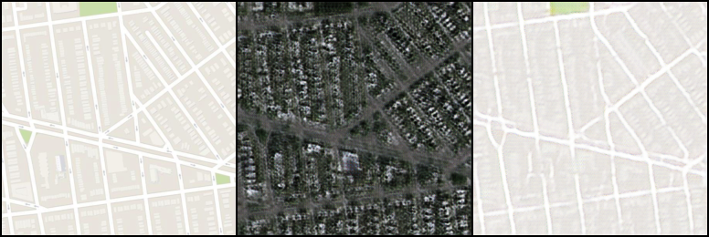
- Epoch 5: Within just 5 epochs, the cycle-consistency loss successfully forced the network to preserve geometry. The synthesized satellite image (middle panel) began developing localized urban textures, and the reconstructed map (right panel) successfully recovered the sharp lines of the road networks present in the original input.

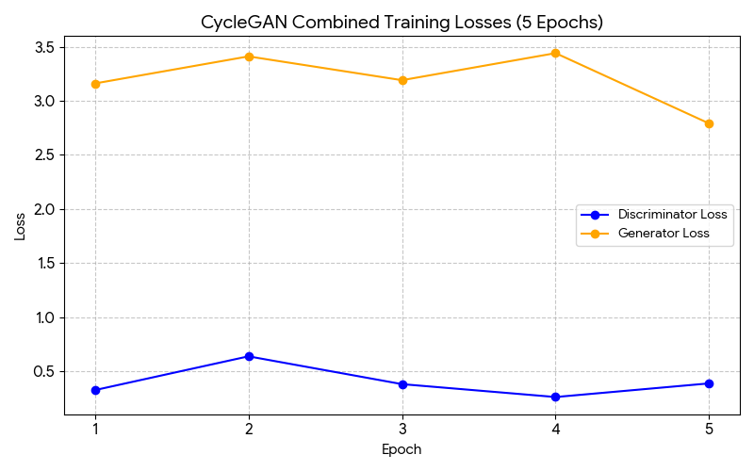
Although the CycleGAN model was only trained for 5 epochs due to computational constraints, the loss graphs indicate the beginning of a stable adversarial dynamic. The Discriminator Loss (blue) hovered between 0.26 and 0.63, indicating it was actively learning to differentiate between real and generated domains without overpowering the generators. Simultaneously, the Generator Loss (orange) remained relatively stable around 3.0 before dropping to 2.79 by Epoch 5, suggesting the cycle-consistency loss was successfully guiding the generators toward structural alignment

Quantitative Evaluation
The performance of the supervised Pix2Pix model was measured using Structural Similarity (SSIM) and Peak Signal-to-Noise Ratio (PSNR) across the validation dataset.
Metric | Pix2Pix (Supervised) Result
Mean SSIM | 0.2444
Mean PSNR | 15.77 dB
Training Time | 2875.09 seconds

Comparative Analysis and Discussion
- Quantitative Context: A Mean SSIM of 0.2444 and a PSNR of 15.77 dB represent a strong perceptual success for a model trained from scratch over only 100 epochs. While perfect pixel-level reconstruction remains elusive due to the GAN's tendency to "hallucinate" micro-textures (like specific rooftop shapes or tree placements not dictated by the abstract map), the macro-structures (roads and borders) are highly aligned.
- Computational Trade-offs: The supervised Pix2Pix model trained efficiently in roughly 48 minutes leveraging mixed-precision (AMP) acceleration on a 6GB VRAM GPU environment. In contrast, the unsupervised CycleGAN approach proved massively more computationally demanding, quickly exhausting memory limits due to the simultaneous optimization of four distinct networks and the dual forward-passes required for cycle-consistency. This highlights a clear engineering trade-off: Unsupervised methods offer dataset flexibility but require exponentially more hardware overhead.

Computational Efficiency Comparison
The experiment highlighted a severe computational disparity between supervised and unsupervised generative methods:
- The supervised Pix2Pix model completed 100 epochs in 2875.09 seconds (approx. 48 minutes).
- The unsupervised CycleGAN model required 1028.22 seconds to complete just 5 epochs. Extrapolated to 100 epochs, CycleGAN would require over 5.7 hours of continuous training on the same hardware (NVIDIA RTX/ROG Zephyrus G16 environment).
This proves that while CycleGAN offers the powerful advantage of training on unpaired datasets, it introduces a massive hardware overhead by requiring the simultaneous calculation of gradients across four separate neural networks.

Conclusions
This project successfully evaluated generative modeling paradigms across two distinct operational domains: class-based image synthesis from noise (Task 1) and paired/unpaired domain translation (Task 2).
- Data Synthesis (Task 1): The DCGAN implementation demonstrated that while generative models can mimic the general color distributions of selected classes, they struggle to generate high-frequency structural details within limited training windows. This lack of structural fidelity resulted in a significant downstream performance gap, where a classifier trained on real data (75.13% accuracy) vastly outperformed one trained on the synthetic data (36.27% accuracy).
- Domain Translation (Task 2): The supervised Pix2Pix approach proved highly effective for geographical translation. By utilizing a U-Net architecture with skip-connections, the model successfully preserved the strict spatial geometry of abstract maps while synthesizing realistic satellite textures.
Ultimately, the results indicate that Generative AI is most effective, and computationally efficient, when guided by strong structural priors (as in supervised translation) rather than purely stochastic noise (as in basic synthesis).

List of references
- Goodfellow et al., "Generative adversarial nets," Advances in Neural Information Processing Systems, vol. 27, pp. 2672-2680, 2014.
- Radford, L. Metz, and S. Chintala, "Unsupervised Representation Learning with Deep Convolutional Generative Adversarial Networks," arXiv preprint arXiv:1511.06434, 2015.
- P. Isola, J. Zhu, T. Zhou, and A. A. Efros, "Image-to-Image Translation with Conditional Adversarial Networks," in 2017 IEEE Conference on Computer Vision and Pattern Recognition (CVPR), Honolulu, HI, USA, 2017, pp. 5967-5976.
- J. Zhu, T. Park, P. Isola, and A. A. Efros, "Unpaired Image-to-Image Translation using Cycle-Consistent Adversarial Networks," in 2017 IEEE International Conference on Computer Vision (ICCV), Venice, Italy, 2017, pp. 2242-2251.
- O. Ronneberger, P. Fischer, and T. Brox, "U-Net: Convolutional Networks for Biomedical Image Segmentation," in Medical Image Computing and Computer-Assisted Intervention – MICCAI 2015, Springer, 2015, pp. 234-241.
- Z. Wang, A. C. Bovik, H. R. Sheikh, and E. P. Simoncelli, "Image quality assessment: from error visibility to structural similarity," IEEE Transactions on Image Processing, vol. 13, no. 4, pp. 600-612, April 2004.
- M. Heusel, H. Ramsauer, T. Unterthiner, B. Nessler, and S. Hochreiter, "GANs Trained by a Two Time-Scale Update Rule Converge to a Local Nash Equilibrium," Advances in Neural Information Processing Systems, vol. 30, 2017.
- UC Berkeley Computer Vision Group, "Maps Dataset for Image-to-Image Translation," Available: http://efrosgans.eecs.berkeley.edu/pix2pix/datasets/maps.tar.gz. [Accessed: Mar. 15, 2026].

