
Kaunas University of Technology
Faculty of Informatics
Visual Explanations

Kamil Alakbarov
Project author
Assoc. Prof. Dr. Agnė Paulauskaitė-Tarasevičienė
Assoc. Prof. Dr. Dalia Čalnerytė
Assoc. Prof. Dr. Andrius Kriščiūnas
Professors
Kaunas, 2026
Table of contents
Introduction 3
1. Description of the Dataset 4
1.1. Dataset Specifications 4
2. Description of Machine Learning Models and Training Analysis 5
2.1. Model Architectures 5
2.2. Training Parameters 6
2.3. Training & Validation Curves Analysis 7
2.4. Performance Metrics & Confusion Matrices 7
3. Analysis of Local Explainability (Model 1 vs Model 2) 9
3.1. Insights on Explainability Methods 9
3.2. Analysis of Correctly Classified Instances 10
3.3. Analysis of Misclassified Instances 10
3.4. Complementary vs. Conflicting Explanations 11
4. Class Model Visualization and Analysis 12
Conclusions 13
List of references 14

Introduction
As Machine Learning (ML) and Deep Learning (DL) models become increasingly complex, they often operate as "black boxes," providing highly accurate predictions without human-interpretable reasoning. In critical fields such as autonomous driving, healthcare, and finance, accuracy alone is insufficient; users must be able to trust the model's decision-making process. Explainable AI (XAI) bridges this gap by providing visual and mathematical insights into what features a model utilizes to make its predictions.
The objective of this project is to train two distinctly different Convolutional Neural Network (CNN) architectures—a simple, custom-built CNN and a deep, pre-trained ResNet-18 model—and analyze their behavior using state-of-the-art visual explainability techniques. By comparing these models, this report investigates the "complexity gap" and how deeper architectures learn higher-level semantic representations compared to simple spatial frequencies.
- Local Explainability: Diagnosing individual predictions (both correct and incorrect) using Grad-CAM, LIME, and RISE to determine if the models are looking at the actual subject or relying on spurious background correlations (the "Clever Hans" effect).
- Global Explainability: Utilizing Activation Maximization to generate class model visualizations, revealing the "ideal" structural representation of each class as learned by the respective models.

Description of the Dataset
To conduct a robust explainability analysis, the STL-10 dataset was selected. Designed specifically for developing unsupervised feature learning and deep learning algorithms, STL-10 is uniquely suited for visual explainability tasks due to its higher resolution and clear subject matter.

Dataset Specifications
- Format: All images are strictly in RGB format.
- Resolution: Images are 96 x 96 pixels. This larger spatial resolution (compared to alternatives like CIFAR-10's 32 x 32) is critical for this project, as it allows methods like Grad-CAM and LIME to generate clear, distinct, and human-readable heatmaps and super-pixel boundaries.
- Classes: The dataset consists of 10 distinct classes: Airplane, Bird, Car, Cat, Deer, Dog, Horse, Monkey, Ship, and Truck. (This safely exceeds the project requirement of at least 5 classes).
- Volume: Each of the 10 classes contains 500 training images and 800 test images, easily satisfying the requirement of at least 200 images per class.

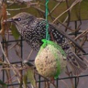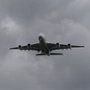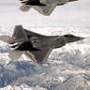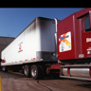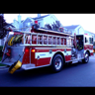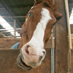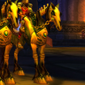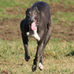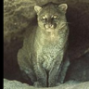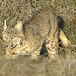

Description of Machine Learning Models and Training Analysis
To analyze the impact of model complexity on explainability, two distinct Convolutional Neural Network (CNN) architectures were implemented and evaluated. The contrast between these models serves to highlight how depth and pre-training influence feature extraction and decision-making.

Model Architectures
Model 1: SimpleCNN (Custom Architecture)
The first model is a lightweight, custom-built CNN designed to represent a baseline, low-complexity architecture trained from scratch.
- Architecture Scheme: It consists of three convolutional layers (with 3 x 3 kernels and padding), each followed by a ReLU activation function and a 2 x 2 Max Pooling layer. The flattened output is passed through two Fully Connected (Linear) layers, culminating in a 10-node output layer corresponding to the dataset classes.
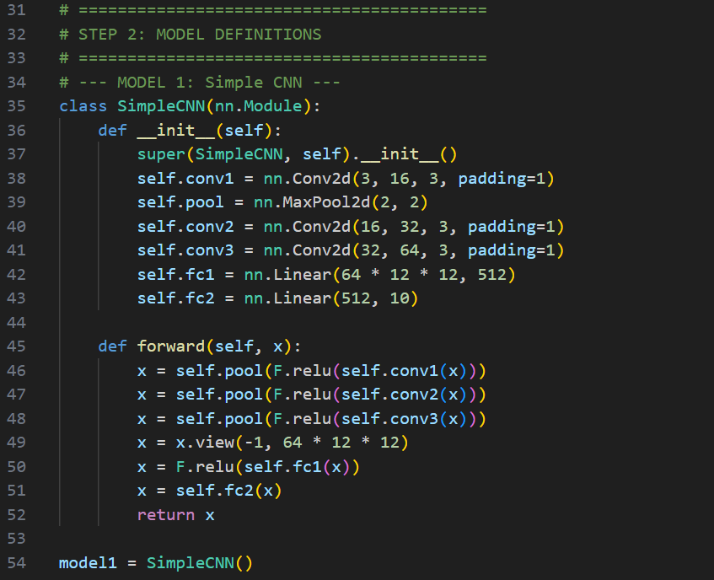
- Complexity: This model has a relatively small number of parameters. Due to its shallow depth, it is primarily capable of learning low-level spatial frequencies, broad color regions, and simple edges, making it highly susceptible to background noise.

Model 2: ResNet-18 (Deep Transfer Learning)
The second model utilizes the ResNet-18 architecture, representing a highly complex, deep network.
- Architecture Scheme: ResNet-18 consists of 18 deep layers utilizing residual block connections (skip connections) that mitigate the vanishing gradient problem, allowing the network to learn highly complex, non-linear representations.
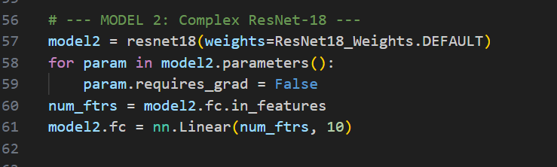
- Complexity & Pre-training: To establish a significant "complexity gap" between the two models, this network was initialized with pre-trained weights (trained on the massive ImageNet dataset). The early layers were frozen to retain their general feature-extraction capabilities, while the final fully connected layer was replaced and fine-tuned specifically for our 10 STL-10 classes.

Training Parameters
Both models were trained and evaluated using the same standardized parameters to ensure a fair comparison:
- Optimizer: Adam (Adaptive Moment Estimation) with a learning rate of 0.001.
- Loss Function: Cross-Entropy Loss, standard for multi-class classification tasks.
- Batch Size: 32 images per batch.
- Hardware: PyTorch with CUDA acceleration (NVIDIA GPU).
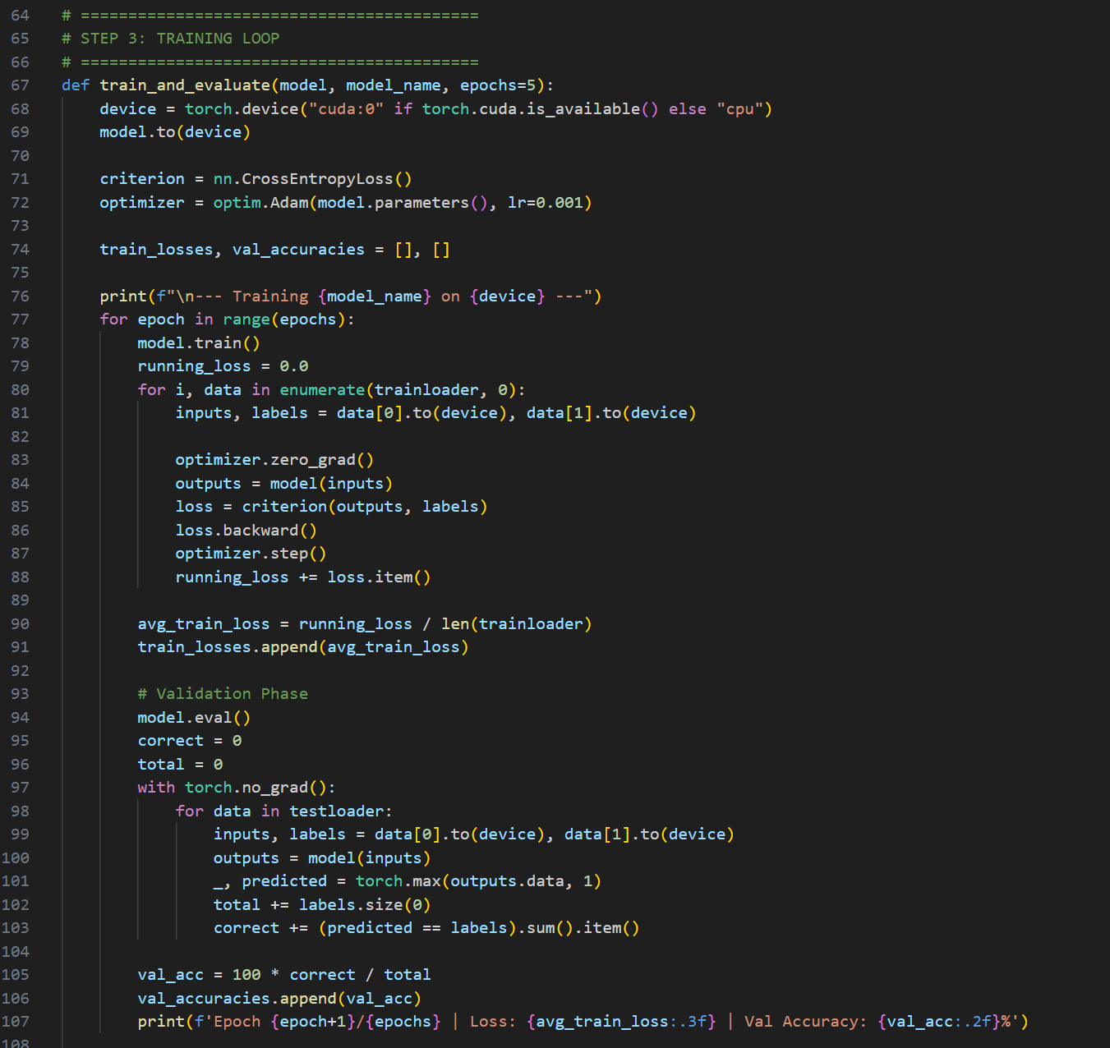

Training & Validation Curves Analysis
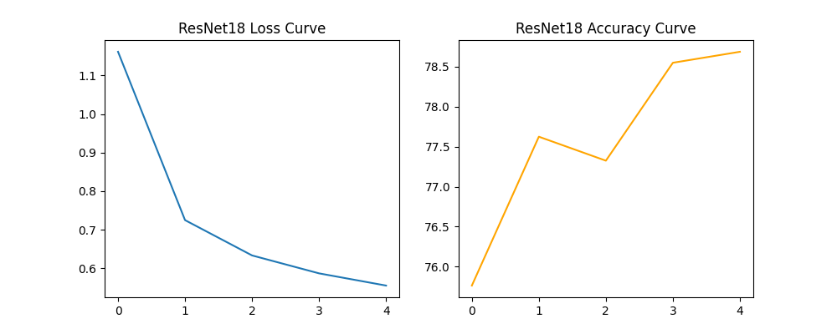
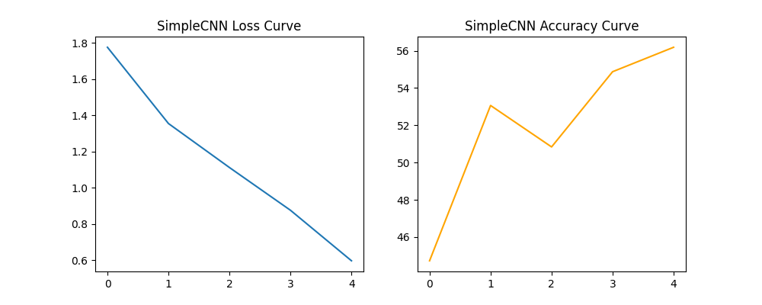
Figure 2: Training loss and validation accuracy curves for SimpleCNN (left) and pre-trained ResNet-18 (right).
As observed in the training curves, the SimpleCNN demonstrated standard learning behavior, with training loss steadily decreasing. However, its validation accuracy quickly plateaued around 56%. This indicates the model reached its maximum capacity for feature extraction relatively early; it simply lacks the depth to differentiate complex subjects.
Conversely, the ResNet-18 model started with a much lower initial loss and immediately achieved high validation accuracy, ultimately stabilizing near 79%. The pre-trained weights allowed the model to bypass the initial stages of learning basic edges and curves, immediately applying high-level semantic understanding to the new dataset.

Performance Metrics & Confusion Matrices
The performance metrics (Precision, Recall, and F1-Scores) and the resulting confusion matrices provide granular insight into the models' limitations:
- SimpleCNN Vulnerabilities: The confusion matrix for Model 1 reveals significant class overlap. The model struggled heavily to differentiate between visually similar classes in similar environments. For instance, it frequently confused "cat" with "dog," and "airplane" with "bird." Because the model relies on low-level features (like the blue background of a sky or the green background of grass), it cannot distinguish the physical anatomy of the subjects.
- ResNet-18 Robustness: Model 2 demonstrates a strong, distinct diagonal on its confusion matrix, indicating high precision across almost all classes. While minor confusion still exists (e.g., occasional misclassifications between four-legged animals like cats and dogs), the deep network successfully separates objects based on actual structural features rather than relying purely on background color palettes.
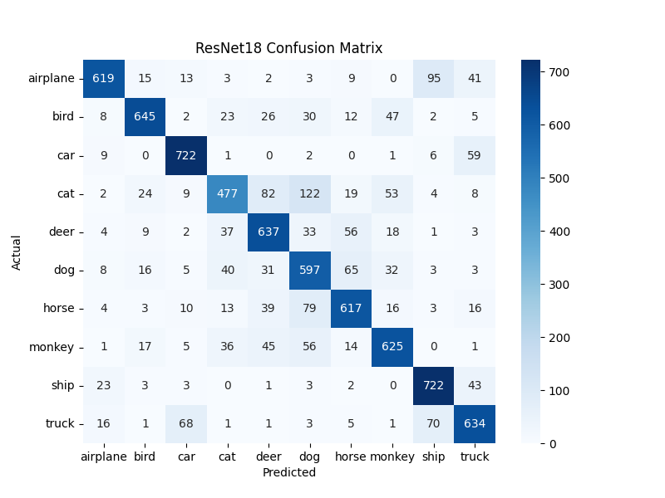
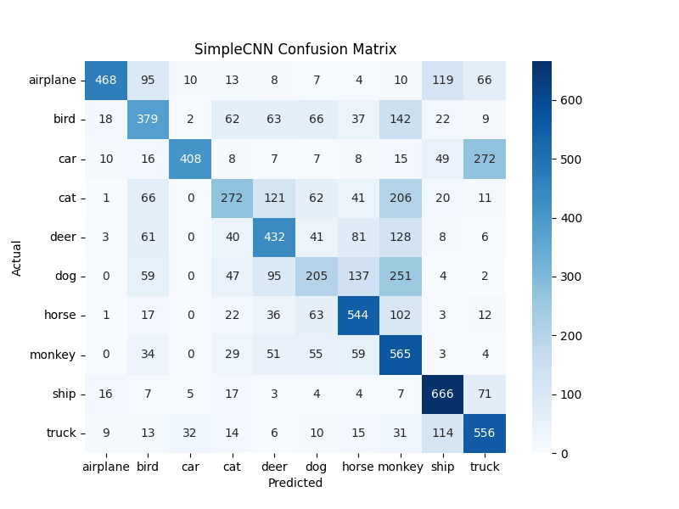
Figure 3: Confusion Matrices comparing class-wise predictive accuracy and error distribution between models.

Analysis of Local Explainability (Model 1 vs Model 2)
To understand the decision-making process of both models, local explainability analysis was performed on at least 15 instances from the test set (10 correctly classified and 5 misclassified). Three distinct local explanation methods were utilized: Grad-CAM, LIME, and RISE.

Insights on Explainability Methods
Each method provided a unique "lens" into the models' feature extraction:
- Grad-CAM (Gradient-weighted Class Activation Mapping): Provided smooth, continuous heatmaps by analyzing the gradients flowing into the final convolutional layer. It was highly effective at highlighting the general "center of attention" but sometimes lacked fine-grained boundaries.
- LIME (Local Interpretable Model-agnostic Explanations): Excelled at identifying specific structural boundaries by grouping pixels into "super-pixels." It clearly demonstrated whether the model cared about the geometric shape of the object or merely arbitrary patches of the background.
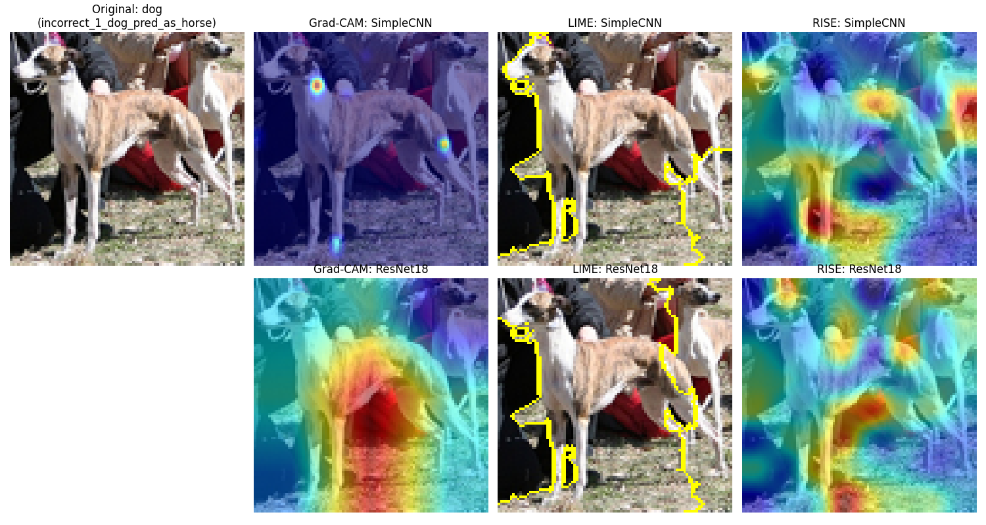
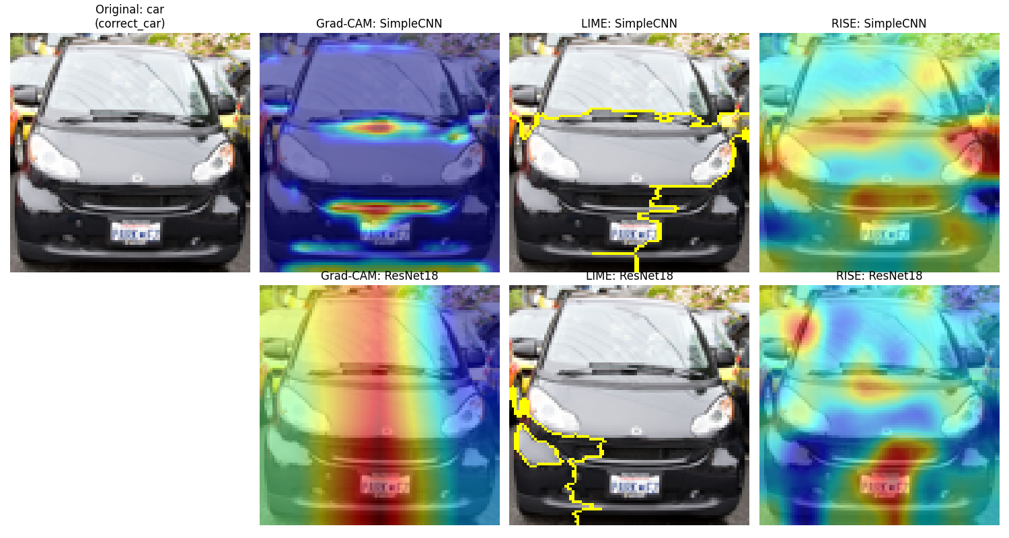
- RISE (Randomized Input Sampling for Explanation): Provided highly detailed, probabilistic heatmaps by passing thousands of randomly masked versions of the image through the network. It often captured smaller, finer details that Grad-CAM missed (such as highlighting a specific wheel or an animal's eye).

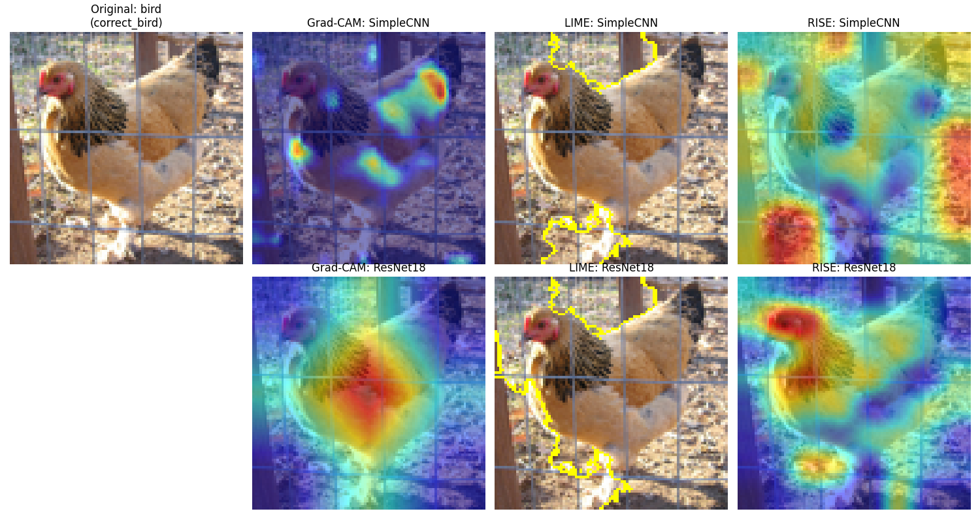
Figure 4: Local explainability comparison on correctly classified instances. Top row: SimpleCNN. Bottom row: ResNet-18.

Analysis of Correctly Classified Instances
Even when both models correctly classified an image, the explainability tools revealed a massive difference in how they arrived at the answer:
- SimpleCNN (The "Clever Hans" Effect): The visualizations expose a critical flaw in the SimpleCNN: it relies heavily on spurious background correlations rather than the subject itself. For example, when classifying a deer or a truck, the explainability tools showed the model focusing entirely on the green grass and trees. When classifying ships or airplanes, it looked primarily at the flat blue textures of the sky and water. This model cannot be trusted, as it is classifying the environment, not the object.
- ResNet-18 (Semantic Feature Focus): The deep model successfully learned true semantic features. For the car, it focused directly on the chassis and grill. For the horse, it targeted the eye and facial structure. The model correctly isolated the subjects from their backgrounds.

Analysis of Misclassified Instances

Analyzing misclassified instances provides the most compelling insights into the limitations of neural networks. We observed three primary categories of failure:

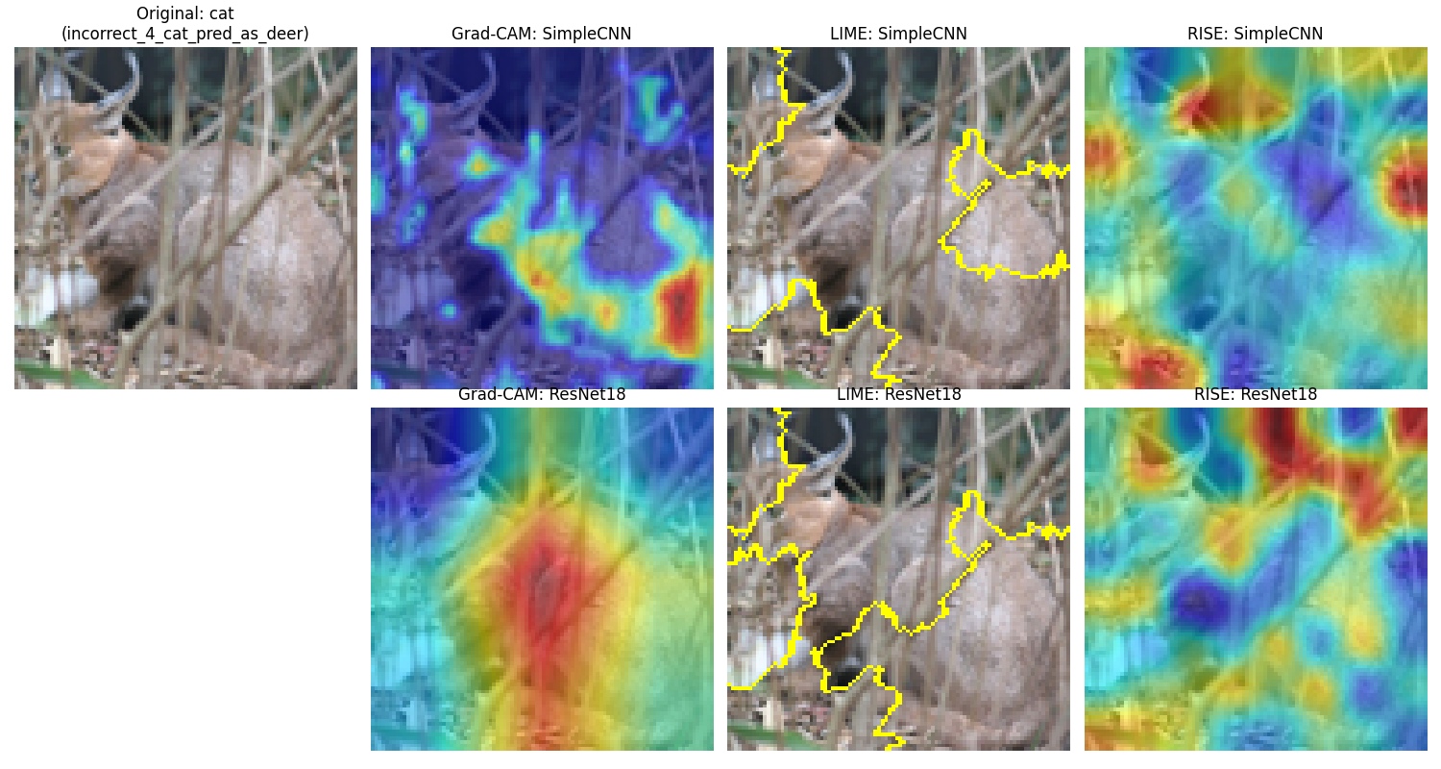
Figure 5: Diagnosing model failures on misclassified instances using local explainability.
- Context Confusion: In one instance (Deer predicted as Airplane), the deer was photographed running on a vast, flat, blue-white snowy path. ResNet-18's explainability heatmaps completely ignored the deer and focused intensely on the flat snow. The model incorrectly associated the vast, flat background texture with the sky, leading to an "Airplane" prediction.
- Semantic and Structural Overlap: In another instance, a Greyhound dog was predicted as a Horse. Grad-CAM and RISE focused perfectly on the torso and long, slender legs of the dog. Because a Greyhound's physical structure is remarkably similar to a horse's anatomy, the model made a logical error despite looking at the correct features.
- Feature Occlusion: When defining features (like a cat's face) were hidden behind thick branches or tall grass, the model was forced to rely on secondary, less reliable textures (like the brown fur blending into the woodland environment), leading to misclassifications like predicting a cat as a deer.

Complementary vs. Conflicting Explanations
- Complementary Explanations (ResNet-18): For the complex model, the three methods were highly complementary, significantly increasing our trust in the model. Grad-CAM would highlight an animal's face, RISE confirmed this with high-intensity spots in the exact same region, and LIME drew a neat super-pixel boundary right around those identical features. All three independent mathematical approaches agreed on what mattered.
- Conflicting Explanations (SimpleCNN): Conversely, for the simple model, the methods often yielded conflicting and chaotic results. Grad-CAM might highlight a reflection, LIME might grab a background fence, and RISE might highlight an empty corner. When explainability methods conflict in this manner, it is a strong quantitative indicator that the model's prediction is fragile and based on scattered noise rather than a unified concept.

Class Model Visualization and Analysis
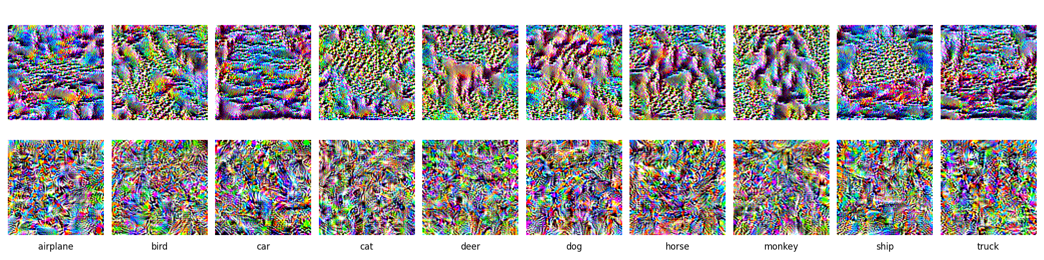
Unlike local explainability (which analyzes a single prediction), global explainability asks: "What does the model think the ideal representation of a class looks like?" To answer this, Activation Maximization was performed. Starting from random noise, gradient ascent was used to optimize the image pixels until the final output neuron for a specific class was maximized.
Figure 6: Global class model visualizations via Activation Maximization. Top row shows SimpleCNN's low-level feature dependency; Bottom row shows ResNet-18's high-level semantic texture extraction.
Comparing the two models side-by-side perfectly illustrates the architectural complexity gap:
- SimpleCNN (Low-Level Feature Dependency): The top row reveals that the simple model has primarily learned color palettes and basic repetitive textures. There are no distinct semantic shapes. The patterns are abstract and heavily biased by background colors (e.g., blue/teal for airplanes and ships, earthy greens for animals). This confirms the local explainability findings: the simple model classifies images by general color regions.
- ResNet-18 (High-Level Feature Extraction): The bottom row presents vastly more complex, high-frequency visual representations. While still abstract, there is clear evidence of high-level feature extraction. Classes like "Bird," "Cat," and "Dog" show intricate, repeating patterns mimicking feathers or fur, alongside faint structural shapes like eyes and beaks. Classes like "Car" and "Truck" exhibit sharper, geometric, and metallic-looking edges.

Conclusions
This project successfully demonstrates the critical importance of Explainable AI (XAI) in evaluating Machine Learning models. Relying purely on traditional performance metrics, such as accuracy or loss curves, provides an incomplete and potentially dangerous view of a model's reliability.
Through the application of Grad-CAM, LIME, RISE, and Activation Maximization, several key conclusions were reached:
- The Accuracy-Trust Fallacy: A model can arrive at the correct answer for the wrong reasons. The SimpleCNN frequently achieved correct classifications by exploiting background context (the "Clever Hans" effect), proving that accuracy does not inherently equal trust.
- The Complexity Gap: Deeper architectures utilizing transfer learning (ResNet-18) are fundamentally vastly superior at extracting true, high-level semantic features (shapes, distinct textures) rather than relying on low-level spatial frequencies and color biases.
- Robustness of XAI Tools: When a model is reasoning soundly, different explainability methods (gradient-based, perturbation-based, and sampling-based) provide complementary, overlapping explanations. When a model is guessing based on noise, these methods yield conflicting results.
Ultimately, visual explainability transforms models from opaque black boxes into transparent systems, allowing developers to diagnose systemic failures, debug architectural flaws, and ensure that AI systems deployed in the real world are making decisions based on sound, human-interpretable logic.

List of references
- Coates, A., Ng, A., & Lee, H. (2011). An analysis of single-layer networks in unsupervised feature learning. In Proceedings of the Fourteenth International Conference on Artificial Intelligence and Statistics (pp. 215-223). JMLR Workshop and Conference Proceedings. (STL-10 Dataset)
- Erhan, D., Bengio, Y., Courville, A., & Vincent, P. (2009). Visualizing higher-layer features of a deep network. University of Montreal, 1341(3), 1. (Activation Maximization / Class Model Visualization)
- He, K., Zhang, X., Ren, S., & Sun, J. (2016). Deep residual learning for image recognition. In Proceedings of the IEEE Conference on Computer Vision and Pattern Recognition (CVPR) (pp. 770-778). (ResNet-18 Architecture)
- Lapuschkin, S., Wäldchen, S., Binder, A., Montavon, G., Samek, W., & Müller, K. R. (2019). Unmasking Clever Hans predictors and assessing what machines really learn. Nature Communications, 10(1), 1096. (The "Clever Hans" effect in ML models)
- Petsiuk, V., Das, A., & Saenko, K. (2018). RISE: Randomized Input Sampling for Explanation of Black-box Models. In Proceedings of the British Machine Vision Conference (BMVC). (RISE Explainability Method)
- Ribeiro, M. T., Singh, S., & Guestrin, C. (2016). "Why should I trust you?" Explaining the predictions of any classifier. In Proceedings of the 22nd ACM SIGKDD International Conference on Knowledge Discovery and Data Mining (pp. 1135-1144). (LIME Explainability Method)
- Selvaraju, R. R., Cogswell, M., Das, A., Vedantam, R., Parikh, D., & Batra, D. (2017). Grad-CAM: Visual explanations from deep networks via gradient-based localization. In Proceedings of the IEEE International Conference on Computer Vision (ICCV) (pp. 618-626). (Grad-CAM Explainability Method)

