Indian Institute of Management Bangalore
PGP 2026-28 | Decision Sciences II

GoodBelly: Do In-Store Promotions Drive Sales?
A regression analysis of in-store demos, endcap placement and sales-rep coverage across 126 Whole Foods stores

Case Study Report
Group # [____]

Team member | Roll number
[Name 1] | [Roll no.]
[Name 2] | [Roll no.]
[Name 3] | [Roll no.]
[Name 4] | [Roll no.]
[Name 5] | [Roll no.]

Submitted: October 6, 2026 | Course: Decision Sciences II

Executive Summary
Problem. GoodBelly (a probiotic juice) must justify its in-store marketing spend. We use multiple regression on 1,386 store-week observations (126 Whole Foods stores, May 4 to July 13, 2010) to test whether regional sales reps, endcap displays and in-store demos raise weekly unit sales, and for how long.
Modelling. We first fitted a linear model with all eight variables (Model 1: R² = 0.67). Its residuals were skewed with heavy tails and showed autocorrelation (Durbin-Watson = 1.39), so it fails the regression assumptions. We then used stepwise regression on a pool of the eight variables plus 16 hand-picked interaction terms, and repeated the search on all 154 two-, three- and four-way products, which selected the identical model. Stepwise selected an Endcap × Rep interaction first, followed by Rep, the three demo dummies and Price, and rejected the neighbourhood variables. The resulting Model 2 has R² = 0.81 (adjusted 0.81), and its residuals are near-normal (skew -0.01, kurtosis 3.0) with Durbin-Watson = 2.11. The assumption problems of Model 1 came from the missing interaction, not from the scale of sales, so no log transformation is needed.
Key findings.
- Endcaps work only together with a regional rep. In stores with a regional rep an endcap adds about 454 units a week (95% CI 438 to 471). In stores without a rep the endcap effect is zero (p = 0.96). Average weekly units are 757 for endcap-with-rep versus 218 for endcap-without-rep.
- Demos work, and the lift persists. A demo adds 107 units in the demo week and about 73 per week in weeks 1-3 and 75 in weeks 4-5+ (all p<0.001). Weeks 1-3 and 4-5+ are not different (partial F p = 0.85), so there is no decay within five weeks. One demo yields about 476 extra units over six weeks.
- Regional sales reps help on their own: about +59 units a week, even without an endcap.
- Price matters, but demand is inelastic: each extra $1 lowers units by about 22 a week (elasticity at the mean about -0.36).
- Neighbourhood context and region do not matter once the promotion variables are in the model.
Recommendations. (1) Pay for endcaps only in stores with a regional rep, and extend rep coverage first; (2) keep funding demos and judge them over a six-week window, not demo-day sales; (3) do not rely on price cuts to drive volume; (4) test endcaps in a few more non-rep stores, because the no-rep result rests on only three stores; (5) collect store traffic and longer data to learn when the demo lift fades.

1. Understanding the Problem and the Data
GoodBelly is a start-up with no budget for national advertising, so it relies on in-store marketing at Whole Foods (about 75% of 2009 sales). By July 2010, management questioned whether demos boost sales at all, whether any boost is only temporary, and whether endcap promotions are worth it. We study three controllable levers: (a) a regional sales rep (face-to-face contact) versus the national rep only, (b) an endcap (end-of-aisle display), and (c) in-store demos. The data have 126 stores × 11 weekly observations (the case note says 10 weeks; the file has 11 distinct dates).
Variable | Description | Mean / share
Units (Y) | Units sold per store per week | 253.8 (SD 111; range 48-1,041)
Price | Average retail price ($) | 4.11 (SD 0.46)
Rep | 1 if regional sales rep | 55% of store-weeks
Endcap | 1 if endcap promotion | 3.8% (53 store-weeks, 12 stores)
Demo / Demo1-3 / Demo4-5 | Demo this week / 1-3 weeks ago / 4-5+ weeks ago | 5.8% / 15.7% / 7.6%
Natural, Fitness | Natural retailers / fitness centres within 5 miles | 1.45 / 2.48

Data checks. No missing values except Region (13 stores, unused in the main model). The three demo dummies mark how recently a store ran a demo (this week, 1-3 weeks ago, 4-5+ weeks ago); "no recent demo" is the base, and 34 store-weeks have more than one flag set because the store held repeat demos. Raw means hint at the story: store-weeks with a demo average 401 units against 245 without, and stores with a regional rep average 299 against 199 without. Regression is needed because these levers overlap.
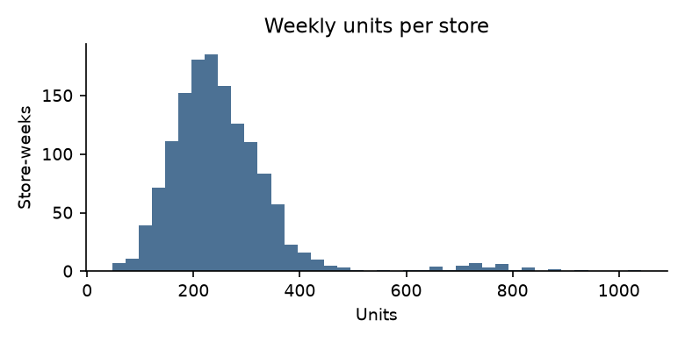
Figure 1. Distribution of weekly units per store-week (right-skewed).

2. Question 1: Model of Sales vs. Promotional Effort

2.1 Baseline model with all variables (Model 1)
Model 1: Units = β0 + β1·Price + β2·Rep + β3·Endcap + β4·Demo + β5·Demo1-3 + β6·Demo4-5 + β7·Natural + β8·Fitness + ε, estimated by OLS on all 1,386 observations.
Variable | Coef. | Std. err. | t-stat | p-value | Std. beta
Intercept | 298.49*** | 16.18 | 18.44 | <0.001 | -
Average retail price ($) | -28.54*** | 3.95 | -7.22 | <0.001 | -0.12
Regional sales rep (1/0) | 77.44*** | 3.86 | 20.04 | <0.001 | 0.35
Endcap promotion (1/0) | 305.10*** | 9.06 | 33.69 | <0.001 | 0.53
Demo this week (1/0) | 111.13*** | 7.40 | 15.01 | <0.001 | 0.23
Demo 1-3 weeks ago (1/0) | 73.52*** | 4.90 | 15.02 | <0.001 | 0.24
Demo 4-5+ weeks ago (1/0) | 67.57*** | 6.54 | 10.33 | <0.001 | 0.16
Natural retailers within 5 mi | -1.59 | 1.78 | -0.90 | 0.370 | -0.01
Fitness centres within 5 mi | -1.02 | 1.08 | -0.94 | 0.347 | -0.01
R² / adj. R² / F | 0.673 / 0.671 / 353.7 |  |  | <0.001

Reading Model 1. The model explains 67% of the variance and the overall F-test is significant (F = 353.7, p<0.001). Holding other factors constant, an endcap adds about 305 units a week, a regional rep 77, a demo 111 in the demo week and 74 and 68 in the weeks after, and each extra $1 of price removes 29 units. Natural retailers and fitness centres are not significant (p = 0.37, 0.35). Section 3 shows that Model 1 fails its assumption checks, so we do not stop here.

2.2 Building the final model by stepwise regression (Model 2)
Rather than choose variables ourselves, we let forward stepwise regression pick them (as taught in class). The candidate pool is the eight variables plus 16 interaction terms (rep, endcap and price crossed with the demo stages, and rep or endcap crossed with each other and with the neighbourhood variables). At each step the variable with the largest partial correlation with units enters if its partial F-test gives p < 0.05 (p-in), and any variable already in is removed if p > 0.10 (p-out).
Step | Variable entered | t-stat | p-value | R² | Adj. R² | ΔR²
1 | Endcap × Rep (1 only if both) | 41.0 | <0.001 | 0.548 | 0.548 | 0.548
2 | Regional sales rep (1/0) | 22.1 | <0.001 | 0.666 | 0.666 | 0.118
3 | Demo 1-3 weeks ago (1/0) | 16.6 | <0.001 | 0.722 | 0.722 | 0.056
4 | Demo this week (1/0) | 16.7 | <0.001 | 0.769 | 0.768 | 0.047
5 | Demo 4-5+ weeks ago (1/0) | 14.3 | <0.001 | 0.798 | 0.798 | 0.030
6 | Average retail price ($) | -7.3 | <0.001 | 0.806 | 0.805 | 0.007

Exhaustive check. To make sure we did not miss a better combination, we repeated stepwise on a pool containing every two-, three- and four-way product of the eight variables (154 terms, 108 usable after dropping terms that are non-zero in fewer than 10 rows). The selected model is identical in all four pools (main effects only; plus two-way; plus two- and three-way; plus all up to four-way). Adding each of the 117 remaining terms to Model 2 one at a time, none is significant (smallest p = 0.09; about 6 would be expected to pass at 5% by chance alone). In 10-fold cross-validation with whole stores held out, Model 2 has the lowest prediction error (RMSE 49.1 units against 68.0 for Model 1), ties with a lasso on all terms (49.5) and beats gradient boosting (50.4) and random forest (52.6). Putting all 108 terms into one ordinary regression overfits badly (RMSE 305).
What stepwise told us. The Endcap × Rep interaction enters first and alone explains 55% of the variation. The plain Endcap variable never enters; once the interaction is in, adding Endcap back is insignificant (p = 0.96). Rep, the three demo dummies and Price follow. Natural, Fitness and all other interactions are never selected (Section 6). No variable was removed at any step. Running stepwise on the eight main effects only gives a model with R² = 0.67 and the same assumption problems as Model 1; adding the single interaction raises R² from 0.67 to 0.81.
Variable | Coef. | Std. err. | p-value | 95% CI | Std. beta
Intercept | 276.58*** | 12.16 | <0.001 | 252.7 to 300.4 | -
Endcap × Rep (1 only if both) | 454.42*** | 8.47 | <0.001 | 437.8 to 471.0 | 0.65
Regional sales rep (1/0) | 59.44*** | 2.99 | <0.001 | 53.6 to 65.3 | 0.27
Demo this week (1/0) | 106.76*** | 5.70 | <0.001 | 95.6 to 117.9 | 0.23
Demo 1-3 weeks ago (1/0) | 73.38*** | 3.76 | <0.001 | 66.0 to 80.8 | 0.24
Demo 4-5+ weeks ago (1/0) | 74.56*** | 5.03 | <0.001 | 64.7 to 84.4 | 0.18
Average retail price ($) | -22.06*** | 3.04 | <0.001 | -28.0 to -16.1 | -0.09
R² / adj. R² / F | 0.806 / 0.805 / 954.0 |  | <0.001

Model 2: Units = 276.6 + 454.4·(Endcap × Rep) + 59.4·Rep + 106.8·Demo + 73.4·Demo1-3 + 74.6·Demo4-5 − 22.1·Price.
Observations.
- Endcap × Rep = 454: the endcap adds about 454 units a week, but only in stores that also have a regional rep. It has the largest standardised beta (0.65).
- Rep = 59: a regional rep adds about 59 units a week on its own. In an endcap store with a rep the combined gain is about 514 units.
- Demo stages: about +107 units in the demo week and about +73 and +75 afterwards. Price: each extra $1 removes about 22 units; at the mean this is an elasticity of -0.36, so a 10% price cut raises units only about 3.6%.
- Natural retailers and fitness centres are not selected: nearby competition or health-conscious traffic does not explain sales once promotions are controlled.
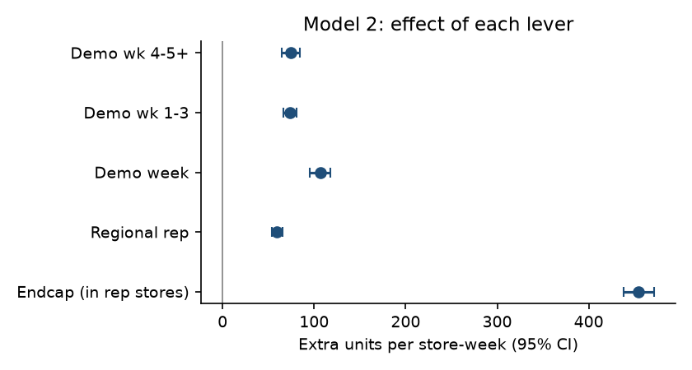
Figure 2. Effect of each lever in extra units per store-week, with 95% confidence intervals (Model 2).

3. Question 2: Do the Regression Assumptions Hold?
We checked each assumption of linear regression on Model 1 and on the stepwise Model 2, using residual plots, P-P/Q-Q plots, the Durbin-Watson statistic, VIFs and outlier measures.
Assumption | Check | Model 1 (all variables) | Model 2 (stepwise) | Verdict
Linearity / constant variance | Residuals vs fitted | Uneven; block of large negative residuals at high fitted values | Centred on zero, even spread | M2 satisfactory
Independence | Durbin-Watson | 1.39 | 2.11 | M2 close to 2
Normality | P-P / Q-Q, skew, kurtosis | skew -0.93, kurt 8.5 | skew -0.01, kurt 3.0 | M2 near-normal
No multicollinearity | Max VIF | 1.26 | 1.27 | No problem
Outliers / influence | |Std. residual| > 3; Cook's D | 23 outliers; max D 0.10 | 5 outliers; max D 0.02 | None influential

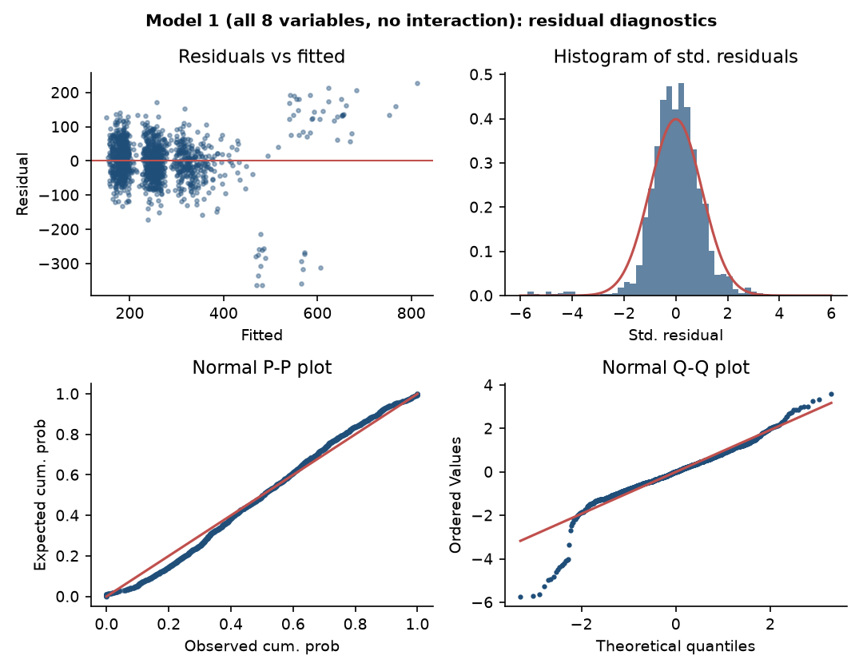
Figure 3. Model 1 diagnostics: uneven residual spread, a block of large negative residuals and a heavy left tail in the Q-Q plot.
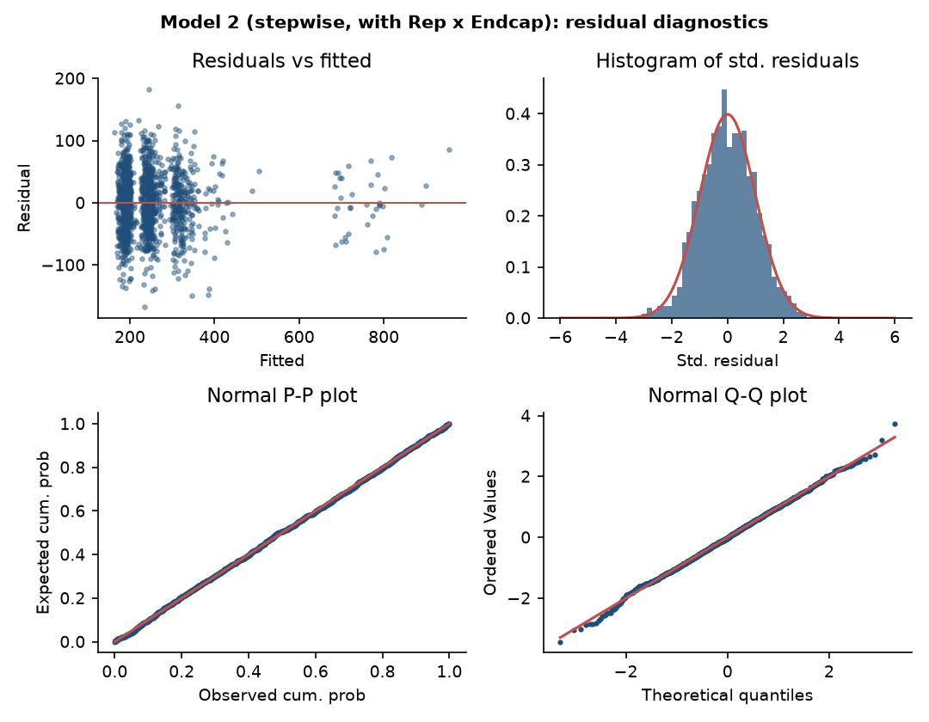
Figure 4. Model 2 diagnostics: residuals are centred on zero with even spread and the P-P and Q-Q plots follow the diagonal.
Conclusion on assumptions. Model 1 fails; Model 2 satisfies the assumptions reasonably well.
- Linearity / constant variance: in Model 1 a block of large negative residuals (down to about -370 units) sits among the high-fitted store-weeks. They are the endcap weeks in the three stores without a regional rep (Bethesda, Coral Gables, Sarasota), which the model wrongly expected to sell hundreds of extra units. Adding the Endcap × Rep interaction removes this pattern. In the language of omitted variable bias, the missing interaction made Model 1 mis-specified.
- Independence: each store appears 11 times, so autocorrelation is a concern. Durbin-Watson is 1.39 for Model 1 (positive autocorrelation) and 2.11 for Model 2, essentially the no-autocorrelation value of 2. (The data are stacked store by store, so this is a rough check.)
- Normality: Model 2 residuals have skew -0.01 and kurtosis 3.05, almost exactly normal (0 and 3), against -0.93 and 8.5 for Model 1.
- Multicollinearity: all VIFs are below 1.3 (rule of thumb: a problem above 4). Rep and the Endcap × Rep term do not inflate each other (VIFs 1.27 and 1.05).
- Outliers and leverage: only 5 store-weeks have standardised residuals beyond ±3 (against 23 in Model 1). 194 points exceed the leverage cut-off 2(k+1)/n = 0.010, and the five highest-leverage points are all endcap-with-rep weeks (Pearl, Redmond, Redwood City, Roosevelt Square), but the maximum Cook's distance is only 0.02, far below 1. No observation is influential.
Additional analysis performed to verify the model: (i) stepwise selection with interaction terms; (ii) a partial F-test showing the Endcap × Rep interaction is highly significant (F = 944, p<0.001); (iii) tests that Natural and Fitness, Region and all other interactions add nothing (Section 6); (iv) a log version of Model 2, which is worse (R² 0.61, kurtosis 5.8), so we keep units on the original scale.

4. Question 3: Does the Demo Program Boost Sales, and for How Long?
Yes. In Model 2 all three demo coefficients are positive and significant (p<0.001), holding rep, endcap and price fixed.
Period relative to demo | Extra units per store-week | 95% CI | p-value
Demo week | 107 | 96 to 118 | <0.001
Weeks 1-3 after | 73 | 66 to 81 | <0.001
Weeks 4-5+ after | 75 | 65 to 84 | <0.001

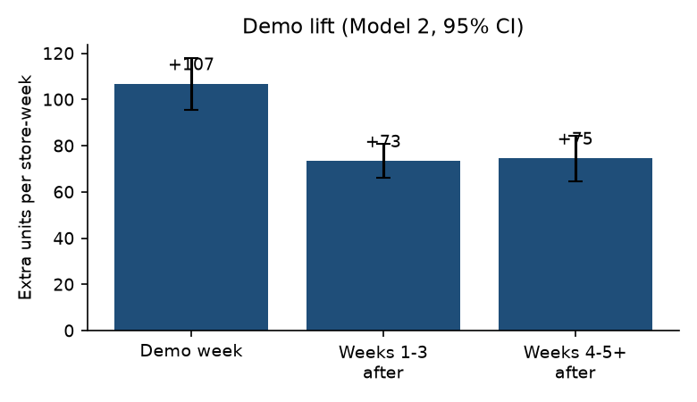
Figure 5. Demo lift by period (Model 2, 95% confidence intervals).
How long does the lift last? The lift is largest in the demo week (107 units), then settles at about 73-75 units and stays there in weeks 4-5+. A partial F-test shows that Demo1-3 and Demo4-5 are not different (F = 0.04, p = 0.85), whereas the demo week is significantly higher than the weeks after (Demo vs Demo1-3: F = 24.0, p<0.001). So: an immediate spike, then a durable lift of about 75 units a week that has not decayed by week 5. The last category is open-ended ("at least 4-5 weeks") and the window is short, so we know the effect lasts at least five weeks but not when it ends.
Payoff per demo. Over the six weeks (the demo week, three weeks of Demo1-3 and two of Demo4-5) a demo yields about 107 + 3×73 + 2×75 ≈ 476 extra units, of which only about 22% falls in the demo week. Judging demos on demo-day sales alone understates their value by a factor of about four.
Caveat: demos were not randomly assigned. Management moved demos to higher-traffic Whole Foods stores, so some of the lift may reflect store quality. This is an association, and the true causal effect may be somewhat smaller.

5. Question 4: Does In-Store Placement Affect Sales?
Yes, but only when a regional rep is present. Endcap placement is the largest lever, yet its effect depends entirely on rep coverage. Of the 53 endcap store-weeks, 36 are in 9 stores with a regional rep and 17 are in 3 stores without one (Bethesda, Coral Gables, Sarasota).
Store-week group | Store-weeks | Avg weekly units
No endcap, no rep | 607 | 198
No endcap, regional rep | 726 | 276
Endcap, no rep | 17 | 218
Endcap, regional rep | 36 | 757

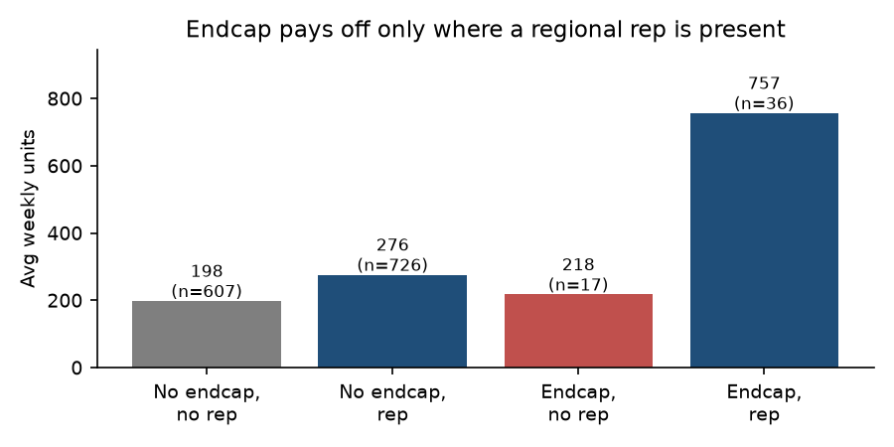
Figure 6. Average weekly units by endcap and sales-rep coverage. An endcap without a rep shows no lift.
Regression result. After controlling for the other variables, an endcap adds 454 units a week in rep stores (95% CI 438 to 471, p<0.001) and about zero in non-rep stores (coefficient 0.6, p = 0.96). The combined effect of rep and endcap is about 514 extra units a week.
Other placement-related factors we tested. None of the other 15 interaction terms is significant when added to Model 2 (p-values between 0.15 and 0.95); in particular Endcap × Demo (p = 0.27) and Rep × Demo (p = 0.77) are insignificant, so demos work equally with or without an endcap or a rep. The ten Region dummies are jointly insignificant (partial F = 0.89, p = 0.54).
Caution. The no-rep result rests on only 3 stores and 17 store-weeks. It is a clear and large difference, but it should be confirmed with more endcaps in non-rep stores. A plausible reason (not tested here) is that a regional rep sets up and maintains the display and keeps the shelf stocked.

6. Question 5: Improving and Refining the Model
The table summarises the refinements we tried and what each told us.
Refinement | What we did | Result
Stepwise selection | Forward, p-in 0.05 / p-out 0.10, 8 variables + 16 interactions | Selected 6 terms; R² 0.67 → 0.81
Endcap × Rep interaction | Added to Model 1; partial F-test | F = 944, p<0.001; fixes the residual problems
Other 15 interactions | Added one at a time to Model 2 | All insignificant (p 0.15 to 0.95)
All 2-, 3-, 4-way products | Stepwise on 154 terms; each term added to Model 2; 10-fold CV | Same model selected; none of 117 terms significant; best prediction error (RMSE 49.1)
Natural and Fitness | Added back; partial F-test | F = 0.04, p = 0.96; excluded
Plain Endcap term | Added back to Model 2 | p = 0.96; excluded
Region dummies | 10 dummies; partial F-test | p = 0.54; adj. R² 0.805 → 0.805; not needed
Log transformation | Same 6 terms on ln(units) | R² 0.61, kurtosis 5.8; worse, so not used

Further suggestions:
- Add explanatory variables: store size or foot traffic (a likely omitted variable, since demos and endcaps went to bigger stores), competitor prices and promotions, and holidays (the July 4 week is in the window). Omitted variables could bias the lever coefficients.
- Strengthen the endcap-with-rep finding: collect more endcap weeks in stores without a rep, and record whether the display was actually stocked and set up.
- Model decay more finely: replace Demo1-3 and Demo4-5 with a separate dummy for each week since the demo, using a longer data period.
- Randomise demos, endcaps and reps across comparable stores in a pilot so the effects can be read as causal.
- Clean the data: Region is missing for 13 stores, the data note says 10 weeks but the file has 11, and Rep and Natural change over time in a few stores (confirm these are real changes).

7. Question 6: Managerial Implications and Recommendations
- Pair every endcap with a regional rep. An endcap adds about 454 units a week in rep stores and nothing elsewhere. Do not pay for endcaps in stores without face-to-face coverage; extend rep coverage first, then place endcaps. Combined, rep plus endcap is worth about 514 units a week.
- Keep and extend the demo programme, and measure it over six weeks. One demo is worth about 476 extra units, most of which arrive after demo day. Evaluate demos on cumulative lift, not demo-week sales, and compare that gain with the cost per demo. Demos work with or without a rep or endcap, so they remain the most flexible lever.
- Put regional reps where there are none. About 55% of store-weeks already have face-to-face coverage and a rep alone adds about 59 units a week. Roll out to uncovered stores in waves, which also gives a natural comparison group.
- Do not rely on price cuts. With an elasticity near -0.4, a 10% price cut raises units only about 3.6%, so revenue falls. Use price for margin, not volume.
- Do not target stores by neighbourhood or region. The number of nearby natural retailers or gyms, and the region, do not predict sales once promotions are in the model; target by store traffic.
- Close the data gaps. Record store traffic, display execution and competitor activity, add endcap tests in non-rep stores, and extend tracking beyond 11 weeks to see when the demo effect fades.
Limitations. Observational data, 11 weeks, one retailer, only 53 endcap store-weeks (and only 17 without a rep), and non-random assignment of demos, endcaps and reps. The direction of the findings is clear; the exact magnitudes are less certain.

Appendix A. Supporting Results

A1. Model 1 plus the Endcap × Rep interaction (all variables kept)
Variable | Coef. | Std. err. | p-value
Intercept | 275.86*** | 12.49 | <0.001
Average retail price ($) | -22.09*** | 3.05 | <0.001
Regional sales rep (1/0) | 59.38*** | 3.03 | <0.001
Endcap promotion (1/0) | 0.47 | 12.12 | 0.969
Demo this week (1/0) | 106.77*** | 5.71 | <0.001
Demo 1-3 weeks ago (1/0) | 73.39*** | 3.77 | <0.001
Demo 4-5+ weeks ago (1/0) | 74.58*** | 5.04 | <0.001
Natural retailers within 5 mi | 0.21 | 1.37 | 0.876
Fitness centres within 5 mi | 0.22 | 0.84 | 0.796
Endcap × Rep (1 only if both) | 454.06*** | 14.78 | <0.001
R² / adj. R² | 0.806 / 0.805

With the interaction in the model, the plain Endcap coefficient is essentially zero (p = 0.97), as are Natural and Fitness. This is why stepwise removes them.
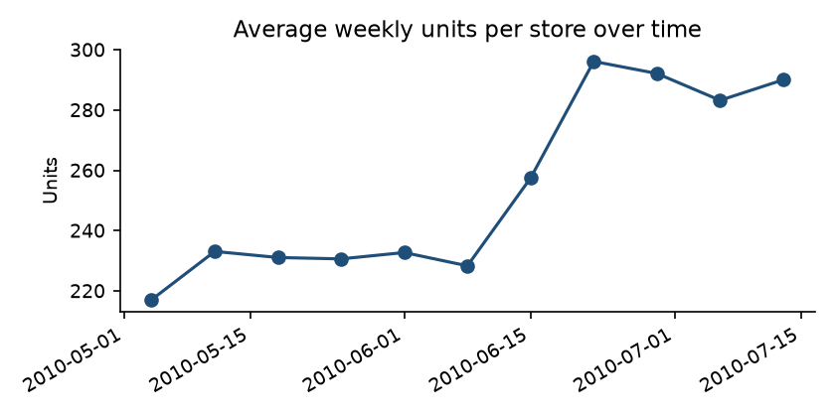
Figure A1. Average weekly units per store over the 11 weeks.
Significance: * p<0.05, p<0.01, * p<0.001. Supporting files in the submission folder: GoodBelly_Analysis.xlsx (data, coefficient tables, diagnostics), analysis.py and fig/ (code and charts).

