Indian Institute of Management Bangalore | PGP 2026-28 | Decision Sciences II

GoodBelly Case Study
Group walkthrough: the full analysis, step by step
Concepts explained in plain English, with the session slides behind each one

Use this document to... | Where
Understand the whole story in 5 minutes | Part 1
Re-read the case and the data | Parts 2-3
Follow how every number was built (with slide references) | Part 4
Look up any concept and find its slide | Part 5
Prepare for questions from the professor | Part 6
Re-run the work yourself (Excel or Python) | Part 7

Slide references use the course PDFs: "S3 p.34" means Session 3 slides, slide 34 (the slide number printed at the bottom of each slide).

Part 1. The story in five minutes
The question. GoodBelly is a start-up selling probiotic juice in Whole Foods. It spends most of its small marketing budget on in-store demos, and its sales reps compete to win endcap displays. In July 2010 management wanted to cut anything that did not clearly raise sales. Our job: use regression to show whether demos, endcaps and regional sales reps work, and for how long.
The data. 126 stores × 11 weeks = 1,386 store-weeks. For each: units sold, price, whether the store had a regional rep, an endcap, a demo (this week, 1-3 weeks ago, or 4-5+ weeks ago), and how many natural-food stores and fitness centres are nearby.
What we did, in four moves.
- Move 1: a first model with everything (Model 1). It fits well (R² = 0.67) but fails the regression checks: the residuals are uneven, skewed and correlated (Durbin-Watson = 1.39).
- Move 2: let the data tell us what is missing. We used stepwise regression, offering it the original variables plus interaction terms. It picked one thing first, an Endcap × Rep interaction: an endcap only works where a regional rep is present.
- Move 3: the final model (Model 2). With that interaction, R² rises to 0.81 and every assumption check passes (Durbin-Watson 2.11, skew -0.01, kurtosis 3.0).
- Move 4: stress-test it. We searched all 154 possible two-, three- and four-way interactions, tried transformations, trends, dummies and outlier removal. Nothing beat Model 2.
The final model.
Units = 276.6 + 454.4·(Endcap × Rep) + 59.4·Rep + 106.8·Demo + 73.4·Demo1-3 + 74.6·Demo4-5 − 22.1·Price
The answers.
Question | Answer
1. Model of sales vs promotions | Model 2 above (R² 0.81)
2. Do the assumptions hold? | Model 1 no; Model 2 yes, reasonably well
3. Do demos work, and for how long? | Yes. +107 units in the demo week, about +73 to +75 a week afterwards, no fade by week 5. One demo is worth about 476 extra units
4. Does placement matter? | Yes, but only with a regional rep: an endcap adds about 454 units a week there and nothing without one
5. How to improve the model? | Model 2 is already about as good as this data allows; more data (store traffic, more endcap tests) is the real improvement
6. What should management do? | Pair endcaps with reps, keep demos (judge over six weeks), do not use price cuts for volume

Part 2. The case in one page
- Company: GoodBelly, made by NextFoods (Colorado), launched January 2008. Organic, dairy-free, vegan juice with a live probiotic culture (Lp299v). It sells at Whole Foods and Safeway.
- Market: the global probiotics market was about $15.4B in 2008 and growing 5-30% a year, against 1-2% for food overall. Dannon's Activia is the best-known competitor.
- Strategy: a small budget, no national advertising, so GoodBelly invests in in-store demos because it believes trial drives sales. The demo programme started in November 2009 and was narrowed to Whole Foods (about 75% of 2009 sales) because smaller stores lacked foot traffic. A demo is a 3-hour tasting by a trained part-time rep, with samples and coupons.
- Endcap competition: the five sales reps compete to get the most stores to place GoodBelly on the endcap (the end-of-aisle display). The winning rep gets a big-screen TV, and stores compete for the best-decorated endcap.
- The problem (July 2010): management wanted to cut spending that did not clearly drive results. Three doubts: do demos boost sales at all? Is the boost only temporary? Does the extra volume justify the cost? The same doubts applied to endcaps.
- Our role: the marketing manager (Marty Wellbeing) asked the intern (Caroline Dickerson) for a statistical case that the CFO would accept.

The data
Variable | What it is | Type
Units (Y) | Units sold per store per week | Number
Price | Average retail price | Number
Rep | 1 = regional sales rep (face-to-face); 0 = national rep only | Dummy
Endcap | 1 = store ran an endcap promotion | Dummy
Demo | 1 = demo this week | Dummy
Demo1-3 (D13) | 1 = a demo 1-3 weeks ago | Dummy
Demo4-5 (D45) | 1 = a demo 4 or more weeks ago | Dummy
Natural, Fitness | Natural retailers / fitness centres within 5 miles | Number

Things to know about the data. (1) The data note says 10 weeks but the file has 11 dates. (2) Only 53 store-weeks (3.8%) have an endcap, in 12 stores. (3) The three demo dummies mark how recently a store ran a demo; "no recent demo" is the base, and 34 rows have more than one flag set because stores held repeat demos. (4) Region is missing for 13 stores, so it is not used in the main model.
Slides: dummy variables and the base category: S5 p.50-51, S6 p.11-13, S6 p.24-28.

Part 3. The tools in two paragraphs
Regression finds the line (or plane) that best predicts Y from the X variables, by minimising the sum of squared errors (OLS). Each coefficient says how much Y changes when that X rises by one unit, holding the other X variables fixed. That "holding fixed" idea (called *control*) is what lets us separate the effect of demos from endcaps from reps even though they overlap.
Slides: SLR and OLS: S2 p.9-18. Multiple regression and "control": S4 p.2-3, S4 p.17-22, S5 p.9-11, S6 p.2-6.
Checking a model means testing whether the assumptions behind the p-values are true: the errors should have mean zero, constant variance, no correlation with each other, and a normal shape. If they fail, the standard errors and p-values cannot be trusted, even if R² looks good. We check with residual plots, a normal Q-Q/P-P plot, and the Durbin-Watson statistic.
Slides: assumptions: S3 p.45 (summary table) and S5 p.20. Residual plots: S2 p.30, S3 p.34-43. Autocorrelation and Durbin-Watson: S3 p.44, S8 p.33-37.

Part 4. How we built the analysis, step by step
Each step has the same layout: what we did, why, the slides behind the concept, how to do it in Excel, and what we got. You can follow along with the dataset in Excel.

Step 1: Look at the data first
What we did. We summarised each column (mean, spread, range) and compared raw averages.
Why. You must know the shape of Y and spot problems before modelling. Raw averages hint at the story but cannot separate overlapping levers.
Slides: correlation and covariance (ideas of association): S1 p.11-16; correlation is not causation: S1 p.28.
How (Excel). Data → Data Analysis → Descriptive Statistics on Units; Insert → Histogram.
What we got. Units average 254 (range 48 to 1,041) and are right-skewed. Store-weeks with a demo average 401 units against 245 without. Endcap weeks average 584 against 241. But these gaps overlap: a store can have a demo, an endcap and a rep at once.

Step 2: Build Model 1: regress Units on all eight variables
What we did. We ran multiple regression of Units on Price, Rep, Endcap, Demo, Demo1-3, Demo4-5, Natural and Fitness.
Why. It is the natural first model and a baseline that we can test.
Slides: MLR model: S4 p.2-3; Excel output blocks (R², ANOVA, coefficients): S2 p.26-29; overall F-test: S5 p.21; t-test for each coefficient: S3 p.17-23, S5 p.22.
How (Excel). Data → Data Analysis → Regression. Y range = Units. X range = the eight columns side by side. Tick Labels, Residuals, Residual Plots, Normal Probability Plots.
What we got. R² = 0.673, adjusted R² = 0.671, F = 354 (p<0.001), standard error 63.7 units.
Variable | Coefficient | t | p-value
Price | -28.5 | -7.2 | <0.001
Rep | 77.4 | 20.0 | <0.001
Endcap | 305.1 | 33.7 | <0.001
Demo | 111.1 | 15.0 | <0.001
Demo1-3 | 73.5 | 15.0 | <0.001
Demo4-5 | 67.6 | 10.3 | <0.001
Natural | -1.6 | -0.9 | 0.370
Fitness | -1.0 | -0.9 | 0.347

How to read it. The overall F-test (H₀: all slopes = 0) says the model is useful. Each t-test (H₀: that coefficient = 0) says whether the variable matters: p < 0.05 means yes. For example, "holding the others fixed, an endcap adds about 305 units a week." Natural and Fitness have p ≈ 0.35, so they add nothing. Remember (S5 p.23-25) that these t-tests are *conditional* on the other variables being in the model, so you never drop two variables on t-tests alone.

Step 3: Compare the levers with standardised coefficients
What we did. We converted each coefficient to a standardised beta (b × SD of X ÷ SD of Y).
Why. Raw coefficients are in different units (dollars vs yes/no), so you cannot compare 305 (Endcap) with 28 (Price). Standardising puts them on one scale.
Slides: standardised coefficients and the Bendrix trap: S5 p.30-34.
How (Excel). Compute b × STDEV(X) / STDEV(Y) for each variable (SPSS and JASP report it directly).
What we got. Endcap 0.53 > Rep 0.35 > Demo1-3 0.24 ≈ Demo 0.23 > Demo4-5 0.16 > Price -0.12. Endcap is the strongest lever and price the weakest.

Step 4: Check for multicollinearity (VIF)
What we did. We regressed each X on the other X variables and computed VIF = 1 / (1 − R²).
Why. If predictors move together, their standard errors blow up and t-tests mislead. Rule of thumb: VIF above 4 is a problem.
Slides: multicollinearity and VIF: S4 p.41-45; the rule that no X should be a linear combination of others: S5 p.20.
How (Excel). For each X, run a regression of that X on the rest; take R²; VIF = 1/(1−R²).
What we got. All VIFs are between 1.02 and 1.26 (the highest is Rep). No multicollinearity.

Step 5: Check the regression assumptions on Model 1 (Question 2)
What we did. We plotted residuals against fitted values, drew a histogram and P-P/Q-Q plots of the residuals, and computed Durbin-Watson, skew and kurtosis.
Why. The p-values are only trustworthy if the assumptions hold. A high R² does not guarantee that.
Slides: residuals vs X: S2 p.30; homoscedasticity and heteroscedasticity: S3 p.34-36, S8 p.39-40; normality and Q-Q plot: S3 p.42-43; autocorrelation: S3 p.44; Durbin-Watson: S8 p.35-37; summary of assumptions: S3 p.45, S5 p.20.
How (Excel). Tick Residual Plots and Normal Probability Plots in the Regression dialog. Durbin-Watson = SUMXMY2 of consecutive residuals ÷ SUMSQ of residuals.
What we got. Model 1 fails: the residuals have uneven spread and a block of very negative values (down to about -370 units); Durbin-Watson is 1.39 (ideal is 2; below 2 means positive autocorrelation); skew -0.93, kurtosis 8.5 (a normal distribution has 0 and 3).
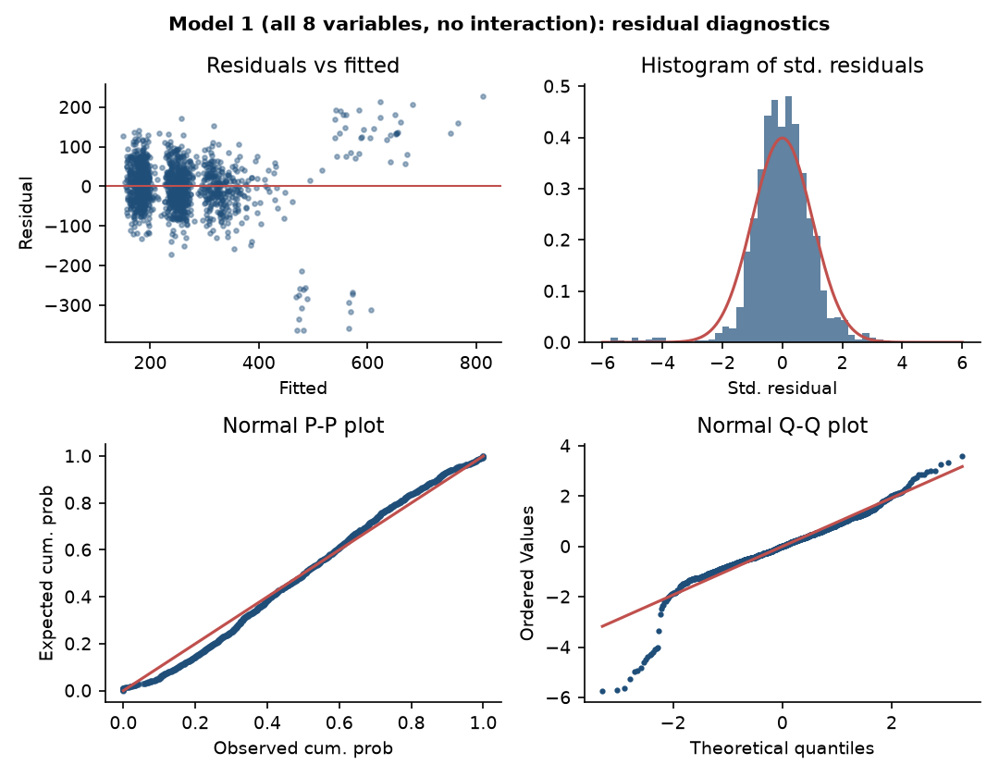
Figure 1. Model 1 diagnostics: uneven spread, a block of large negative residuals, heavy left tail.
Key insight. The big negative residuals are rows where the model expected a large sale and the store sold far less. A pattern like this means the model is missing something, and what it is missing is a clue, not just noise. In the slide language this is a mis-specified model, similar to omitted variable bias (S4 p.24-30): something that matters is missing from the equation.

Step 6: Find what is missing: interactions and stepwise regression
What we did. We asked stepwise regression to build the model from scratch. We offered it the 8 variables plus 16 interaction terms (products such as Endcap × Rep, Rep × Demo, Price × Rep).
Why. An interaction lets the effect of one variable depend on another. Our hypothesis: an endcap needs somebody to set it up and keep it stocked, so it may only work where a regional rep is present. Stepwise lets the data decide which variables deserve to be in the model, instead of us choosing by eye.
Slides: interaction variables: S6 p.48-54 (Gender Discrimination Model 3); stepwise algorithm: S7 p.31-33 and p.54; part and partial correlation: S5 p.12-19, S7 p.35-48; partial F-test: S5 p.26-29, S7 p.51; p-in / p-out: S7 p.31-33, p.54; forward and backward: S7 p.57-58.
How (Excel). In Excel: create a column =Rep*Endcap and add it as a regressor; use the partial F-test to confirm it helps. In SPSS/JASP, run the stepwise or forward method (the class outputs in S7 p.36-49 show the "Variables Entered/Removed" table).
What we got. Stepwise follows the class algorithm: start empty; add the variable with the largest partial correlation if its partial F-test passes p-in = 0.05; re-check the variables already in (p-out = 0.10); repeat until nothing changes.
Step | Variable entered | t-stat | R² after | Added R²
1 | Endcap × Rep | 41.0 | 0.548 | 0.548
2 | Rep | 22.1 | 0.666 | 0.118
3 | Demo1-3 | 16.6 | 0.722 | 0.056
4 | Demo | 16.7 | 0.769 | 0.047
5 | Demo4-5 | 14.3 | 0.798 | 0.030
6 | Price | -7.3 | 0.806 | 0.007

What this told us. The Endcap × Rep interaction entered first and by itself explains 55% of the variation. The plain Endcap variable never enters. Natural, Fitness and the other 15 interactions never enter. The order shows how much new variation each variable explains: a variable that applies to more rows (Demo1-3 covers 15.7% of rows, Demo only 5.8%) explains more total variation even if its effect per row is similar.

Step 7: See the discovery in the raw data
What we did. We split all store-weeks into four groups by endcap and rep.
Why. A regression result is easier to trust when you can see it in simple averages.
Slides: dummy variables and group means: S6 p.35-40 (Model 1, Salary vs Gender is just the two group means).
How (Excel). Use a PivotTable (rows: Endcap, columns: Rep, values: average of Units).
What we got. See the table below and Figure 2.
Group | Store-weeks | Average weekly units
No endcap, no rep | 607 | 198
No endcap, regional rep | 726 | 276
Endcap, no rep | 17 | 218
Endcap, regional rep | 36 | 757

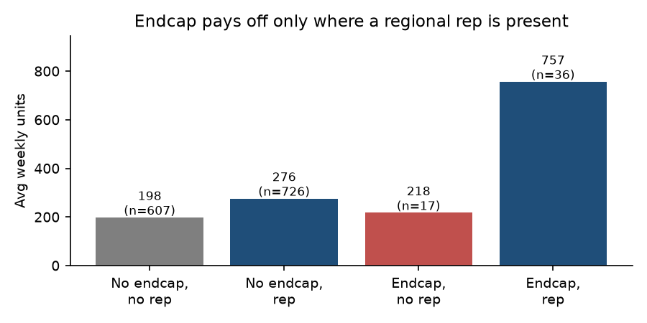
Figure 2. An endcap without a regional rep shows no lift.
The 17 "endcap without rep" weeks come from just three stores (Bethesda, Coral Gables, Sarasota). They sold almost nothing extra, and they were exactly the large negative residuals in Model 1. So Model 1 failed because it assumed an endcap works everywhere.

Step 8: Model 2: the final model
What we did. We fitted the model that stepwise chose: Units on Endcap × Rep, Rep, Demo, Demo1-3, Demo4-5 and Price.
Why. It is simpler than Model 1 (6 terms instead of 8) and much better.
Slides: MLR output and interpretation: S2 p.26-29, S4 p.15; adjusted R² (R² always rises when you add variables, adjusted R² penalises that): S5 p.42-45; interpreting the intercept (valid only within the range of the data): S8 p.3-11.
How (Excel). Regression dialog with columns: Rep×Endcap, Rep, Demo, Demo1-3, Demo4-5, Price.
What we got. R² = 0.806, adjusted R² = 0.805, F = 954, standard error 49.0 units. All coefficients p<0.001.
Term | Coefficient | 95% CI | What it means
Endcap × Rep | +454.4 | 438 to 471 | Extra units from an endcap, only in stores that also have a rep
Rep | +59.4 | 54 to 65 | A regional rep on its own
Demo | +106.8 | 96 to 118 | Demo week
Demo1-3 | +73.4 | 66 to 81 | Each of weeks 1-3 after a demo
Demo4-5 | +74.6 | 65 to 84 | Each of weeks 4-5+ after a demo
Price | -22.1 | -28 to -16 | Each extra $1 of price

The intercept (276.6) is the predicted sales when every variable is zero, including price = $0, which never happens. Slide S8 p.9-11 warns that the line is only valid inside the range of the data, so we do not interpret the intercept on its own.
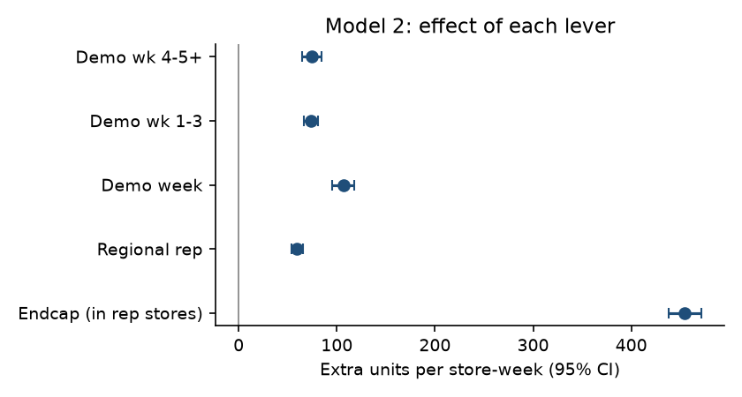
Figure 3. Effect of each lever in extra units per store-week, with 95% confidence intervals.

Step 9: Check Model 2 against the assumptions (Question 2 again)
What we did. We repeated every check from Step 5, and added outlier analysis.
Why. The new model must pass the same tests that Model 1 failed.
Slides: assumption checks: as in Step 5; outliers, leverage, Cook's distance, DFFIT: S8 p.16-31 (Cook's D > 1 influential: S8 p.24; leverage cut-offs 2(k+1)/n and 3(k+1)/n: S8 p.27).
How (Excel). Same plots as Step 5. For outliers, standardised residuals beyond ±3; leverage and Cook's distance from SPSS/JASP save options.
What we got. See the table. Model 2 passes.
Check | Model 1 | Model 2
Residuals vs fitted | uneven, big negative block | centred on zero, even
Durbin-Watson (2 is ideal) | 1.39 | 2.11
Skew / kurtosis (normal: 0 / 3) | -0.93 / 8.5 | -0.01 / 3.05
Largest VIF | 1.26 | 1.27
Residuals beyond ±3 | 23 | 5
Largest Cook's distance (influential if > 1) | 0.10 | 0.02

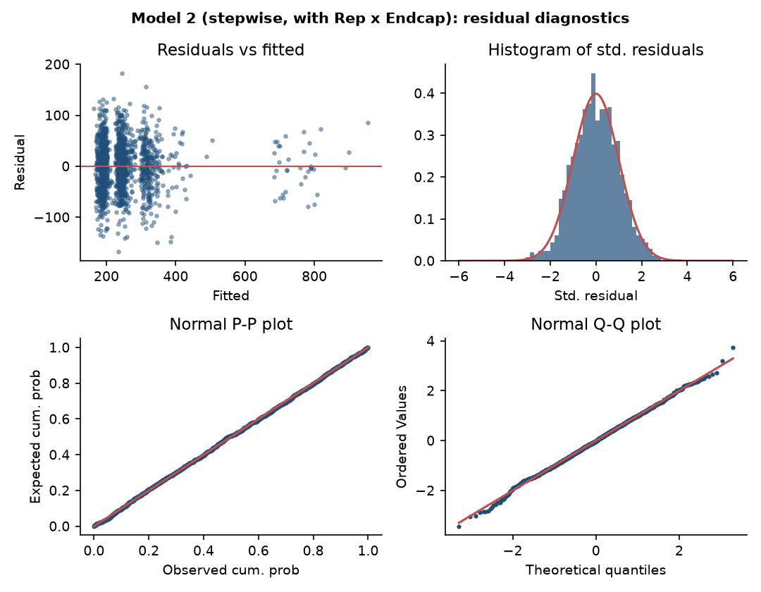
Figure 4. Model 2 diagnostics: residuals centred, even spread, P-P and Q-Q plots on the diagonal.
Why we did not use a log transformation. In class, a pattern in the residuals is fixed by transforming a variable (S8 p.38-46). We tried it: a log of Units with the same terms gives R² 0.61 and still a heavy left tail. The log was only hiding the missing interaction, so once the interaction is in, the plain model in units is both simpler and better. (Log-log models are still useful for elasticities: S2 p.47. We report a price elasticity of about -0.36 at the mean.)

Step 10: Do demos work, and for how long? (Question 3)
What we did. We read the three demo coefficients and tested whether Demo1-3 and Demo4-5 are equal with a partial F-test.
Why. To see whether the lift fades we compare the early afterglow (weeks 1-3) with the late one (weeks 4-5+). If the two are equal, there is no fade.
Slides: partial F-test: S5 p.26-29 (F = [(SSE_reduced − SSE_full) / number of restrictions] ÷ [SSE_full / (n−k−1)]; formulae slide S5 p.29); interpreting a dummy coefficient: S7 p.29.
How (Excel). Run the full model and a reduced model where Demo1-3 and Demo4-5 are replaced by their sum; compare SSE; F.DIST.RT gives the p-value.
What we got. All three demo coefficients are positive with p<0.001. Test of Demo1-3 = Demo4-5: F = 0.04, p = 0.85, so no fade within five weeks. Test of Demo = Demo1-3: F = 24.0, p<0.001, so the demo week is higher than the afterglow.
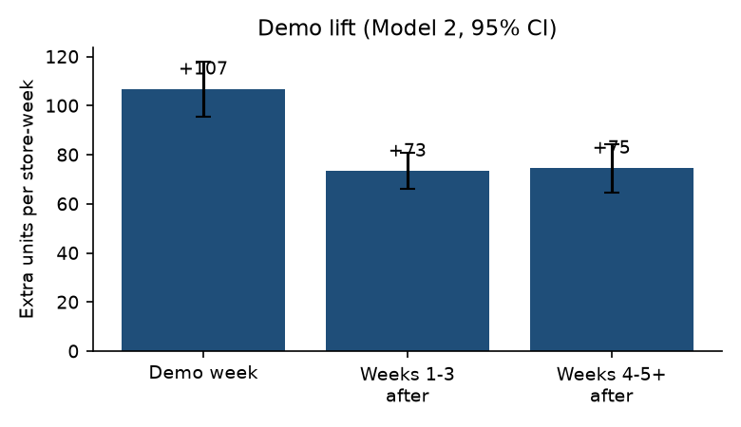
Figure 5. Demo lift by period.
Payoff of one demo: 107 + 3×73 + 2×75 ≈ 476 extra units over six weeks. Only about 22% of that is on demo day, so judging a demo by demo-day sales understates it about four times. Limit: the last category means "4-5 weeks or more", so we know the lift lasts at least five weeks, not when it ends.

Step 11: Does placement matter? (Question 4)
What we did. We read the Endcap × Rep and Rep coefficients, and tested whether anything else adds to the model: the plain Endcap term, other interactions, and Region.
Why. We want to know whether the endcap result is robust and whether placement works differently in other conditions.
Slides: interaction interpretation (dummy shifts the intercept; dummy × variable shifts the slope): S6 p.48-54; partial F-test for a group of dummies: S5 p.26-29.
How (Excel). Add each extra term to Model 2, one at a time, and look at its t-test or partial F p-value.
What we got. An endcap adds about 454 units a week in stores with a regional rep (95% CI 438 to 471). Adding the plain Endcap term back gives p = 0.96, so it does nothing without a rep. A rep on its own adds about 59. None of the other 15 interactions is significant (p between 0.15 and 0.95), and Region is not significant (p = 0.54).

Step 12: Refine and stress-test the model (Question 5)
What we did. We tried every improvement that the course covers, plus a search over all possible interactions.
Why. A good analyst checks whether a better model exists before declaring victory.
Slides: adjusted R² and partial F: S5 p.26-29, p.42-45; polynomial and log transformations: S8 p.38-46; criteria beyond p-values (AIC, BIC, Mallows Cp) and "modeling is as much an art as a science": S7 p.55; outliers: S8 p.16-31.
How (Excel). Add each candidate to Model 2 and compare adjusted R² and the partial F-test p-value.
What we got. Nothing improves Model 2. The table summarises the tests.
Idea tried | Result
Add Natural and Fitness back | p = 0.96, no gain
Add Region dummies (10) | p = 0.54, no gain
Price squared; ln(Price); time trend; week dummies | all p > 0.5, no gain
Store dummies (125) | R² up to 0.820 but adjusted R² falls (0.802); p = 0.94
Remove the 5 outliers | coefficients essentially unchanged
Log of Units | worse (R² 0.61, heavy tail remains)
All 154 two-, three- and four-way interactions | same 6-term model chosen; none of the 117 remaining terms significant (smallest p = 0.09)
Out-of-sample prediction (10-fold, whole stores held out) | Model 2 error 49.1 units vs 68.0 for Model 1

Why nothing helps. The remaining unexplained variation (about 19%) looks like week-to-week noise: residuals are uncorrelated with price, week and neighbourhood, have the same spread in every group, and show no leftover store effect. The real improvement would be new data: store size or foot traffic (a likely omitted variable), competitor prices, holidays, more endcap tests in non-rep stores, and a longer window.

Step 13: Turn the results into recommendations (Question 6)
What we did. We translated each finding into an action.
Why. The CFO needs decisions backed by numbers, not coefficients.
Slides: the managerial-implications style of the Session 3 examples: S3 p.18-23 (turn each test into a statement the manager can use).
What we got. See the table.
Finding | Recommendation
Endcap +454 units only with a rep | Pair every endcap with a regional rep; extend rep coverage first
A demo is worth about 476 units, no fade in 5 weeks | Keep demos; judge them over six weeks, not demo-day sales
Rep alone +59 units | Add reps to stores that have none, in waves
Price elasticity about -0.36 | Do not use price cuts for volume; revenue falls
Natural, Fitness and Region not significant | Target by store traffic, not neighbourhood
Only 3 non-rep endcap stores | Test endcaps in a few more non-rep stores to confirm

Part 5. Concept glossary with slide references
Look up any term. "Where we used it" points to the step in Part 4.
Concept | Plain-English meaning | Slides | Where we used it
Covariance and correlation | Direction and strength of a linear association between two variables | S1 p.11-16 | Step 1
Correlation is not causation | A link between two things does not prove one causes the other | S1 p.28 | Limitations
OLS and the best-fit line | Pick the line that minimises the sum of squared errors | S2 p.9-18 | Step 2
SST = SSR + SSE, R² | Total variation = explained + unexplained; R² is the explained share | S2 p.19-25 | Steps 2, 8
Excel regression output | Blocks: regression statistics, ANOVA, coefficients | S2 p.26-29 | Steps 2, 8
Residual plot | Residuals vs X or fitted values; should show no pattern | S2 p.30 | Steps 5, 9
Log transformations and interpretation | Log-log: elasticity; log-linear: % change | S2 p.38-47, S8 p.38-46 | Step 9
t-test for a coefficient | Tests H₀: coefficient = 0 (does X matter?) | S3 p.17-23, S5 p.22 | Steps 2, 11
Confidence interval for a coefficient | Range of plausible values of the true effect | S3 p.24 | Step 8
Homoscedasticity / heteroscedasticity | Constant vs changing spread of the errors | S3 p.34-36, S8 p.39-40 | Step 5
Normality of errors, Q-Q / P-P plot | Errors should be normally distributed; points follow the diagonal | S3 p.42-43 | Steps 5, 9
Autocorrelation, Durbin-Watson | Errors correlated with each other; DW near 2 is fine | S3 p.44, S8 p.33-37 | Steps 5, 9
Summary of assumptions | The full checklist for SLR and MLR | S3 p.45, S5 p.20 | Steps 5, 9
Confidence vs prediction interval | Interval for the mean vs for one new observation | S3 p.47-51 | Not used (we explain, not predict)
Multiple regression and "control" | Effect of one X holding the others fixed (partialling out) | S4 p.2-3, p.17-22, S5 p.9-11, S6 p.2-6 | Steps 2, 8
Omitted variable bias (OVB) | Leaving out a variable related to both Y and an X biases the coefficients | S4 p.24-31 | Steps 5, 12
Multicollinearity and VIF | Predictors correlated with each other inflate standard errors; VIF > 4 is a warning | S4 p.41-45 | Step 4
OVB vs multicollinearity decision table | When to include a variable that is related to Y and X | S4 p.45 | Step 4
Partial and part (semi-partial) correlation | Correlation between Y and X2 after removing X1 from both (partial) or from X2 only (part) | S5 p.12-19 | Step 6
Overall F-test | Tests whether all slopes are zero (is the model useful?) | S5 p.21 | Steps 2, 8
Partial F-test | Tests whether a group of variables adds to the model | S5 p.26-29 | Steps 6, 10, 11, 12
Standardised coefficients | Coefficients on one scale, so levers can be compared | S5 p.30-34 | Step 3
Adjusted R² | R² penalised for extra variables; R² alone always rises | S5 p.42-45 | Steps 8, 12
Dummy (categorical) variables and the base | m categories need m−1 dummies; each coefficient is a difference from the base | S5 p.50-57, S6 p.11-28 | Steps 2, 7, 10
Interaction variable | A product of two variables; lets an effect depend on another variable | S6 p.48-54 | Steps 6, 7, 11
Stepwise, forward and backward selection | Add or remove variables using partial F with p-in / p-out | S7 p.31-55, p.57-58 | Step 6
AIC, BIC, Mallows Cp | Other criteria for choosing models | S7 p.55 | Step 12
Interpreting the intercept | Valid only inside the range of the data | S8 p.3-14 | Step 8
Outliers, leverage, Cook's distance, DFFIT | Large residual; extreme X; influence of one row on the fit | S8 p.16-31 | Step 9

Part 6. Questions the professor may ask (with answers)
Q. Why did you not just use the model with all the variables?
We did, as Model 1. It has R² 0.67 but fails the assumption checks (Durbin-Watson 1.39, heavy left tail, uneven residuals), so its p-values cannot be trusted. A high R² does not make a model valid.
Q. What is an interaction and why did you add one?
An interaction is a product of two variables. It lets one variable's effect depend on another. Stepwise picked Endcap × Rep first, meaning an endcap only works in stores with a regional rep. That fixed the residual problems and raised R² from 0.67 to 0.81.
Q. How does stepwise regression work?
Start with no variables. Add the one with the largest partial correlation if its partial F-test passes p-in (0.05). Then re-check the variables already in and remove any whose p exceeds p-out (0.10). Repeat until nothing changes. (S7 p.54)
Q. Why is the order Endcap × Rep, Rep, Demo1-3, Demo, Demo4-5, Price?
At each step stepwise adds the variable that explains the most remaining variation. Variables that apply to more rows or have larger gaps come first. The order is not an importance ranking.
Q. What does the Endcap × Rep coefficient of 454 mean?
In a store with a regional rep, an endcap adds about 454 extra units a week. Without a rep the endcap adds nothing. A rep alone adds about 59.
Q. Which assumptions did you test and how?
Linearity and constant variance (residuals vs fitted), independence (Durbin-Watson), normality (histogram, P-P and Q-Q plots, skew, kurtosis), no multicollinearity (VIF), and outliers (standardised residuals, leverage, Cook's distance).
Q. What is Durbin-Watson?
A statistic between 0 and 4 for autocorrelation. Near 2 means no autocorrelation; below 2, positive. Ours moved from 1.39 to 2.11. (S8 p.35-37)
Q. What does VIF tell you?
How much a predictor is explained by the others. VIF = 1/(1−R²), and above 4 signals multicollinearity. Ours are all below 1.3. (S4 p.43)
Q. Do demos work, and for how long?
Yes. About +107 units in the demo week and +73 to +75 a week afterwards. A partial F-test finds no difference between weeks 1-3 and 4-5+ (p = 0.85), so no fade within five weeks. We only know it lasts at least five weeks.
Q. How did you test whether the lift fades?
A partial F-test: fit the full model, fit a model where Demo1-3 and Demo4-5 are combined, and compare SSE. F = [(SSE_red − SSE_full)/1] ÷ [SSE_full/(n−k−1)]. (S5 p.26-29)
Q. Why not a log transformation?
We tried it. With the interaction in, the log version is worse (R² 0.61, heavy tail still there). The earlier problems came from a missing interaction, not from the scale of sales. (S8 p.38-46)
Q. Can you say the endcap causes the extra sales?
No. The data are observational, not an experiment. Demos and endcaps were not assigned randomly. We report associations, and the endcap-without-rep result rests on only three stores.
Q. What is the weakest part of your analysis?
The no-rep endcap result (3 stores, 17 store-weeks), the open-ended last demo category, and the rep coefficient, which drops to about 38 when each store is compared only with itself (some of the rep effect may be store size).
Q. Why is the intercept not interpreted?
It is the prediction at price = $0, outside the range of the data. The regression line is only valid within the range of observations. (S8 p.9-11)

Part 7. Reproduce it yourself, and the files

In Excel (as in class)
- Open Case Study Dataset.xlsx, sheet "Real Data". Add a column Rep×Endcap = Sales Rep × Endcap.
- Data → Data Analysis → Regression. Model 1: Y = Units, X = Price, Sales Rep, Endcap, Demo, Demo1-3, Demo4-5, Natural, Fitness. Tick Residuals, Residual Plots, Normal Probability Plots.
- Read the summary output: R², adjusted R², ANOVA F, then each coefficient with its t-stat and p-value.
- Check the residual plots; compute Durbin-Watson from the residual column.
- Model 2: Y = Units, X = Rep×Endcap, Sales Rep, Demo, Demo1-3, Demo4-5, Price. Compare R², residual plots and Durbin-Watson with Model 1.
- For the demo-duration test, add a column Demo1-5 = Demo1-3 + Demo4-5, run the reduced model, and use F = [(SSE_red − SSE_full)/1] ÷ [SSE_full/(n−k−1)] and F.DIST.RT.
- For stepwise, use SPSS/JASP with the forward or stepwise method (p-in 0.05, p-out 0.10), as in Session 7. Check the exact menu names in your software.

With the Python script
Put analysis.py and Case Study Dataset.xlsx in one folder and run: python3 analysis.py. It reads the dataset directly and reproduces every number in the report (about 15 seconds). It needs pandas, statsmodels, scikit-learn, scipy and matplotlib.

What is in the folder
File | What it is
Submission/GoodBelly_Case_Study_Report.docx / .pdf | The case report (cover, one-page summary, main report, appendix)
Submission/GoodBelly_Analysis.xlsx | Data, coefficient tables, stepwise path, diagnostics, interaction search
Submission/analysis.py | Complete analysis, reproducible from the dataset
Submission/fig/ | Charts used in the report
Group walkthrough/ | This document

What we deliberately left out because it is beyond the course: fixed-effects models, clustered standard errors, formal tests such as RESET and Breusch-Pagan, instrumental variables and mixed models. The checks we use are the ones taught in Sessions 3, 4, 5, 7 and 8.

