**Exercise No:1**

**Date:**

**Aim:**

To write a python program to display the calendar of a given month and year.

**Program:**

import calendar

year=int(input())

month=int(input())

count=0

n=year

while(n>0):

count=count+1

n=n//10

if(month>12 or count!=4):

print("Invalid Input")

else:

print(calendar.month(year,month))

**link:**

<http://103.53.53.18/mod/vpl/forms/edit.php?id=229&userid=1763>

**Output:**

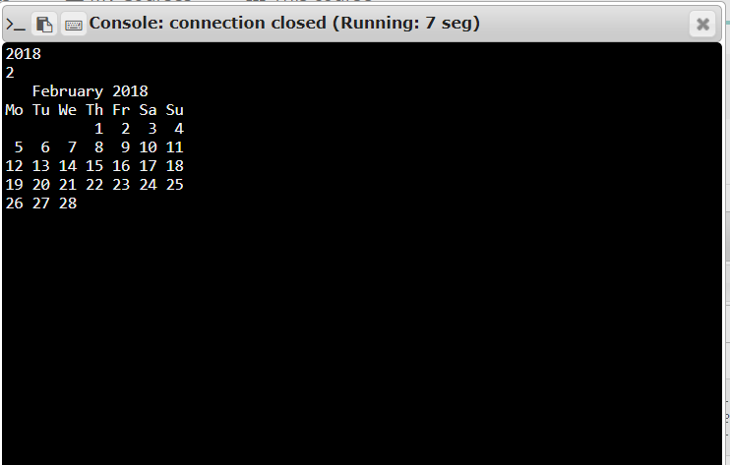

**Result:**

Thus , the calendar for the given month and year is displayed.