**Exercise No:10**

**Date:**

**Aim:**

To write a python program to display the number of uppercase and lowercase letters in a given string.

**Program:**

def string_test(s):

d={"UPPER_CASE":0, "LOWER_CASE":0}

for i in s:

if(i.islower()):

d["LOWER_CASE"]=d["LOWER_CASE"]+1

if(i.isupper()):

d["UPPER_CASE"]=d["UPPER_CASE"]+1

print("No.of Upper case characters :",d["UPPER_CASE"])

print("No.of Lower case characters :",d["LOWER_CASE"])

s=input()

string_test(s)

**LINK:**

<http://103.53.53.18/mod/vpl/forms/edit.php?id=325&userid=1763#>

**Output:**

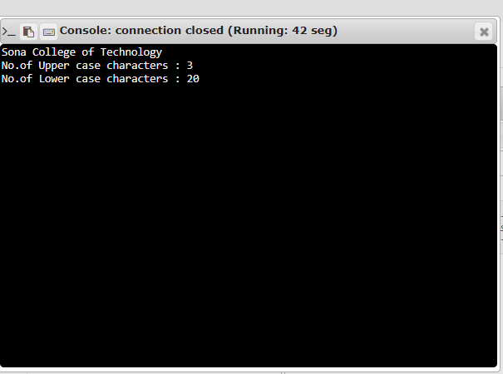

**Result:**

Thus, the number of uppercase and lowercase letters of a given string are calculated.