**Exercise No:11**

**Date:**

**Aim:**

To write a python program to find and display the GCD of the given two numbers.

**Program:**

def gcd(a,b):

lst=[]

if(a==0 and b==0):

return 0

else:

if(a>b):

n=a

else:

n=b

for i in range(1,n):

if(a%i==0 and b%i==0):

lst.append(i)

return(max(lst))

a=int(input("Enter first number:"))

b=int(input("Enter second number:"))

GCD=gcd(a,b)

print("GCD is: ")

print(GCD)

**LINK:** <http://103.53.53.18/mod/vpl/forms/edit.php?id=326&userid=1763#>

**Output:**

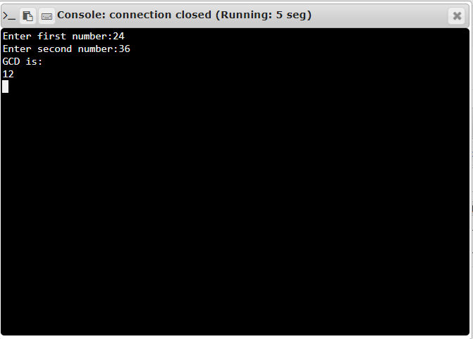

**Result:**

Thus, the gcd of the two given numbers is calculated and displayed.