**Exercise No: 13**

**Date:**

**Aim:**

To write a python program to display the price of the items of apparel shop by implementing the concept of class and object.

**Program:**

class Apparel:

counter=100

def __init__(self,price,item_type):

Apparel.counter+=1

self.item_id=item_type[0]+str(Apparel.counter)

self.price=price

self.item_type=item_type

def calculate_price(self):

self.price+=self.price*0.05

def get_price(self):

return self.price

def set_price(self,price):

self.price=price

return self.price

def get_item_id(self):

return self.item_id

def get_item_type(self):

return self.item_type

class Cotton(Apparel):

def __init__(self,price,discount):

super().__init__(price,'Cotton')

self.discount=discount

def calculate_price(self):

super().calculate_price()

price=self.get_price()

price-=price*(self.discount/100)

price+=price*0.05

self.set_price(price)

return price

def get_discount(self):

return self.discount

class Silk(Apparel):

def __init__(self,price):

super().__init__(price,'Silk')

self.points=None

def calculate_price(self):

super().calculate_price()

if(self.get_price()>10000):

self.points=10

else:

self.points=3

return self.set_price(self.get_price()+(self.get_price()*0.1))

def get_points(self):

return self.points

silk=int(input())

cotton=int(input())

discount=int(input())

a=Silk(silk)

print(a.calculate_price())

b=Cotton(cotton,discount)

print(b.calculate_price())

**LINK:**

<http://103.53.53.18/mod/vpl/forms/edit.php?id=328&userid=1763#>

**Output:**

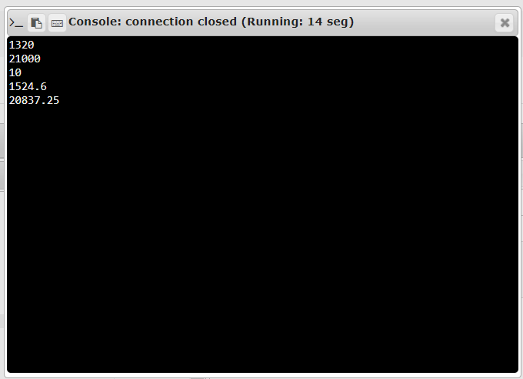

**Result:**

Thus the price of the apparel shop is calculated by implementing the concepts of class and objects.