**Exercise No: 14**

**Date:**

**Aim:**

To write a python program to check if the given string of brackets is valid or not.

**Program:**

def areBracketsBalanced(expr):

stack=[]

brackets=['(','[','{']

for i in range(len(expr)):

if(expr[i] in brackets):

stack.append(expr[i])

else:

if not stack:

return False

cur=stack.pop()

if(cur=='(' and expr[i]!=')'):

return False

if(cur=='[' and expr[i]!=']'):

return False

if(cur=='{' and expr[i]!='}'):

return False

if stack:

return False

else:

return True

if __name__=="__main__":

expr=input()

if(areBracketsBalanced(expr)):

print("valid")

else:

print("invalid")

**LINK:**

<http://103.53.53.18/mod/vpl/forms/edit.php?id=327&userid=1763#>

**Output:**

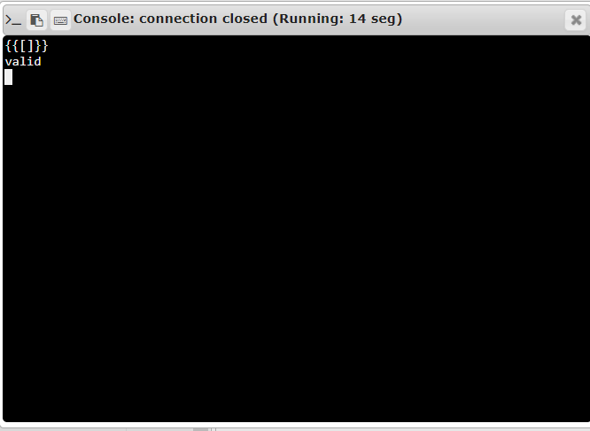

**Result:**

Thus the program to check whether the brackets are balanced is written and executed.