**Exercise No:2**

**Date:**

**Aim:**

To write a python program to count the number of occurrences of x in a given list using the function countX(lst,x).

**Program:**

def countX(lst,x):

count=0

for element in lst:

if(element==x):

count=count+1

print(count)

lst=[]

n=int(input())

for i in range(0,n):

element=int(input())

lst.append(element)

x=int(input())

countX(lst,x)

**LINK:**

[http://103.53.53.18/mod/vpl/forms/edit.php?id=230&userid=1763#](http://103.53.53.18/mod/vpl/forms/edit.php?id=230&userid=1763)

**Output:**

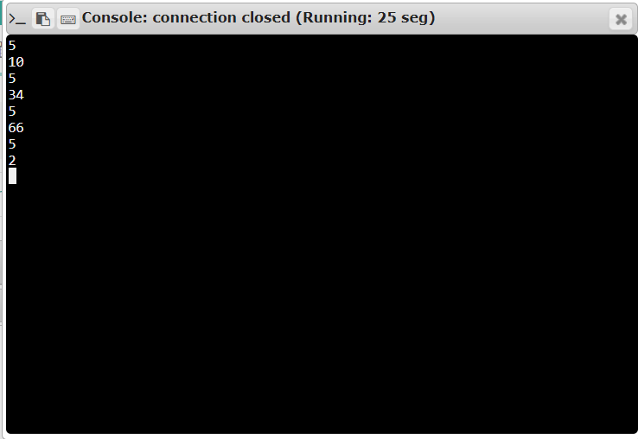

5

10

5

34

5

66

5

2**Result:**

Thus the program for counting the occurrence of a given number in a list is written and executed.