**Exercise No:3**

**Date:**

**Aim:**

To write a python program to remove and print every second number from a list of numbers until the list becomes empty using a function removeThirdNumber(int_list).

**Program:**

def removeThirdNumber(int_list):

a=0

pos=2-1

len_lst=(len(int_list))

while len_lst>0:

a=(pos+a)%len_lst

print(int_list.pop(a))

len_lst=len_lst-1

lst=[]

n=int(input())

for i in range(0,n):

element=int(input())

lst.append(element)

removeThirdNumber(lst)

**LINK:**

[http://103.53.53.18/mod/vpl/forms/edit.php?id=231&userid=1763#](http://103.53.53.18/mod/vpl/forms/edit.php?id=231&userid=1763)

**Output:**

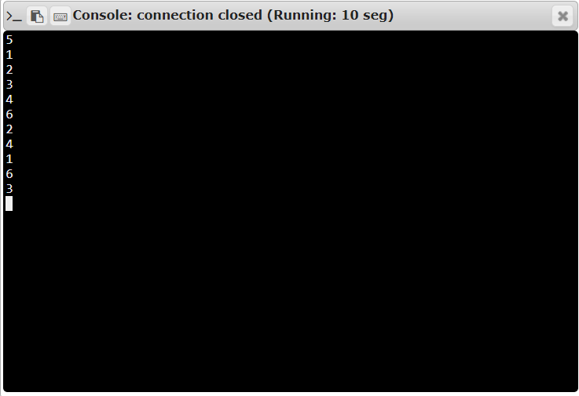

**Result:**

Thus the program for removing every second number and displaying it until the list is empty is executed.