**Exercise No:4**

**Date:**

**Aim:**

To write a python program to display a single string after interchanging the first two characters of two different strings.

**Program:**

def swapchar(c,d):

countc=0

countd=0

for x in c:

if(x==" "):

countc=countc+1

clen=len(c)-countc

for y in c:

if(y==" "):

countd=countd+1

dlen=len(d)-countd

if(clen<2 or dlen<2):

print("Invalid")

elif(c[0]==" "):

c1=d[:2]+c[3:]

d1=c[:3]+d[2:]

print(c1,end="")

print(d1)

else:

c1=d[:2]+c[2:]

d1=c[:2]+d[2:]

print(c1,end="")

print(d1)

a=input()

b=input()

swapchar(a,b)

**Output:**

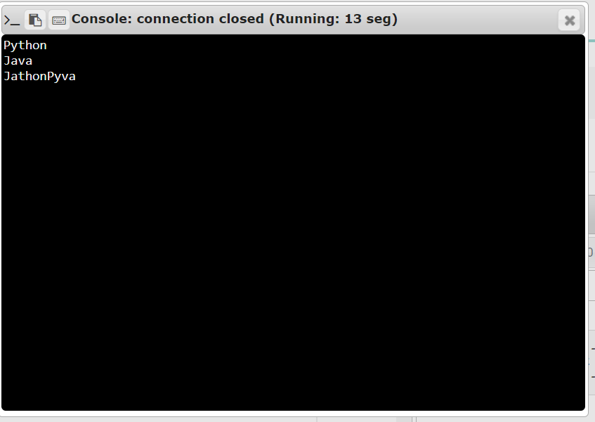

**Result:**

Thus, the first two characters of two different strings are interchanged and are displayed as a single string .