**Exercise No:5**

**Date:**

**Aim:**

To write a python program to check if the given string is a pangram , if not pangram then the missing alphabets are displayed.

**Program:**

def pangram(a):

alpha="abcdefghijklmnopqrstuvwxyz"

for c in alpha:

if c not in a:

print(c,end="")

s=input()

a=s.lower()

pangram(a)

**LINK:**

<http://103.53.53.18/mod/vpl/forms/edit.php?id=235&userid=1763#>

**Output:**

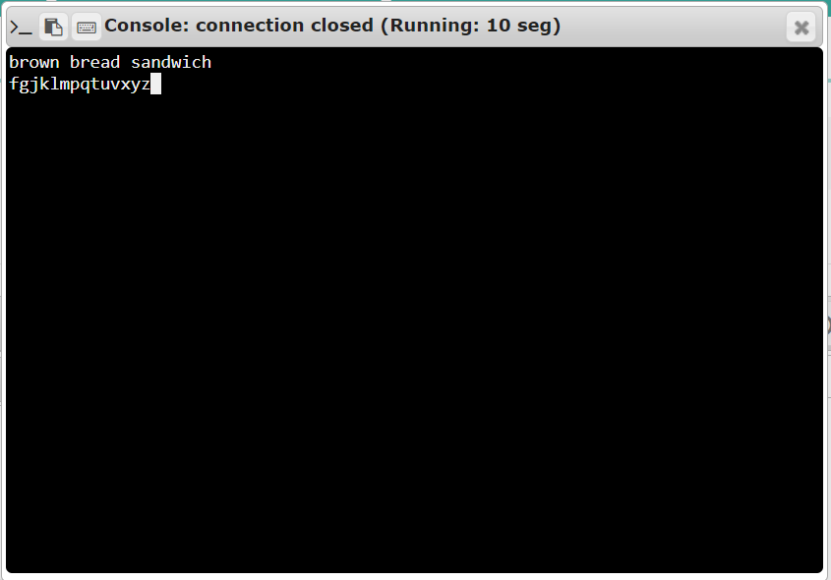

**Result:**

Thus it is checked if the given string is a pangram or not.