**ExerciseNo:7**

**Date:**

**Aim:**

To perform few operations on lists.

**Program:**

**linK:** <http://103.53.53.18/mod/hvp/view.php?id=316>

**Output:**

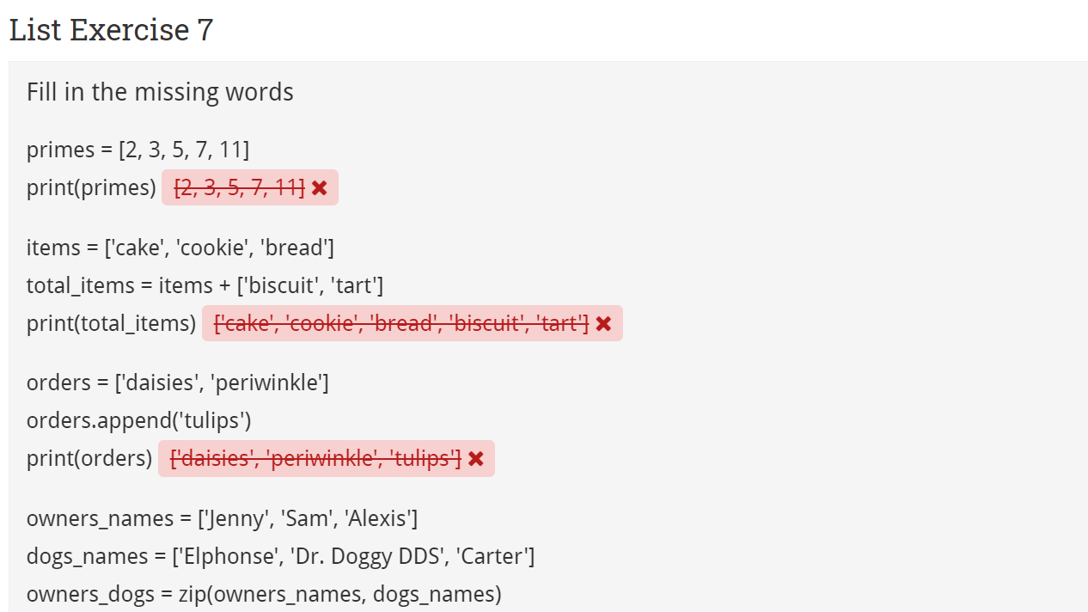

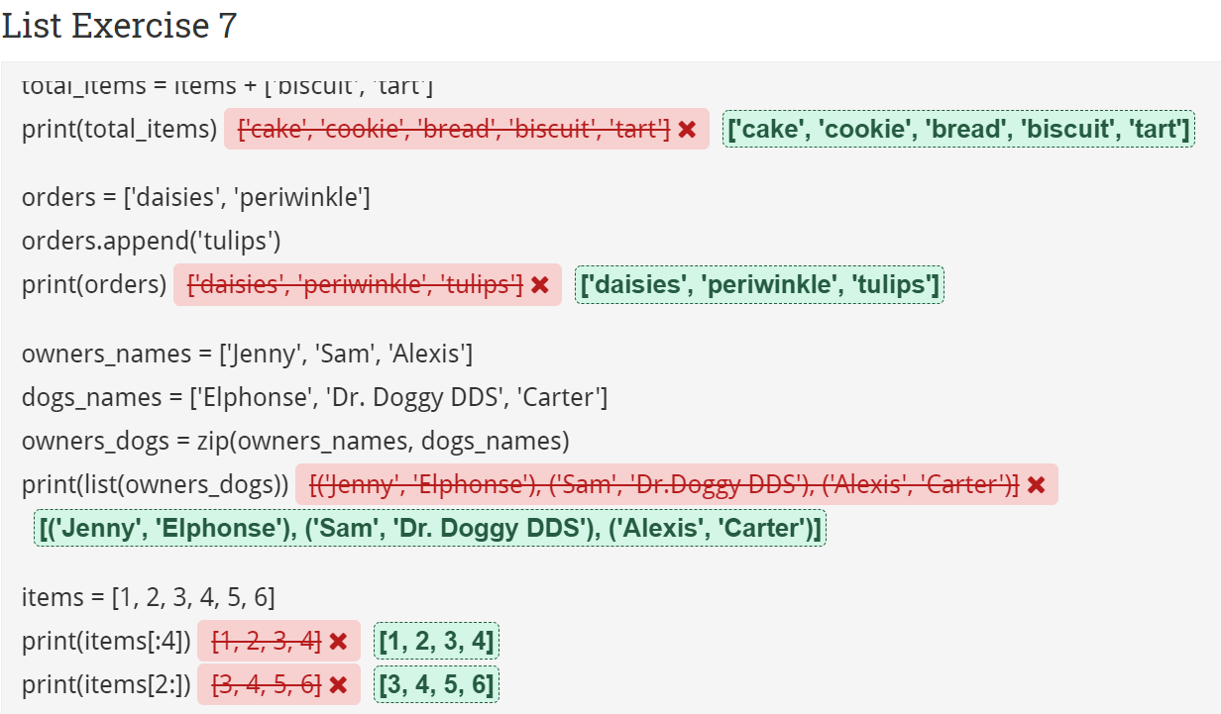

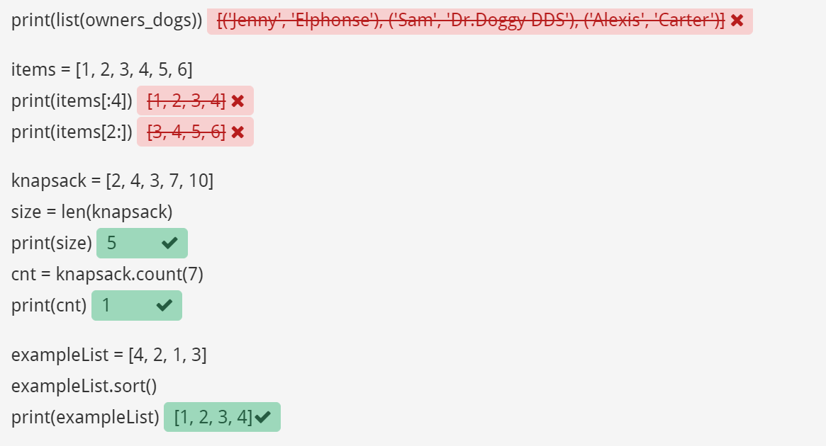

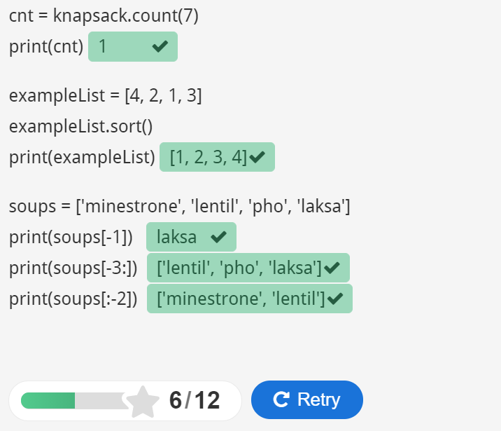

**Result:**

Hence, various operations on lists are performed .