**Exercise No: 8**

**Date:**

**Aim:**

To write a python program to input a list of numbers along with its cube roots and display the list which is sorted based on the second number.

**Program:**

def sort_lst(lst):

for i in range(len(lst)):

for j in range(len(lst)-i-1):

if(lst[j][1]>lst[j+1][1]):

temp=lst[j]

lst[j]=lst[j+1]

lst[j+1]=temp

return lst

n=int(input())

a=[]

b=[]

lst=[]

for i in range(n):

x=int(input())

a.append(x)

for i in range(n):

b.append(pow(a[i],3))

lst=list(zip(a,b))

print(lst)

res=sort_lst(lst)

print(res)

**LINK:**

[http://103.53.53.18/mod/vpl/forms/edit.php?id=317&userid=1763#](http://103.53.53.18/mod/vpl/forms/edit.php?id=317&userid=1763)

**Output:**

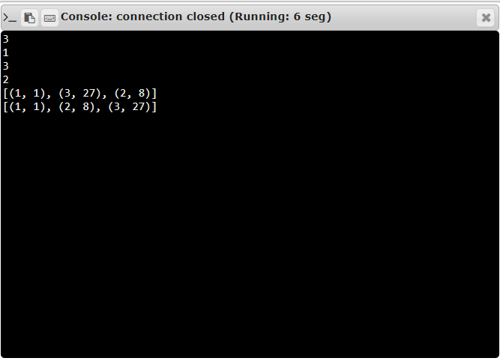

**RESULT:**

Thus the list having pairs of numbers and its cube roots is sorted based on its cube roots and displayed.