**Exercise No : 9**

**Date:**

**Aim:**

To perform few operations on dictionaries.

**Program:**

**LINK:** <http://103.53.53.18/mod/hvp/view.php?id=329>

**Output:**

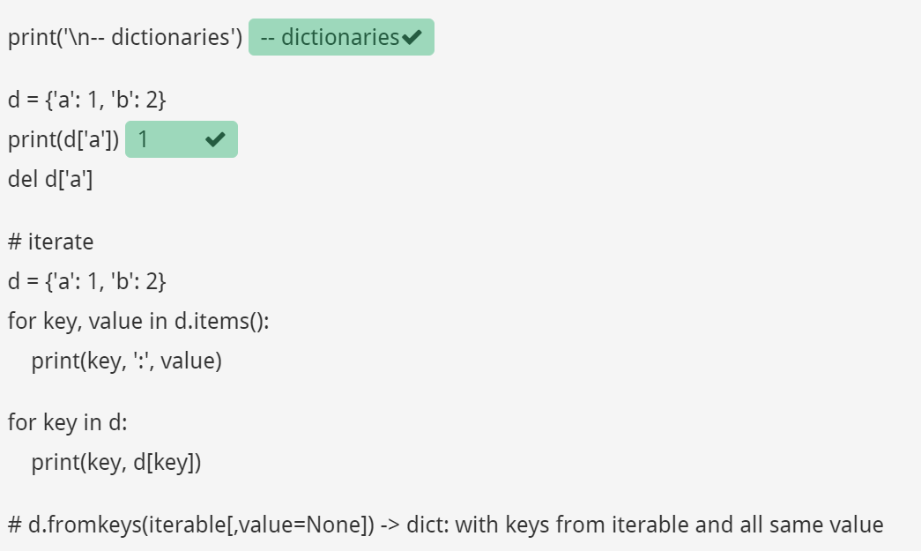

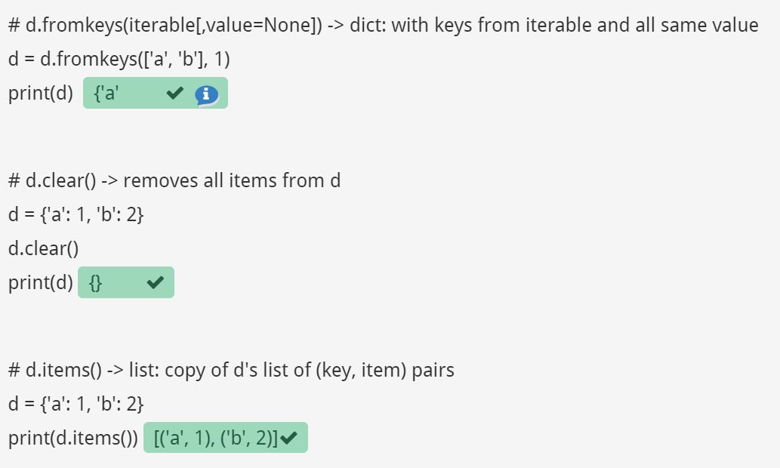

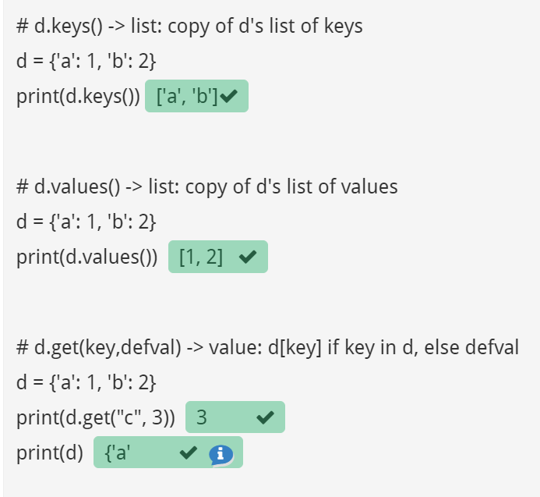

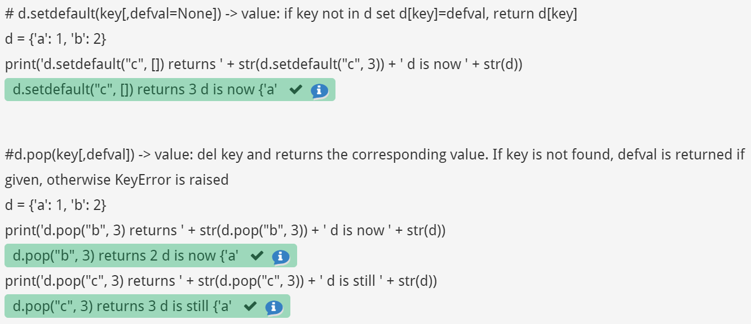

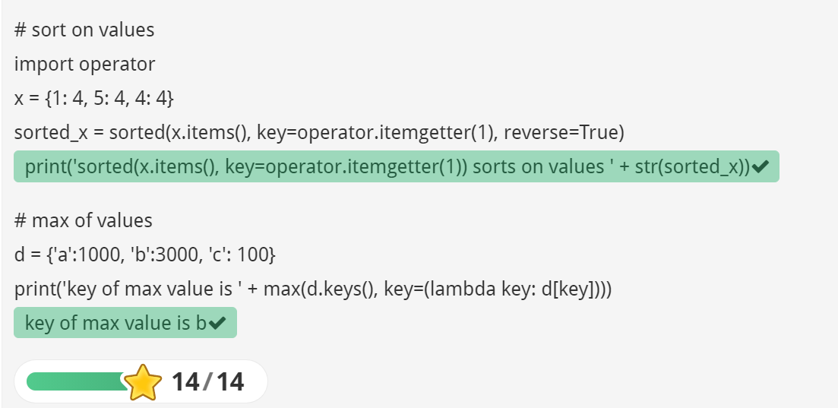

**Result:**

Thus , various operations on dictionaries are performed.