MAD and PWA LAB

**Aim:** Selecting features for application development, the features should comprise of:

1. Common widgets
2. Should include icons, images, charts etc.
3. Should have an interactive Form
4. Should apply navigation, routing and gestures
5. Should connect with FireBase database

|  |  |
| --- | --- |
| **Screenshot** | **Features** |
|  | **Landing Page**   1. Sign in using email (Firebase Authentication). 2. Firebase integration to store and retrieve user data (e.g., name, email). 3. Google and Facebook sign in option |

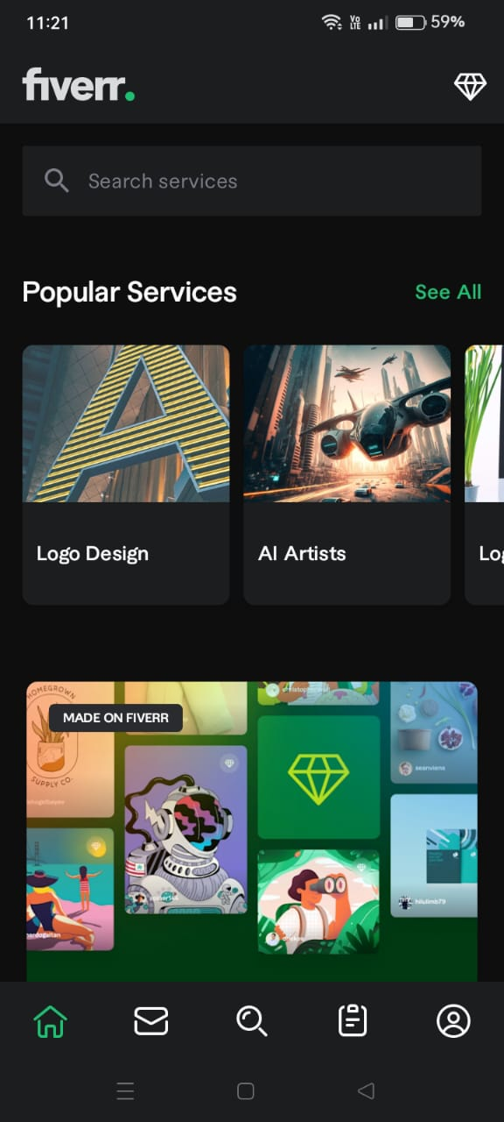

Homepage:

* 1. Display a staggered grid of services fetched from Firestore.
  2. Navigation icons for Home, Favorites, Search, and Profile.
  3. Each service widget includes icons for "Save," "Share," and "Like."
  4. Search bar to search new services.

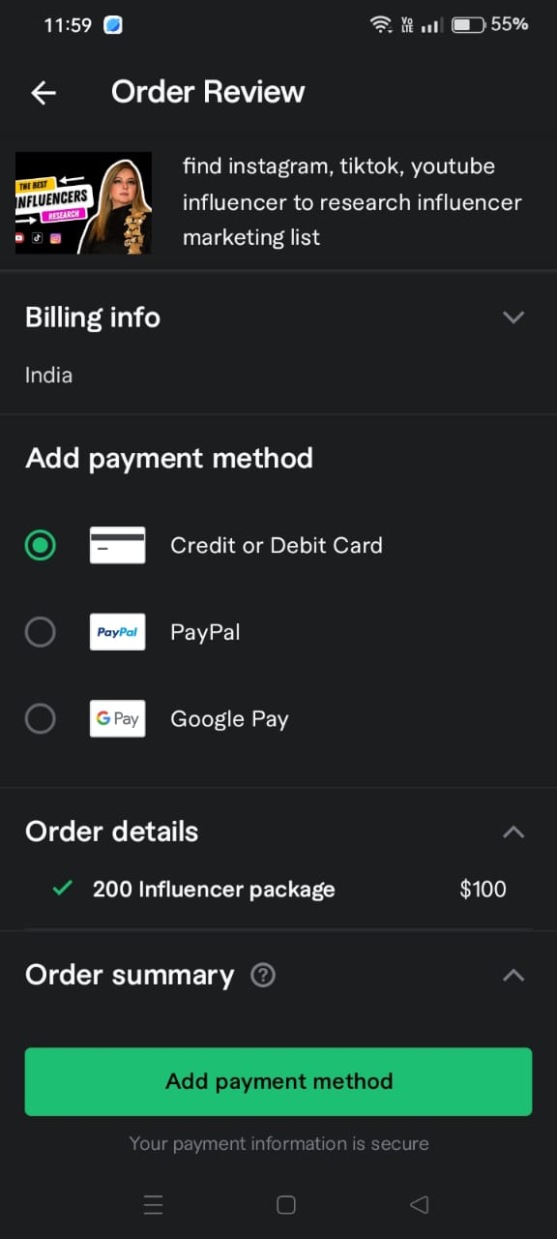

Billing Page:

1. The interactive form to fill in the payment details.

2. Options to choose from to make the payment.

3. Validation of details before initiating the payment.

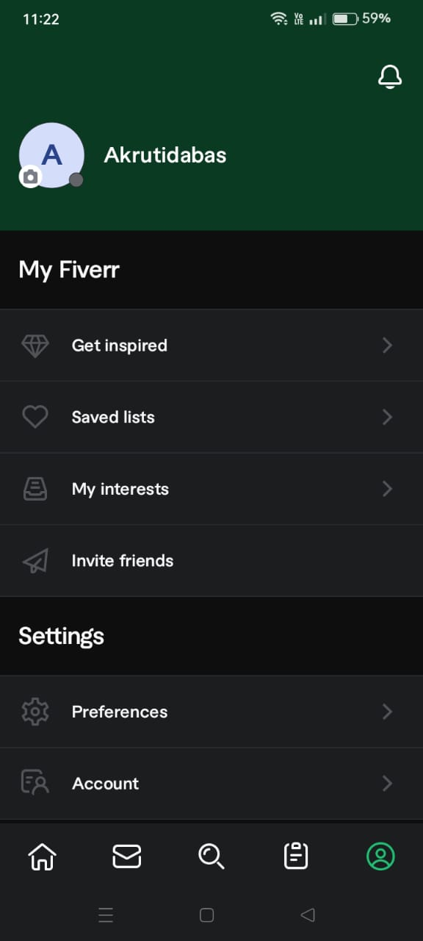

**User Profile Page:**

1. Display user's name, email, and profile picture.

2. Tabs for viewing saved lists, intersts and inspiration.

3. Button to edit profile details.

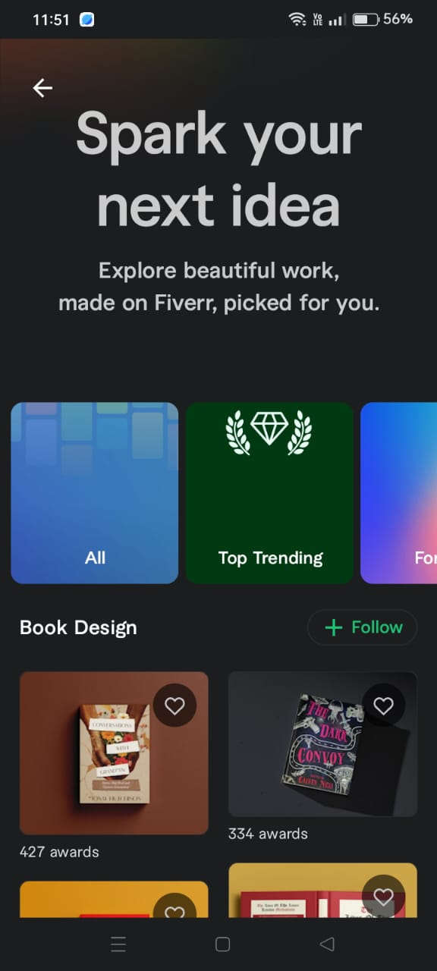

Inspiration Section

1. Display of new inspirations to start anew.
2. Option to organize images into custom boards.
3. Gesture controls for long-press to delete or drag to reorder.
4. Option to follow favorite page.