**Experiment – 7: MongoDB**

|  |  |
| --- | --- |
| **Name of Student** | **AKRUTI DABAS** |
| **Class Roll No** | **D15A / 11** |
| **D.O.P.** |  |
| **D.O.S.** |  |
| **Sign and Grade** |  |

**Aim:** To study CRUD operations in MongoDB

**Problem Statement:**

1. Create a new database to storage student details of IT dept( Name, Roll no,  class name)  and perform the following on the database
   * 1. Insert one student details
     2. Insert at once multiple student details
     3. Display student for a particular class
     4. Display students of specific roll no in a class
     5. Change the roll no of a student
     6. Delete entries of particular student
2. Create a set of RESTful endpoints using Node.js, Express, and Mongoose for handling student data operations.

The endpoints should support:

* Retrieve a list of all students.
* Retrieve details of an individual student by ID.
* Add a new student to the database.
* Update details of an existing student by ID.
* Delete a student from the database by ID.

Connect the server to MongoDB using Mongoose, and store student data with attributes: name, age, and grade.

**Output:**

Create a new database to storage student details of IT dept

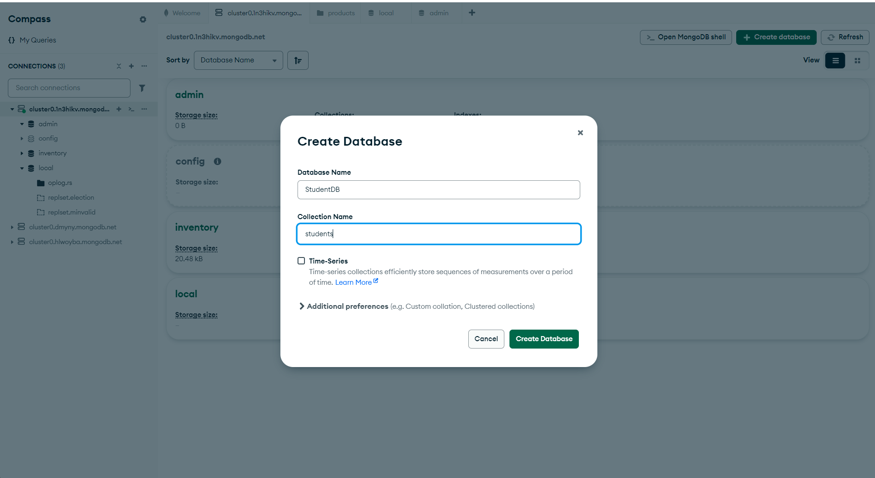

Inserted details of one student.

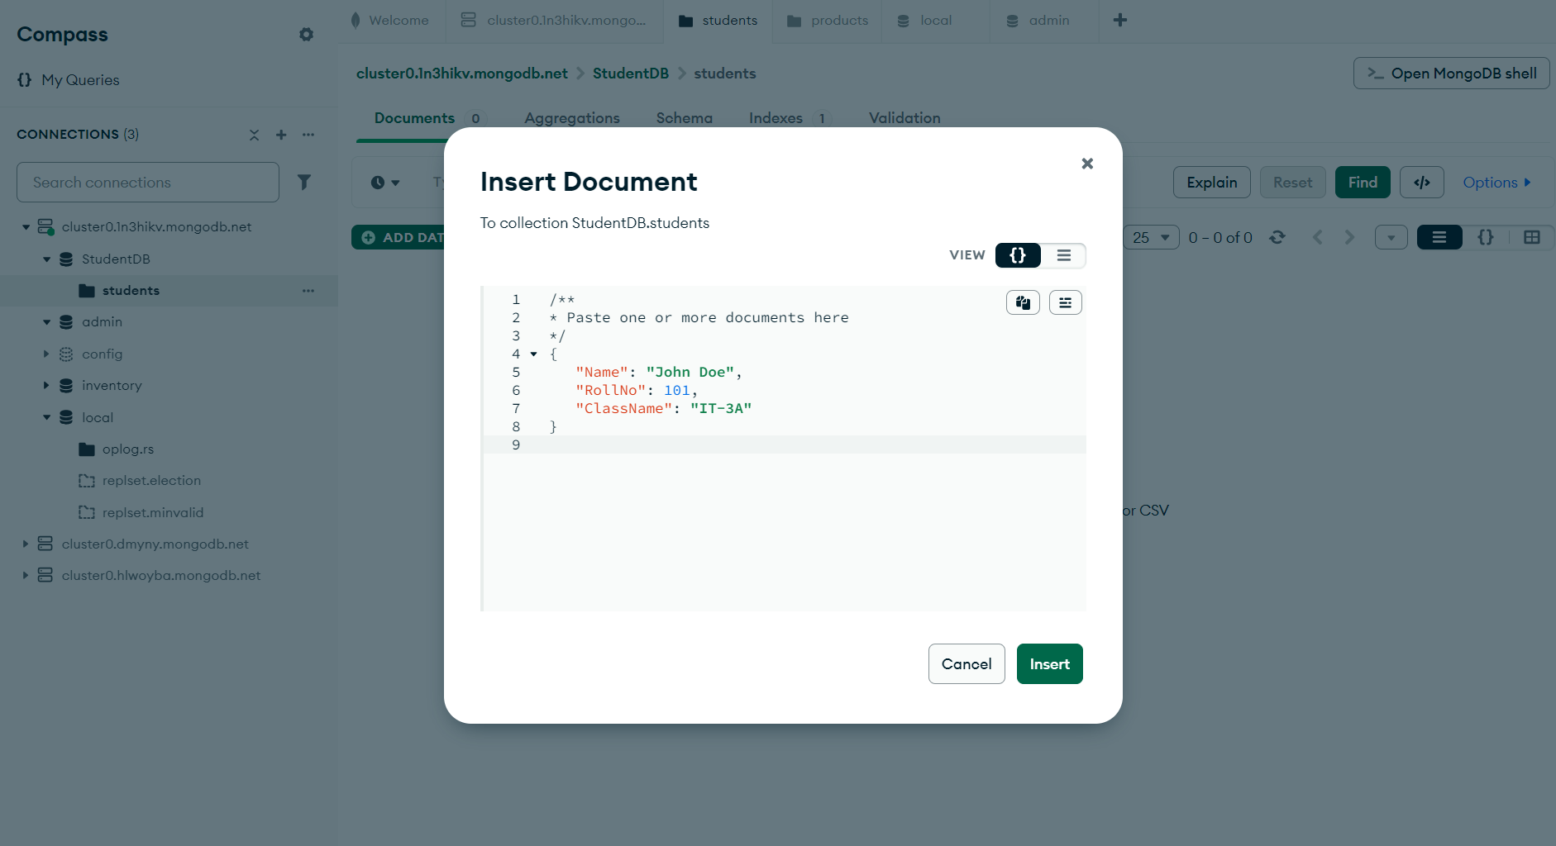

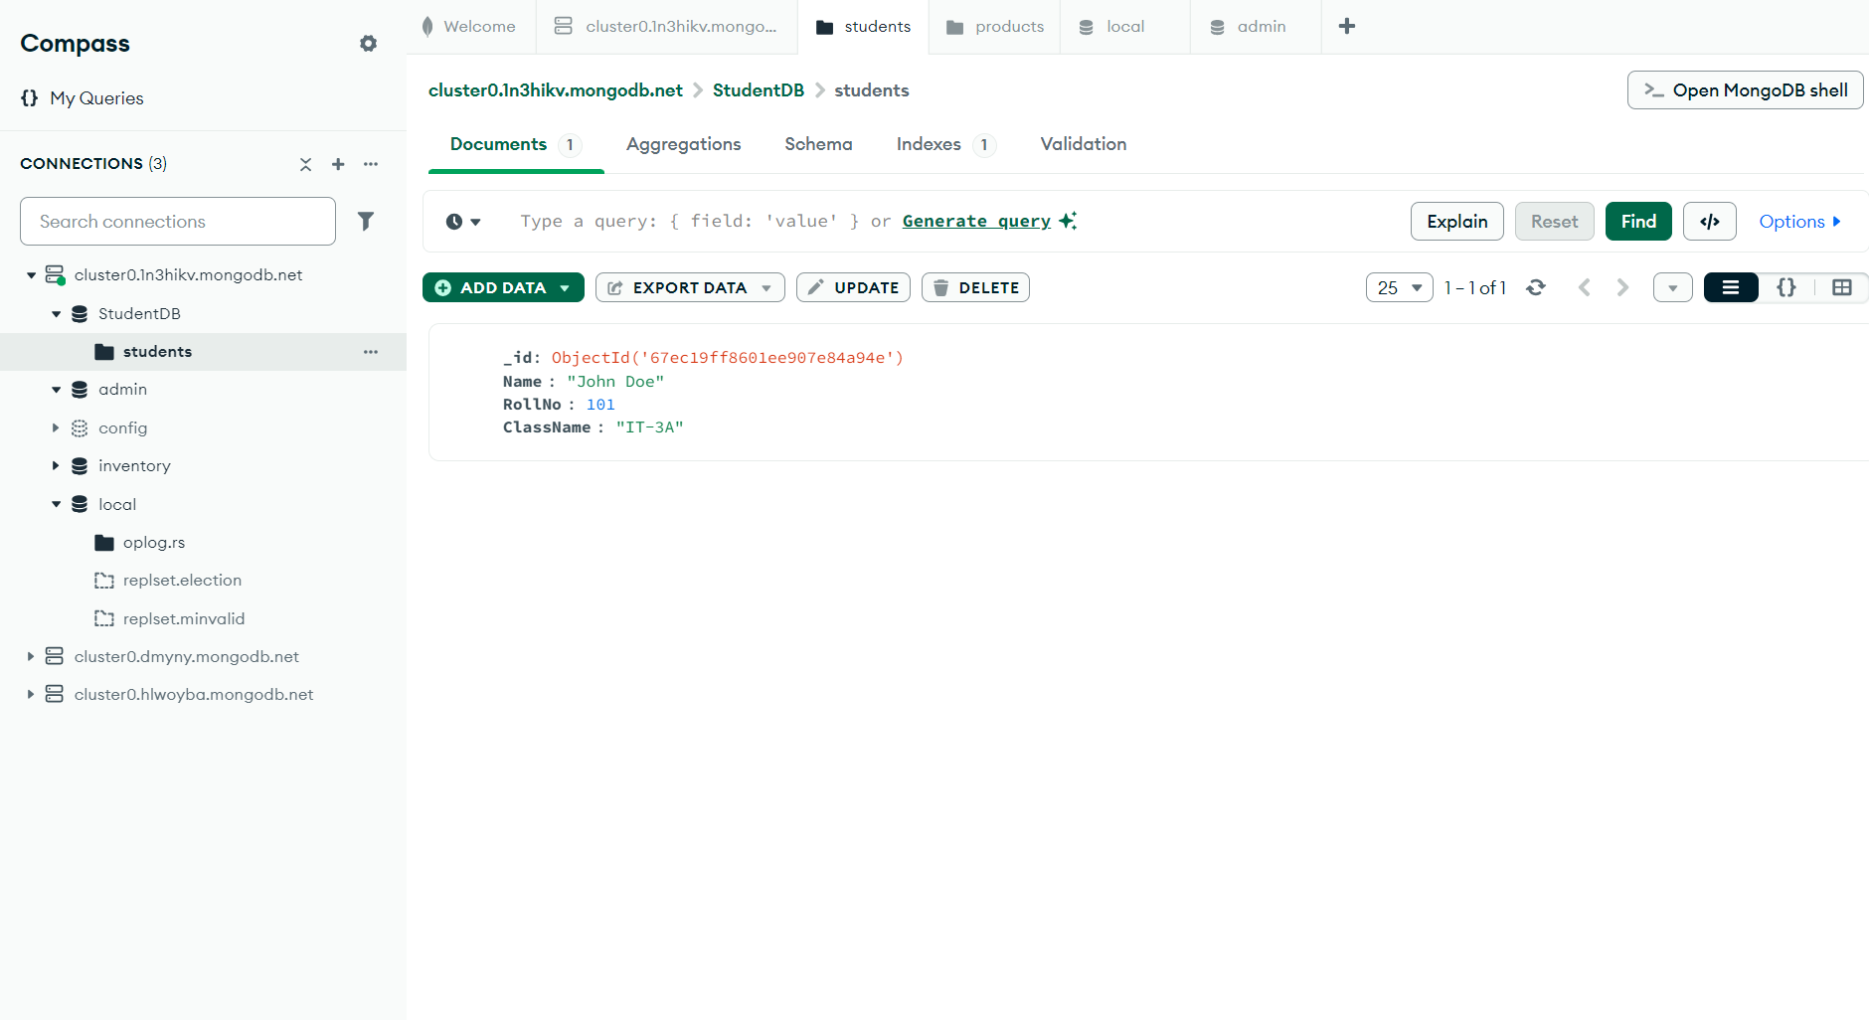

Inserted multiple student details at once.

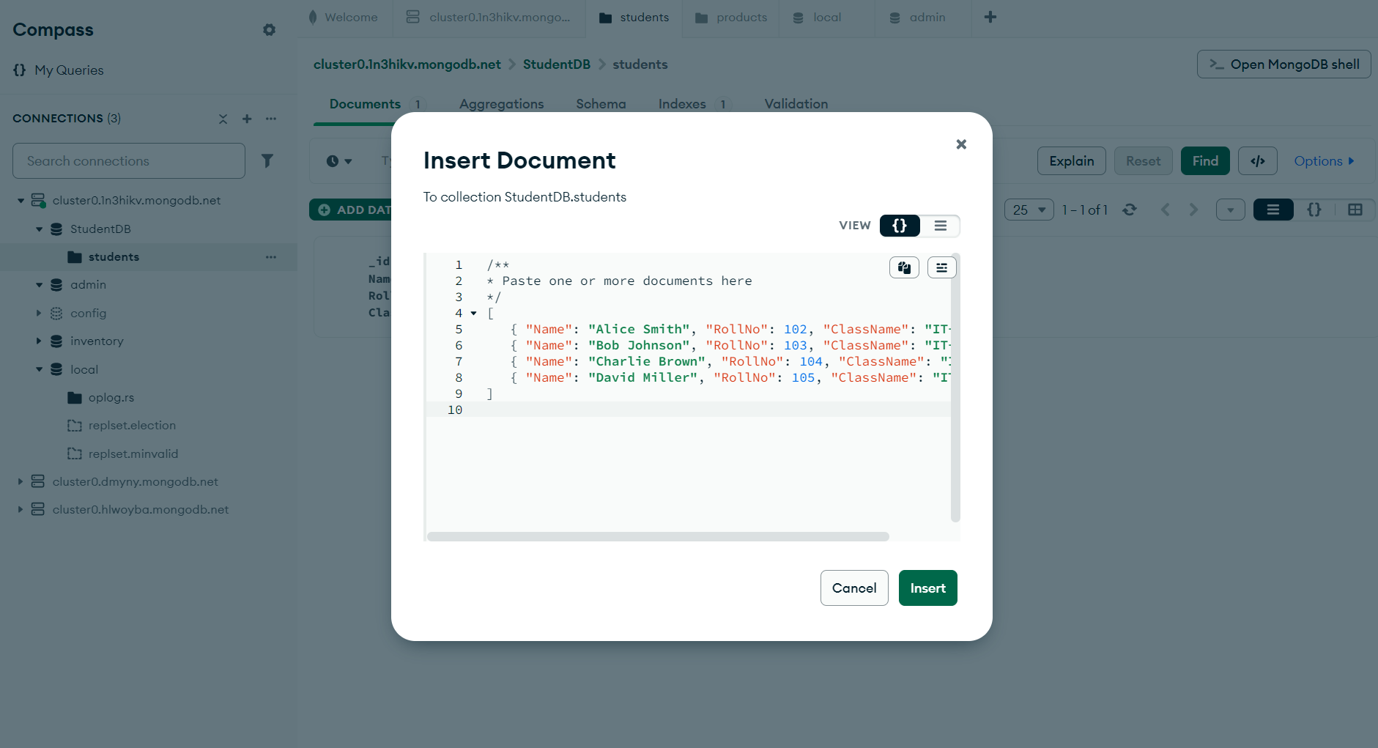

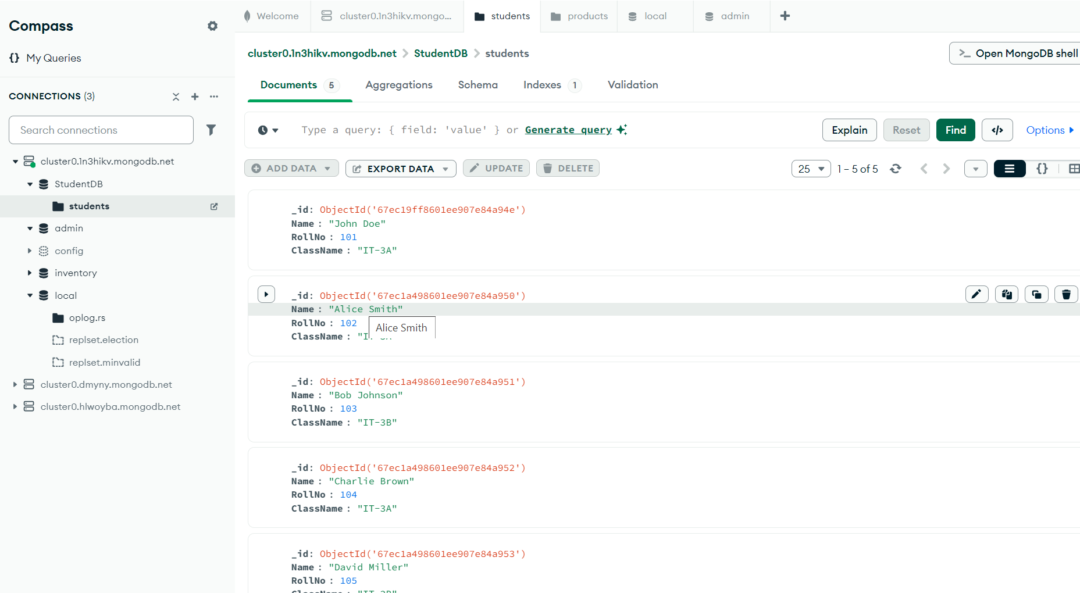

Display student for a particular class

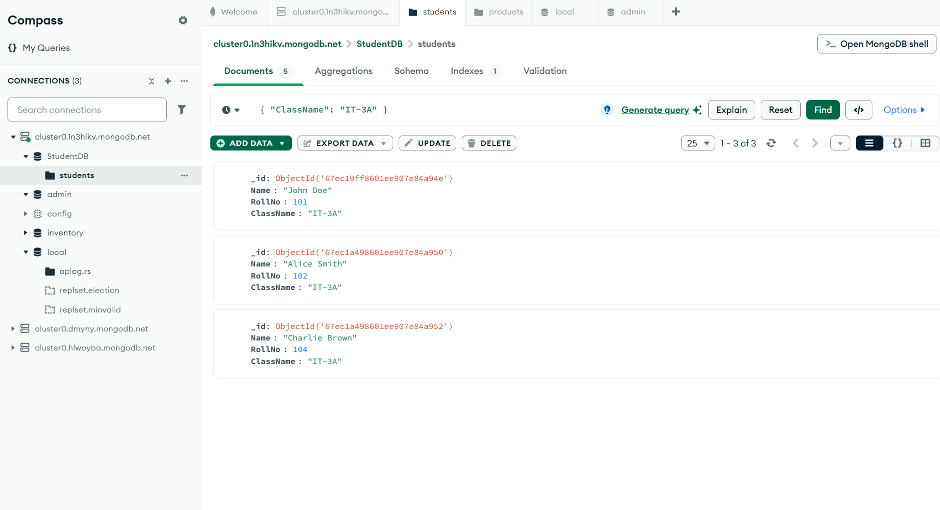

Display students of specific roll no in a class

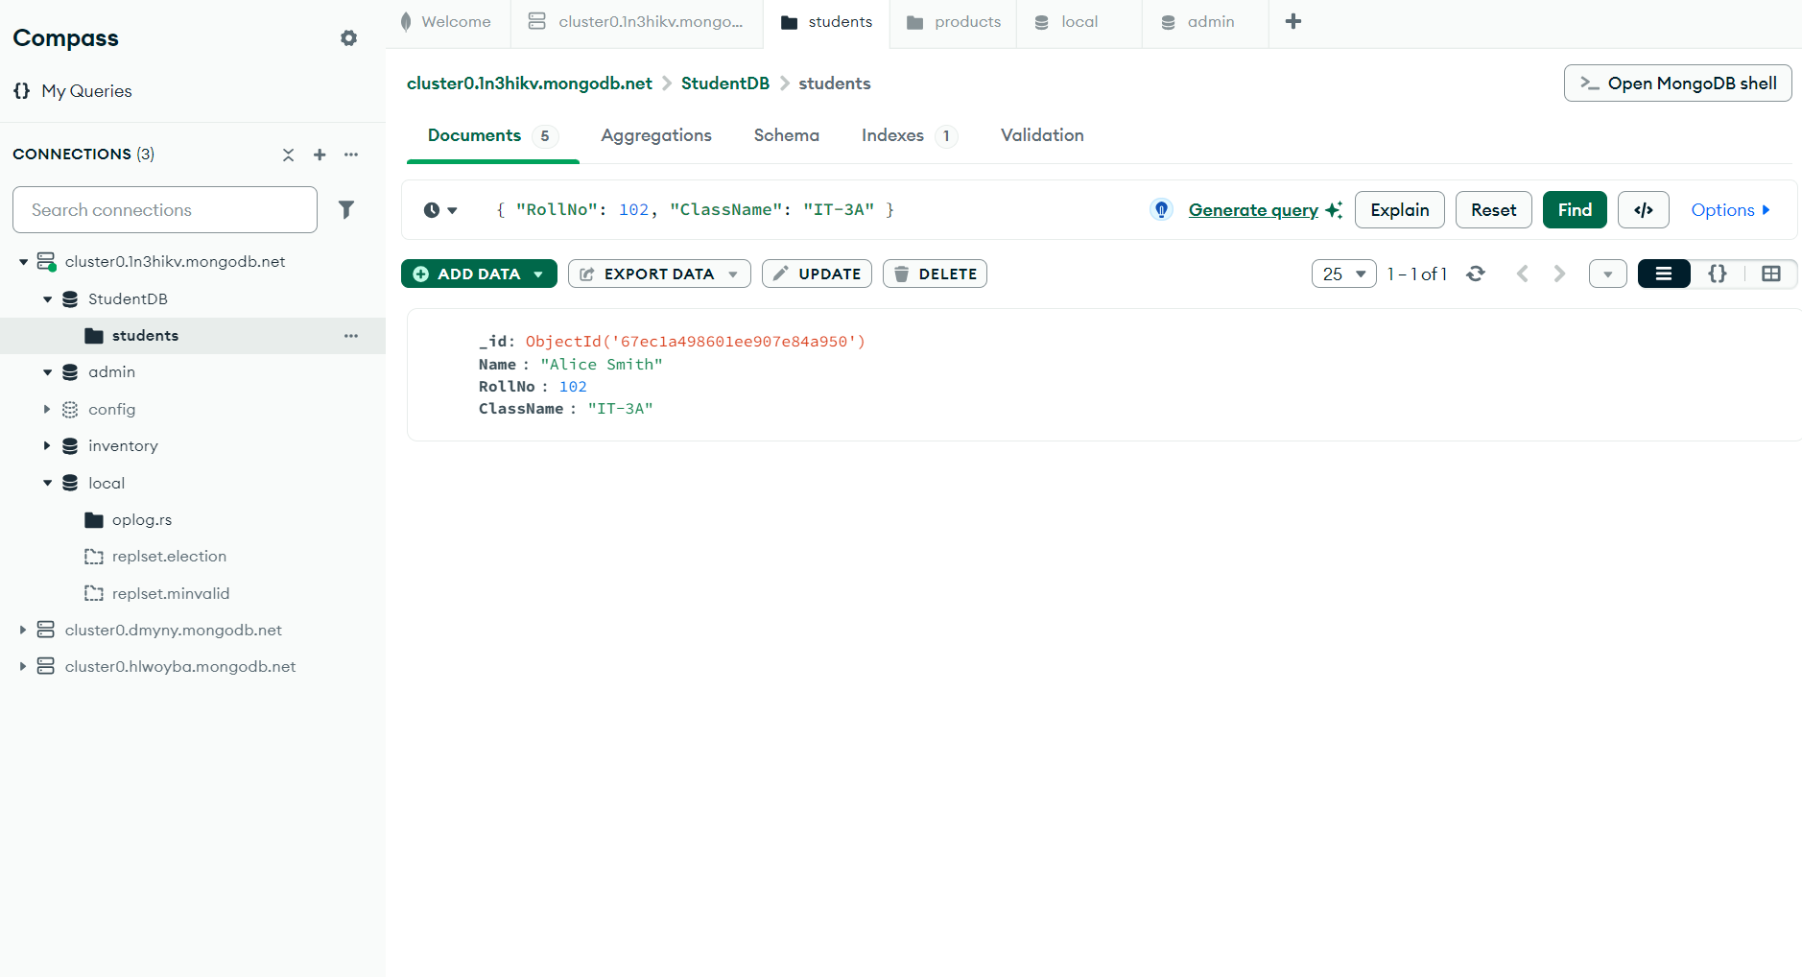

Change the roll no of a student

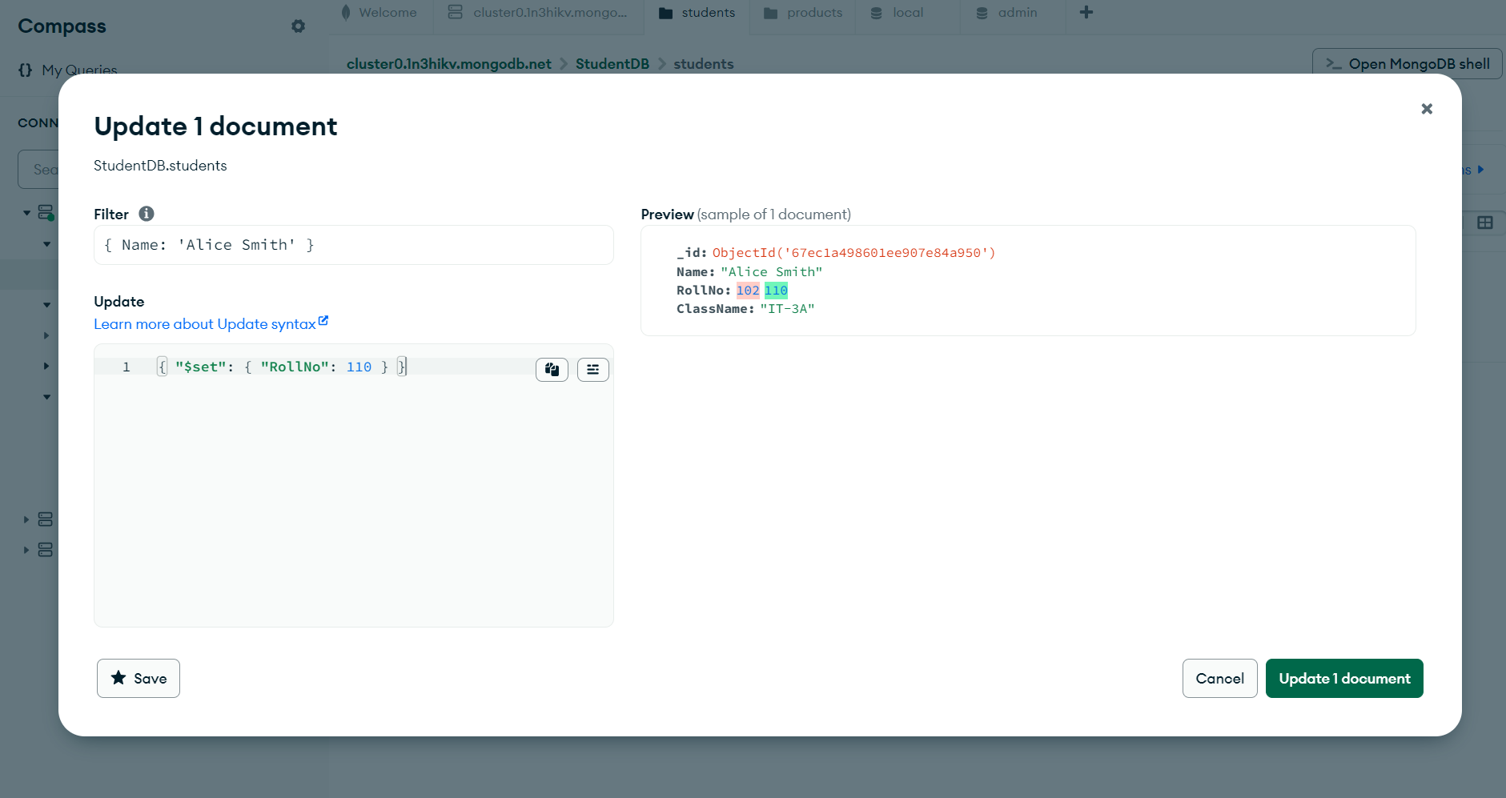

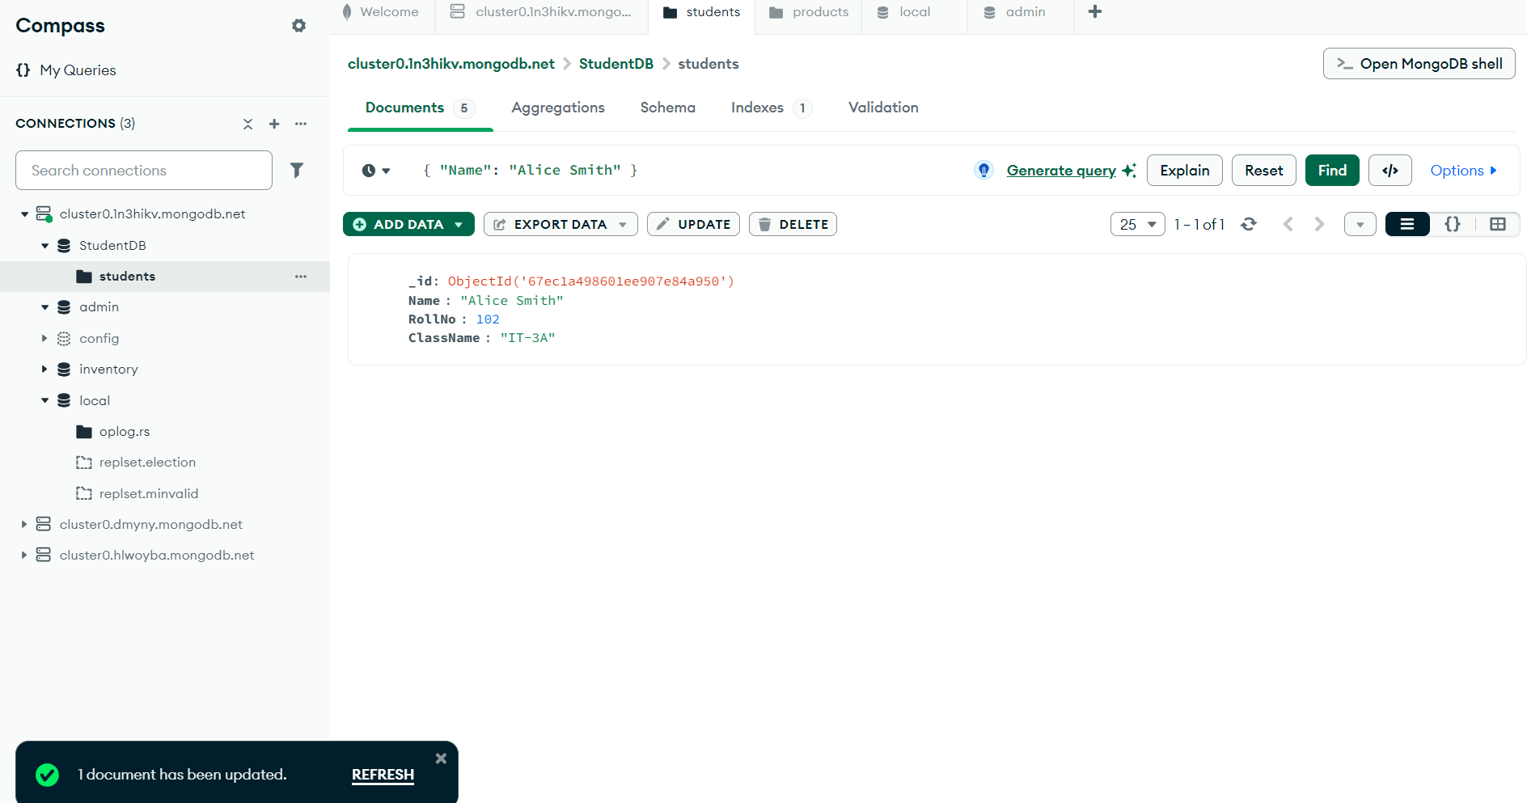

Delete entries of particular student

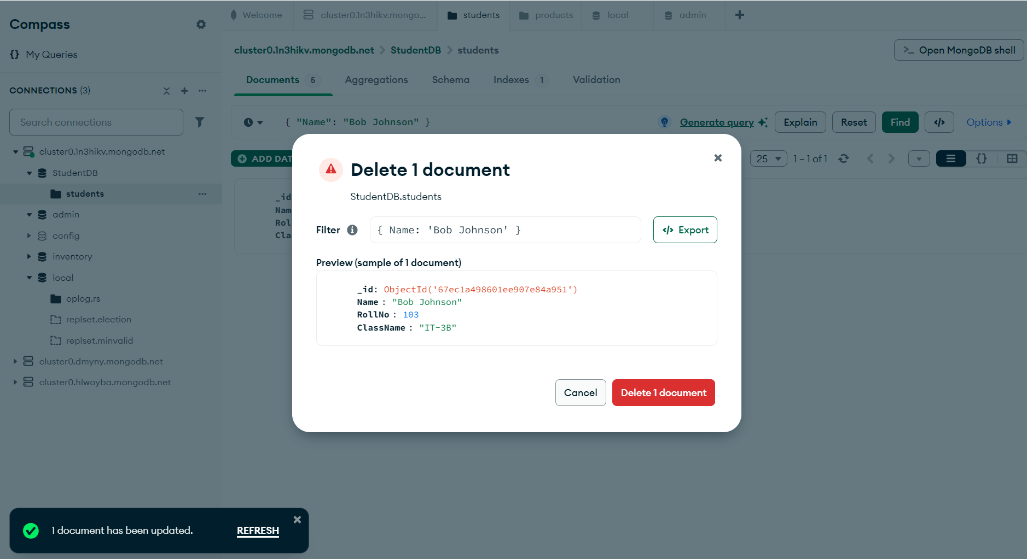

Create a set of RESTful endpoints using Node.js, Express, and Mongoose for handling student data operations.

Server.js

require('dotenv').config();

const express = require('express');

const mongoose = require('mongoose');

const cors = require('cors');

// Initialize Express App

const app = express();

app.use(cors());

app.use(express.json());

// Connect to MongoDB Atlas

mongoose.connect(process.env.MONGO_URI, {

    useNewUrlParser: true,

    useUnifiedTopology: true

}).then(() => console.log('MongoDB Connected'))

  .catch(err => console.log('Error: ', err));

// Define Student Schema (For Student DB)

const studentSchema = new mongoose.Schema({

    Name: { type: String, required: true },

    RollNo: { type: Number, required: true, unique: true },

    ClassName: { type: String, required: true }

});

const Student = mongoose.model('Student', studentSchema);

// Routes

app.get('/', (req, res) => res.send('Student API is Running 🚀'));

// 1️⃣ Retrieve all students

app.get('/students', async (req, res) => {

    try {

        const students = await Student.find();

        res.json(students);

    } catch (error) {

        res.status(500).json({ message: 'Server Error' });

    }

});

// 2️⃣ Retrieve a student by ID

app.get('/students/:id', async (req, res) => {

    try {

        const student = await Student.findById(req.params.id);

        if (!student) return res.status(404).json({ message: 'Student Not Found' });

        res.json(student);

    } catch (error) {

        res.status(500).json({ message: 'Server Error' });

    }

});

// 3️⃣ Add a new student

app.post('/students', async (req, res) => {

    try {

        const { Name, RollNo, ClassName } = req.body;

        // Validation: Ensure all fields are present

        if (!Name || !RollNo || !ClassName) {

            return res.status(400).json({ message: 'Invalid Data. All fields are required.' });

        }

        const newStudent = new Student({ Name, RollNo, ClassName });

        await newStudent.save();

        res.status(201).json(newStudent);

    } catch (error) {

        if (error.code === 11000) {

            return res.status(400).json({ message: 'Roll Number already exists.' });

        }

        res.status(400).json({ message: 'Invalid Data' });

    }

});

// 4️⃣ Update a student by ID

app.put('/students/:id', async (req, res) => {

    try {

        const updatedStudent = await Student.findByIdAndUpdate(req.params.id, req.body, { new: true });

        if (!updatedStudent) return res.status(404).json({ message: 'Student Not Found' });

        res.json(updatedStudent);

    } catch (error) {

        res.status(500).json({ message: 'Server Error' });

    }

});

// 5️⃣ Delete a student by ID

app.delete('/students/:id', async (req, res) => {

    try {

        const deletedStudent = await Student.findByIdAndDelete(req.params.id);

        if (!deletedStudent) return res.status(404).json({ message: 'Student Not Found' });

        res.json({ message: 'Student Deleted' });

    } catch (error) {

        res.status(500).json({ message: 'Server Error' });

    }

});

// Start Server

const PORT = process.env.PORT || 5000;

app.listen(PORT, () => console.log(`Server running on port ${PORT}`));

Retrieve a list of all students.

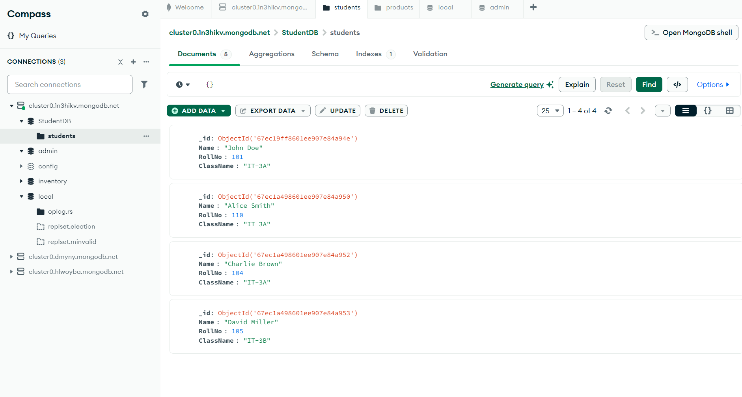

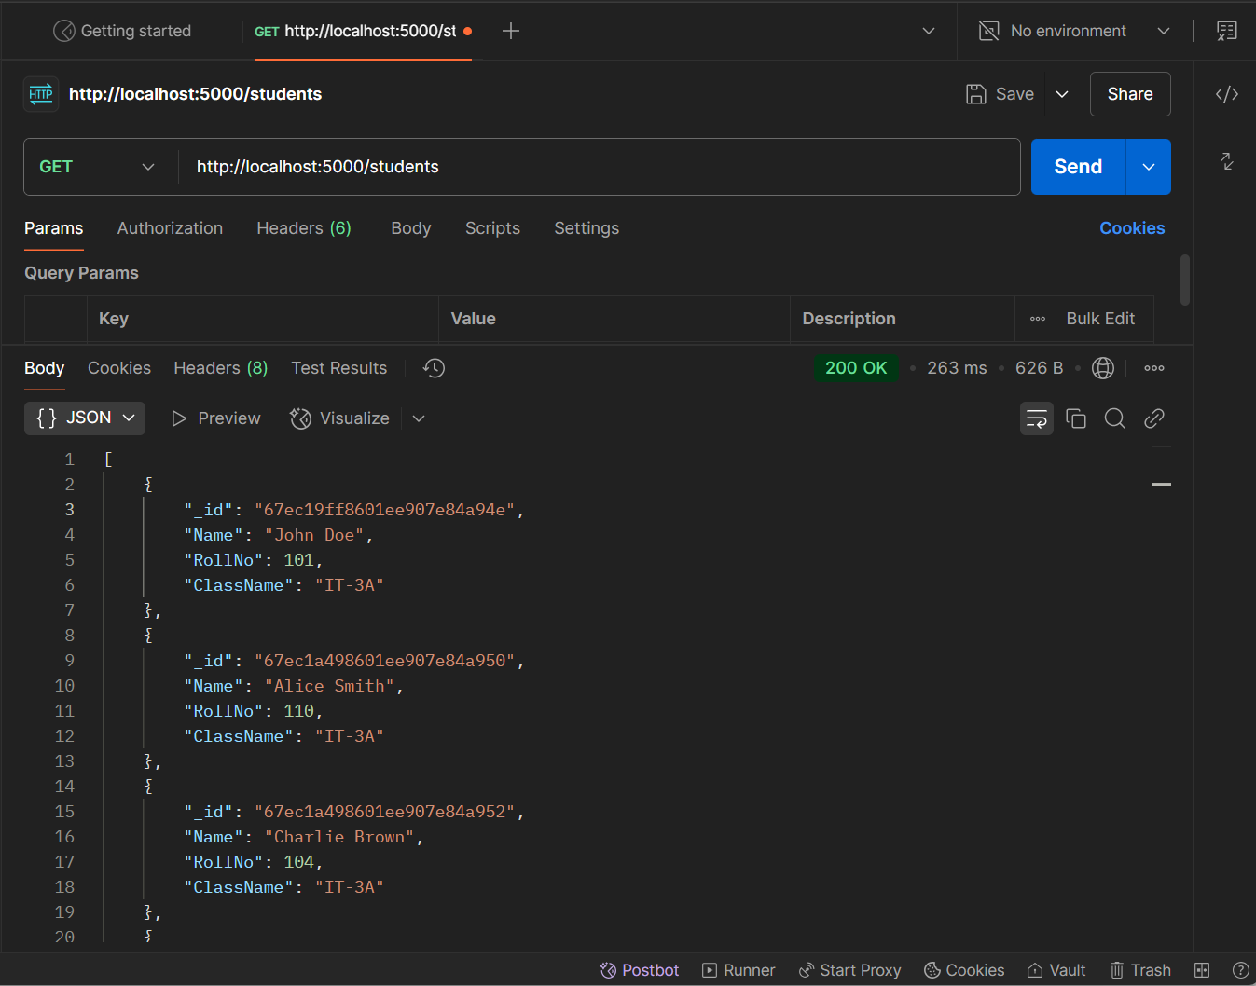

Retrieve details of an individual student by ID.

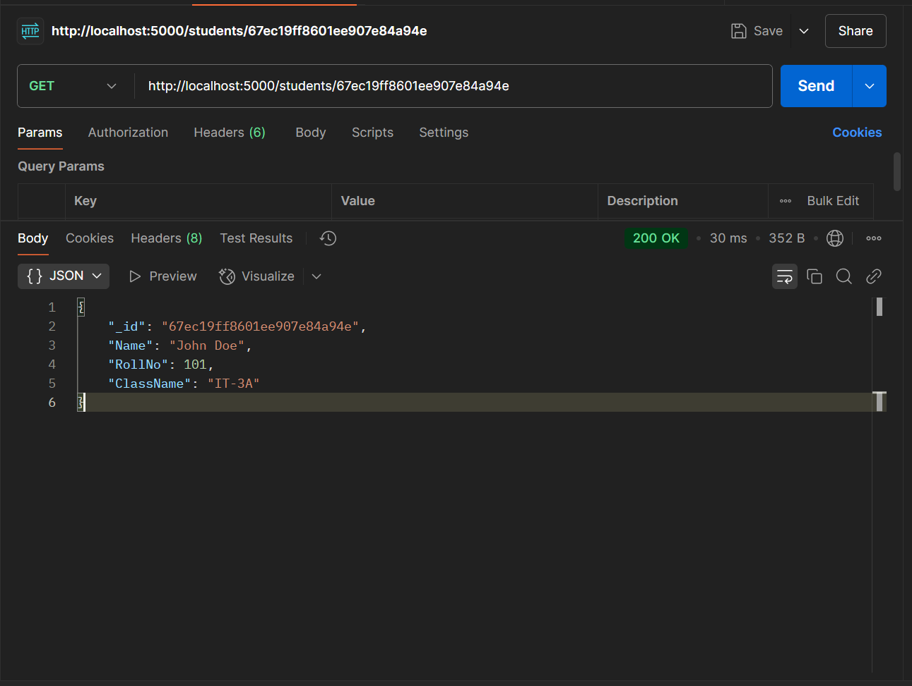

Add a new student to the database.

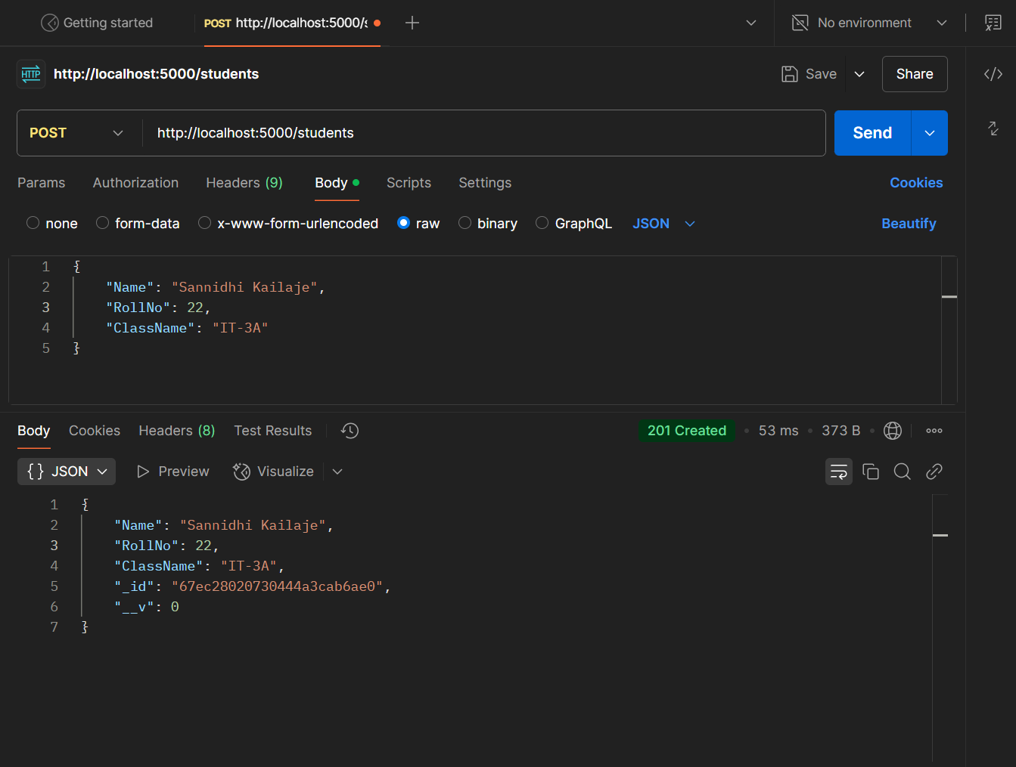

Update details of an existing student by ID.

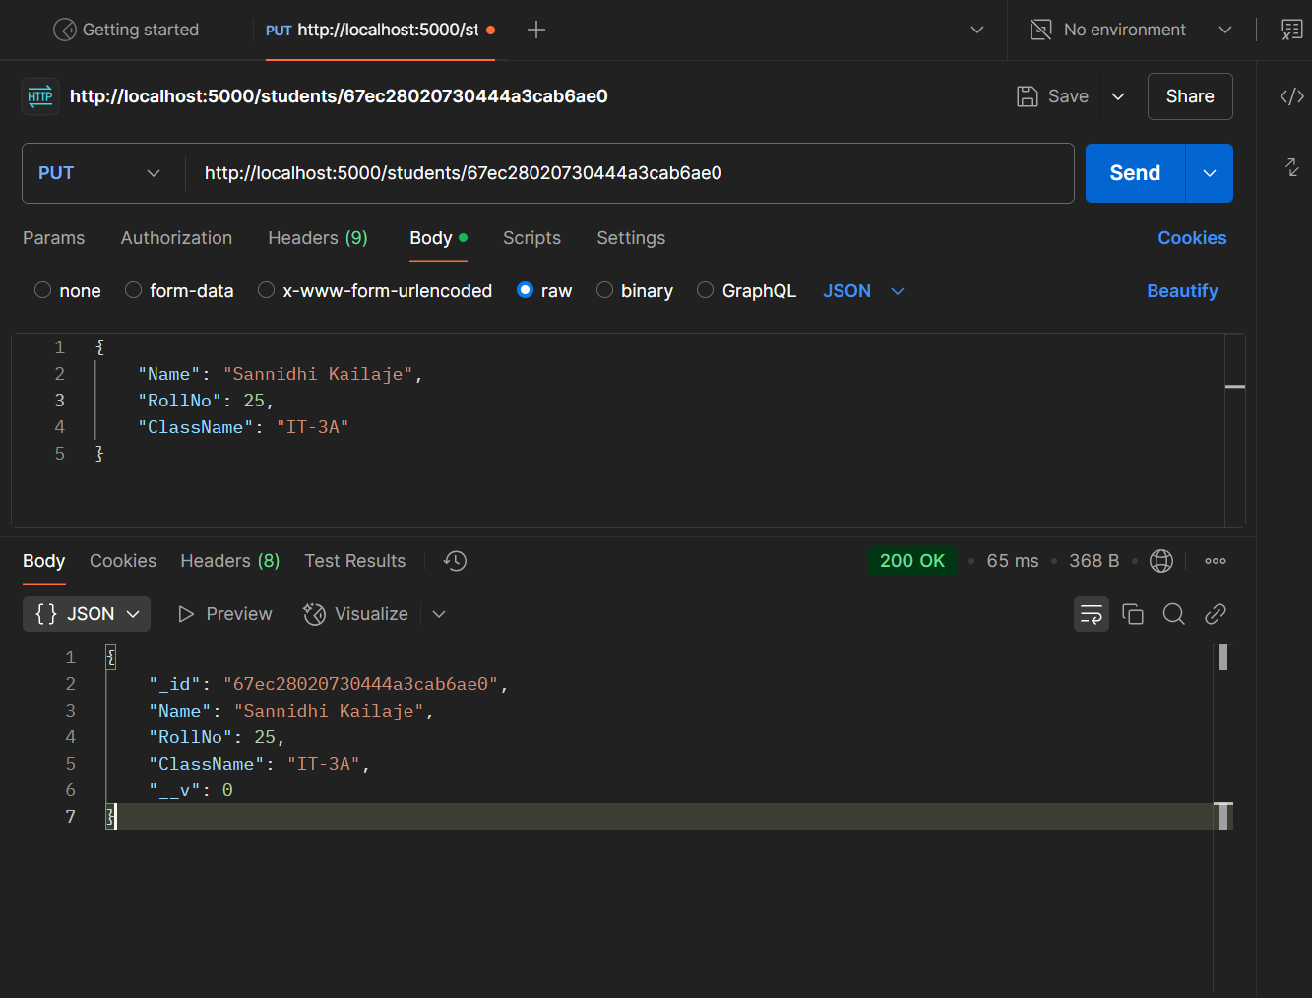

Delete a student from the database by ID.

