**Experiment 8 : To study Angular JS**

|  |  |
| --- | --- |
| **Name of Student** | **AKRUTI DABAS** |
| **Class Roll No** | **D15A / 11** |
| **D.O.P.** |  |
| **D.O.S.** |  |
| **Sign and Grade** |  |

**Aim:** To study AngularJS

**Problem Statement:**

1. Demonstrate with an AngularJS code one way data binding and two way data binding in

AngularJS

1. Implement a basic authentication system for a web application using AngularJS. Create a simple login page that takes a username and password, and upon submission, checks for a hardcoded set of credentials. If the credentials are valid, display a success message; otherwise, show an error message. Demonstrate AngularJS controller, module and form directives.
2. Users want to search for books by title, author, or genre. To accomplish this, develop an AngularJS custom filter named bookFilter and include it into the application.
3. Create a reusable and modular custom AngularJS service to handle user authentication. Include this service into an application.

**Theory:-**

1. **What are directives? Name some of the most commonly used directives in AngularJS application**

Directives are one of the core features of AngularJS that allow developers to extend HTML functionality. They are special markers on DOM elements (such as attributes, elements, or CSS classes) that tell AngularJS to attach specific behaviors to those elements or transform them.

Commonly Used Directives in AngularJS:

* 1. ng-app: Defines the root element of an AngularJS application.

* 1. ng-model: Binds the value of an input, select, or textarea to a variable.

* 1. ng-bind: Replaces the content of an HTML element with the value of an expression.

* 1. ng-repeat: Iterates over an array or collection to generate repeated elements.

* 1. ng-if: Conditionally includes or removes elements from the DOM.

* 1. ng-show / ng-hide: Shows or hides an element based on a Boolean expression.

* 1. ng-click: Binds a click event to a function in the controller.

1. **What is data binding in AngularJS?**

Data binding is the process of synchronizing data between the model and the view. AngularJS supports two types of data binding:

One-way Data Binding: The model updates the view, but changes in the view do not affect the model. Example: <span ng-bind="message"></span>

Two-way Data Binding: The model and view are linked such that changes in one reflect in the other. Example:

<input type="text" ng-model="username">

<p>Hello, {{username}}!</p>

Two-way data binding is one of AngularJS's most powerful features, reducing the need for manual DOM manipulation.3.

1. **How is form validation done in AngularJS?**

Form validation in AngularJS ensures that user input is correct before submission. AngularJS provides built-in directives for form validation:

* 1. ng-required: Ensures that an input field is mandatory.
  2. ng-minlength / ng-maxlength: Sets minimum and maximum character limits for input fields.

* 1. ng-pattern: Validates input based on a regular expression pattern.
  2. ng-disabled: Disables a form element based on an expression.

Example:

<form name="userForm">

<input type="email" name="email" ng-model="userEmail" ngrequired="true">

<span ng-show="userForm.email.$error.required">Email is required.</span> </form>

AngularJS tracks form states such as $pristine, $dirty, $valid, and $invalid to provide real-time validation feedback.

1. **What is the use of AngularJS Controllers in the application?**

AngularJS controllers are JavaScript functions used to define application logic and manage the flow of data between the view and the model. Controllers are attached to the DOM using the ng-controller directive.

Key Functions of Controllers:

* 1. Define scope variables: Controllers bind data to the view using the $scope object.
  2. Handle business logic: Controllers process user input and manipulate the model accordingly.
  3. Communicate with services: They fetch data from APIs or services.

Example:

app.controller('MainController', function($scope) {

$scope.message = "Welcome to AngularJS!";

});

In the view:

<div ng-controller="MainController">

<p>{{ message }}</p>

</div>

Controllers improve the maintainability of AngularJS applications by separating concerns.

1. **What is the use of AngularJS Filters in the application?**

Filters in AngularJS modify data before displaying it in the view. They can be used within expressions and directives like ng-repeat.

Commonly Used Filters:

* 1. uppercase / lowercase: Converts text to upper or lower case.
  2. currency: Formats numbers as currency.
  3. date: Formats date values.
  4. filter: Filters an array based on a specified condition.
  5. orderBy: Sorts an array by a specified property.

Example:

<p>{{ "hello world" | uppercase }}</p>

<p>{{ 1000 | currency }}</p>

<p>{{ myDate | date:'short' }}</p>

Filters enhance the readability of data and improve user experience.

**Output:**

**Index.html**

<!DOCTYPE html>

<html lang="en" ng-app="BookApp">

<head>

<meta charset="UTF-8">

<meta name="viewport" content="width=device-width, initial-scale=1.0">

<title>Book Finder & Login</title>

<script

src="https://ajax.googleapis.com/ajax/libs/angularjs/1.8.2/angular.min.js"></script> <script src="https://cdn.tailwindcss.com"></script>

</head>

<body class="bg-gray-100 text-gray-900">

<div class="container mx-auto p-6" ng-controller="AuthController">

<h1 class="text-3xl font-bold text-center mb-6">Welcome to Book Finder</h1>

<!-- One-Way and Two-Way Data Binding Demo -->

<div class="max-w-md mx-auto bg-white p-6 rounded-lg shadow-md mb-6" ngcontroller="BindingController">

<h2 class="text-2xl font-semibold mb-4">Data Binding Demo</h2>

<p class="mb-2">One-Way Binding: <span>{{ staticText }}</span></p>

<label class="block mb-2">Two-Way Binding: </label>

<input type="text" ng-model="dynamicText" placeholder="Type something..." class="w-full p-2 border rounded-md mb-2">

<p>You typed: {{ dynamicText }}</p>

</div>

<!-- Login Form -->

<div class="max-w-md mx-auto bg-white p-6 rounded-lg shadow-md" nghide="isAuthenticated">

<h2 class="text-2xl font-semibold mb-4">Login</h2>

<form ng-submit="login()" class="space-y-4">

<input type="text" ng-model="user.username" placeholder="Username" class="w-full p-2 border rounded-md">

<input type="password" ng-model="user.password" placeholder="Password" class="w-full p-2 border rounded-md">

<button type="submit" class="w-full bg-blue-500 text-white py-2 rounded-md hover:bg-blue-600">Login</button>

</form>

<p class="text-red-500 mt-2" ng-show="errorMessage">{{errorMessage}}</p>

</div>

<!-- Book Search -->

<div class="mt-8" ng-show="isAuthenticated" ng-controller="BookController">

<h2 class="text-2xl font-semibold mb-4">Search Books</h2>

<input type="text" ng-model="searchQuery" placeholder="Search by title, author, or genre" class="w-full p-2 border rounded-md mb-4">

<div class="grid grid-cols-1 md:grid-cols-3 gap-4">

<div class="bg-white p-4 rounded-md shadow-md" ng-repeat="book in books | bookFilter:searchQuery">

<h3 class="text-lg font-semibold">{{ book.title }}</h3>

<p class="text-gray-600">Author: {{ book.author }}</p>

<p class="text-gray-500">Genre: {{ book.genre }}</p>

</div>

</div>

</div>

</div>

<script>

var app = angular.module('BookApp', []);

app.controller('AuthController', function($scope, AuthService) {

$scope.user = {};

$scope.isAuthenticated = false;

$scope.errorMessage = "";

$scope.login = function() {

if (AuthService.authenticate($scope.user.username, $scope.user.password)) {

$scope.isAuthenticated = true;

$scope.errorMessage = "";

}

else {

$scope.errorMessage = "Invalid username or password";

}

};

});

app.controller('BookController', function($scope) {

$scope.books = [

{ title: 'The Great Gatsby', author: 'F. Scott Fitzgerald', genre: 'Fiction' },

{ title: '1984', author: 'George Orwell', genre: 'Dystopian' },

{ title: 'To Kill a Mockingbird', author: 'Harper Lee', genre: 'Classic' },

{ title: 'Moby-Dick', author: 'Herman Melville', genre: 'Adventure' },

{ title: 'Pride and Prejudice', author: 'Jane Austen', genre: 'Romance' },

{ title: 'War and Peace', author: 'Leo Tolstoy', genre: 'Historical' },

{ title: 'The Catcher in the Rye', author: 'J.D. Salinger', genre: 'Coming-of-Age' },

{ title: 'The Hobbit', author: 'J.R.R. Tolkien', genre: 'Fantasy' },

{ title: 'Brave New World', author: 'Aldous Huxley', genre: 'Science Fiction' }, { title: 'The Lord of the Rings', author: 'J.R.R. Tolkien', genre: 'Fantasy' }

];

});

app.controller('BindingController', function($scope) { $scope.staticText = "Sannidhi Kailaje / 22 / D15A";

$scope.dynamicText = "";

});

app.filter('bookFilter', function() { return function(books, query) { if (!query) return books; query = query.toLowerCase(); return books.filter(book => book.title.toLowerCase().includes(query) || book.author.toLowerCase().includes(query) || book.genre.toLowerCase().includes(query)

);

};

});

app.service('AuthService', function() {

var validCredentials = { username: 'admin', password: '1234' }; this.authenticate = function(username, password) {

return username === validCredentials.username && password === validCredentials.password;

};

});

</script>

</body>

</html>

**One-Way & Two-Way Data Binding Demo**

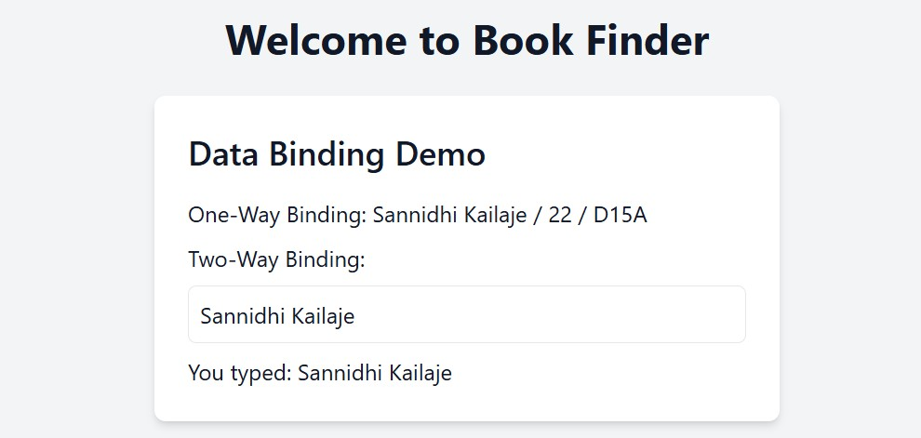

**Login Page**

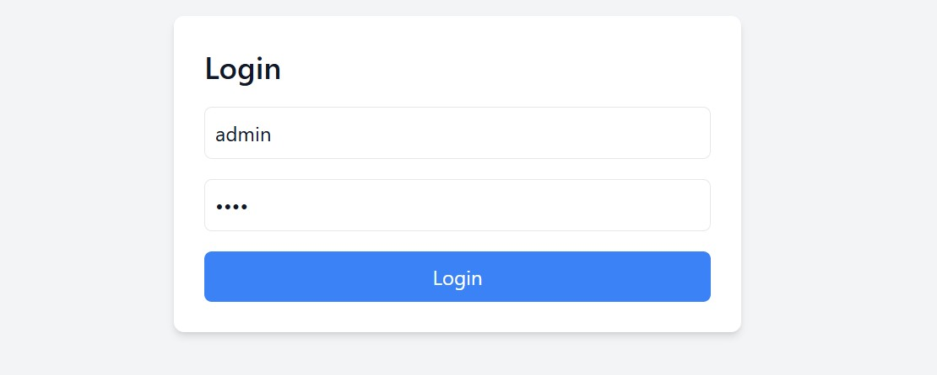

**Book Finder Page**

