**Vagrant + Load Balancer**

* Install Virtual Box
* Install vagrant here:

C:\Software_Personal\vagrantBOX\vagrant

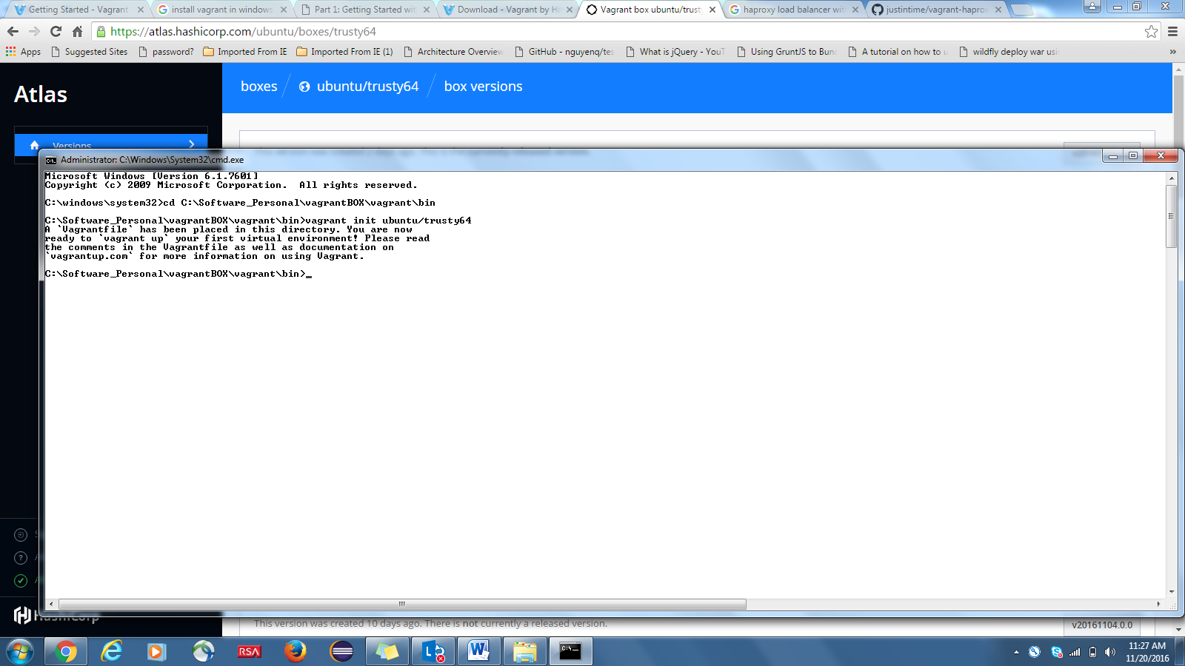

**Open three terminal:**

vagrant up haproxy && vagrant ssh haproxy

Web1:

Run Command Prompt with Admin Rigts at following Location:

C:\Software_Personal\vagrantBOX\vagrant\bin

run *vagrant up web1 && vagrant ssh web1*

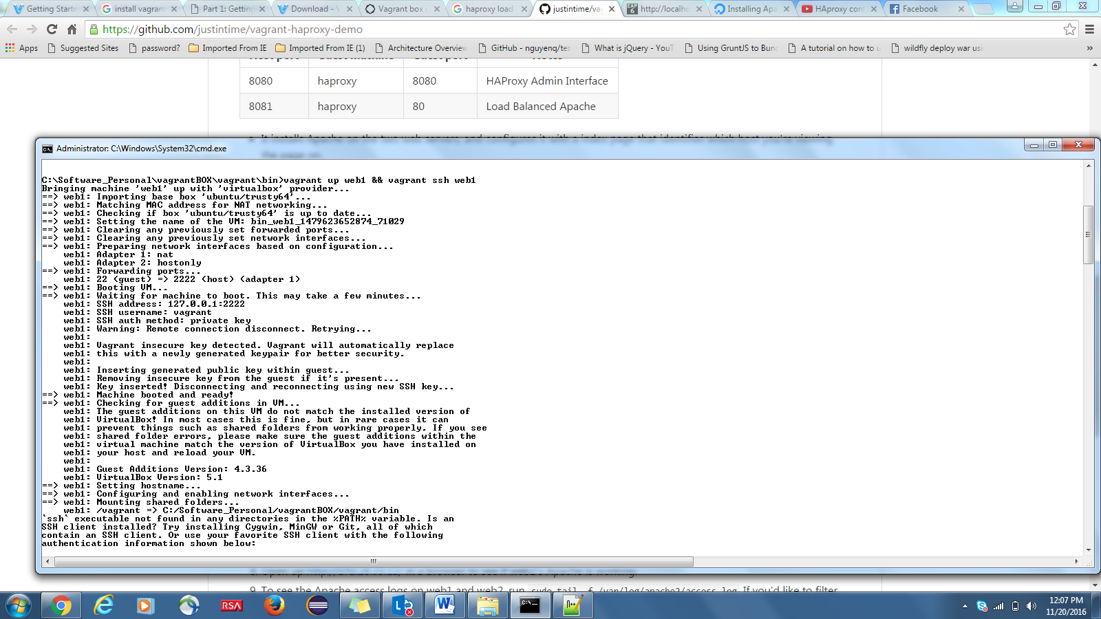

**Login to web1 through putty:**

SSH PORT :2222

Host: 127.0.0.1

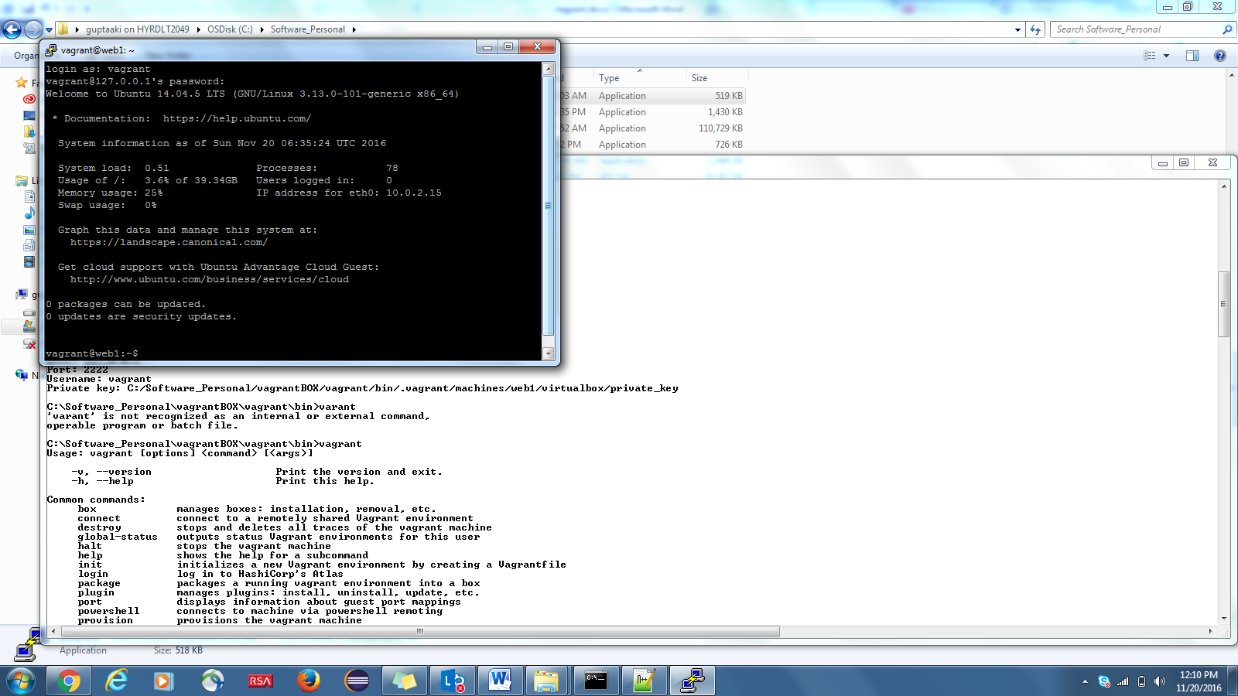

Install Apache web server on bah shell insode web1(Server 1 )

sudo apt-get install apache2

Check if Apache got intall properly:

Private IP for web1: 172.28.33.11(defined in Vagrant file)

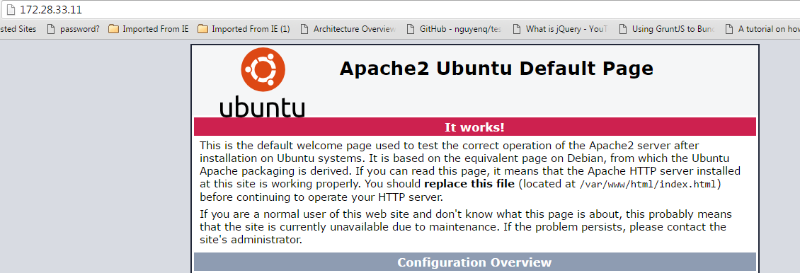

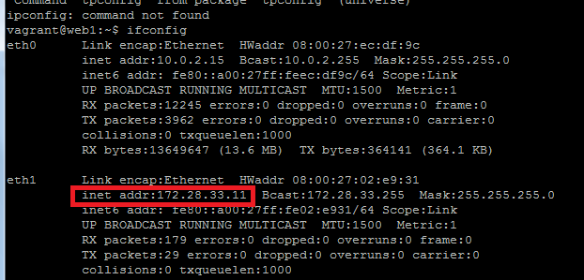

Shows private IP associated with web1

Step2:

Connect to web2 using port: **2200**

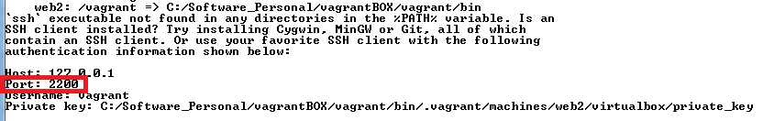

Private IP for web2:

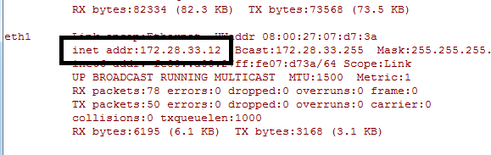

Web2 : default Apache Page:

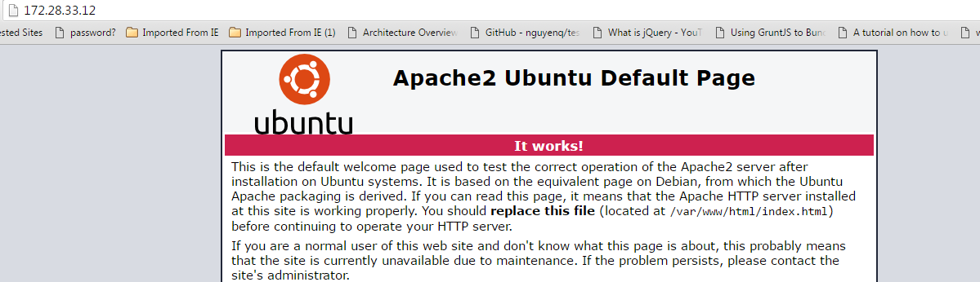

Install HAProxy:



Vagrant File:

Vagrant.configure("2") do |config|

# The most common configuration options are documented and commented below.

# For a complete reference, please see the online documentation at

# https://docs.vagrantup.com.

# Every Vagrant development environment requires a box. You can search for

# boxes at https://atlas.hashicorp.com/search.

config.vm.box = "ubuntu/trusty64"

config.vm.define :haproxy, primary: true do |haproxy_config|

haproxy_config.vm.hostname = 'haproxy'

haproxy_config.vm.network :forwarded_port, guest: 8080, host: 8080

haproxy_config.vm.network :forwarded_port, guest: 80, host: 8082

haproxy_config.vm.network :private_network, ip: "172.28.33.10"

end

config.vm.define :web1 do |web1_config|

web1_config.vm.hostname = 'web1'

web1_config.vm.network :private_network, ip: "172.28.33.11"

end

config.vm.define :web2 do |web2_config|

web2_config.vm.hostname = 'web2'

web2_config.vm.network :private_network, ip: "172.28.33.12"

end

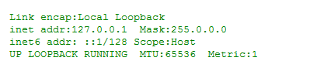

**Install/Check HAProxy version:**



**Admin Console for HAProxy:**

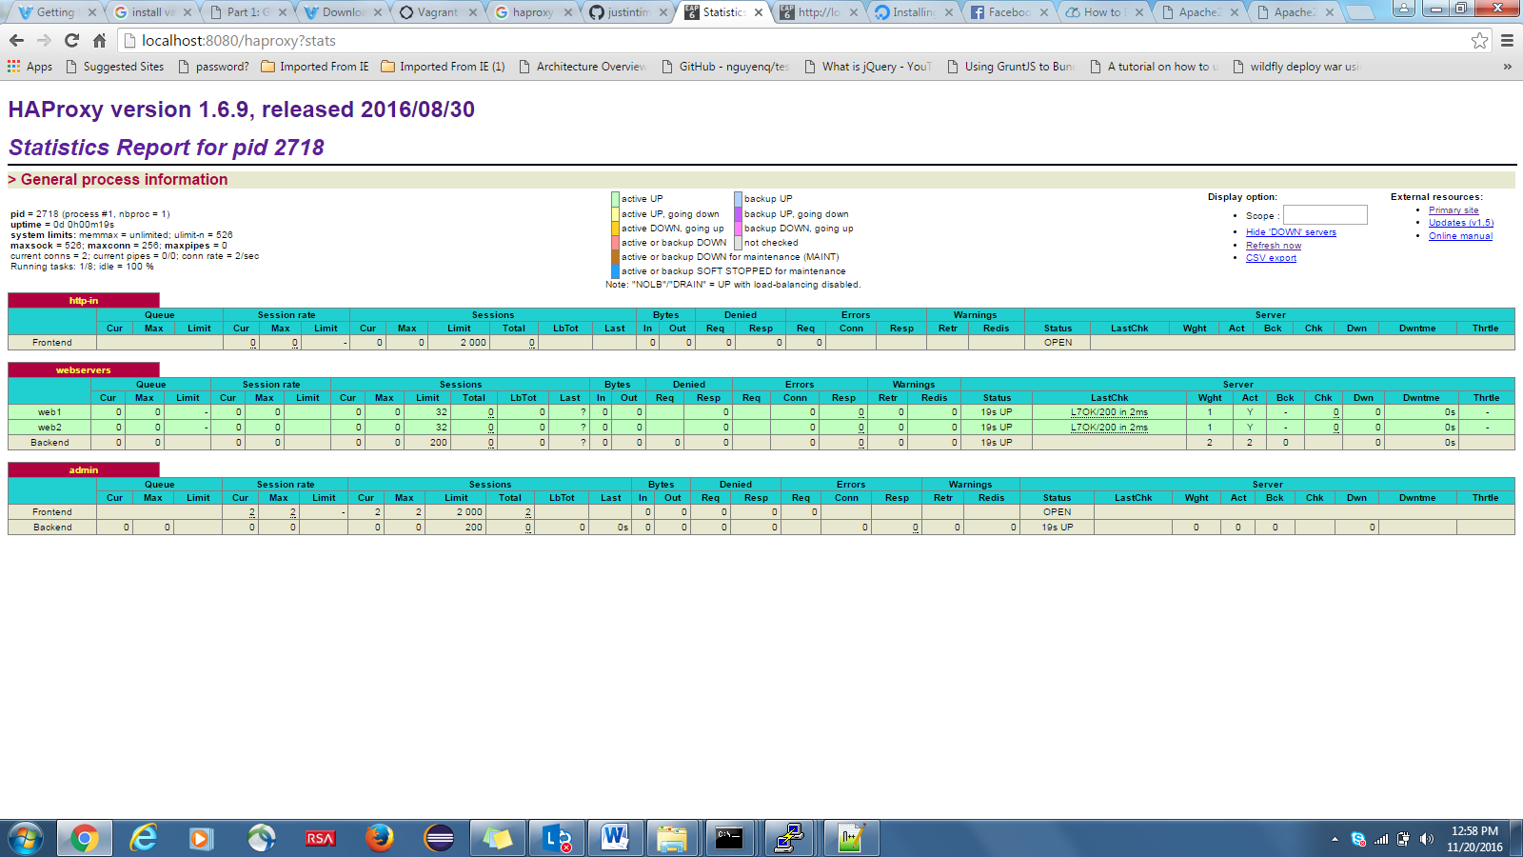

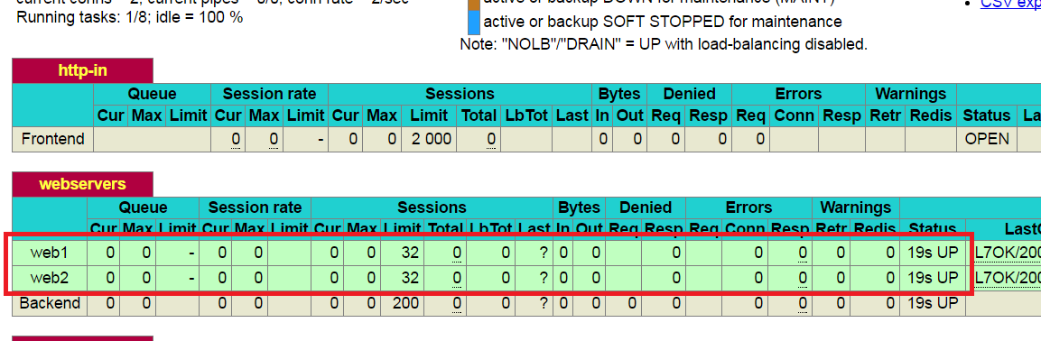

Now change the Default landing page of Apache for both servers to ensure that both pages are being servered by HAProxy(Load Balancer)