Computer Vision
CCA 3 - Practical Coding Assignment
Units 3, 4 and 5: Restoration & Segmentation, Feature Extraction, Object Recognition & Motion Estimation

Table 1: Submission details
Item | Details
Student | Akki Mujawdiya
PRN | 1272250543
Course | Computer Vision - CCA 3
Date | 22 October 2026
Git repository | PASTE YOUR GITHUB REPO URL HERE
Project explanation video | PASTE YOUR GOOGLE DRIVE VIDEO LINK HERE
Google Drive folder (originals + outputs) | PASTE YOUR GOOGLE DRIVE FOLDER LINK HERE
Shared with | rahul.inchal.inchal24@gmail.com, rahul.inchal.vf@mitwpu.edu.in

Introduction
This report documents the practical assignment for Units 3, 4 and 5. Using my own photograph and my own video I implemented image restoration, morphological processing and segmentation (Task 1), feature extraction and image matching (Task 2), object recognition with Haar cascades and YOLO (Task 3) and video motion estimation (Task 4). The code is written in Python with OpenCV, NumPy, Matplotlib, scikit-image and Ultralytics YOLO. All numbers and images in this report were produced by the code in the Git repository.

1. Input
Table 2: Input data used
Input | File | Details / how it was used
Original photograph | photo.jpeg | Captured with my own phone/camera, not edited. Used in Tasks 1, 2 and 3. Working size 675x900 after resizing a copy in memory.
Second photograph | Photo2.jpeg | Same object/scene from a different position. Used for SIFT matching in Task 2.
Object photograph (optional) | not used | Several touching objects, used for the watershed segmentation in Task 1.
Original video | video.mp4 | Self-recorded, unedited. 960x540 at 30.0 fps, 180 frames (about 6.0 s). Used in Tasks 3 and 4.

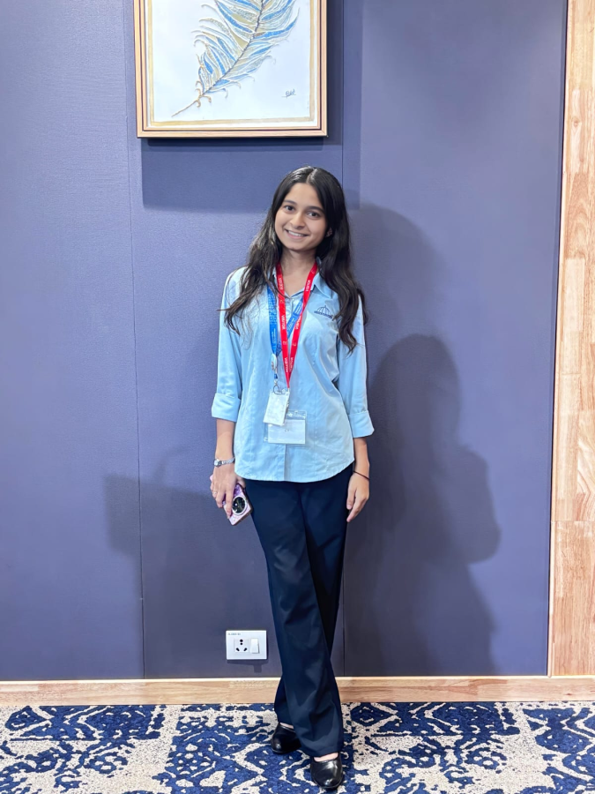
Figure 1: Original photograph used for Tasks 1-3 (resized copy).
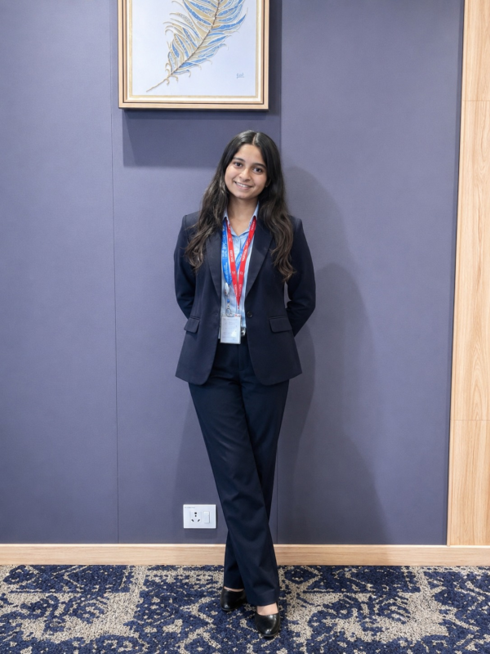
Figure 2: Second photograph of the same object/scene used for SIFT matching.
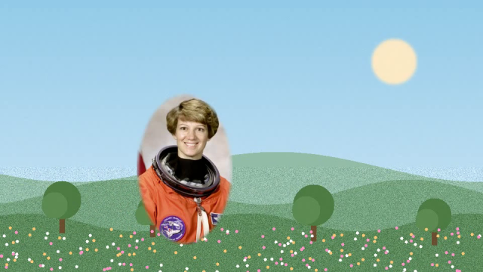
Figure 3: Sample frame from the self-recorded video.
Folder layout and how to place the input files is described in data/README.md in the repository. Large raw videos are kept on Google Drive instead of Git.

2. Source Code
Repository: PASTE YOUR GITHUB REPO URL HERE
Table 3: Source files
File | What it does
src/utils.py | Shared helpers: finding inputs, loading images, saving figures and CSV/JSON.
src/task1_restoration_segmentation.py | Noise, median/Gaussian restoration, PSNR/SSIM, thresholding, morphology, Canny, watershed.
src/task2_features.py | HOG visualisation, SIFT keypoints, ratio-test matching + RANSAC, rotation/resize experiments.
src/task3_detection.py | Haar cascade face detection and YOLOv8 detection with boxes, labels and scores.
src/task4_motion.py | Frame differencing, MOG2 background subtraction, Lucas-Kanade optical flow.
src/run_all.py / src/make_report.py | Run all tasks / build this report.

The complete source listing is given in Appendix A.

3. Task 1 - Image Restoration and Segmentation (Unit 3)

3.1 Image restoration
Explanation. I added two kinds of noise to the clean photograph: Gaussian noise (sigma = 25) which changes every pixel a little, and salt-and-pepper noise (5% of pixels set to pure black or white). Each noisy image was restored with a 3x3 median filter, a 5x5 median filter and a 5x5 Gaussian filter (sigma = 1.2). Quality was measured against the clean image with PSNR (higher is better) and SSIM (closer to 1 is better).
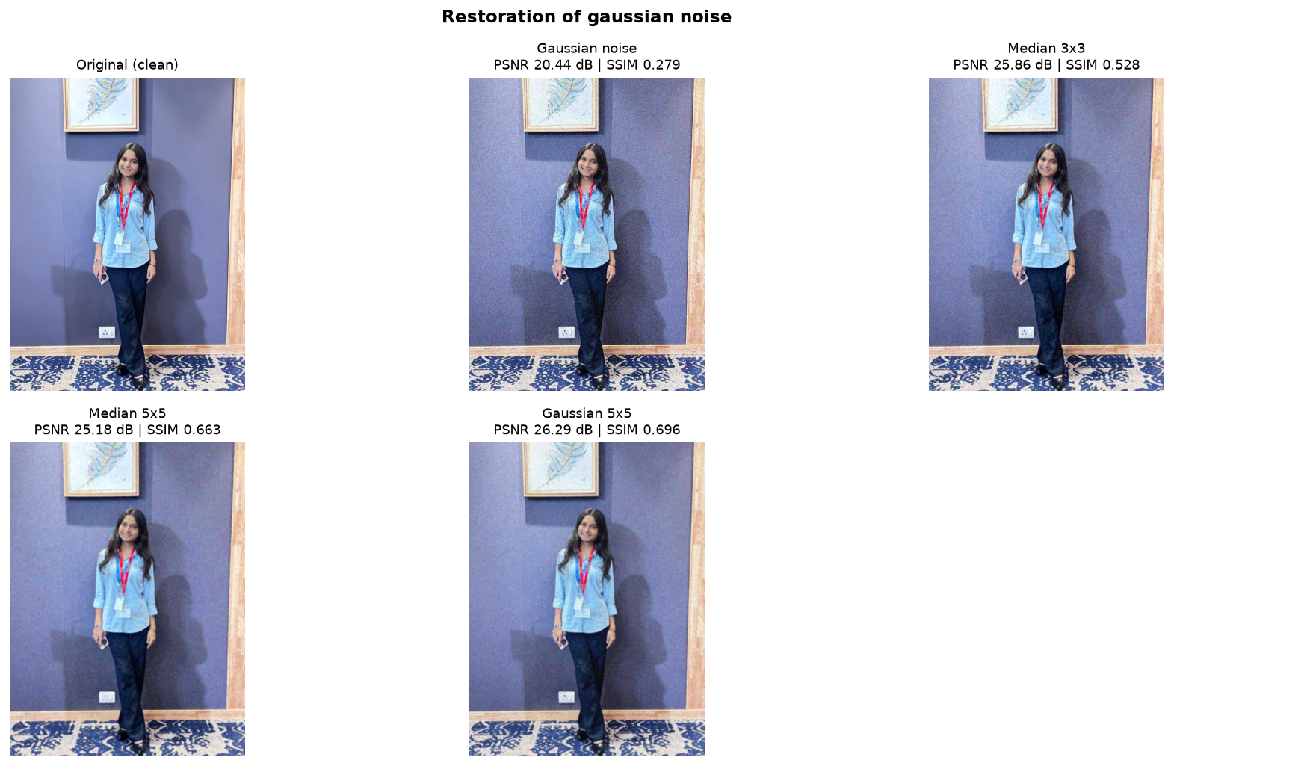
Figure 4: Original, Gaussian noisy image and the three restored versions.
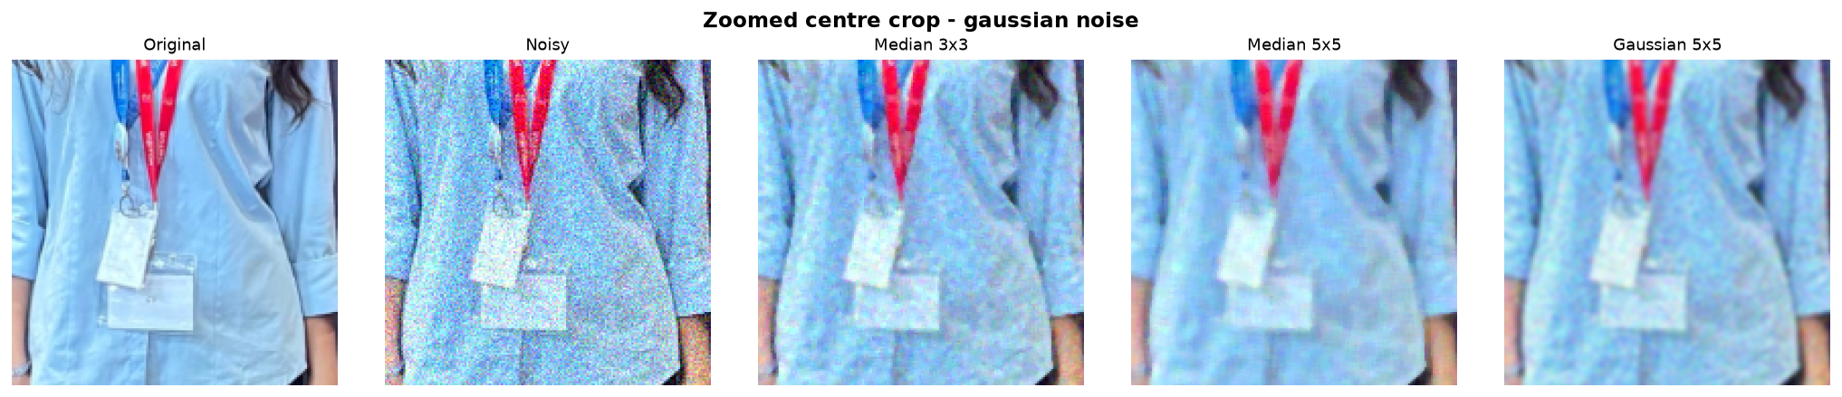
Figure 5: Zoomed centre crop for Gaussian noise (easier to compare detail).
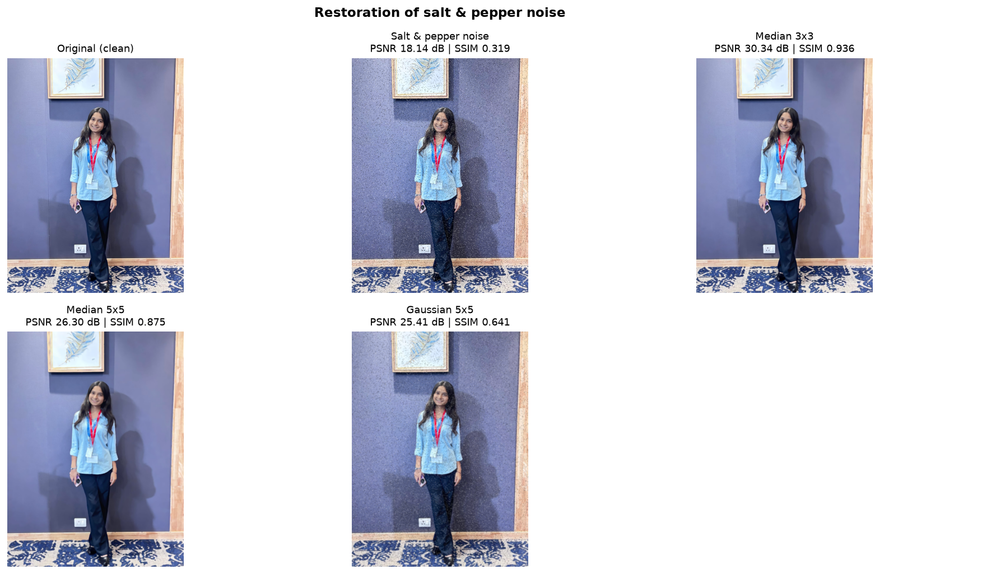
Figure 6: Original, salt-and-pepper noisy image and the three restored versions.
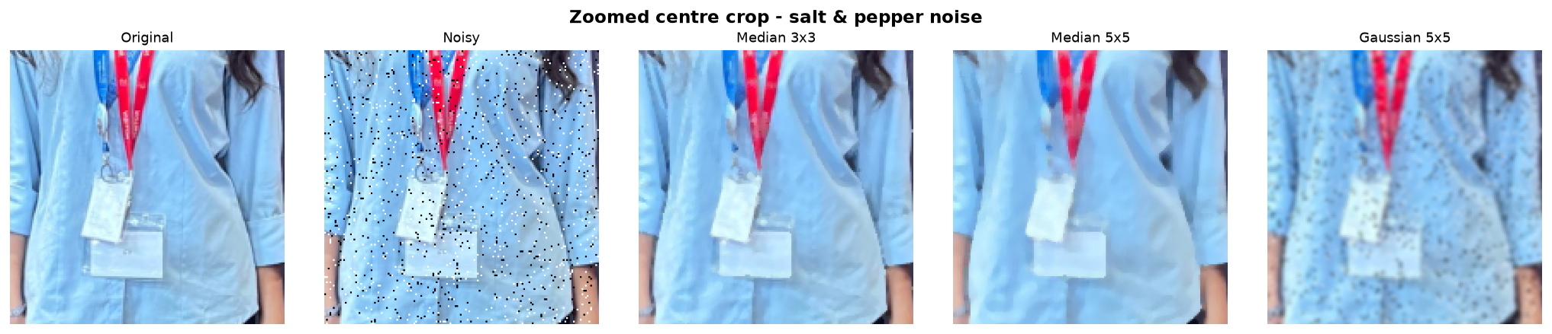
Figure 7: Zoomed centre crop for salt-and-pepper noise (easier to compare detail).
Table 4: PSNR and SSIM compared with the clean photograph
Noise type | Image | PSNR (dB) | SSIM
Gaussian noise | Noisy (no filter) | 20.44 | 0.2793
Gaussian noise | Median 3x3 | 25.86 | 0.5279
Gaussian noise | Median 5x5 | 25.18 | 0.6626
Gaussian noise | Gaussian 5x5 | 26.29 | 0.6961
Salt & pepper noise | Noisy (no filter) | 18.14 | 0.3192
Salt & pepper noise | Median 3x3 | 30.34 | 0.936
Salt & pepper noise | Median 5x5 | 26.3 | 0.875
Salt & pepper noise | Gaussian 5x5 | 25.41 | 0.6406

Comparison.
- Gaussian noise: the noisy image scored 20.44 dB / SSIM 0.2793. The best PSNR came from Gaussian 5x5 (26.29 dB) and the best SSIM from Gaussian 5x5 (0.6961).
- Salt & pepper noise: the noisy image scored 18.14 dB / SSIM 0.3192. The best PSNR came from Median 3x3 (30.34 dB) and the best SSIM from Median 3x3 (0.936).
The median filter is clearly the right tool for salt-and-pepper noise because the extreme black/white pixels are outliers that the median simply ignores, while the Gaussian filter averages them into their neighbours and leaves grey blotches. For Gaussian noise the two filters are much closer: Gaussian smoothing matches the noise statistics and gives a good PSNR, while the larger median kernel keeps edges a bit better (higher SSIM) at the cost of a slightly 'painted' look. Bigger kernels remove more noise but blur fine detail.

3.2 Thresholding, morphology and edge detection
Explanation. The photo was converted to grayscale, smoothed with a 5x5 Gaussian and binarised using a fixed threshold (127), Otsu's automatic threshold (T = 130) and an adaptive Gaussian threshold. Otsu's binary mask was then cleaned with erosion, dilation, opening and closing using a 5x5 elliptical structuring element. Canny edge detection was run with fixed thresholds (100/200) and with thresholds chosen from the image median (92/183).
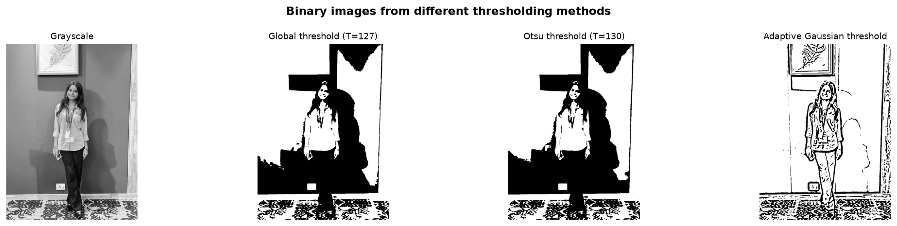
Figure 8: Binary images from global, Otsu and adaptive thresholding.
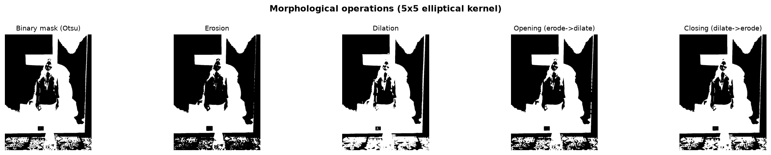
Figure 9: Erosion, dilation, opening and closing of the Otsu mask.
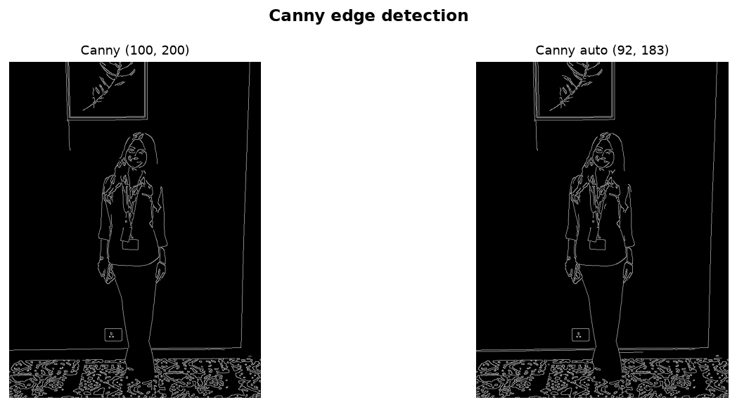
Figure 10: Canny edge maps with fixed and automatic thresholds.
Comparison.
- Otsu picks the threshold from the histogram itself, so it adapts to each photo better than a hand-picked 127; adaptive thresholding handles uneven lighting but also picks up texture/noise.
- Erosion shrinks white regions and removes small specks; dilation grows them and fills small gaps. Opening removes isolated noise without shrinking big objects much; closing fills small holes inside objects.
- Canny with fixed thresholds marked 3.48% of pixels as edges, the automatic version 3.65%. The automatic version needs no tuning when the lighting changes.

3.3 Watershed segmentation
Explanation. Watershed was applied to 'photo.jpeg', which contains several objects that sit close to or touch each other. Steps: Otsu threshold, opening to remove noise, distance transform, threshold of the distance map to get one marker per object, then cv2.watershed floods from these markers and draws boundary lines where the regions meet. The algorithm found 126 segments.
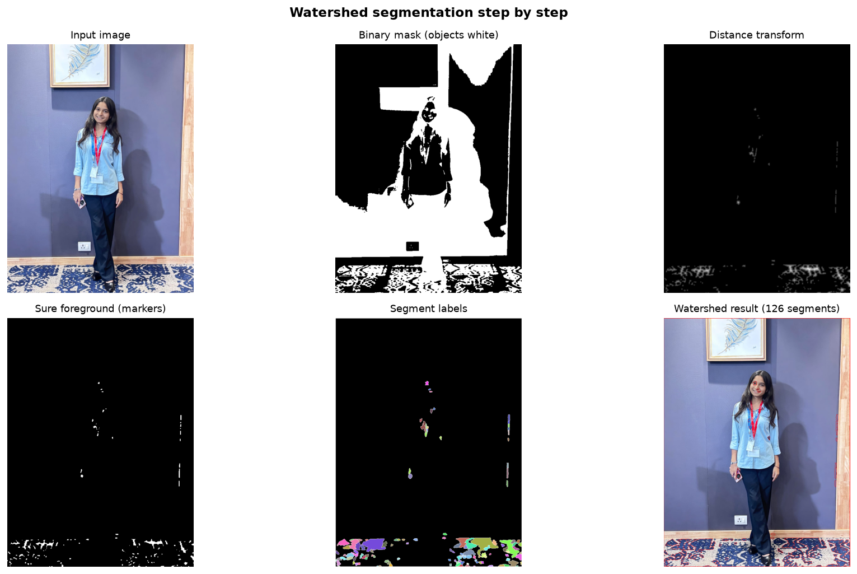
Figure 11: Watershed pipeline: mask, distance transform, markers, labels and result.
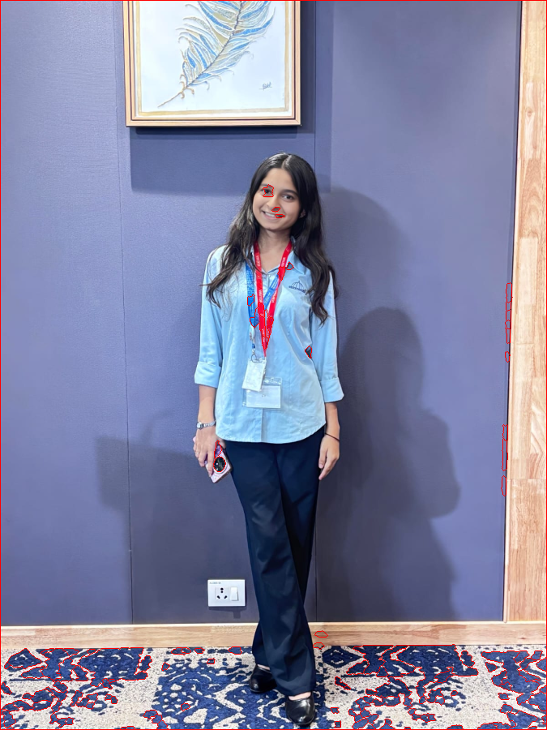
Figure 12: Final watershed boundaries (red) on the input image.
Comparison. Plain thresholding would merge touching objects into one blob. The distance transform turns each blob into a 'hill' and the markers are placed on the hill tops, so touching objects get separated. Watershed is sensitive to the marker threshold: too low merges objects, too high splits one object into several (over-segmentation).

4. Task 2 - Feature Extraction and Image Matching (Unit 4)

4.1 HOG features
Explanation. Both photos were converted to grayscale and resized to 256x256. HOG divides the image into 16x16 pixel cells, builds a 9-bin histogram of gradient orientations in each cell and normalises over 2x2 cell blocks. The result is a descriptor vector of length 8100. The visualisation shows the dominant edge direction in each cell. The cosine similarity between the HOG vectors of my two photos is 0.895 (different viewpoints, so HOG is not expected to be identical).
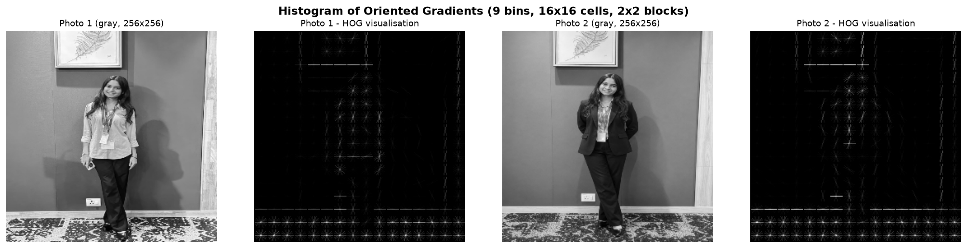
Figure 13: HOG visualisation for both photographs.

4.2 SIFT keypoints
Explanation. SIFT finds scale-invariant keypoints and describes each with a 128-number descriptor. It found 1871 keypoints in photo 1 and 1931 in photo 2.
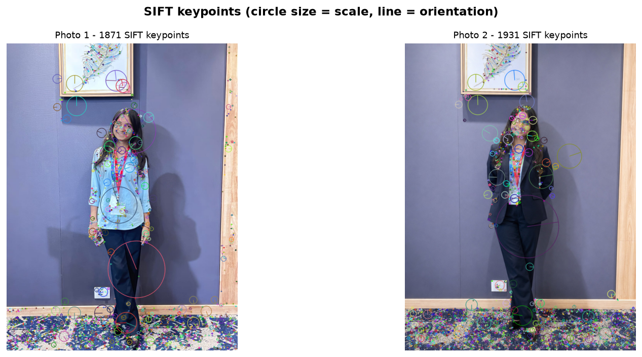
Figure 14: SIFT keypoints on both photographs (circle size = scale).

4.3 Matching, rotation and resizing
Explanation. Descriptors were matched with a brute-force matcher and Lowe's ratio test (ratio 0.75). RANSAC then fits a homography; matches that agree with it are 'inliers' (green) and the rest are outliers (red). The experiment was repeated after rotating photo 2 by 45 degrees, resizing it to 50%, and doing both together.
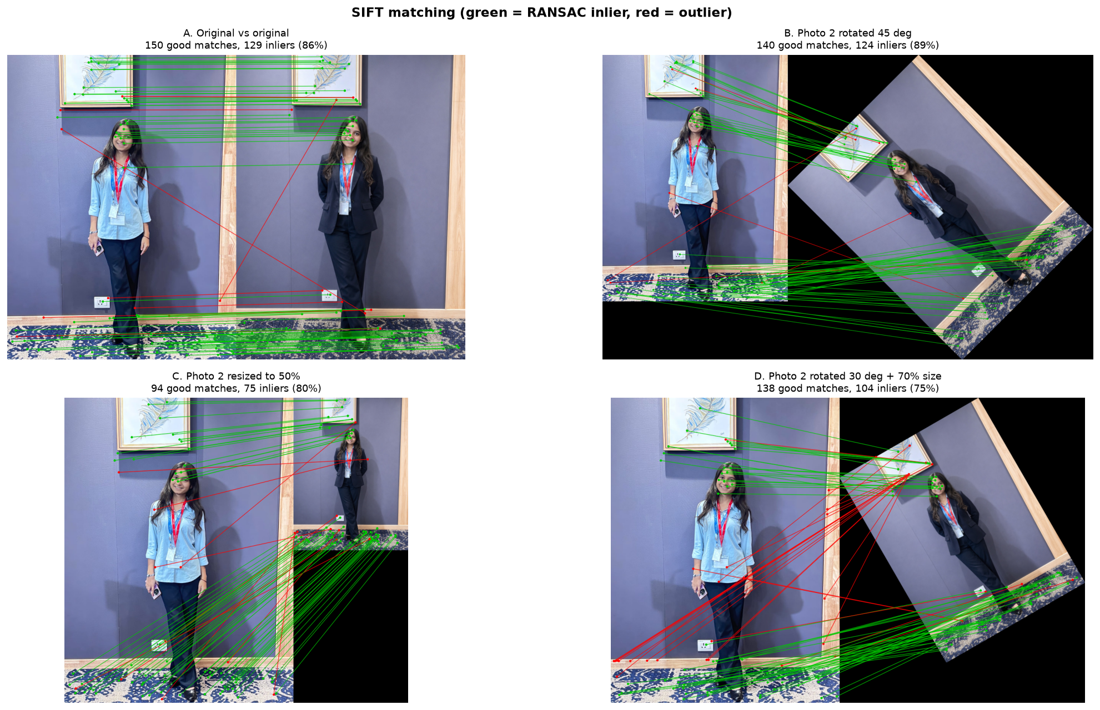
Figure 15: SIFT matches for the original pair and the rotated/resized versions.
Table 5: Matching quality for each experiment
Experiment | Keypoints (photo 1) | Keypoints (photo 2 version) | Good matches (ratio test) | RANSAC inliers | Inlier ratio | Avg match distance
A. Original vs original | 1871 | 1931 | 150 | 129 | 86.0% | 188.6
B. Photo 2 rotated 45 deg | 1871 | 2000 | 140 | 124 | 88.6% | 193.1
C. Photo 2 resized to 50% | 1871 | 514 | 94 | 75 | 79.8% | 198.5
D. Photo 2 rotated 30 deg + 70% size | 1871 | 1147 | 138 | 104 | 75.4% | 196.5

Comparison.
The highest inlier ratio was in 'B. Photo 2 rotated 45 deg' (88.6%) and the fewest inliers were found in 'C. Photo 2 resized to 50%' (75). SIFT is built to be invariant to scale and rotation, so matching still works after rotating or resizing the image, although the number of matches drops when the image is shrunk (fewer pixels means fewer detectable keypoints). Rotation adds black borders that can create a few extra, unmatched keypoints.

5. Task 3 - Object Recognition with Viola-Jones and YOLO (Unit 5)
Explanation. Viola-Jones uses Haar-like features and a cascade of classifiers; I used OpenCV's pretrained frontal-face model (scaleFactor 1.1, minNeighbors 5). It gives no true confidence, so the 'weight' from detectMultiScale3 is shown instead. YOLO (yolov8n.pt) is a pretrained deep network that detects 80 COCO classes in a single pass; the confidence threshold was 0.25. Both were run on the photo and 5 frames from the video.
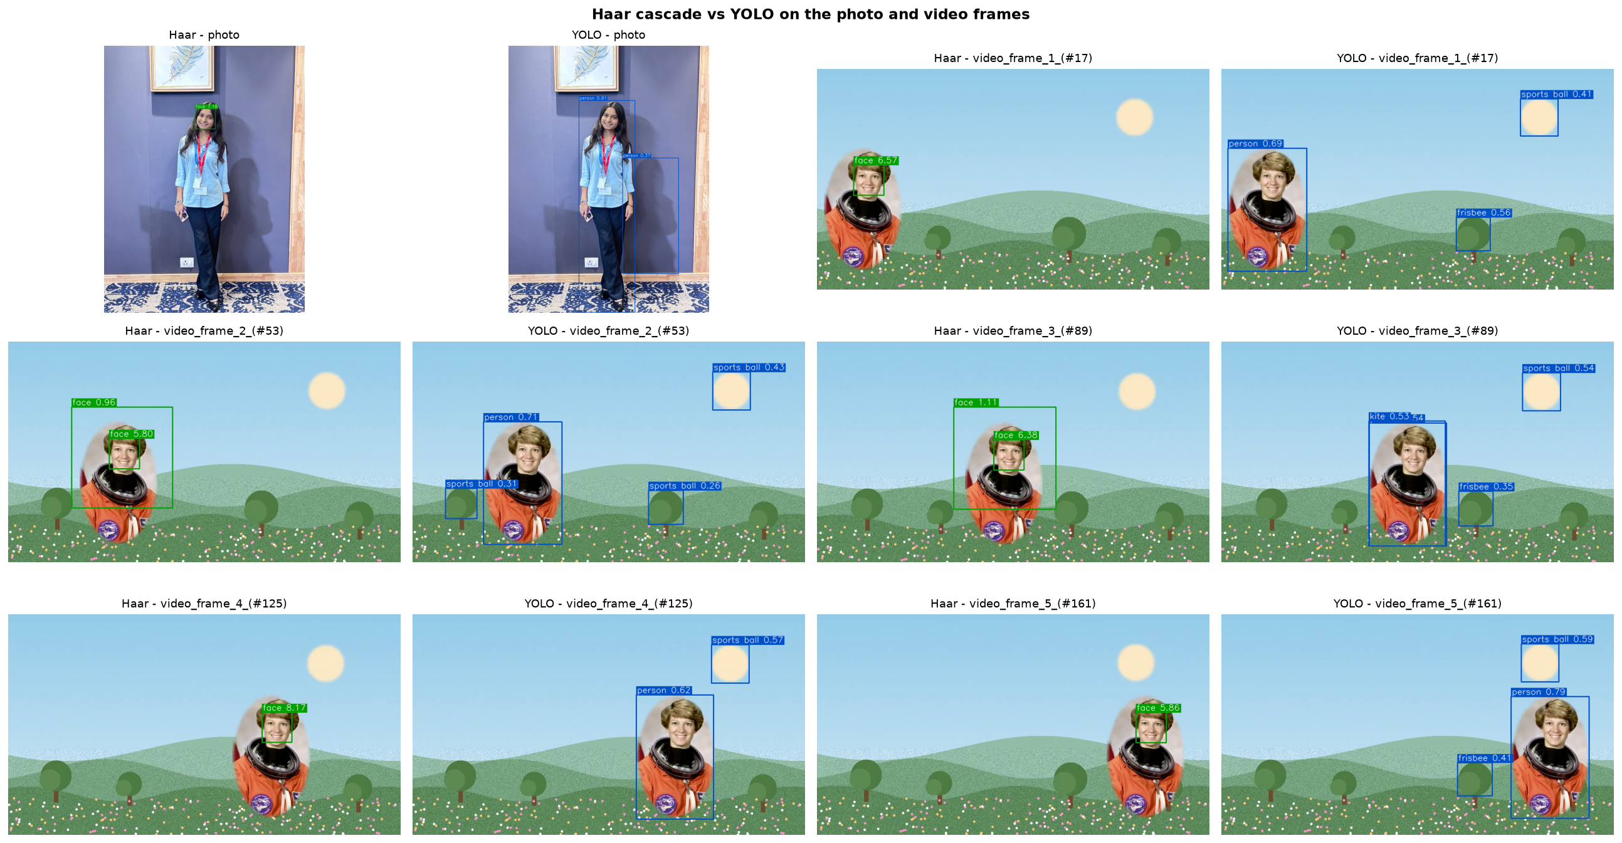
Figure 16: Haar cascade (left of each pair) vs YOLO (right) on all test images.
Table 6: Detector comparison per image
Image | Haar faces | Haar time (ms) | YOLO objects | YOLO classes | YOLO time (ms) | Observation
photo | 1 | 3736 | 2 | person x2 | 11157 | Both detectors roughly agree
video_frame_1_(#17) | 1 | 181 | 3 | frisbee x1, person x1, sports ball x1 | 106 | Both detectors roughly agree
video_frame_2_(#53) | 2 | 132 | 4 | person x1, sports ball x3 | 84 | Haar reported more faces than YOLO reported people (check for a false positive)
video_frame_3_(#89) | 2 | 129 | 4 | frisbee x1, kite x1, person x1, sports ball x1 | 77 | Haar reported more faces than YOLO reported people (check for a false positive)
video_frame_4_(#125) | 1 | 136 | 2 | person x1, sports ball x1 | 75 | Both detectors roughly agree
video_frame_5_(#161) | 1 | 141 | 3 | frisbee x1, person x1, sports ball x1 | 70 | Both detectors roughly agree

Detailed side-by-side images:
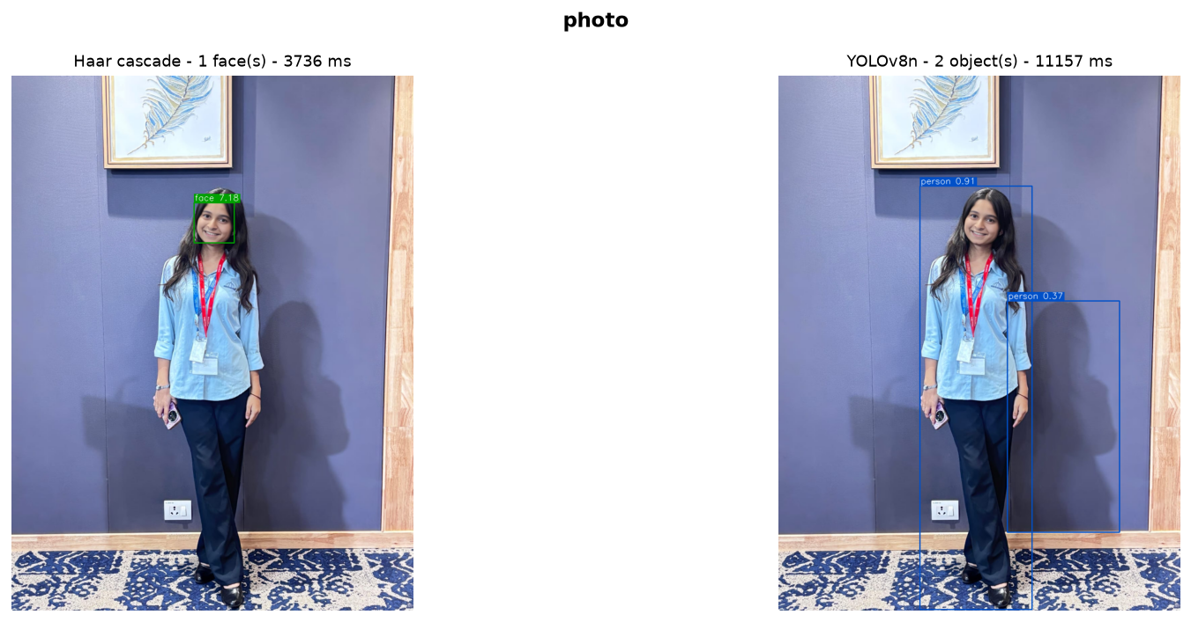
Figure 17: Haar vs YOLO - photo.
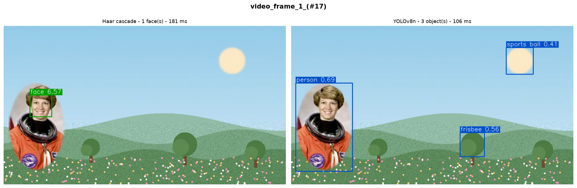
Figure 18: Haar vs YOLO - video_frame_1_(#17).
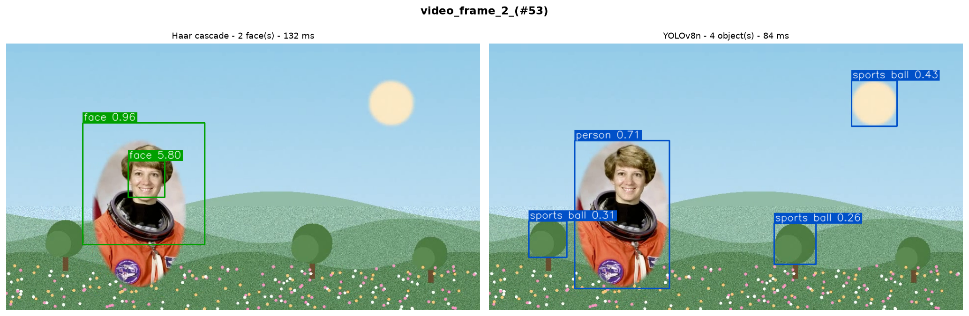
Figure 19: Haar vs YOLO - video_frame_2_(#53).
Comparison and failure cases.
Failure cases I observed
In video frames 2 and 3, the Haar cascade found two faces, but there is only one person in the scene. In frame 3, one box is correct and sits on the face (score 6.38). The second box is much bigger and covers the whole head and shoulders (score 1.11). This second box is a false detection. Its score is very low, which means the detector was not sure about it. Haar checks many window sizes over the image, so sometimes a wrong window passes by mistake. YOLO did not make this mistake.
YOLO also made some wrong detections. In frame 3 it called the round sun a “sports ball” (confidence 0.54) and a small round tree a “frisbee” (confidence 0.35). It also gave the person a second wrong label, “kite” (confidence 0.53), along with the correct “person” label. None of these objects are in the scene. YOLO only knows 80 fixed classes, so when it sees a round or flat shape, it picks the closest class it knows. All these wrong labels have low confidence, so raising the confidence threshold from 0.25 to about 0.6 would remove most of them.
The first image took much longer to process (about 3.7 seconds for Haar and 11 seconds for YOLO) than the later frames (about 130 ms and 80 ms). This is because the first run includes one-time start-up work, like loading the model. The later times are the fair comparison.
Conclusion for Task 3
Haar is fast and light, but it only finds faces that look straight at the camera, and it can give extra or oversized boxes. YOLO is more flexible and gives real confidence scores, but it can still name objects that are not there when its confidence is low. Raising the thresholds (minNeighbors for Haar and conf for YOLO) reduces both kinds of wrong detections.

6. Task 4 - Video Motion Estimation (Unit 5)
Explanation. 107 consecutive frames starting at frame 72 of my video were analysed after resizing to 640 px width. (1) Frame differencing: absolute difference of two consecutive gray frames, blurred, thresholded at 25 and cleaned with morphology. (2) GMM background subtraction: OpenCV's MOG2 models each pixel as a mixture of Gaussians learned over earlier frames (the model was warmed up on the frames before the start frame); shadows were removed from the mask. (3) Lucas-Kanade optical flow: Shi-Tomasi corners are tracked from one frame to the next; the median motion of all points is taken as camera shake and subtracted, so points that still move (red arrows) belong to the moving object.
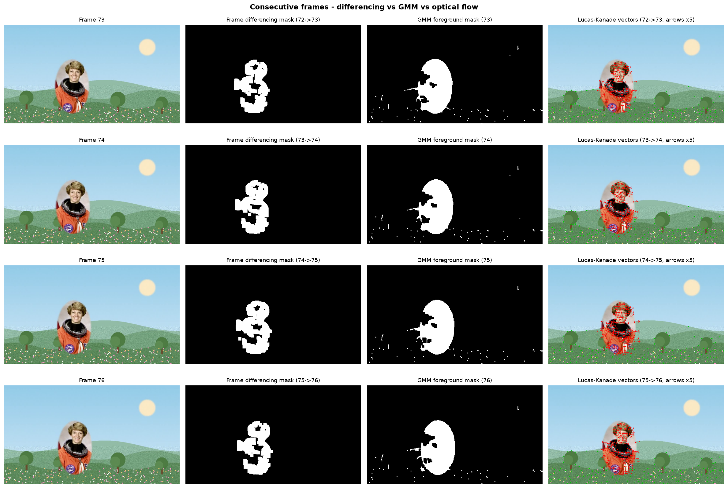
Figure 20: Consecutive frames with differencing masks, GMM masks and optical-flow vectors.
Selected foreground masks and motion vectors are also saved individually in outputs/task4/masks_diff, masks_gmm and flow. A side-by-side demo video (motion_demo.mp4) is saved in outputs/task4 and uploaded to Google Drive.
Table 7: Comparison of frame differencing, GMM background subtraction and Lucas-Kanade optical flow
Method | Output | Avg foreground area (% of frame) / moving points | Avg blobs per frame | Avg time per frame (ms) | Strengths / weaknesses
Frame differencing | Binary motion mask (changed pixels) | 5.95 | 1.9 | 0.62 | Very fast, no model; only edges of the mover show up and it reacts to any camera shake
GMM background subtraction (MOG2) | Binary foreground mask (full object) | 8.47 | 1.0 | 4.92 | Fills the whole object and ignores static background, but needs warm-up and a steady camera
Lucas-Kanade optical flow | Sparse motion vectors (direction + speed) | 89.3 moving of 250 tracked pts | - | 10.88 | Only method that gives direction and speed, but only at corner points, not whole regions

Comparison.
- Frame differencing is the fastest and needs no training, but between consecutive frames it mostly highlights only the edges of the moving object and breaks up into several small blobs; any camera shake also shows up as 'motion'.
- GMM background subtraction gives a more complete silhouette of the mover as a single region because it compares against a learned background, but it needs warm-up frames, costs more time per frame and struggles if the camera moves.
- Lucas-Kanade optical flow is the only one of the three that tells direction and speed of the motion, but it is sparse (only corner points) and can lose points on plain, textureless areas.
- Best choice depends on the goal: GMM to locate the object, differencing for a quick motion trigger, optical flow to measure how it moves.

7. Conclusion
In this assignment I implemented restoration, segmentation, feature extraction, object recognition and motion estimation on my own photographs and video. The main results were:
- Restoration: Median 3x3 worked best for salt-and-pepper noise (30.34 dB), and Gaussian 5x5 gave the best PSNR for Gaussian noise (26.29 dB).
- Segmentation: Otsu thresholding + morphological opening gave clean masks, Canny gave thin edges, and watershed with distance-transform markers separated touching objects.
- Feature matching: SIFT kept matching correctly after rotation and resizing, confirming its scale and rotation invariance.
- Detection: YOLO is more general and robust than the Haar cascade, while Haar is quicker and lighter but limited to frontal faces.
- Motion: differencing, GMM and optical flow each answer a different question (where did pixels change, what is foreground, how is it moving), so they are best used together.
All source code, example outputs and the README are in the Git repository: PASTE YOUR GITHUB REPO URL HERE
Project explanation video: PASTE YOUR GOOGLE DRIVE VIDEO LINK HERE

Appendix A - Source code listing

src/utils.py
"""
utils.py - small helpers that every task script uses.

Nothing clever in here: finding the input files, loading/resizing images,
saving figures and writing CSV/JSON results.
"""
import csv
import json
from pathlib import Path

import cv2
import numpy as np
import matplotlib

matplotlib.use("Agg") # no pop-up windows, we only save figures to disk
import matplotlib.pyplot as plt

ROOT = Path(__file__).resolve().parent.parent
DATA_DIR = ROOT / "data"
OUT_DIR = ROOT / "outputs"

IMAGE_EXTS = (".jpg", ".jpeg", ".png", ".bmp", ".webp")
VIDEO_EXTS = (".mp4", ".mov", ".avi", ".mkv", ".m4v")

# ----------------------------------------------------------------------------
# files and folders
# ----------------------------------------------------------------------------
def find_input(stem, exts):
"""Look inside data/ for a file called <stem>.<any allowed extension>."""
if not DATA_DIR.exists():
return None
for p in sorted(DATA_DIR.iterdir()):
if p.stem.lower() == stem and p.suffix.lower() in exts:
return p
return None

def need_input(stem, exts, what):
"""Same as find_input but stops with a friendly message if it is missing."""
p = find_input(stem, exts)
if p is None:
raise SystemExit(
f"\n[!] Could not find {what}.\n"
f" Put a file named '{stem}' (one of {', '.join(exts)}) inside the data/ folder.\n"
f" See data/README.md for details.\n"
)
return p

def task_dir(name):
d = OUT_DIR / name
d.mkdir(parents=True, exist_ok=True)
return d

def load_config():
cfg = {
"student_name": "Student",
"prn": "",
"course": "Computer Vision - CCA 3",
"git_url": "",
"explanation_video_url": "",
"drive_folder_url": "",
}
path = ROOT / "config.json"
if path.exists():
with open(path, encoding="utf-8") as f:
cfg.update(json.load(f))
return cfg

# ----------------------------------------------------------------------------
# images
# ----------------------------------------------------------------------------
def load_image(path, max_side=900):
"""Read an image (BGR). Big phone photos are shrunk so everything runs fast."""
img = cv2.imread(str(path))
if img is None:
raise SystemExit(f"[!] OpenCV could not read '{path}'. Is it a valid jpg/png?")
h, w = img.shape[:2]
scale = max_side / max(h, w)
if scale < 1:
img = cv2.resize(img, None, fx=scale, fy=scale, interpolation=cv2.INTER_AREA)
return img

def resize_to_width(img, width):
h, w = img.shape[:2]
if w <= width:
return img
scale = width / w
return cv2.resize(img, None, fx=scale, fy=scale, interpolation=cv2.INTER_AREA)

def to_rgb(img):
if img.ndim == 2:
return img
return cv2.cvtColor(img, cv2.COLOR_BGR2RGB)

def save_img(path, img):
cv2.imwrite(str(path), img)

def save_grid(images, titles, path, cols=3, cell=(5, 4), suptitle=None):
"""Put several images into one labelled figure and save it."""
n = len(images)
rows = int(np.ceil(n / cols))
fig, axes = plt.subplots(rows, cols, figsize=(cell[0] * cols, cell[1] * rows))
axes = np.atleast_1d(axes).ravel()
for ax in axes:
ax.axis("off")
for ax, im, t in zip(axes, images, titles):
if im.ndim == 2:
ax.imshow(im, cmap="gray", vmin=0, vmax=255 if im.dtype == np.uint8 else None)
else:
ax.imshow(to_rgb(im))
ax.set_title(t, fontsize=10)
if suptitle:
fig.suptitle(suptitle, fontsize=13, fontweight="bold")
fig.tight_layout()
fig.savefig(path, dpi=130, bbox_inches="tight")
plt.close(fig)

# ----------------------------------------------------------------------------
# video
# ----------------------------------------------------------------------------
def open_video(path):
cap = cv2.VideoCapture(str(path))
if not cap.isOpened():
raise SystemExit(
f"[!] Could not open video '{path}'.\n"
" If it is an iPhone .MOV, convert a copy with ffmpeg (see data/README.md)."
)
info = {
"fps": cap.get(cv2.CAP_PROP_FPS) or 30.0,
"frames": int(cap.get(cv2.CAP_PROP_FRAME_COUNT)),
"width": int(cap.get(cv2.CAP_PROP_FRAME_WIDTH)),
"height": int(cap.get(cv2.CAP_PROP_FRAME_HEIGHT)),
}
info["duration"] = info["frames"] / info["fps"] if info["fps"] else 0
return cap, info

def read_frame_at(cap, index):
cap.set(cv2.CAP_PROP_POS_FRAMES, index)
ok, frame = cap.read()
return frame if ok else None

# ----------------------------------------------------------------------------
# results
# ----------------------------------------------------------------------------
def write_csv(path, header, rows):
with open(path, "w", newline="", encoding="utf-8") as f:
w = csv.writer(f)
w.writerow(header)
w.writerows(rows)

def read_csv(path):
with open(path, newline="", encoding="utf-8") as f:
return list(csv.DictReader(f))

def write_json(path, data):
with open(path, "w", encoding="utf-8") as f:
json.dump(data, f, indent=2)

def read_json(path):
with open(path, encoding="utf-8") as f:
return json.load(f)

src/task1_restoration_segmentation.py
"""
Task 1 (Unit 3) - Image restoration and segmentation

Part A : add Gaussian + salt-and-pepper noise, restore with median and Gaussian
filters, compare with the clean photo using PSNR and SSIM.
Part B : thresholding, erosion / dilation / opening / closing, Canny edges and
watershed segmentation.

Run: python src/task1_restoration_segmentation.py
"""
import cv2
import numpy as np
from skimage.metrics import peak_signal_noise_ratio as psnr
from skimage.metrics import structural_similarity as ssim

from utils import (IMAGE_EXTS, find_input, load_image, need_input, save_grid,
save_img, task_dir, write_csv, write_json)

# ----------------------------------------------------------------------------
# Part A - noise and restoration
# ----------------------------------------------------------------------------
def add_gaussian_noise(img, sigma=25, seed=1):
rng = np.random.default_rng(seed)
noise = rng.normal(0, sigma, img.shape)
return np.clip(img.astype(np.float64) + noise, 0, 255).astype(np.uint8)

def add_salt_pepper(img, amount=0.05, seed=1):
"""amount = fraction of pixels that get corrupted (half salt, half pepper)."""
rng = np.random.default_rng(seed)
out = img.copy()
r = rng.random(img.shape[:2])
out[r < amount / 2] = 0 # pepper
out[(r >= amount / 2) & (r < amount)] = 255 # salt
return out

FILTERS = {
"Median 3x3": lambda x: cv2.medianBlur(x, 3),
"Median 5x5": lambda x: cv2.medianBlur(x, 5),
"Gaussian 5x5": lambda x: cv2.GaussianBlur(x, (5, 5), 1.2),
}

def center_crop(img, size=160):
h, w = img.shape[:2]
y0, x0 = max(0, h // 2 - size // 2), max(0, w // 2 - size // 2)
crop = img[y0:y0 + size, x0:x0 + size]
return cv2.resize(crop, None, fx=2, fy=2, interpolation=cv2.INTER_NEAREST)

def run_restoration(img, out):
noisy_versions = {
"Gaussian noise": ("gaussian", add_gaussian_noise(img)),
"Salt & pepper noise": ("saltpepper", add_salt_pepper(img)),
}
rows = []
for noise_name, (tag, noisy) in noisy_versions.items():
images = [img, noisy]
titles = ["Original (clean)"]
p0, s0 = psnr(img, noisy), ssim(img, noisy, channel_axis=2)
titles.append(f"{noise_name}\nPSNR {p0:.2f} dB | SSIM {s0:.3f}")
rows.append([noise_name, "Noisy (no filter)", round(p0, 2), round(s0, 4)])
save_img(out / f"{tag}_noisy.png", noisy)

for fname, fn in FILTERS.items():
restored = fn(noisy)
p, s = psnr(img, restored), ssim(img, restored, channel_axis=2)
rows.append([noise_name, fname, round(p, 2), round(s, 4)])
images.append(restored)
titles.append(f"{fname}\nPSNR {p:.2f} dB | SSIM {s:.3f}")
save_img(out / f"{tag}_{fname.lower().replace(' ', '_')}.png", restored)

save_grid(images, titles, out / f"restoration_{tag}.png", cols=3,
suptitle=f"Restoration of {noise_name.lower()}")
# zoomed crops make the difference between filters much easier to see
save_grid([center_crop(i) for i in images],
["Original", "Noisy"] + list(FILTERS.keys()),
out / f"restoration_{tag}_zoom.png", cols=5, cell=(3.2, 3.4),
suptitle=f"Zoomed centre crop - {noise_name.lower()}")

write_csv(out / "restoration_metrics.csv",
["Noise type", "Image", "PSNR (dB)", "SSIM"], rows)
return rows

# ----------------------------------------------------------------------------
# Part B - thresholding, morphology, edges
# ----------------------------------------------------------------------------
def run_threshold_morph_edges(img, out):
gray = cv2.cvtColor(img, cv2.COLOR_BGR2GRAY)
blur = cv2.GaussianBlur(gray, (5, 5), 0)

otsu_val, otsu = cv2.threshold(blur, 0, 255, cv2.THRESH_BINARY + cv2.THRESH_OTSU)
_, fixed = cv2.threshold(blur, 127, 255, cv2.THRESH_BINARY)
adaptive = cv2.adaptiveThreshold(blur, 255, cv2.ADAPTIVE_THRESH_GAUSSIAN_C,
cv2.THRESH_BINARY, 31, 5)
save_grid([gray, fixed, otsu, adaptive],
["Grayscale", "Global threshold (T=127)",
f"Otsu threshold (T={otsu_val:.0f})", "Adaptive Gaussian threshold"],
out / "thresholding.png", cols=4, cell=(4.2, 3.6),
suptitle="Binary images from different thresholding methods")
save_img(out / "binary_otsu.png", otsu)

# morphology works on white objects, so make the smaller region white
binary = otsu if np.mean(otsu) < 127 else cv2.bitwise_not(otsu)
kernel = cv2.getStructuringElement(cv2.MORPH_ELLIPSE, (5, 5))
erosion = cv2.erode(binary, kernel, iterations=1)
dilation = cv2.dilate(binary, kernel, iterations=1)
opening = cv2.morphologyEx(binary, cv2.MORPH_OPEN, kernel)
closing = cv2.morphologyEx(binary, cv2.MORPH_CLOSE, kernel)
save_grid([binary, erosion, dilation, opening, closing],
["Binary mask (Otsu)", "Erosion", "Dilation",
"Opening (erode->dilate)", "Closing (dilate->erode)"],
out / "morphology.png", cols=5, cell=(3.6, 3.2),
suptitle="Morphological operations (5x5 elliptical kernel)")
for name, im in [("erosion", erosion), ("dilation", dilation),
("opening", opening), ("closing", closing)]:
save_img(out / f"morph_{name}.png", im)

# Canny: one fixed pair of thresholds and one picked automatically from the median
canny_fixed = cv2.Canny(blur, 100, 200)
med = np.median(blur)
lo, hi = int(max(0, 0.67 * med)), int(min(255, 1.33 * med))
canny_auto = cv2.Canny(blur, lo, hi)
save_grid([canny_fixed, canny_auto],
["Canny (100, 200)", f"Canny auto ({lo}, {hi})"],
out / "canny_edges.png", cols=2, cell=(6, 4.5),
suptitle="Canny edge detection")
save_img(out / "canny_fixed.png", canny_fixed)

return {
"otsu_threshold": float(otsu_val),
"canny_auto_low": lo,
"canny_auto_high": hi,
"edge_pixels_fixed_pct": round(100 * np.count_nonzero(canny_fixed) / canny_fixed.size, 2),
"edge_pixels_auto_pct": round(100 * np.count_nonzero(canny_auto) / canny_auto.size, 2),
"foreground_pct_after_opening": round(100 * np.count_nonzero(opening) / opening.size, 2),
}

# ----------------------------------------------------------------------------
# Part B - watershed
# ----------------------------------------------------------------------------
def run_watershed(img, out):
gray = cv2.cvtColor(img, cv2.COLOR_BGR2GRAY)
blur = cv2.GaussianBlur(gray, (5, 5), 0)
_, bw = cv2.threshold(blur, 0, 255, cv2.THRESH_BINARY + cv2.THRESH_OTSU)

# decide which side is "object": the image border is usually background
border = np.concatenate([bw[0, :], bw[-1, :], bw[:, 0], bw[:, -1]])
if border.mean() > 127:
bw = cv2.bitwise_not(bw)

kernel = np.ones((3, 3), np.uint8)
opening = cv2.morphologyEx(bw, cv2.MORPH_OPEN, kernel, iterations=2)

# a blob covering a big chunk of the image is almost certainly uneven
# lighting / background, not an object - drop it
n_cc, cc, cc_stats, _ = cv2.connectedComponentsWithStats(opening)
for i in range(1, n_cc):
if cc_stats[i, cv2.CC_STAT_AREA] > 0.25 * opening.size:
opening[cc == i] = 0

sure_bg = cv2.dilate(opening, kernel, iterations=3)
dist = cv2.distanceTransform(opening, cv2.DIST_L2, 5)

# threshold the distance map separately inside every blob (50% of that blob's
# own maximum) so small and large objects both get a marker
sure_fg = np.zeros_like(opening)
n_cc, cc = cv2.connectedComponents(opening)
for i in range(1, n_cc):
region = cc == i
sure_fg[region & (dist > 0.5 * dist[region].max())] = 255
unknown = cv2.subtract(sure_bg, sure_fg)

n_markers, markers = cv2.connectedComponents(sure_fg)
markers = markers + 1 # background becomes 1, objects 2, 3, ...
markers[unknown == 255] = 0 # 0 = "let watershed decide"
markers = cv2.watershed(img.copy(), markers)

result = img.copy()
result[markers == -1] = (0, 0, 255) # watershed lines in red
n_segments = len([m for m in np.unique(markers) if m > 1])

# random colours for the label map
rng = np.random.default_rng(3)
colours = rng.integers(60, 255, size=(markers.max() + 2, 3), dtype=np.uint8)
label_img = np.zeros_like(img)
for m in range(2, markers.max() + 1):
label_img[markers == m] = colours[m]
label_img[markers == -1] = (255, 255, 255)

dist_vis = cv2.normalize(dist, None, 0, 255, cv2.NORM_MINMAX).astype(np.uint8)
save_grid([img, bw, dist_vis, sure_fg, label_img, result],
["Input image", "Binary mask (objects white)", "Distance transform",
"Sure foreground (markers)", "Segment labels",
f"Watershed result ({n_segments} segments)"],
out / "watershed_steps.png", cols=3, cell=(5, 4),
suptitle="Watershed segmentation step by step")
save_img(out / "watershed_result.png", result)
return n_segments

# ----------------------------------------------------------------------------
def main():
out = task_dir("task1")
photo_path = need_input("photo", IMAGE_EXTS, "your original photograph")
img = load_image(photo_path)
print(f"[task1] using {photo_path.name} ({img.shape[1]}x{img.shape[0]})")
save_img(out / "input_photo.png", img)

print("[task1] part A - noise and restoration")
rows = run_restoration(img, out)

print("[task1] part B - threshold, morphology, canny")
info = run_threshold_morph_edges(img, out)

print("[task1] part B - watershed")
obj_path = find_input("objects", IMAGE_EXTS)
ws_img = load_image(obj_path, max_side=700) if obj_path else img
ws_source = obj_path.name if obj_path else photo_path.name
if obj_path:
save_img(out / "input_objects.png", ws_img)
n_segments = run_watershed(ws_img, out)

info.update({
"photo_file": photo_path.name,
"image_size": f"{img.shape[1]}x{img.shape[0]}",
"watershed_source": ws_source,
"watershed_segments": n_segments,
})
write_json(out / "summary.json", info)
print("[task1] done ->", out)

if __name__ == "__main__":
main()

src/task2_features.py
"""
Task 2 (Unit 4) - Feature extraction and image matching

1. HOG features + visualisation
2. SIFT keypoints and descriptors
3. SIFT matching between the two photos (Lowe ratio test + RANSAC)
4. Repeat after rotating / resizing the second photo
5. Compare the matching quality in a table

Run: python src/task2_features.py
"""
import cv2
import numpy as np
from skimage import exposure
from skimage.feature import hog

from utils import (IMAGE_EXTS, find_input, load_image, need_input, save_grid,
save_img, task_dir, write_csv, write_json)

RATIO = 0.75 # Lowe's ratio test threshold

# ----------------------------------------------------------------------------
# HOG
# ----------------------------------------------------------------------------
def hog_features(img):
gray = cv2.cvtColor(img, cv2.COLOR_BGR2GRAY)
gray = cv2.resize(gray, (256, 256)) # fixed size -> fixed length descriptor
vec, vis = hog(gray, orientations=9, pixels_per_cell=(16, 16),
cells_per_block=(2, 2), visualize=True, channel_axis=None)
vis = exposure.rescale_intensity(vis, in_range=(0, vis.max() + 1e-9), out_range=(0, 255))
return gray, vec, vis.astype(np.uint8)

# ----------------------------------------------------------------------------
# SIFT + matching
# ----------------------------------------------------------------------------
def sift_detect(img, sift):
gray = cv2.cvtColor(img, cv2.COLOR_BGR2GRAY)
kp, des = sift.detectAndCompute(gray, None)
return kp, des

def match_sift(kp1, des1, kp2, des2):
"""Ratio-test matching, then RANSAC homography to count geometric inliers."""
if des1 is None or des2 is None or len(kp1) < 2 or len(kp2) < 2:
return [], 0, np.zeros(0, dtype=np.uint8)
bf = cv2.BFMatcher(cv2.NORM_L2)
knn = bf.knnMatch(des1, des2, k=2)
good = [p[0] for p in knn if len(p) == 2 and p[0].distance < RATIO * p[1].distance]
good.sort(key=lambda m: m.distance)

inliers, mask = 0, np.zeros(len(good), dtype=np.uint8)
if len(good) >= 4:
src = np.float32([kp1[m.queryIdx].pt for m in good]).reshape(-1, 1, 2)
dst = np.float32([kp2[m.trainIdx].pt for m in good]).reshape(-1, 1, 2)
H, m = cv2.findHomography(src, dst, cv2.RANSAC, 5.0)
if m is not None:
mask = m.ravel().astype(np.uint8)
inliers = int(mask.sum())
return good, inliers, mask

def rotate_keep_all(img, angle):
"""Rotate around the centre and enlarge the canvas so nothing gets cut off."""
h, w = img.shape[:2]
M = cv2.getRotationMatrix2D((w / 2, h / 2), angle, 1.0)
cos, sin = abs(M[0, 0]), abs(M[0, 1])
new_w, new_h = int(h * sin + w * cos), int(h * cos + w * sin)
M[0, 2] += new_w / 2 - w / 2
M[1, 2] += new_h / 2 - h / 2
return cv2.warpAffine(img, M, (new_w, new_h))

def draw_matches_colored(img1, kp1, img2, kp2, matches, inlier_mask, max_draw=80):
"""Side-by-side canvas; RANSAC inliers drawn in green, outliers in red."""
h = max(img1.shape[0], img2.shape[0])
canvas = np.zeros((h, img1.shape[1] + img2.shape[1], 3), np.uint8)
canvas[:img1.shape[0], :img1.shape[1]] = img1
canvas[:img2.shape[0], img1.shape[1]:] = img2
offset = img1.shape[1]
for m, ok in list(zip(matches, inlier_mask))[:max_draw]:
x1, y1 = map(int, kp1[m.queryIdx].pt)
x2, y2 = kp2[m.trainIdx].pt
x2, y2 = int(x2) + offset, int(y2)
colour = (0, 200, 0) if ok else (0, 0, 255)
cv2.line(canvas, (x1, y1), (x2, y2), colour, 1, cv2.LINE_AA)
cv2.circle(canvas, (x1, y1), 3, colour, -1)
cv2.circle(canvas, (x2, y2), 3, colour, -1)
return canvas

def make_fallback_second_image(img):
"""Only used when the student has not supplied photo2 yet (so the code still runs)."""
h, w = img.shape[:2]
crop = img[int(0.05 * h):int(0.95 * h), int(0.08 * w):int(0.98 * w)]
crop = cv2.convertScaleAbs(crop, alpha=0.9, beta=15)
return cv2.resize(crop, (int(w * 0.9), int(h * 0.9)))

# ----------------------------------------------------------------------------
def main():
out = task_dir("task2")
img1 = load_image(need_input("photo", IMAGE_EXTS, "your original photograph"), max_side=800)
p2 = find_input("photo2", IMAGE_EXTS)
if p2 is None:
print("\n[!] WARNING: data/photo2.* not found - creating a fake second image from photo.\n"
" Add your real second photo of the same object/scene before submitting!\n")
img2 = make_fallback_second_image(img1)
second_name = "(auto-generated placeholder)"
else:
img2 = load_image(p2, max_side=800)
second_name = p2.name
save_img(out / "input_photo1.png", img1)
save_img(out / "input_photo2.png", img2)

# ---- 1. HOG -----------------------------------------------------------
print("[task2] HOG")
g1, v1, hog1 = hog_features(img1)
g2, v2, hog2 = hog_features(img2)
save_grid([g1, hog1, g2, hog2],
["Photo 1 (gray, 256x256)", "Photo 1 - HOG visualisation",
"Photo 2 (gray, 256x256)", "Photo 2 - HOG visualisation"],
out / "hog_visualisation.png", cols=4, cell=(4, 4),
suptitle="Histogram of Oriented Gradients (9 bins, 16x16 cells, 2x2 blocks)")
save_img(out / "hog_photo1.png", hog1)
save_img(out / "hog_photo2.png", hog2)
hog_similarity = float(np.dot(v1, v2) / (np.linalg.norm(v1) * np.linalg.norm(v2) + 1e-9))

# ---- 2. SIFT keypoints --------------------------------------------------
print("[task2] SIFT keypoints")
sift = cv2.SIFT_create(nfeatures=2000)
kp1, des1 = sift_detect(img1, sift)
kp2, des2 = sift_detect(img2, sift)
vis_kp1 = cv2.drawKeypoints(img1, kp1, None, flags=cv2.DRAW_MATCHES_FLAGS_DRAW_RICH_KEYPOINTS)
vis_kp2 = cv2.drawKeypoints(img2, kp2, None, flags=cv2.DRAW_MATCHES_FLAGS_DRAW_RICH_KEYPOINTS)
save_grid([vis_kp1, vis_kp2],
[f"Photo 1 - {len(kp1)} SIFT keypoints", f"Photo 2 - {len(kp2)} SIFT keypoints"],
out / "sift_keypoints.png", cols=2, cell=(7, 5.5),
suptitle="SIFT keypoints (circle size = scale, line = orientation)")

# ---- 3 + 4. matching experiments ---------------------------------------
experiments = [
("A. Original vs original", img2),
("B. Photo 2 rotated 45 deg", rotate_keep_all(img2, 45)),
("C. Photo 2 resized to 50%", cv2.resize(img2, None, fx=0.5, fy=0.5, interpolation=cv2.INTER_AREA)),
("D. Photo 2 rotated 30 deg + 70% size",
cv2.resize(rotate_keep_all(img2, 30), None, fx=0.7, fy=0.7, interpolation=cv2.INTER_AREA)),
]
rows, vis_imgs, vis_titles = [], [], []
for i, (name, im) in enumerate(experiments):
print(f"[task2] matching - {name}")
kpb, desb = sift_detect(im, sift)
good, inliers, mask = match_sift(kp1, des1, kpb, desb)
avg_dist = float(np.mean([m.distance for m in good])) if good else 0.0
inlier_ratio = inliers / len(good) if good else 0.0
rows.append([name, len(kp1), len(kpb), len(good), inliers,
f"{100 * inlier_ratio:.1f}%", round(avg_dist, 1)])

canvas = draw_matches_colored(img1, kp1, im, kpb, good, mask)
save_img(out / f"matches_{chr(ord('A') + i)}.png", canvas)
vis_imgs.append(canvas)
vis_titles.append(f"{name}\n{len(good)} good matches, {inliers} inliers "
f"({100 * inlier_ratio:.0f}%)")

save_grid(vis_imgs, vis_titles, out / "sift_matching_comparison.png", cols=2,
cell=(9, 5), suptitle="SIFT matching (green = RANSAC inlier, red = outlier)")

write_csv(out / "matching_results.csv",
["Experiment", "Keypoints (photo 1)", "Keypoints (photo 2 version)",
"Good matches (ratio test)", "RANSAC inliers", "Inlier ratio",
"Avg match distance"], rows)
write_json(out / "summary.json", {
"photo2_file": second_name,
"hog_vector_length": int(len(v1)),
"hog_cosine_similarity": round(hog_similarity, 3),
"ratio_test": RATIO,
"keypoints_photo1": len(kp1),
"keypoints_photo2": len(kp2),
})
print("[task2] done ->", out)

if __name__ == "__main__":
main()

src/task3_detection.py
"""
Task 3 (Unit 5) - Object recognition with Viola-Jones (Haar cascade) and YOLO

* Haar cascade: pretrained frontal-face model that ships with OpenCV
* YOLO: pretrained YOLOv8-nano from Ultralytics (trained on COCO, 80 classes)

The detectors are run on the photograph and on a few frames taken from the video.
Boxes, labels and scores are drawn, then the two approaches are compared.

Run: python src/task3_detection.py
"""
import time

import cv2
import numpy as np

from utils import (IMAGE_EXTS, VIDEO_EXTS, load_image, need_input, open_video,
read_frame_at, resize_to_width, save_grid, save_img, task_dir,
write_csv, write_json)

N_VIDEO_FRAMES = 5 # how many frames to take from the video
YOLO_WEIGHTS = "yolov8n.pt" # downloaded automatically the first time
YOLO_CONF = 0.25

# ----------------------------------------------------------------------------
# Haar (Viola-Jones)
# ----------------------------------------------------------------------------
def load_haar():
path = cv2.data.haarcascades + "haarcascade_frontalface_default.xml"
cascade = cv2.CascadeClassifier(path)
if cascade.empty():
raise SystemExit("[!] Could not load the Haar cascade file from OpenCV.")
return cascade

def run_haar(cascade, img):
gray = cv2.cvtColor(img, cv2.COLOR_BGR2GRAY)
gray = cv2.equalizeHist(gray)
t0 = time.perf_counter()
rects, _, weights = cascade.detectMultiScale3(
gray, scaleFactor=1.1, minNeighbors=5, minSize=(40, 40), outputRejectLevels=True)
ms = (time.perf_counter() - t0) * 1000
dets = []
for (x, y, w, h), wt in zip(rects, weights):
dets.append({"label": "face", "conf": float(wt), "box": (int(x), int(y), int(x + w), int(y + h))})
return dets, ms

# ----------------------------------------------------------------------------
# YOLO
# ----------------------------------------------------------------------------
def load_yolo():
try:
from ultralytics import YOLO
return YOLO(YOLO_WEIGHTS)
except Exception as e: # no internet, package missing, ...
raise SystemExit(
f"[!] Could not load YOLO ({e}).\n"
" Check 'pip install ultralytics' and that you are online for the first run\n"
f" (it downloads {YOLO_WEIGHTS} automatically).")

def run_yolo(model, img):
t0 = time.perf_counter()
res = model.predict(img, conf=YOLO_CONF, verbose=False)[0]
ms = (time.perf_counter() - t0) * 1000
dets = []
for b in res.boxes:
x1, y1, x2, y2 = [int(v) for v in b.xyxy[0].tolist()]
dets.append({"label": res.names[int(b.cls[0])], "conf": float(b.conf[0]),
"box": (x1, y1, x2, y2)})
return dets, ms

# ----------------------------------------------------------------------------
# drawing
# ----------------------------------------------------------------------------
def draw(img, dets, colour):
out = img.copy()
thick = max(2, img.shape[1] // 400)
scale = max(0.5, img.shape[1] / 1400)
for d in dets:
x1, y1, x2, y2 = d["box"]
cv2.rectangle(out, (x1, y1), (x2, y2), colour, thick)
text = f"{d['label']} {d['conf']:.2f}"
(tw, th), _ = cv2.getTextSize(text, cv2.FONT_HERSHEY_SIMPLEX, scale, 1)
top = max(0, y1 - th - 6)
cv2.rectangle(out, (x1, top), (x1 + tw + 4, top + th + 6), colour, -1)
cv2.putText(out, text, (x1 + 2, top + th + 1), cv2.FONT_HERSHEY_SIMPLEX,
scale, (255, 255, 255), 1, cv2.LINE_AA)
return out

def describe_case(name, haar, yolo):
"""Spot places where the two detectors disagree - these are the interesting cases."""
faces = len(haar)
persons = len([d for d in yolo if d["label"] == "person"])
notes = []
if faces > 0 and persons == 0:
notes.append("Haar found a face but YOLO found no person (possible Haar false positive "
"or YOLO miss)")
if persons > 0 and faces == 0:
notes.append("YOLO found a person but Haar found no face (face not frontal, too small, "
"or partly hidden)")
if faces > persons and persons > 0:
notes.append("Haar reported more faces than YOLO reported people (check for a false positive)")
if faces == 0 and persons == 0 and not yolo:
notes.append("Neither detector found anything")
return "; ".join(notes) if notes else "Both detectors roughly agree"

# ----------------------------------------------------------------------------
def collect_inputs(out):
"""Photo + a few evenly spaced video frames, all saved to disk."""
items = []
photo = resize_to_width(load_image(need_input("photo", IMAGE_EXTS, "your photograph"), 1280), 960)
items.append(("photo", photo))

cap, info = open_video(need_input("video", VIDEO_EXTS, "your video"))
frames_dir = out / "input_frames"
frames_dir.mkdir(exist_ok=True)
picks = np.linspace(0.1, 0.9, N_VIDEO_FRAMES) * max(info["frames"] - 1, 1)
for k, idx in enumerate(picks, start=1):
frame = read_frame_at(cap, int(idx))
if frame is None:
continue
frame = resize_to_width(frame, 960)
items.append((f"video_frame_{k}_(#{int(idx)})", frame))
save_img(frames_dir / f"frame_{k}_{int(idx)}.png", frame)
cap.release()
return items, info

def main():
out = task_dir("task3")
items, info = collect_inputs(out)
haar = load_haar()
yolo = load_yolo()
print(f"[task3] {len(items)} images to process")

det_rows, cmp_rows = [], []
for name, img in items:
h_dets, h_ms = run_haar(haar, img)
y_dets, y_ms = run_yolo(yolo, img)
safe = name.replace("(", "").replace(")", "").replace("#", "")
h_img = draw(img, h_dets, (0, 160, 0))
y_img = draw(img, y_dets, (200, 80, 0))
save_img(out / f"{safe}_haar.png", h_img)
save_img(out / f"{safe}_yolo.png", y_img)
save_grid([h_img, y_img],
[f"Haar cascade - {len(h_dets)} face(s) - {h_ms:.0f} ms",
f"YOLOv8n - {len(y_dets)} object(s) - {y_ms:.0f} ms"],
out / f"{safe}_comparison.png", cols=2, cell=(8, 5.5), suptitle=name)

for d in h_dets:
det_rows.append([name, "Haar", d["label"], round(d["conf"], 3), *d["box"]])
for d in y_dets:
det_rows.append([name, "YOLO", d["label"], round(d["conf"], 3), *d["box"]])

classes = {}
for d in y_dets:
classes[d["label"]] = classes.get(d["label"], 0) + 1
class_text = ", ".join(f"{k} x{v}" for k, v in sorted(classes.items())) or "-"
note = describe_case(name, h_dets, y_dets)
cmp_rows.append([name, len(h_dets), round(h_ms), len(y_dets), class_text, round(y_ms), note])
print(f" {name}: haar={len(h_dets)} yolo={len(y_dets)} ({class_text})")

write_csv(out / "all_detections.csv",
["Image", "Detector", "Label", "Confidence / weight", "x1", "y1", "x2", "y2"], det_rows)
write_csv(out / "detector_comparison.csv",
["Image", "Haar faces", "Haar time (ms)", "YOLO objects", "YOLO classes",
"YOLO time (ms)", "Observation"], cmp_rows)

# one overview figure with every image for the report
overview, titles = [], []
for name, _ in items:
safe = name.replace("(", "").replace(")", "").replace("#", "")
for tag, label in (("haar", "Haar"), ("yolo", "YOLO")):
overview.append(cv2.imread(str(out / f"{safe}_{tag}.png")))
titles.append(f"{label} - {name}")
save_grid(overview, titles, out / "overview_all.png", cols=4, cell=(5, 3.6),
suptitle="Haar cascade vs YOLO on the photo and video frames")

write_json(out / "summary.json", {
"yolo_model": YOLO_WEIGHTS,
"yolo_conf_threshold": YOLO_CONF,
"images_processed": len(items),
"video_frames_total": info["frames"],
"video_fps": round(info["fps"], 2),
})
print("[task3] done ->", out)

if __name__ == "__main__":
main()

src/task4_motion.py
"""
Task 4 (Unit 5) - Video motion estimation

1. extract consecutive frames from the video
2. frame differencing
3. GMM background subtraction (OpenCV MOG2)
4. Lucas-Kanade sparse optical flow
5. save foreground masks and motion-vector images
6. compare the three methods (table + side-by-side video)

Run: python src/task4_motion.py
"""
import time

import cv2
import numpy as np

from utils import (VIDEO_EXTS, need_input, open_video, resize_to_width, save_grid,
save_img, task_dir, write_csv, write_json)

WORK_WIDTH = 640 # frames are shrunk to this width for speed
START_FRACTION = 0.4 # start analysing 40% into the clip
N_PAIRS = 4 # consecutive frame pairs shown in the figure
DEMO_FRAMES = 150 # length of the side-by-side demo video
WARMUP = 120 # frames fed to the background model before the start frame
MIN_AREA = 150 # ignore blobs smaller than this many pixels

LK_PARAMS = dict(winSize=(21, 21), maxLevel=3,
criteria=(cv2.TERM_CRITERIA_EPS | cv2.TERM_CRITERIA_COUNT, 30, 0.01))
FEATURE_PARAMS = dict(maxCorners=250, qualityLevel=0.01, minDistance=8, blockSize=7)

def prep(frame):
return resize_to_width(frame, WORK_WIDTH)

# ----------------------------------------------------------------------------
# the three methods
# ----------------------------------------------------------------------------
def frame_difference(prev_gray, gray, thresh=25):
diff = cv2.absdiff(prev_gray, gray)
diff = cv2.GaussianBlur(diff, (5, 5), 0)
_, mask = cv2.threshold(diff, thresh, 255, cv2.THRESH_BINARY)
mask = cv2.morphologyEx(mask, cv2.MORPH_OPEN, np.ones((3, 3), np.uint8))
mask = cv2.dilate(mask, np.ones((5, 5), np.uint8), iterations=2)
return mask

def gmm_mask(subtractor, frame):
raw = subtractor.apply(frame)
_, mask = cv2.threshold(raw, 200, 255, cv2.THRESH_BINARY) # 127 = shadow, drop it
mask = cv2.morphologyEx(mask, cv2.MORPH_OPEN, np.ones((3, 3), np.uint8))
mask = cv2.morphologyEx(mask, cv2.MORPH_CLOSE, np.ones((7, 7), np.uint8))
return mask

def lucas_kanade(prev_gray, gray):
"""Track corner features between two frames.
Returns old points, new points, per-point motion after removing camera shake."""
p0 = cv2.goodFeaturesToTrack(prev_gray, mask=None, **FEATURE_PARAMS)
if p0 is None:
return np.zeros((0, 2)), np.zeros((0, 2)), np.zeros(0)
p1, st, _ = cv2.calcOpticalFlowPyrLK(prev_gray, gray, p0, None, **LK_PARAMS)
st = st.ravel() == 1
old, new = p0.reshape(-1, 2)[st], p1.reshape(-1, 2)[st]
if len(old) == 0:
return old, new, np.zeros(0)
flow = new - old
camera = np.median(flow, axis=0) # most points are background -> median = camera motion
residual = np.linalg.norm(flow - camera, axis=1)
return old, new, residual

# ----------------------------------------------------------------------------
# drawing
# ----------------------------------------------------------------------------
def count_blobs(mask):
n, _, stats, _ = cv2.connectedComponentsWithStats(mask)
return sum(1 for i in range(1, n) if stats[i, cv2.CC_STAT_AREA] >= MIN_AREA)

def overlay_mask(frame, mask, colour):
out = frame.copy()
out[mask > 0] = (0.4 * out[mask > 0] + 0.6 * np.array(colour)).astype(np.uint8)
cnts, _ = cv2.findContours(mask, cv2.RETR_EXTERNAL, cv2.CHAIN_APPROX_SIMPLE)
for c in cnts:
if cv2.contourArea(c) >= MIN_AREA:
x, y, w, h = cv2.boundingRect(c)
cv2.rectangle(out, (x, y), (x + w, y + h), (0, 255, 255), 2)
return out

def draw_flow(frame, old, new, residual, moving_thresh=1.0, arrow_scale=5):
"""Arrows are stretched x5 because motion between consecutive frames is tiny."""
out = frame.copy()
for (x0, y0), (x1, y1), r in zip(old, new, residual):
moving = r > moving_thresh
colour = (0, 0, 255) if moving else (0, 200, 0)
end = (int(x0 + (x1 - x0) * arrow_scale), int(y0 + (y1 - y0) * arrow_scale))
cv2.arrowedLine(out, (int(x0), int(y0)), end, colour, 1, tipLength=0.3)
cv2.circle(out, (int(x0), int(y0)), 2, colour, -1)
return out

def label(img, text):
out = img.copy()
cv2.rectangle(out, (0, 0), (out.shape[1], 24), (0, 0, 0), -1)
cv2.putText(out, text, (6, 17), cv2.FONT_HERSHEY_SIMPLEX, 0.55, (255, 255, 255), 1, cv2.LINE_AA)
return out

def mask_to_bgr(mask):
return cv2.cvtColor(mask, cv2.COLOR_GRAY2BGR)

# ----------------------------------------------------------------------------
def main():
out = task_dir("task4")
for sub in ("frames", "masks_diff", "masks_gmm", "flow"):
(out / sub).mkdir(exist_ok=True)

cap, info = open_video(need_input("video", VIDEO_EXTS, "your video"))
total = info["frames"]
start = int(total * START_FRACTION)
last = min(total - 2, start + max(DEMO_FRAMES, N_PAIRS + 1))
warm_start = max(0, start - WARMUP)
print(f"[task4] video: {info['width']}x{info['height']} @ {info['fps']:.1f} fps, {total} frames")
print(f"[task4] analysing frames {start} to {last} (background model warm-up from {warm_start})")

subtractor = cv2.createBackgroundSubtractorMOG2(history=300, varThreshold=25, detectShadows=True)
cap.set(cv2.CAP_PROP_POS_FRAMES, warm_start)

writer = None
prev_gray = None
stats = {"diff": [], "gmm": [], "lk": []} # per-frame measurements
still_rows = []

idx = warm_start
while idx <= last:
ok, raw = cap.read()
if not ok:
break
frame = prep(raw)
gray = cv2.GaussianBlur(cv2.cvtColor(frame, cv2.COLOR_BGR2GRAY), (3, 3), 0)

t0 = time.perf_counter()
g_mask = gmm_mask(subtractor, frame)
t_gmm = (time.perf_counter() - t0) * 1000

if idx >= start and prev_gray is not None:
pair_no = idx - start # 1, 2, 3 ... for the first pairs

t0 = time.perf_counter()
d_mask = frame_difference(prev_gray, gray)
t_diff = (time.perf_counter() - t0) * 1000

t0 = time.perf_counter()
old, new, residual = lucas_kanade(prev_gray, gray)
t_lk = (time.perf_counter() - t0) * 1000

area = frame.shape[0] * frame.shape[1]
moving_pts = int(np.sum(residual > 1.0)) if len(residual) else 0
stats["diff"].append((100 * np.count_nonzero(d_mask) / area, count_blobs(d_mask), t_diff))
stats["gmm"].append((100 * np.count_nonzero(g_mask) / area, count_blobs(g_mask), t_gmm))
stats["lk"].append((len(old), moving_pts,
float(np.mean(residual)) if len(residual) else 0.0, t_lk))

flow_img = draw_flow(frame, old, new, residual)
diff_view = overlay_mask(frame, d_mask, (0, 0, 255))
gmm_view = overlay_mask(frame, g_mask, (255, 0, 0))

if 1 <= pair_no <= N_PAIRS:
save_img(out / "masks_diff" / f"diff_mask_{idx}.png", d_mask)
save_img(out / "masks_gmm" / f"gmm_mask_{idx}.png", g_mask)
save_img(out / "flow" / f"flow_{idx}.png", flow_img)
still_rows.append([frame, d_mask, g_mask, flow_img, idx])

# side-by-side demo video (2x2 grid)
if idx - start <= DEMO_FRAMES:
grid = np.vstack([
np.hstack([label(frame, f"Original (frame {idx})"),
label(diff_view, "Frame differencing")]),
np.hstack([label(gmm_view, "GMM background subtraction (MOG2)"),
label(flow_img, "Lucas-Kanade optical flow (red = moving)")]),
])
if writer is None:
fourcc = cv2.VideoWriter_fourcc(*"mp4v")
writer = cv2.VideoWriter(str(out / "motion_demo.mp4"), fourcc,
min(info["fps"], 30), (grid.shape[1], grid.shape[0]))
writer.write(grid)

if start <= idx <= start + N_PAIRS:
save_img(out / "frames" / f"frame_{idx}.png", frame)
prev_gray = gray
idx += 1

cap.release()
if writer is not None:
writer.release()
if not still_rows:
raise SystemExit("[!] Video too short to analyse - record at least a few seconds.")

# ---- the comparison figure: one row per frame pair --------------------
imgs, titles = [], []
for frame, d_mask, g_mask, flow_img, i in still_rows:
imgs += [frame, d_mask, g_mask, flow_img]
titles += [f"Frame {i}", f"Frame differencing mask ({i - 1}->{i})",
f"GMM foreground mask ({i})", f"Lucas-Kanade vectors ({i - 1}->{i}, arrows x5)"]
save_grid(imgs, titles, out / "motion_comparison_grid.png", cols=4, cell=(4.6, 3.2),
suptitle="Consecutive frames - differencing vs GMM vs optical flow")

# ---- numbers for the comparison table --------------------------------
d = np.array(stats["diff"])
g = np.array(stats["gmm"])
lk = np.array(stats["lk"])
rows = [
["Frame differencing", "Binary motion mask (changed pixels)",
round(d[:, 0].mean(), 2), round(d[:, 1].mean(), 1), round(d[:, 2].mean(), 2),
"Very fast, no model; only edges of the mover show up and it reacts to any camera shake"],
["GMM background subtraction (MOG2)", "Binary foreground mask (full object)",
round(g[:, 0].mean(), 2), round(g[:, 1].mean(), 1), round(g[:, 2].mean(), 2),
"Fills the whole object and ignores static background, but needs warm-up and a steady camera"],
["Lucas-Kanade optical flow", "Sparse motion vectors (direction + speed)",
f"{lk[:, 1].mean():.1f} moving of {lk[:, 0].mean():.0f} tracked pts", "-",
round(lk[:, 3].mean(), 2),
"Only method that gives direction and speed, but only at corner points, not whole regions"],
]
write_csv(out / "method_comparison.csv",
["Method", "Output", "Avg foreground area (% of frame) / moving points",
"Avg blobs per frame", "Avg time per frame (ms)", "Strengths / weaknesses"], rows)
write_json(out / "summary.json", {
"video_resolution": f"{info['width']}x{info['height']}",
"fps": round(info["fps"], 2),
"total_frames": total,
"duration_s": round(info["duration"], 1),
"start_frame": start,
"frames_analysed": len(stats["diff"]),
"work_width": WORK_WIDTH,
"mean_flow_residual_px": round(float(lk[:, 2].mean()), 3),
})
print("[task4] done ->", out)

if __name__ == "__main__":
main()

src/run_all.py
"""
run_all.py - run the four tasks one after another (or just the ones you pick).

python src/run_all.py # everything
python src/run_all.py 1 2 # only tasks 1 and 2
python src/run_all.py --report # run everything and build the Word report
"""
import sys
import time
import traceback

import task1_restoration_segmentation as t1
import task2_features as t2
import task3_detection as t3
import task4_motion as t4

TASKS = {"1": t1, "2": t2, "3": t3, "4": t4}

def main():
args = sys.argv[1:]
want_report = "--report" in args
chosen = [a for a in args if a in TASKS] or list(TASKS)

failed = []
for key in chosen:
print(f"\n===== TASK {key} =====")
t0 = time.time()
try:
TASKS[key].main()
except SystemExit as e: # friendly error messages from the scripts
print(e)
failed.append(key)
except Exception:
traceback.print_exc()
failed.append(key)
print(f"(task {key} took {time.time() - t0:.1f} s)")

if want_report:
import make_report
make_report.main()

print("\n==========================================")
if failed:
print("Finished, but these tasks had problems:", ", ".join(failed))
else:
print("All selected tasks finished. Check the outputs/ folder.")

if __name__ == "__main__":
main()

src/make_report.py
"""
make_report.py - builds the main technical report (Word .docx) from the results
that the four task scripts saved in outputs/.

python src/make_report.py

Before running: fill in config.json (name, PRN, Git URL, video link, Drive link).
The numbers in the text are read from the CSV/JSON result files, so the report
always matches what your code actually produced.
Open the .docx afterwards, read it once, and tweak any wording you like.
"""
import datetime
from pathlib import Path

from docx import Document
from docx.enum.table import WD_TABLE_ALIGNMENT
from docx.enum.text import WD_ALIGN_PARAGRAPH
from docx.oxml import OxmlElement
from docx.oxml.ns import qn
from docx.shared import Inches, Pt, RGBColor

from utils import (DATA_DIR, IMAGE_EXTS, OUT_DIR, ROOT, VIDEO_EXTS, find_input,
load_config, read_csv, read_json)

fig_counter = 0
table_counter = 0

# ----------------------------------------------------------------------------
# small docx helpers
# ----------------------------------------------------------------------------
def shade(cell, hex_fill):
tc_pr = cell._tc.get_or_add_tcPr()
shd = OxmlElement("w:shd")
shd.set(qn("w:val"), "clear")
shd.set(qn("w:color"), "auto")
shd.set(qn("w:fill"), hex_fill)
tc_pr.append(shd)

def para(doc, text, bold=False, italic=False, size=None, align=None):
p = doc.add_paragraph()
run = p.add_run(text)
run.bold, run.italic = bold, italic
if size:
run.font.size = Pt(size)
if align:
p.alignment = align
return p

def bullet(doc, text):
doc.add_paragraph(text, style="List Bullet")

def figure(doc, path, caption, width=6.2):
"""Insert an image with a numbered caption. Skips quietly if the file is missing."""
global fig_counter
path = Path(path)
if not path.exists():
para(doc, f"[image not found: {path.name} - run the task script first]", italic=True)
return
fig_counter += 1
doc.add_picture(str(path), width=Inches(width))
doc.paragraphs[-1].alignment = WD_ALIGN_PARAGRAPH.CENTER
cap = doc.add_paragraph()
cap.alignment = WD_ALIGN_PARAGRAPH.CENTER
r = cap.add_run(f"Figure {fig_counter}: {caption}")
r.italic, r.font.size = True, Pt(9.5)

def table(doc, header, rows, caption, widths=None, font=9):
global table_counter
table_counter += 1
cap = doc.add_paragraph()
r = cap.add_run(f"Table {table_counter}: {caption}")
r.bold, r.font.size = True, Pt(10)
t = doc.add_table(rows=1, cols=len(header))
t.style = "Table Grid"
t.alignment = WD_TABLE_ALIGNMENT.CENTER
for i, h in enumerate(header):
c = t.rows[0].cells[i]
c.text = ""
run = c.paragraphs[0].add_run(str(h))
run.bold, run.font.size = True, Pt(font)
shade(c, "D9E2F3")
for row in rows:
cells = t.add_row().cells
for i, v in enumerate(row):
cells[i].text = ""
cells[i].paragraphs[0].add_run(str(v)).font.size = Pt(font)
if widths:
for row in t.rows:
for i, w in enumerate(widths):
row.cells[i].width = Inches(w)
doc.add_paragraph()

def code_block(doc, text):
for line in text.splitlines():
p = doc.add_paragraph()
p.paragraph_format.space_after = Pt(0)
p.paragraph_format.space_before = Pt(0)
run = p.add_run(line if line else " ")
run.font.name = "Consolas"
run._element.rPr.rFonts.set(qn("w:eastAsia"), "Consolas")
run.font.size = Pt(7)

def read_or_none(fn, path):
try:
return fn(path)
except Exception:
return None

# ----------------------------------------------------------------------------
# text that depends on the results
# ----------------------------------------------------------------------------
def best_filter(rows, noise):
sub = [r for r in rows if r["Noise type"] == noise and "Noisy" not in r["Image"]]
if not sub:
return None
best_p = max(sub, key=lambda r: float(r["PSNR (dB)"]))
best_s = max(sub, key=lambda r: float(r["SSIM"]))
base = [r for r in rows if r["Noise type"] == noise and "Noisy" in r["Image"]][0]
return best_p, best_s, base

# ----------------------------------------------------------------------------
def main():
cfg = load_config()
t1, t2 = OUT_DIR / "task1", OUT_DIR / "task2"
t3, t4 = OUT_DIR / "task3", OUT_DIR / "task4"
s1 = read_or_none(read_json, t1 / "summary.json") or {}
s2 = read_or_none(read_json, t2 / "summary.json") or {}
s3 = read_or_none(read_json, t3 / "summary.json") or {}
s4 = read_or_none(read_json, t4 / "summary.json") or {}

doc = Document()
st = doc.styles["Normal"]
st.font.name, st.font.size = "Calibri", Pt(11)
for sec in doc.sections:
sec.left_margin = sec.right_margin = Inches(0.9)
sec.top_margin = sec.bottom_margin = Inches(0.9)

# ---------------- cover -------------------------------------------------
para(doc, "Computer Vision", size=14, align=WD_ALIGN_PARAGRAPH.CENTER)
para(doc, "CCA 3 - Practical Coding Assignment", bold=True, size=24, align=WD_ALIGN_PARAGRAPH.CENTER)
para(doc, "Units 3, 4 and 5: Restoration & Segmentation, Feature Extraction, "
"Object Recognition & Motion Estimation", size=12, align=WD_ALIGN_PARAGRAPH.CENTER)
doc.add_paragraph()
table(doc, ["Item", "Details"], [
["Student", cfg["student_name"]],
["PRN", cfg["prn"]],
["Course", cfg["course"]],
["Date", datetime.date.today().strftime("%d %B %Y")],
["Git repository", cfg["git_url"]],
["Project explanation video", cfg["explanation_video_url"]],
["Google Drive folder (originals + outputs)", cfg["drive_folder_url"]],
["Shared with", "rahul.inchal.inchal24@gmail.com, rahul.inchal.vf@mitwpu.edu.in"],
], "Submission details", widths=[2.3, 4.4], font=10)
doc.add_page_break()

# ---------------- 0. intro ------------------------------------------------
doc.add_heading("Introduction", 1)
para(doc, "This report documents the practical assignment for Units 3, 4 and 5. "
"Using my own photograph and my own video I implemented image restoration, "
"morphological processing and segmentation (Task 1), feature extraction and "
"image matching (Task 2), object recognition with Haar cascades and YOLO (Task 3) "
"and video motion estimation (Task 4). The code is written in Python with OpenCV, "
"NumPy, Matplotlib, scikit-image and Ultralytics YOLO. All numbers and images in this "
"report were produced by the code in the Git repository.")

# ---------------- 1. input ------------------------------------------------
doc.add_heading("1. Input", 1)
photo = find_input("photo", IMAGE_EXTS)
photo2 = find_input("photo2", IMAGE_EXTS)
video = find_input("video", VIDEO_EXTS)
objects = find_input("objects", IMAGE_EXTS)
vid_txt = (f"{s4.get('video_resolution', '?')} at {s4.get('fps', '?')} fps, "
f"{s4.get('total_frames', '?')} frames (about {s4.get('duration_s', '?')} s)")
table(doc, ["Input", "File", "Details / how it was used"], [
["Original photograph", photo.name if photo else "missing",
f"Captured with my own phone/camera, not edited. Used in Tasks 1, 2 and 3. "
f"Working size {s1.get('image_size', '?')} after resizing a copy in memory."],
["Second photograph", photo2.name if photo2 else "missing",
"Same object/scene from a different position. Used for SIFT matching in Task 2."],
["Object photograph (optional)", objects.name if objects else "not used",
"Several touching objects, used for the watershed segmentation in Task 1."],
["Original video", video.name if video else "missing",
f"Self-recorded, unedited. {vid_txt}. Used in Tasks 3 and 4."],
], "Input data used", widths=[1.6, 1.3, 3.8])
figure(doc, t1 / "input_photo.png", "Original photograph used for Tasks 1-3 (resized copy).", 4.5)
figure(doc, t2 / "input_photo2.png", "Second photograph of the same object/scene used for SIFT matching.", 3.6)
if objects:
figure(doc, t1 / "input_objects.png", "Image with multiple touching objects used for watershed.", 4.0)
frames_dir = t4 / "frames"
first_frames = sorted(frames_dir.glob("frame_*.png"))[:1] if frames_dir.exists() else []
for f in first_frames:
figure(doc, f, "Sample frame from the self-recorded video.", 4.2)
para(doc, "Folder layout and how to place the input files is described in data/README.md "
"in the repository. Large raw videos are kept on Google Drive instead of Git.")

# ---------------- 2. source code -------------------------------------------
doc.add_heading("2. Source Code", 1)
para(doc, f"Repository: {cfg['git_url']}")
table(doc, ["File", "What it does"], [
["src/utils.py", "Shared helpers: finding inputs, loading images, saving figures and CSV/JSON."],
["src/task1_restoration_segmentation.py", "Noise, median/Gaussian restoration, PSNR/SSIM, thresholding, morphology, Canny, watershed."],
["src/task2_features.py", "HOG visualisation, SIFT keypoints, ratio-test matching + RANSAC, rotation/resize experiments."],
["src/task3_detection.py", "Haar cascade face detection and YOLOv8 detection with boxes, labels and scores."],
["src/task4_motion.py", "Frame differencing, MOG2 background subtraction, Lucas-Kanade optical flow."],
["src/run_all.py / src/make_report.py", "Run all tasks / build this report."],
], "Source files", widths=[2.6, 4.1])
para(doc, "The complete source listing is given in Appendix A.")

# ---------------- 3. Task 1 ---------------------------------------------------
doc.add_page_break()
doc.add_heading("3. Task 1 - Image Restoration and Segmentation (Unit 3)", 1)
doc.add_heading("3.1 Image restoration", 2)
para(doc, "Explanation. I added two kinds of noise to the clean photograph: Gaussian noise "
"(sigma = 25) which changes every pixel a little, and salt-and-pepper noise (5% of pixels "
"set to pure black or white). Each noisy image was restored with a 3x3 median filter, a 5x5 median "
"filter and a 5x5 Gaussian filter (sigma = 1.2). Quality was measured against the clean image "
"with PSNR (higher is better) and SSIM (closer to 1 is better).")
for tag, name in (("gaussian", "Gaussian"), ("saltpepper", "salt-and-pepper")):
figure(doc, t1 / f"restoration_{tag}.png", f"Original, {name} noisy image and the three restored versions.")
figure(doc, t1 / f"restoration_{tag}_zoom.png", f"Zoomed centre crop for {name} noise (easier to compare detail).")
metrics = read_or_none(read_csv, t1 / "restoration_metrics.csv")
if metrics:
table(doc, ["Noise type", "Image", "PSNR (dB)", "SSIM"],
[[r["Noise type"], r["Image"], r["PSNR (dB)"], r["SSIM"]] for r in metrics],
"PSNR and SSIM compared with the clean photograph", widths=[2.0, 2.0, 1.3, 1.3])
para(doc, "Comparison.", bold=True)
for noise in ("Gaussian noise", "Salt & pepper noise"):
res = best_filter(metrics, noise)
if res:
bp, bs, base = res
bullet(doc, f"{noise}: the noisy image scored {base['PSNR (dB)']} dB / SSIM {base['SSIM']}. "
f"The best PSNR came from {bp['Image']} ({bp['PSNR (dB)']} dB) and the best SSIM "
f"from {bs['Image']} ({bs['SSIM']}).")
para(doc, "The median filter is clearly the right tool for salt-and-pepper noise because the extreme "
"black/white pixels are outliers that the median simply ignores, while the Gaussian filter "
"averages them into their neighbours and leaves grey blotches. For Gaussian noise the two "
"filters are much closer: Gaussian smoothing matches the noise statistics and gives a "
"good PSNR, while the larger median kernel keeps edges a bit better (higher SSIM) at the "
"cost of a slightly 'painted' look. Bigger kernels remove more noise but blur fine detail.")

doc.add_heading("3.2 Thresholding, morphology and edge detection", 2)
para(doc, f"Explanation. The photo was converted to grayscale, smoothed with a 5x5 Gaussian and "
f"binarised using a fixed threshold (127), Otsu's automatic threshold "
f"(T = {s1.get('otsu_threshold', 0):.0f}) and an adaptive Gaussian threshold. "
"Otsu's binary mask was then cleaned with erosion, dilation, opening and closing using a "
"5x5 elliptical structuring element. Canny edge detection was run with fixed thresholds "
f"(100/200) and with thresholds chosen from the image median "
f"({s1.get('canny_auto_low', '?')}/{s1.get('canny_auto_high', '?')}).")
figure(doc, t1 / "thresholding.png", "Binary images from global, Otsu and adaptive thresholding.")
figure(doc, t1 / "morphology.png", "Erosion, dilation, opening and closing of the Otsu mask.")
figure(doc, t1 / "canny_edges.png", "Canny edge maps with fixed and automatic thresholds.")
para(doc, "Comparison.", bold=True)
bullet(doc, "Otsu picks the threshold from the histogram itself, so it adapts to each photo better than "
"a hand-picked 127; adaptive thresholding handles uneven lighting but also picks up texture/noise.")
bullet(doc, "Erosion shrinks white regions and removes small specks; dilation grows them and fills small gaps. "
"Opening removes isolated noise without shrinking big objects much; closing fills small holes inside objects.")
bullet(doc, f"Canny with fixed thresholds marked {s1.get('edge_pixels_fixed_pct', '?')}% of pixels as edges, the "
f"automatic version {s1.get('edge_pixels_auto_pct', '?')}%. The automatic version needs no tuning "
"when the lighting changes.")

doc.add_heading("3.3 Watershed segmentation", 2)
para(doc, f"Explanation. Watershed was applied to '{s1.get('watershed_source', '?')}', which contains "
"several objects that sit close to or touch each other. Steps: Otsu threshold, opening to remove noise, "
"distance transform, threshold of the distance map to get one marker per object, then "
"cv2.watershed floods from these markers and draws boundary lines where the regions meet. "
f"The algorithm found {s1.get('watershed_segments', '?')} segments.")
figure(doc, t1 / "watershed_steps.png", "Watershed pipeline: mask, distance transform, markers, labels and result.")
figure(doc, t1 / "watershed_result.png", "Final watershed boundaries (red) on the input image.", 4.6)
para(doc, "Comparison. Plain thresholding would merge touching objects into one blob. The distance "
"transform turns each blob into a 'hill' and the markers are placed on the hill tops, so "
"touching objects get separated. Watershed is sensitive to the marker threshold: too low "
"merges objects, too high splits one object into several (over-segmentation).")

# ---------------- 4. Task 2 -------------------------------------------------
doc.add_page_break()
doc.add_heading("4. Task 2 - Feature Extraction and Image Matching (Unit 4)", 1)
doc.add_heading("4.1 HOG features", 2)
para(doc, f"Explanation. Both photos were converted to grayscale and resized to 256x256. HOG divides the "
"image into 16x16 pixel cells, builds a 9-bin histogram of gradient orientations in each "
"cell and normalises over 2x2 cell blocks. The result is a descriptor vector of length "
f"{s2.get('hog_vector_length', '?')}. The visualisation shows the dominant edge direction in each cell. "
f"The cosine similarity between the HOG vectors of my two photos is {s2.get('hog_cosine_similarity', '?')} "
"(different viewpoints, so HOG is not expected to be identical).")
figure(doc, t2 / "hog_visualisation.png", "HOG visualisation for both photographs.")

doc.add_heading("4.2 SIFT keypoints", 2)
para(doc, f"Explanation. SIFT finds scale-invariant keypoints and describes each with a 128-number descriptor. "
f"It found {s2.get('keypoints_photo1', '?')} keypoints in photo 1 and {s2.get('keypoints_photo2', '?')} in photo 2.")
figure(doc, t2 / "sift_keypoints.png", "SIFT keypoints on both photographs (circle size = scale).")

doc.add_heading("4.3 Matching, rotation and resizing", 2)
para(doc, "Explanation. Descriptors were matched with a brute-force matcher and Lowe's ratio test "
f"(ratio {s2.get('ratio_test', 0.75)}). RANSAC then fits a homography; matches that agree with it are "
"'inliers' (green) and the rest are outliers (red). The experiment was repeated after rotating "
"photo 2 by 45 degrees, resizing it to 50%, and doing both together.")
figure(doc, t2 / "sift_matching_comparison.png", "SIFT matches for the original pair and the rotated/resized versions.")
mrows = read_or_none(read_csv, t2 / "matching_results.csv")
if mrows:
table(doc, list(mrows[0].keys()), [list(r.values()) for r in mrows],
"Matching quality for each experiment", font=8)
best = max(mrows, key=lambda r: float(r["Inlier ratio"].strip("%")))
worst = min(mrows, key=lambda r: int(r["RANSAC inliers"]))
para(doc, "Comparison.", bold=True)
para(doc, f"The highest inlier ratio was in '{best['Experiment']}' ({best['Inlier ratio']}) and the fewest "
f"inliers were found in '{worst['Experiment']}' ({worst['RANSAC inliers']}). SIFT is built to "
"be invariant to scale and rotation, so matching still works after rotating or resizing the image, "
"although the number of matches drops when the image is shrunk (fewer pixels means fewer detectable "
"keypoints). Rotation adds black borders that can create a few extra, unmatched keypoints.")

# ---------------- 5. Task 3 -------------------------------------------------
doc.add_page_break()
doc.add_heading("5. Task 3 - Object Recognition with Viola-Jones and YOLO (Unit 5)", 1)
para(doc, "Explanation. Viola-Jones uses Haar-like features and a cascade of classifiers; I used OpenCV's "
"pretrained frontal-face model (scaleFactor 1.1, minNeighbors 5). It gives no true confidence, so "
"the 'weight' from detectMultiScale3 is shown instead. YOLO "
f"({s3.get('yolo_model', 'yolov8n.pt')}) is a pretrained deep network that detects 80 COCO classes "
f"in a single pass; the confidence threshold was {s3.get('yolo_conf_threshold', 0.25)}. "
f"Both were run on the photo and {max(int(s3.get('images_processed', 1)) - 1, 0)} frames from the video.")
figure(doc, t3 / "overview_all.png", "Haar cascade (left of each pair) vs YOLO (right) on all test images.", 6.6)
crows = read_or_none(read_csv, t3 / "detector_comparison.csv")
if crows:
table(doc, list(crows[0].keys()), [list(r.values()) for r in crows],
"Detector comparison per image", font=8)
para(doc, "Detailed side-by-side images:", bold=True)
for r in crows[:3]:
safe = r["Image"].replace("(", "").replace(")", "").replace("#", "")
figure(doc, t3 / f"{safe}_comparison.png", f"Haar vs YOLO - {r['Image']}.", 6.2)
para(doc, "Comparison and failure cases.", bold=True)
disagreements = [r for r in crows if "agree" not in r["Observation"]]
if disagreements:
for r in disagreements:
bullet(doc, f"{r['Image']}: {r['Observation']}.")
else:
para(doc, "Both detectors agreed on every image I tested.")
h_total = sum(int(r["Haar faces"]) for r in crows)
y_total = sum(int(r["YOLO objects"]) for r in crows)
h_ms = sum(float(r["Haar time (ms)"]) for r in crows) / len(crows)
y_ms = sum(float(r["YOLO time (ms)"]) for r in crows) / len(crows)
para(doc, f"Overall the Haar cascade reported {h_total} faces and YOLO reported {y_total} objects across "
f"{len(crows)} images; average inference time was {h_ms:.0f} ms (Haar) and {y_ms:.0f} ms (YOLO) on my computer. "
"Haar is light and simple but only finds frontal faces, so side views, small faces and "
"partly hidden faces are missed and textured background patches can give false detections. "
"YOLO detects many classes, copes with different poses and sizes, and gives a real "
"confidence score, but it needs a larger model and more computation.")

# ---------------- 6. Task 4 -------------------------------------------------
doc.add_page_break()
doc.add_heading("6. Task 4 - Video Motion Estimation (Unit 5)", 1)
para(doc, f"Explanation. {s4.get('frames_analysed', '?')} consecutive frames starting at frame "
f"{s4.get('start_frame', '?')} of my video were analysed after resizing to {s4.get('work_width', 640)} px "
"width. (1) Frame differencing: absolute difference of two consecutive gray frames, blurred, "
"thresholded at 25 and cleaned with morphology. (2) GMM background subtraction: OpenCV's MOG2 models "
"each pixel as a mixture of Gaussians learned over earlier frames (the model was warmed up on the "
"frames before the start frame); shadows were removed from the mask. (3) Lucas-Kanade optical flow: "
"Shi-Tomasi corners are tracked from one frame to the next; the median motion of all points is taken "
"as camera shake and subtracted, so points that still move (red arrows) belong to the moving object.")
figure(doc, t4 / "motion_comparison_grid.png", "Consecutive frames with differencing masks, GMM masks and optical-flow vectors.", 6.6)
para(doc, "Selected foreground masks and motion vectors are also saved individually in "
"outputs/task4/masks_diff, masks_gmm and flow. A side-by-side demo video (motion_demo.mp4) is "
"saved in outputs/task4 and uploaded to Google Drive.")
mrows = read_or_none(read_csv, t4 / "method_comparison.csv")
if mrows:
table(doc, list(mrows[0].keys()), [list(r.values()) for r in mrows],
"Comparison of frame differencing, GMM background subtraction and Lucas-Kanade optical flow",
font=8)
para(doc, "Comparison.", bold=True)
bullet(doc, "Frame differencing is the fastest and needs no training, but between consecutive frames it mostly "
"highlights only the edges of the moving object and breaks up into several small blobs; any "
"camera shake also shows up as 'motion'.")
bullet(doc, "GMM background subtraction gives a more complete silhouette of the mover as a single region "
"because it compares against a learned background, but it needs warm-up frames, costs more time "
"per frame and struggles if the camera moves.")
bullet(doc, "Lucas-Kanade optical flow is the only one of the three that tells direction and speed of the "
"motion, but it is sparse (only corner points) and can lose points on plain, textureless areas.")
bullet(doc, "Best choice depends on the goal: GMM to locate the object, differencing for a quick motion "
"trigger, optical flow to measure how it moves.")

# ---------------- 7. conclusion -------------------------------------------------
doc.add_heading("7. Conclusion", 1)
para(doc, "In this assignment I implemented restoration, segmentation, feature extraction, object recognition "
"and motion estimation on my own photographs and video. The main results were:")
if metrics:
bp = best_filter(metrics, "Salt & pepper noise")
bg = best_filter(metrics, "Gaussian noise")
if bp and bg:
bullet(doc, f"Restoration: {bp[0]['Image']} worked best for salt-and-pepper noise "
f"({bp[0]['PSNR (dB)']} dB), and {bg[0]['Image']} gave the best PSNR for Gaussian noise "
f"({bg[0]['PSNR (dB)']} dB).")
bullet(doc, "Segmentation: Otsu thresholding + morphological opening gave clean masks, Canny gave thin edges, "
"and watershed with distance-transform markers separated touching objects.")
bullet(doc, "Feature matching: SIFT kept matching correctly after rotation and resizing, confirming its "
"scale and rotation invariance.")
bullet(doc, "Detection: YOLO is more general and robust than the Haar cascade, while Haar is quicker and "
"lighter but limited to frontal faces.")
bullet(doc, "Motion: differencing, GMM and optical flow each answer a different question (where did "
"pixels change, what is foreground, how is it moving), so they are best used together.")
para(doc, "All source code, example outputs and the README are in the Git repository: " + cfg["git_url"])
para(doc, "Project explanation video: " + cfg["explanation_video_url"])

# ---------------- appendix -------------------------------------------------
doc.add_page_break()
doc.add_heading("Appendix A - Source code listing", 1)
for name in ("utils.py", "task1_restoration_segmentation.py", "task2_features.py",
"task3_detection.py", "task4_motion.py", "run_all.py", "make_report.py"):
doc.add_heading(f"src/{name}", 2)
code_block(doc, (ROOT / "src" / name).read_text(encoding="utf-8"))

out_path = ROOT / "outputs" / "Technical_Report.docx"
doc.save(out_path)
print(f"[report] saved {out_path}")
for key in ("git_url", "explanation_video_url", "drive_folder_url", "prn"):
if not cfg.get(key) or "PASTE" in cfg[key] or "YOUR" in cfg[key]:
print(f"[report] reminder: fill in '{key}' in config.json and run again")

if __name__ == "__main__":
main()

