PRACTICAL: 8

Aim
To understand the fundamentals of Seaborn and implement basic visualization techniques for exploratory data analysis.

Objectives
- To learn what Seaborn is and why it is used.
- To import Seaborn and use built-in datasets.
- To plot basic graphs like scatter plot, bar plot, and histogram.
- To understand Seaborn’s default themes and aesthetics.

Theory
Seaborn is a powerful and user-friendly data visualization library built on top of Matplotlib. It is designed to make statistical graphics easier to understand and visually more appealing. In data science and machine learning, visualization plays a crucial role in understanding data patterns, trends, and relationships. Seaborn provides high-level interfaces and beautiful default styles that simplify the process of creating informative plots.

Importance of Seaborn in Data Science
- Helps in exploring datasets quickly using built-in statistical charts.
- Supports Pandas DataFrames, making it easy to visualize real-world datasets.
- Reduces coding effort by providing simpler functions than Matplotlib.

- Great tool for initial Exploratory Data Analysis (EDA), which helps in decision-making.

How Seaborn Works
Seaborn uses Matplotlib as its backend but enhances it with:
- Better themes
- Smarter default settings
- Inbuilt datasets
- Specialized plot functions
It integrates smoothly with Pandas, meaning you can directly pass DataFrame columns to Seaborn functions without manual extraction.

Basic Types of Plots in Seaborn
- Scatter Plots – Show the relationship between two numerical variables.
- Histograms – Represent the distribution of a continuous variable.
- Bar Plots – Show aggregated values (like mean) across categories.
These basic plots help in identifying:
- Data patterns
- Outliers
- Data distribution
- Common trends and comparisons

Basic Seaborn Functions
- scatterplot() – relationship between two variables
- histplot() – distribution of a single variable
- barplot() – comparing categories
Basic Code Implementations:

import seaborn as sns
import matplotlib.pyplot as plt

df = sns.load_dataset("tips")
sns.scatterplot(x="total_bill", y="tip", data=df)
plt.title("Scatter Plot: Total Bill vs Tip")
plt.show()

Output:
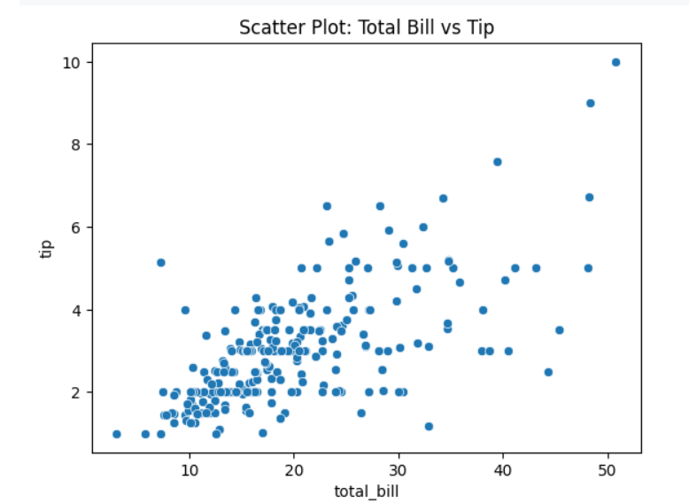
- sns.histplot(df["total_bill"], bins=20)
plt.title("Histogram of Total Bill")
plt.show()

Output:
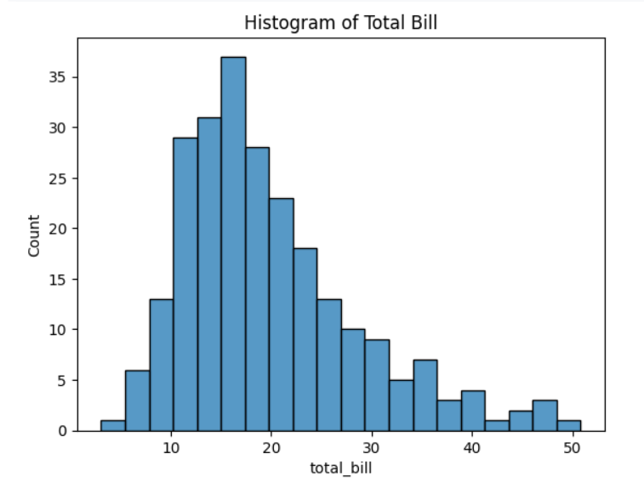
- sns.barplot(x="day", y="total_bill", data=df)
plt.title("Bar Plot: Total Bill by Day")
plt.show()

Output:
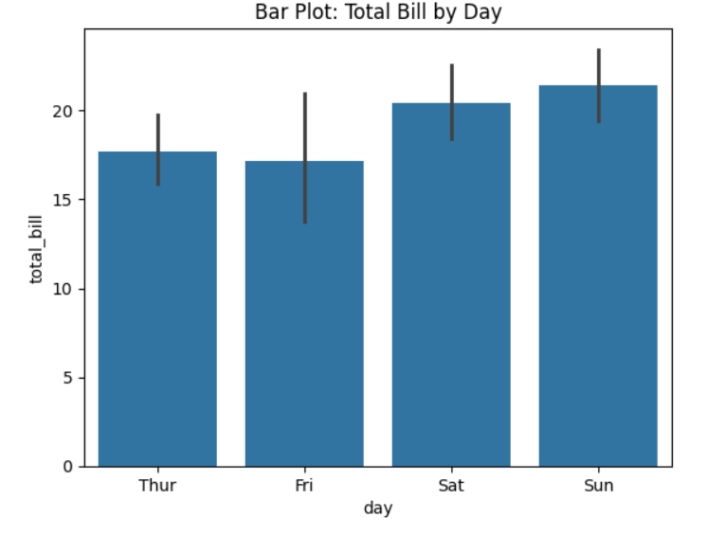

Conclusion
In this practical, we learned the basics of Seaborn and created fundamental plots such as scatter, histogram, and bar plot. These visualizations help us understand relationships and distributions in data.
PRACTICAL: 9

Aim
To implement advanced visualization techniques in Seaborn for deeper data analysis and multivariate visualization.

Objectives
- To learn advanced plotting techniques like heatmap, pairplot, jointplot, and violin plot.
- To analyze multi-variable relationships using Seaborn.
- To understand color maps and annotations in heatmaps.
- To generate complex EDA insights using statistical plots.
THEORY
Advanced Seaborn visualizations provide deeper insights into datasets with complex structures. These visualizations combine statistics, matrices, distributions, and regression curves to help understand multi-variable relationships and patterns effectively.
Why Advanced Seaborn Plots Are Needed
Basic plots are useful for simple data insights, but real-world datasets often contain:
- Multiple variables
- Correlated features
- Hidden distribution shapes
- Category-wise variations

Key Advanced Visualizations

1. Heatmap
A heatmap is a graphical representation of data where individual values in a matrix are shown as colors.
Most commonly, it is used for correlation matrices to identify:
- Strong or weak relationships
- Positive or negative correlations
- Redundant features

2. Pairplot
Pairplot shows pairwise relationships between multiple numerical variables in a dataset.
It automatically generates:
- Scatter plots
- Histograms

3. Jointplot
- A scatter plot
- A histogram/KDE
- Optional regression line

4. Violin Plot
A violin plot shows both:
- The distribution of data (via KDE)
- The summary statistics (like box plot)

Overall Importance
Advanced Seaborn visualizations:
- Reveal hidden patterns
- Highlight correlations
- Detect data imbalance
- Support decision-making for modeling
- Improve the depth of Exploratory Data Analysis (EDA)
Code Implementation
- Heat Map
corr = df.corr(numeric_only=True)
sns.heatmap(corr, annot=True, linewidths=0.5, cmap="coolwarm")
plt.title("Correlation Heatmap")
plt.show()

Output
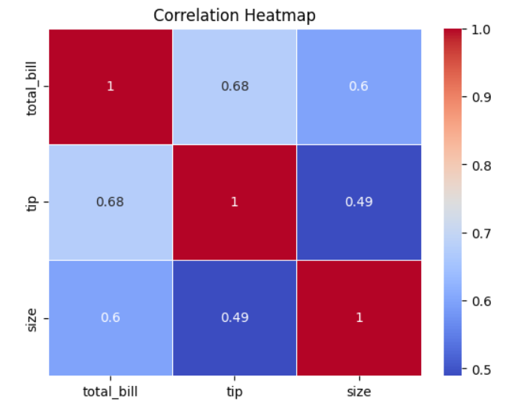
- Joint plot
sns.jointplot(x="total_bill", y="tip", data=df, kind="reg")
plt.show()
Output
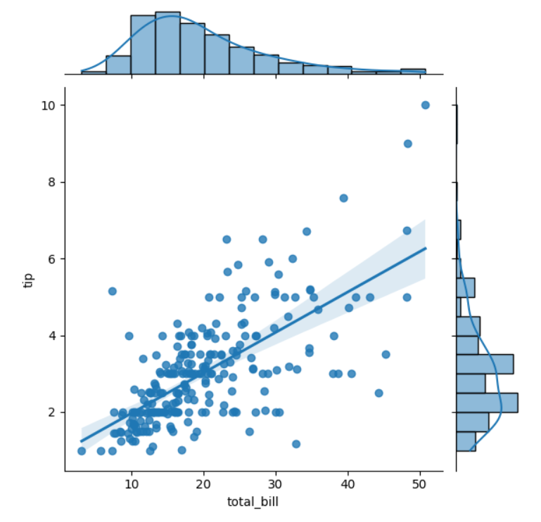
- Violin Plot:
sns.violinplot(x="day", y="total_bill", data=df)
plt.title("Violin Plot: Total Bill by Day")
plt.show()

Output
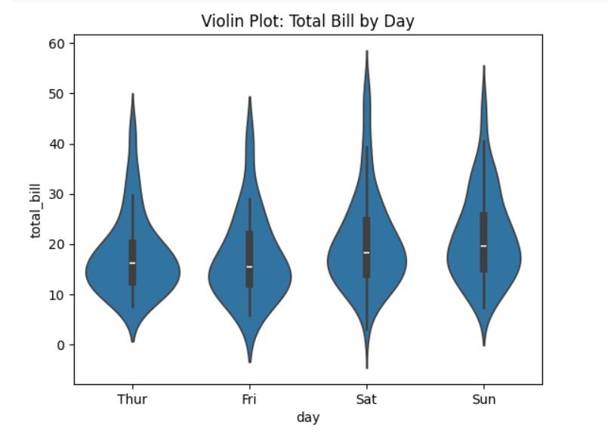
- Pair Plot
sns.pairplot(df)
plt.show()

Output
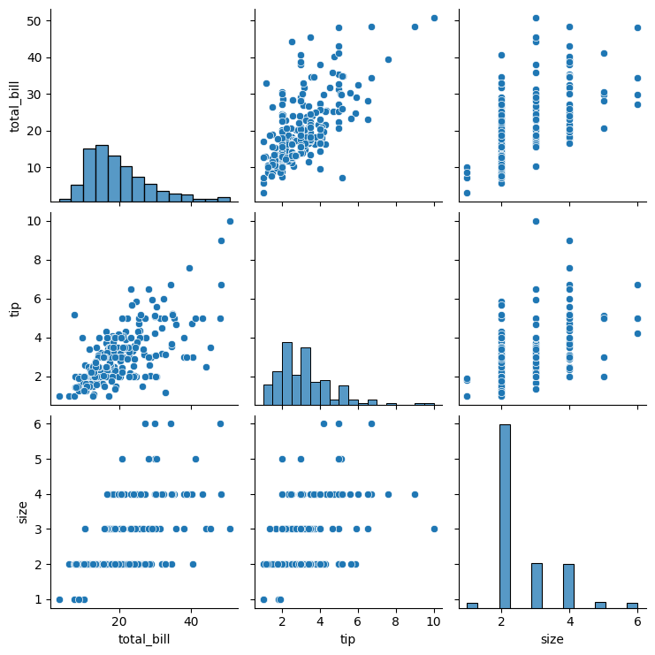
This multi-plot grid helps find trends, correlations, and clusters across many variables at once.

Conclusion
This practical covered advanced Seaborn visualizations that help in multivariate analysis. Using heatmaps, pairplots, jointplots, and violin plots, we can interpret complex patterns, correlations, and distributions effectively.

