PPACTICAL: 2
Objective:
To understand and perform basic NumPy operations such as array creation, indexing, slicing, arithmetic operations, and basic statistical functions.
Indroduction:
NumPy (Numerical Python) is a powerful open-source Python library used for numerical and scientific computation.
It provides a high-performance multidimensional array object called ndarray, along with tools for performing mathematical operations on entire arrays without writing explicit loops.
NumPy forms the foundation of most data analysis and machine learning libraries such as Pandas, TensorFlow, and Scikit-learn.
Key features include:
- Fast array manipulation and broadcasting
- Support for mathematical, logical, and statistical operations
- Integration with C/C++ and Fortran code
- Efficient handling of large datasets
Importing numpy

Running numpy commands
1.Creating a one-dimensional array using a Python list.
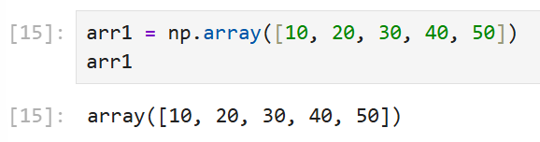
2.Creating arrays using NumPy functions – arange, linspace, zeros, ones, and identity.
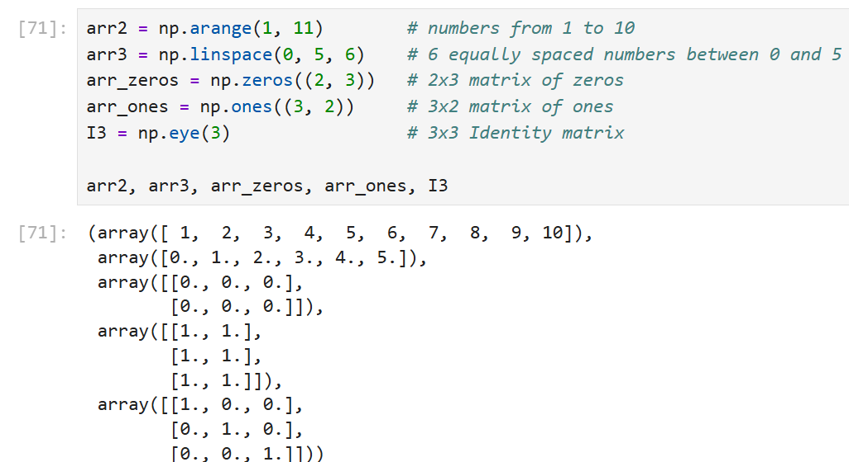

3.Checking basic properties of arrays – data type, shape, and dimensions.
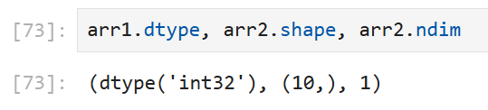
4.Accessing array elements using indexing and slicing.
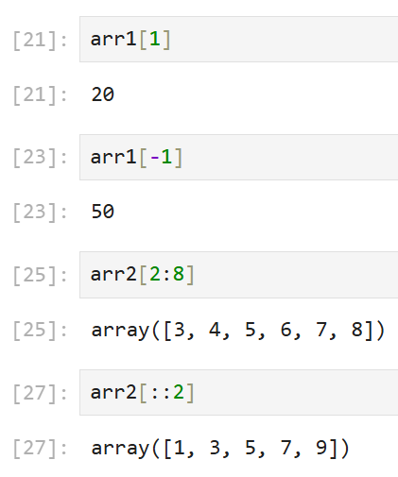
5.Performing arithmetic operations (vectorized operations).
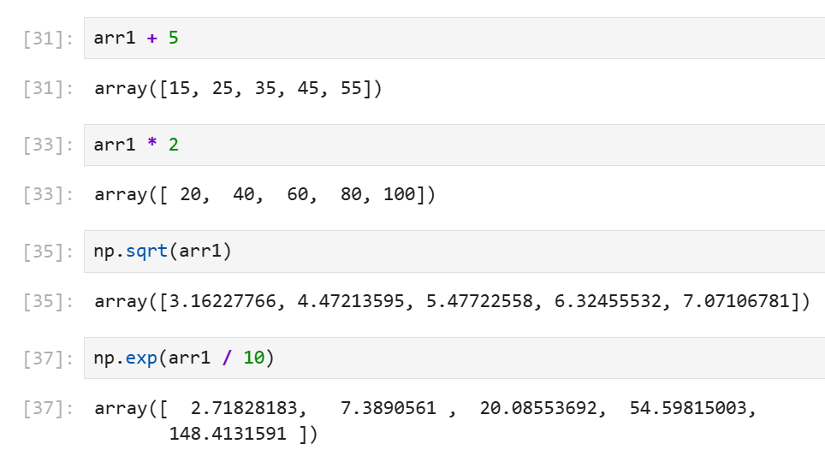

6.Applying aggregate/statistical functions.
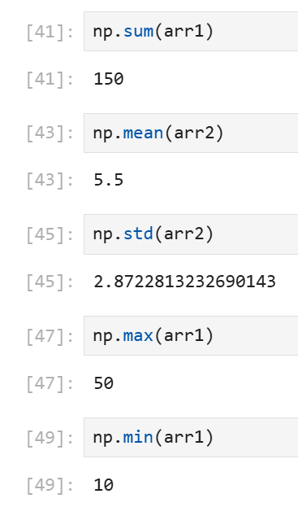
7.Using Boolean masking to filter array elements.
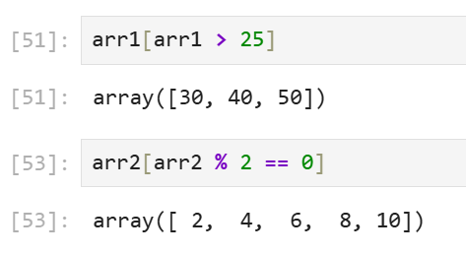
8.Reshaping an array and concatenating two arrays.
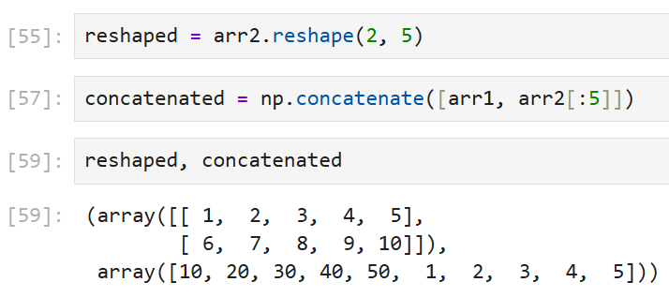

9.Using fancy indexing to access multiple indices.
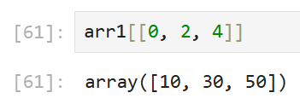
10. Saving and loading arrays using NumPy file functions.
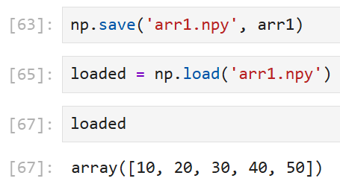
Conclusion:
Thus, basic NumPy operations were successfully implemented.
We learned how to create and manipulate arrays, perform mathematical operations, apply indexing and slicing, compute statistical measures, and manage array data efficiently.
This forms the foundation for data analysis and numerical computation using Python.

