|  |
| --- |
| **KESHAV MEMORIAL INSTITUTE OF TECHNOLOGY (An Autonomous Institute)**  **(Accredited by NBA & NAAC, Approved By A.I.C.T.E., Reg by**  **Govt of TelanganaState &Affiliated to JNTU, Hyderabad)**      A TECHNICAL SEMINAR REPORT ON Block Chain   *Submitted in partial fulfillment of requirement for the award of the degree of*        **BACHELOR OF TECHNOLOGY**  *In*  **COMPUTER SCIENCE AND ENGINEERING**              *Submittedby*    **Akki Eshwar**  **21BD1A0585** |
| **DEPARTMENT OF COMPUTER SCIENCE AND ENGINEERING**  **KESHAV MEMORIAL INSTITUTEOFTECHNOLOGY**  **(An Autonomous Institute)**  **(Approved by AICTE, Affiliated to JNTUH)**  **Narayanaguda, Hyderabad, Telangana-29**  **2024-25** |

**KESHAV MEMORIAL INSTITUTE OF TECHNOLOGY**  **(An Autonomous Institute)** 

**(Accredited by NBA & NAAC, Approved By A.I.C.T.E., Reg by**

**Govt of TelanganaState &Affiliated to JNTU, Hyderabad)**

**CERTIFICATE**

This is to certify that the seminar work entitled **Block Chain** is a bonafide work carried out in the seventh semester by **Akki Eshwar-21BD1A0585** in partial fulfillment for the award of Bachelor of Technology in **COMPUTER SCIENCE & ENGINEERING-CSE** from JNTU Hyderabad during the academic year 2024 - 2025 and no part of this work has been submitted earlier for the award of anydegree.

**TECHNICAL SEMINAR INCHARGE HEAD OF THE DEPARTMENT**



# INDEX

**Table of Contents Page No.**

**1.Abstract I**

**2.Introduction 1**

**3.Key Concepts 2**

**4.Importance Of Block Chain 5**

**5.Characterstics 6**

**6.Advantages 8**

**7.Disadvantages 10**

**8.Applications 12**

## 9.Conclusion 16



## ABSTRACT

**Title:** Block Chain

**Abstract:** Block chain is a decentralized and distributed digital ledger system that enables secure, transparent, and tamper-proof record-keeping across multiple participants in a network. By utilizing a chain of blocks linked together via cryptographic principles, block chain ensures data integrity and trust without the need for a central authority. This technology underpins cryptocurrencies, such as Bitcoin and Ethereum, but its applications extend far beyond digital

Block chain’s decentralized nature offers significant advantages, including enhanced security, transparency, and resilience against data tampering. Each block contains a unique cryptographic hash, a timestamp, and transaction data, creating a traceable and immutable record. This structure has made blockchain appealing across various industries such as finance, supply chain, healthcare, and real estate, where secure and verifiable transactions are paramount.

Through this documentation, we explore the technical architecture, consensus mechanisms, smart contracts, and diverse use cases of blockchain technology. Additionally, we discuss current challenges, scalability concerns, and the future potential of blockchain in driving trust and efficiency in digital ecosystems.

**Student Name:** Akki Eshwar

### Roll Number: 21BD1A0585

**Section:** CSE-E  **Guide Signature:**

**Technical Seminar I/C:**

Page No: I KMIT

## Introduction

Blockchain technology, first introduced with the launch of Bitcoin in 2009 by an anonymous entity known as Satoshi Nakamoto, has revolutionized the way digital transactions are conducted and recorded. This technology operates as a decentralized and distributed ledger that securely records data across a network of computers. Each "block" in the blockchain contains a collection of transaction data, cryptographically linked to the previous block, forming an immutable "chain" that prevents any unauthorized alterations to past records.

At its core, blockchain eliminates the need for intermediaries by enabling peer-to-peer transactions within a transparent and secure ecosystem. This decentralized model enhances security, reduces transaction costs, and fosters transparency, as all participants have access to a single, shared version of the truth. Additionally, blockchain leverages consensus mechanisms, such as Proof of Work (PoW) and Proof of Stake (PoS), to validate transactions and maintain data integrity across the network.

While blockchain is best known for supporting cryptocurrencies like Bitcoin and Ethereum, its applications extend far beyond the financial sector. Industries such as supply chain, healthcare, voting systems, and real estate are exploring blockchain to improve transparency, traceability, and efficiency. The introduction of smart contracts has further expanded blockchain’s potential, allowing programmable, self-executing contracts that automate and enforce agreement terms without human intervention.

This documentation will delve into the foundational principles of blockchain, exploring how it functions, the security mechanisms it employs, and its potential to reshape industries. Through detailed analysis, we aim to provide a comprehensive understanding of blockchain’s architecture, applications, and future developments, as well as the challenges that come with its adoption.

Page No: 1 KMIT

**Key Concepts**

**Distributed Ledger Technology (DLT):** Blockchain is a type of distributed ledger technology that records transactions across a network of nodes, or computers, in a decentralized manner. Each participant in the network holds a copy of the entire ledger, which updates in real time with each new transaction. This ensures data redundancy, reliability, and trust across all users without relying on a central authority.

**Blocks and Chain:** In a blockchain, transactions are grouped into blocks. Each block contains a unique identifier called a cryptographic hash, a timestamp, and data about recent transactions. Blocks are linked to each other in chronological order, creating a "chain." Once added to the chain, blocks cannot be modified, ensuring data immutability.

**Cryptographic Hashing:** A hash is a unique digital fingerprint that represents data within a block. Blockchain uses cryptographic hashing (typically SHA-256 in Bitcoin) to create a fixed-size output that changes if the data is altered in any way. This prevents tampering with transaction data, as any change would result in a completely different hash.

**Decentralization:** Blockchain operates on a decentralized network of nodes, with each participant holding an identical copy of the ledger. This eliminates the need for a central authority or intermediary, reducing costs and enhancing transparency. Decentralization also makes blockchain networks more resilient to single points of failure and censorship.

**Consensus Mechanisms:** Blockchain networks use consensus mechanisms to validate and agree on the state of the ledger. Common mechanisms include:

* **Proof of Work (PoW):** Used by Bitcoin, this requires participants (miners) to solve complex mathematical problems to validate transactions.
* **Proof of Stake (PoS):** Validators are selected based on the amount of cryptocurrency they hold and are willing to "stake" as collateral.
* **Other Mechanisms:** Variants like Delegated Proof of Stake (DPoS) and Byzantine Fault Tolerance (BFT) adapt the consensus model for various use cases.
* **Smart Contracts:** Smart contracts are self-executing contracts with terms directly written into code. They automatically execute and enforce actions when predefined conditions are met, enabling automation in various applications, such as digital agreements, without intermediaries. Platforms like Ethereum popularized the use of smart contracts.

**Public vs. Private Blockchains:**

**Public Blockchains:** Open to anyone and secured through decentralized consensus, allowing for full transparency and openness. Examples include Bitcoin and Ethereum.

**Private Blockchains:** Restricted to a specific group of participants, typically within a business or consortium. Private blockchains offer higher control, privacy, and transaction speed.

**Immutability and Transparency:** Once data is recorded on the blockchain, it is nearly impossible to alter, providing a tamper-proof record. The distributed nature of the blockchain also ensures transparency, as participants can verify and audit the data independently.

**Tokens and Cryptocurrency:** Cryptocurrencies like Bitcoin and Ether represent digital assets native to their blockchains. Tokens can be used for value exchange or as digital assets and are often created on platforms such as Ethereum to support decentralized applications (DApps).

**Nodes:** Nodes are individual computers or devices connected to the blockchain network. They store and validate the distributed ledger, supporting the decentralization and security of the network. Full nodes store a complete copy of the blockchain, while lightweight nodes (or SPVs) store only part of it.

Page No: 3 KMIT

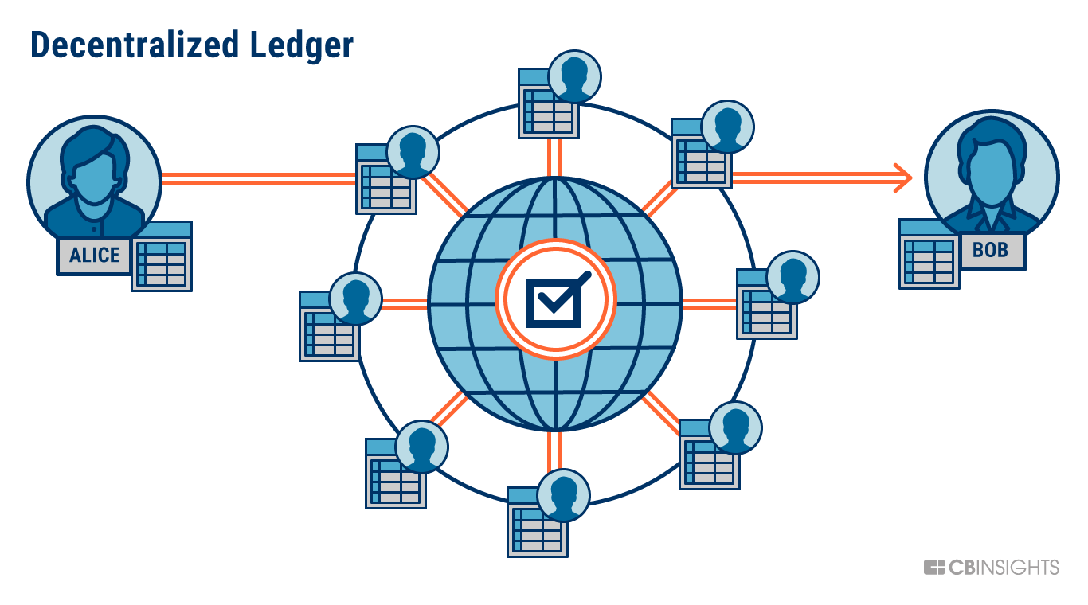

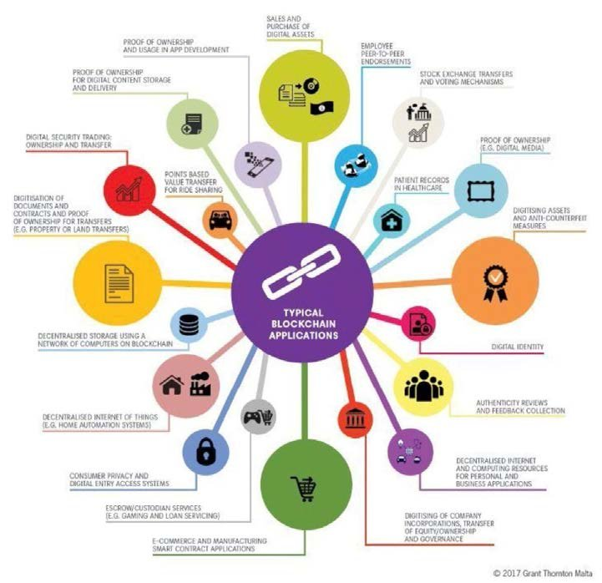

Page No: 4 KMIT

## Importance of Block Chain

Blockchain technology has emerged as one of the most transformative innovations in recent years, with its impact spanning multiple industries and applications. Here are some of the key reasons blockchain is increasingly considered vital:

**Enhanced Security and Data Integrity:** Blockchain’s cryptographic and decentralized structure makes it highly secure. Each transaction is validated by a network of nodes, making it virtually impossible to alter or tamper with past records. This immutability ensures data integrity, which is critical for industries such as finance, healthcare, and government, where secure and accurate record-keeping is essential.

**Decentralization and Trustless Systems:** By removing the need for a central authority, blockchain enables peer-to-peer interactions and transactions without requiring trust between parties. Decentralization reduces the risk of a single point of failure, enhances system resilience, and democratizes access to digital platforms. In areas like financial services, this allows for a more inclusive and accessible system, especially for those without traditional banking options.

**Transparency and Traceability:** Transactions on a blockchain are visible to all participants, making the system inherently transparent. This transparency enables users to track and verify data in real-time, improving accountability. For instance, in supply chain management, blockchain allows tracking of goods from origin to final destination, reducing fraud and increasing consumer confidence in product authenticity.

**Efficiency and Cost Reduction:** Blockchain eliminates the need for intermediaries by facilitating direct, peer-to-peer transactions. This reduces processing times and lowers transaction fees. Smart contracts also automate processes, reducing administrative overhead, cutting down on paperwork, and ensuring accuracy in contract execution, which is particularly beneficial in sectors like insurance and real estate.

**Programmability with Smart Contracts:** The ability to embed smart contracts within blockchain platforms like Ethereum has expanded blockchain’s capabilities far beyond simple transactions. Smart contracts execute actions automatically when conditions are met, enabling use cases like automated supply chain management, transparent voting systems, and secure healthcare data management.

**Financial Inclusion and Digital Identity:** Blockchain provides a secure and verifiable digital identity framework for the unbanked or those lacking formal identity documentation. Through decentralized financial (DeFi) systems, blockchain technology opens new opportunities for people to access financial services, from savings to lending, regardless of geographical or economic barriers.

**Reduction in Fraud and Corruption:** Blockchain’s transparency and immutability make it a powerful tool for combating fraud and corruption. In industries with complex logistics, such as supply chain and trade finance, blockchain reduces the risk of document manipulation or fraudulent activities. Governments are also exploring blockchain to enhance the security of voting systems, improve land registration transparency, and streamline the distribution of public funds.

**Potential for Innovation Across Industries:** Blockchain is being actively explored across a variety of sectors, including healthcare, real estate, logistics, and entertainment. From secure health record management to tracking digital rights for creators, blockchain’s versatility and reliability enable new applications, transforming traditional processes and creating more user-centric models.

**Support for Tokenization and Digital Assets:** Blockchain enables the tokenization of assets, allowing users to represent real-world assets, such as real estate, art, or stocks, as digital tokens on a blockchain. Tokenization makes asset trading more accessible, efficient, and secure, as well as opens new markets for fractional ownership and asset liquidity.

**Fostering a New Digital Economy:** Blockchain underpins decentralized applications (DApps) and decentralized finance (DeFi), creating a new digital economy that operates independently of traditional financial systems. This economy offers users more control over their assets and transactions, often in a more secure, private, and accessible manner.

Page No: 5 KMIT

## Characteristics

### Connectivity

Here’s a detailed outline of the key characteristics of blockchain technology:

Characteristics of Blockchain Technology

1. Decentralization:

Unlike traditional databases that rely on a central authority, blockchain operates in a decentralized manner, distributing data across a network of nodes (computers). Each node holds a copy of the entire blockchain, reducing dependence on a single point of control and making the network more resilient and secure.

2. Immutability:

Once data is added to the blockchain, it is extremely difficult to alter or delete. This immutability is achieved through cryptographic hashing and a consensus mechanism that ensures that any modifications require consensus from the network. As a result, blockchain provides a tamper-proof ledger, which is valuable for applications requiring integrity, such as financial transactions and supply chains.

3. Transparency and Traceability:

All transactions recorded on a blockchain are visible to participants, enabling high levels of transparency. This transparency allows users to trace every transaction, fostering accountability and trust. In industries like food supply and logistics, blockchain’s traceability helps in tracking goods from origin to destination, improving transparency in the supply chain.

4. Security and Cryptographic Protection:

Blockchain leverages cryptographic algorithms to secure data, particularly through hashing and digital signatures. Transactions are signed and verified by nodes in the network, ensuring data integrity and authenticity. This cryptographic foundation, combined with decentralization, makes blockchain highly secure and resilient against cyberattacks.

5. Consensus Mechanism:

Blockchain networks use consensus mechanisms to agree on the validity of transactions and to maintain the ledger’s accuracy. Popular consensus mechanisms include:

-Proof of Work (PoW):** Involves solving complex mathematical problems to validate transactions, commonly used by Bitcoin.

-Proof of Stake (PoS):** Validators are chosen based on the number of coins they hold, making the process more energy-efficient.

-Delegated Proof of Stake (DPoS) and Byzantine Fault Tolerance (BFT):** Variants adapted for specific blockchain applications, prioritizing scalability or security.

6. Distributed Ledger:

Blockchain is a type of distributed ledger technology (DLT) where each node in the network holds an identical copy of the ledger. This ensures consistency across the network and enhances fault tolerance, as the system can continue functioning even if some nodes fail.

7. Smart Contracts:

Smart contracts are self-executing contracts where the terms are embedded in code. When certain conditions are met, the contract executes automatically, eliminating the need for intermediaries and reducing the potential for errors. This feature has extended blockchain’s use cases to industries like insurance, real estate, and finance.

8. Programmability:

Blockchain allows for programmable transactions and applications, often through smart contracts and decentralized applications (DApps). Platforms like Ethereum provide a foundation for building applications that automate and manage complex workflows, expanding blockchain’s applications beyond simple transaction recording.

9. Tokenization and Asset Representation:

Blockchain enables the digital representation of assets as tokens, allowing anything of value—such as currency, real estate, or even intellectual property—to be tokenized. This characteristic allows for fractional ownership, increases asset liquidity, and facilitates trade in otherwise illiquid markets.

10. Pseudonymity and Privacy:

While blockchain transactions are transparent, they are also pseudonymous, meaning that participants are identified by cryptographic addresses rather than personal identities. This provides a level of privacy, though blockchain data is not entirely anonymous. Privacy-focused blockchains and techniques like Zero-Knowledge Proofs (ZKPs) further enhance privacy for sensitive applications.

11. High Availability and Fault Tolerance:

The decentralized nature of blockchain means there is no single point of failure. Since the ledger is distributed across a network of nodes, it is highly available and can continue functioning even if several nodes go offline or are compromised.

12. Scalability and Performance Challenges:

While blockchain offers numerous advantages, it faces scalability issues, particularly on public blockchains like Bitcoin and Ethereum, which can struggle to handle high transaction volumes. Solutions like sharding, sidechains, and layer-2 scaling aim to improve blockchain’s scalability and performance.

These characteristics collectively define blockchain’s unique strengths and challenges, making it a foundational technology for secure, transparent, and decentralized applications. Let me know if there’s a specific characteristic you’d like to explore further!

Page No: 7 KMIT

## Advantages

1 **Enhanced Security:** Blockchain’s decentralized, cryptographic structure makes it highly secure. Transactions are verified by a network of nodes, making data tampering nearly impossible without altering the entire blockchain. This security is especially valuable for sensitive applications, such as financial transactions and health records.

2 **Transparency:** Blockchain transactions are recorded in a public or permissioned ledger visible to all authorized participants, creating a high level of transparency. This transparency allows for independent auditing, which is beneficial for improving accountability in areas like supply chain management and government operations.

3 **Data Integrity and Immutability:** Once data is added to a blockchain, it cannot be altered or deleted without consensus from the network. This immutability ensures a trustworthy record, making blockchain ideal for applications that require data integrity, such as regulatory compliance, financial transactions, and legal documentation.

4 **Decentralization and Reduced Intermediaries:** Blockchain eliminates the need for a central authority, enabling peer-to-peer transactions without intermediaries. This reduces transaction fees, processing times, and reliance on third-party institutions, which is especially beneficial in financial services, cross-border payments, and trade finance.

5 **Improved Traceability and Accountability:** Blockchain provides a complete, immutable record of every transaction, enhancing traceability. In industries like supply chain, users can trace products from origin to destination, reducing fraud and improving accountability by ensuring product authenticity and quality control.

6 **Cost Efficiency:** By removing intermediaries and reducing administrative work, blockchain reduces operational costs. Automated processes, like smart contracts, minimize human error, cut down paperwork, and streamline workflows. This is valuable in industries such as insurance, real estate, and logistics.

7 **Faster Transaction Processing:** Traditional banking and financial systems often require time to verify and settle transactions, especially cross-border payments. Blockchain enables near-instantaneous transaction processing, significantly reducing the time needed to confirm and settle transactions in real-time.

8 **Empowerment through Digital Identity and Financial Inclusion:** Blockchain can provide secure, verifiable digital identities for people without traditional forms of identification, opening access to financial services. Decentralized finance (DeFi) platforms enable users worldwide to access savings, loans, and other financial services without the need for a bank.

9 **Programmable and Automated Transactions (Smart Contracts):** Smart contracts allow predefined rules to execute automatically when conditions are met, enabling automation in various industries. For instance, insurance claims can be automatically processed, and supply chain payments can be released upon product delivery, reducing the need for manual intervention.

10 **Tokenization and Fractional Ownership:** Blockchain enables assets like real estate, art, or stocks to be represented as digital tokens, allowing for fractional ownership and easier trading. This democratizes access to investments, increases liquidity, and creates new opportunities for asset trading and investment.

11 **Innovation and New Economic Models:** Blockchain has enabled new economic models, such as decentralized applications (DApps) and decentralized finance (DeFi), which allow for more user-centric platforms. These applications are often more transparent and accessible, offering alternatives to traditional centralized services.

12 **Reduced Fraud and Corruption:** The transparency, immutability, and traceability of blockchain make it an effective tool in reducing fraud and corruption. By enabling all participants to verify and trace transactions, blockchain enhances accountability and reduces the potential for fraudulent activities, especially in complex logistics and public sectors.

Page No: 9 KMIT

## Disadvantages

**Scalability Issues:** Blockchain networks, especially public ones like Bitcoin and Ethereum, face challenges in handling high transaction volumes. As transaction volume increases, the time and cost to process each transaction can also increase, limiting scalability. Solutions like sharding and layer-2 protocols are under development but have not fully solved the scalability issue for large-scale applications.

**High Energy Consumption:** Many blockchains, particularly those using Proof of Work (PoW) consensus (e.g., Bitcoin), consume significant amounts of energy to validate transactions. Mining requires powerful computers to solve complex mathematical problems, leading to high electricity consumption, which is a concern for environmental sustainability. **Complexity and High Implementation Costs:** Building and integrating blockchain solutions can be complex and costly. Organizations need specialized skills and resources to develop, manage, and maintain blockchain infrastructure, which may deter smaller companies from adoption. Additionally, integrating blockchain into legacy systems can be challenging.

**Data Privacy Concerns:** While blockchain offers transparency, this can be a disadvantage when handling sensitive or personal data. Public blockchains are pseudonymous, but transaction data is still visible to all participants, which could compromise privacy. Solutions like Zero-Knowledge Proofs (ZKPs) and private blockchains aim to address these privacy concerns, but they are not universally applicable.

**Immutability Challenges:** Immutability is both an advantage and a disadvantage. Once data is added to a blockchain, it cannot be altered or deleted, which can be problematic if incorrect or sensitive information is recorded. This immutability can complicate error correction or compliance with regulations like the “right to be forgotten.”

**Regulatory and Legal Uncertainty:** The regulatory landscape for blockchain and cryptocurrencies is still evolving. Inconsistent regulations across countries make it challenging for blockchain companies to operate, especially for cross-border applications. Legal uncertainties regarding data handling, financial compliance, and smart contracts can slow adoption and create operational risks.

**Lack of Interoperability:** Currently, different blockchain networks operate independently and are often incompatible with one another, creating "blockchain silos." This lack of interoperability complicates the exchange of data and assets between networks, limiting blockchain’s potential for wider applications. Cross-chain protocols and interoperability solutions are in development but are still in early stages.

**Potential for Malicious Attacks:** While blockchain is generally secure, it is not immune to attacks. For example, a 51% attack—where a single entity gains control of more than half of a blockchain’s mining power—could allow the entity to manipulate the ledger, reversing transactions or double-spending. While rare and costly to execute, this vulnerability remains a concern, especially for smaller blockchains.

**Storage and Bandwidth Limitations:** As blockchain networks grow, the size of the ledger increases, equiring more storage and bandwidth for nodes to participate fully in the network. This can make it difficult for regular users to maintain a complete copy of the blockchain, which may lead to increased reliance on a smaller number of nodes, reducing decentralization.

**Limited Speed and Efficiency for High-Frequency Transactions:** Blockchain transaction processing can be slower than traditional centralized databases due to its consensus mechanism, especially in systems like Bitcoin where transaction confirmation times can take several minutes. This can be a limitation in use cases that require high transaction speeds, such as retail payments.

**Potential Loss of Assets:** Blockchain transactions are irreversible. If a user loses their private keys, which are essential for accessing their digital assets, there is no way to recover these assets. This risk of irreversible asset loss poses a significant challenge for users and requires robust security practices.

**Misuse and Illicit Activities:** Blockchain’s pseudonymity can also be misused for illegal activities, such as money laundering, tax evasion, or the sale of illicit goods. Regulatory bodies are working on solutions like Know Your Customer (KYC) and Anti-Money Laundering (AML) compliance for blockchain applications, but these measures add complexity and can counter blockchain’s decentralized ethos.

Page No: 11 KMIT

**Applications**

### Smart Homes

1. **Cryptocurrencies and Digital Payments:** Blockchain is the foundational technology behind cryptocurrencies like Bitcoin and Ethereum, enabling peer-to-peer digital payments without intermediaries. Cryptocurrencies offer secure, transparent, and fast transactions, especially valuable for cross-border payments where traditional systems can be costly and slow.
2. **Supply Chain Management:** Blockchain enables greater transparency and traceability in supply chains, allowing businesses and consumers to track the movement and origin of products. Companies like IBM and Walmart are using blockchain to verify product authenticity, reduce fraud, and improve efficiency by automating processes like inventory management and quality checks.
3. **Smart Contracts:** Smart contracts are programmable contracts that execute automatically when predefined conditions are met. They eliminate the need for intermediaries in various applications, from insurance claims processing to property transactions, saving time and reducing human error. Ethereum and other platforms provide the infrastructure for deploying smart contracts widely.
4. **Healthcare:** Blockchain can secure patient data, improve data interoperability, and prevent tampering in healthcare. By providing a unified, encrypted record of patient information, blockchain enhances privacy, allows authorized providers quick access to medical histories, and reduces medical errors, streamlining healthcare workflows and enhancing patient care.
5. **Voting Systems:** Blockchain-based voting systems provide secure, transparent, and tamper-resistant voting records. This technology can increase voter turnout by allowing secure remote voting, reduce election fraud, and enhance transparency in vote counting, creating a reliable system that safeguards democratic processes.
6. **Identity Verification and Digital Identity:** Blockchain-based identity systems give individuals control over their own digital identities, enabling secure, verifiable, and tamper-proof identity verification. This is especially useful in financial services, border control, and government services, helping streamline processes while protecting users’ personal data.
7. **Real Estate and Property Records:** Blockchain simplifies property transactions by providing a secure, transparent ledger for recording ownership, liens, and transfers. This reduces paperwork, speeds up the transfer process, and helps prevent fraud. Blockchain applications in real estate also enable fractional ownership, allowing more accessible investments through tokenization.
8. **Decentralized Finance (DeFi):** DeFi applications enable decentralized financial services like lending, borrowing, and asset trading without traditional intermediaries. Built primarily on platforms like Ethereum, DeFi allows users to access financial services via smart contracts, offering greater control and lower fees than traditional financial systems.
9. **Intellectual Property and Digital Rights Management:** Blockchain can secure and track intellectual property rights, ensuring creators receive fair compensation. By tokenizing digital assets, artists, musicians, and writers can create digital records of ownership and distribution, preventing unauthorized use and ensuring royalties are paid directly to content creators.
10. **Energy Trading and Sustainability:** Blockchain supports peer-to-peer energy trading, allowing consumers to buy and sell excess energy directly. It’s used in tracking renewable energy sources and carbon credits, increasing transparency and helping organizations meet sustainability goals.
11. **Cross-Border Payments and Remittances:** Blockchain facilitates quick, low-cost cross-border payments, helping businesses and individuals avoid the high fees and long processing times associated with traditional banking systems. This is especially valuable for remittances in regions with limited banking infrastructure.
12. **Insurance:** Blockchain can streamline insurance processes, from claims processing to underwriting. Smart contracts can automate claims, improving accuracy and reducing fraud by ensuring only valid claims are paid. Blockchain-based records also improve transparency between insurers and customers, helping to build trust.
13. **Agriculture and Food Safety:** Blockchain is used in agriculture to track the origin, quality, and distribution of food products. By recording each stage of the agricultural supply chain, blockchain ensures food safety, allows quick responses to recalls, and gives consumers more information about the products they buy.
14. **Government and Public Records:** Governments can use blockchain for efficient, secure public records management, from birth and death certificates to property titles and licenses. This reduces administrative costs, prevents document tampering, and improves accessibility for citizens, making government services more efficient.
15. **Education and Credential Verification:** Blockchain enables secure, verifiable academic records and credentials. Students and institutions can store and share degrees, certificates, and transcripts on a blockchain, making it easier for employers and educational institutions to verify qualifications and reduce fraud.
16. **Gaming and Digital Collectibles (NFTs):** Blockchain allows for the creation and ownership of non-fungible tokens (NFTs), unique digital assets that represent ownership of virtual items. These are popular in gaming and digital art, where players and collectors can buy, sell, and trade rare virtual items on decentralized platforms.

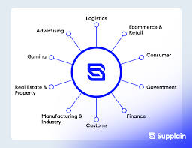

Page No: 15

## Conclusion

Blockchain technology has emerged as a transformative force, offering new ways to secure, share, and manage data across various sectors. Its unique characteristics—decentralization, transparency, immutability, and security—set it apart from traditional systems, enabling secure peer-to-peer transactions, automated workflows through smart contracts, and efficient data sharing. Blockchain’s impact is evident in fields such as finance, healthcare, supply chain, and digital identity, where it enhances efficiency, reduces costs, and fosters trust among participants.

However, blockchain still faces challenges, including scalability, energy consumption, regulatory uncertainty, and privacy concerns. As these obstacles are addressed, blockchain will likely continue to evolve, supported by ongoing innovation in consensus mechanisms, interoperability, and privacy solutions.

In a rapidly digitalizing world, blockchain holds the potential to redefine traditional processes, introduce new economic models, and empower individuals by giving them more control over their digital interactions. Its versatility makes it a promising technology for the future, enabling a more transparent, secure, and decentralized digital ecosystem. As industries and governments further explore its applications, blockchain is poised to become a foundational component of the next-generation digital infrastructure.

Page No: 16 KMIT