Name-Akshat Yadav

Batch-C1

Roll no-16010122221

Tutorial Name-[Tutorial 1:P1:Correlation and Regression using RAssignment](https://lms-kjsce.somaiya.edu/mod/assign/view.php?id=59191).

Date-19-01-2024

Q.1: Draw scatter diagram and determine the coefficient of correlation for the

Following data

X : 23, 27, 28, 29, 30, 31, 33, 35, 36, 39.

Y : 18, 22, 23, 24, 25, 26, 28, 29, 30, 32.

**CODE**

x=c(23, 27, 28, 29, 30, 31, 33, 35, 36, 39)

y=c(18, 22, 23, 24, 25, 26, 28, 29, 30, 32)

r=cor(x,y)

plot(x,y,main="scatter diagram",xlab="soil temp",ylab="germination")

cat("coefficient of correlation is",r)

paste("name & roll no", "Akshat Yadav ,1601012221")

**OUTPUT**

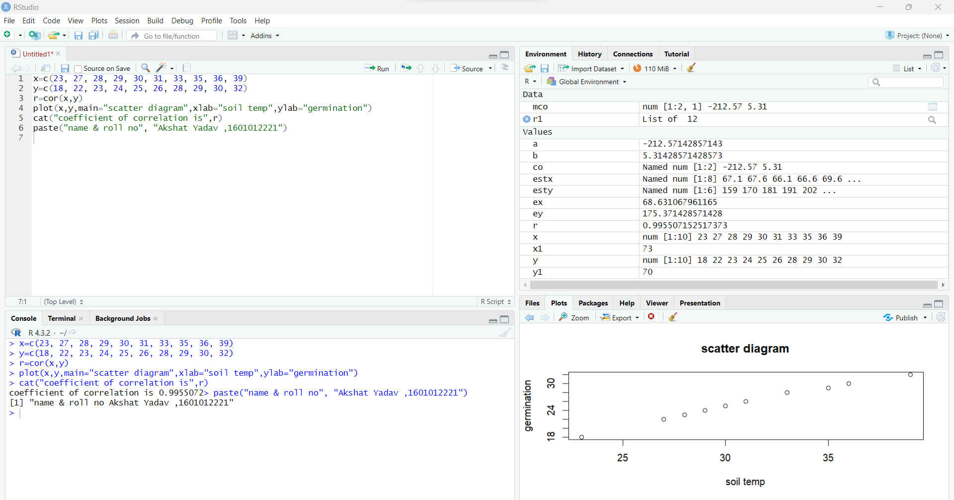

Q.2 The following table gives the age of car (x) of a certain make and annual

Maintenance Cost (y).Obtain the equation of the line of regression of cost

On age.

Age of a car : 2 4 6 8

Maintenance: 1 2 2.5 3

Estimate the cost when age is 10

Plot equation of regression line of Y on X

**CODE :**

x=c(2,4,6,8)

y=c(1,2,2.5,3)

r1=lm(y~x) # gives equation of of regression of y on x

co=coef(r1)# gives values of constantsa,b in equation y=a+b*x

mco=matrix(co) # column matrix of constantsa,b

a=mco[1,1]

cat ("constant term a is",a)

b=mco[2,1]

cat ("value of b is",b)

esty=fitted(r1)# gives estimated values of y for the given values of x

cat ("estimated values of y are", esty) # display estimated values of y for the given values of x

x1=10

ey=a+b*x1

cat ("estimated value of sale for year 10 is",ey)

plot (x,y,pch="+") # plots points corresponding to x and given value of y (+)

points(x,esty,pch="*") # plots points corresponding to x and it’s estimated value of y (*)

lines(x,y , col="green") # plots line corresponding to x and given value of y (+) using green colour

lines(x,esty , col="red")# plots line between x and estimated value of y (*) using red colour

paste("name & roll no", "Akshat Yadav ,16010122221")

**OUTPUT**

**Constant terms a and b of regression line of y on x(i.e.y=a+bx) are 0.5**

**and 0.325**

**If X=10 then estimated value of Y is 3.75**

**R Studio Screen.**

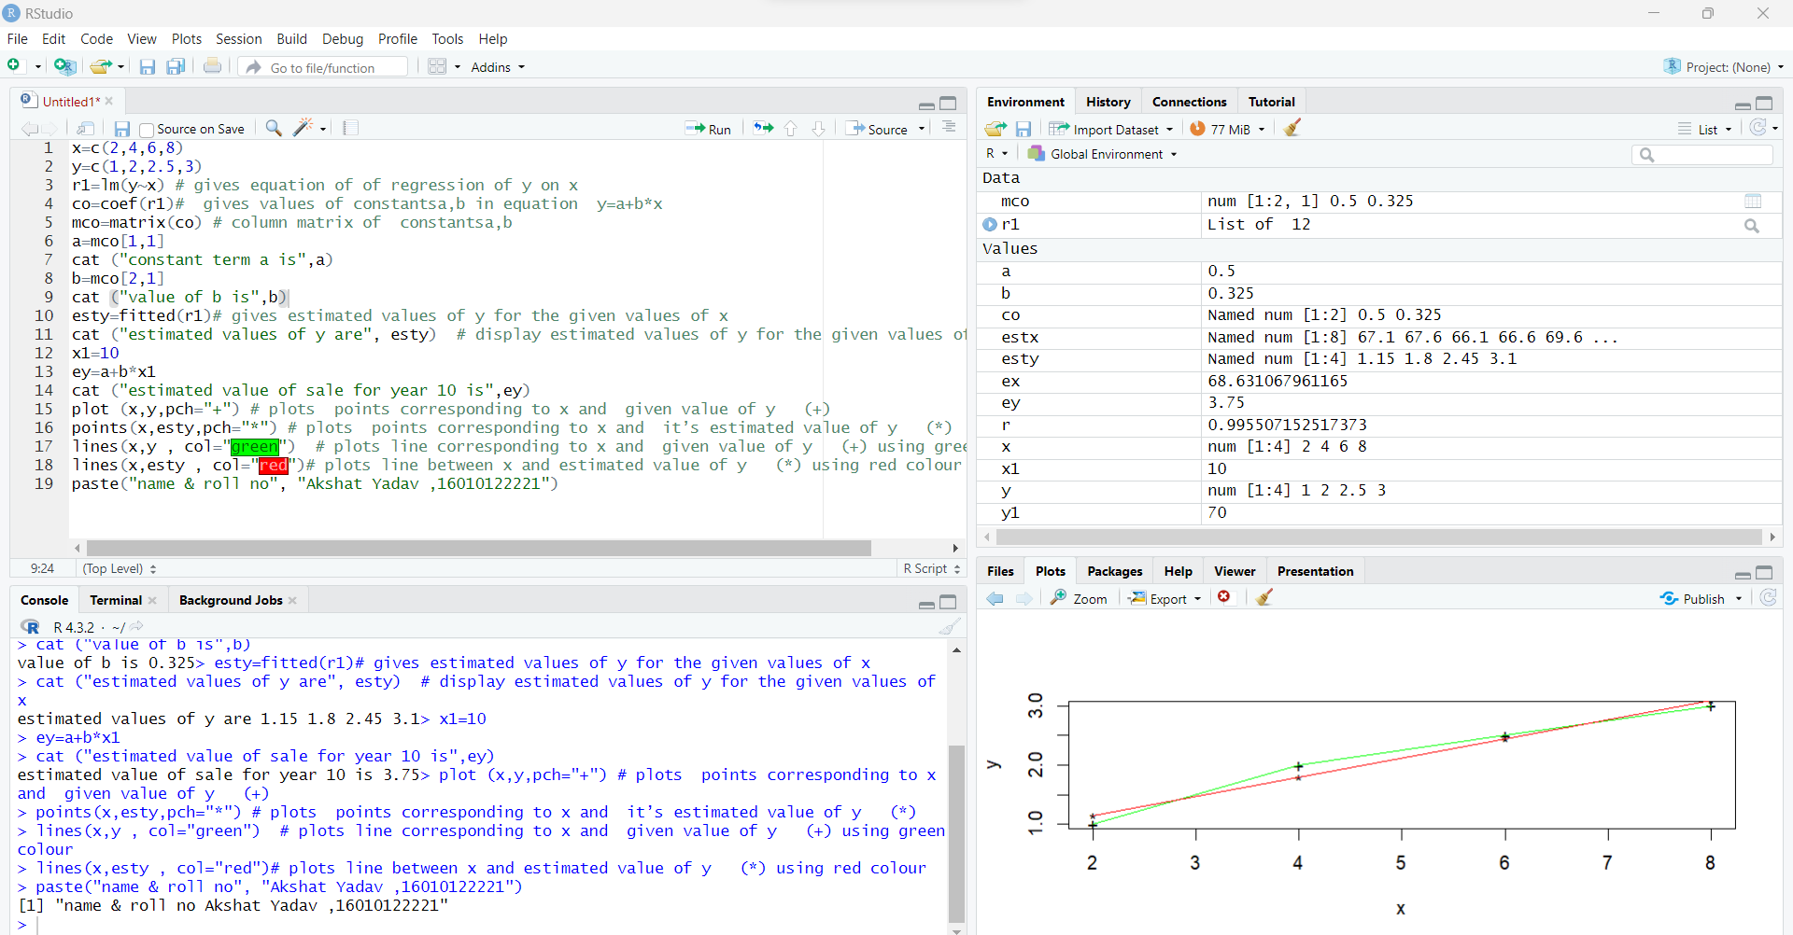

Q.3 Find the equations of lines of regression of x on y for the following data.

x : 5 6 7 8 9 10 11

y : 11 14 14 15 12 17 16

Estimate x when y is 20

Plot equation of regression line of x on y

**CODE :**

x=c(5,6,7,8,9,10,11)

y=c(11,14,14,15,12,17,16)

r1=lm(x~y) # gives equation of of regression line of x on y(i.e.x=a+by)

co=coef(r1) # gives values of a,b

mco=matrix(co) # column matrix of a,b

a=mco[1,1]

cat ("constant term a is",a)

b=mco[2,1]

cat ("value of b is",b)

estx=fitted(r1) # gives estimated values of y for the given values of x

cat ("estimated values of x are", estx) # display estimated values of y for the given values of x

y1=20

ex=a+b*y1

cat ("estimated value of X is",ex)

plot (x,y,pch="+") # plots points corresponding to x and given value of y (+)

points(estx,y,pch="*") # plots points corresponding to x and it’s estimated value of y (*)

lines(x,y , col="green") # plots line corresponding to x and given value of y (+) using green colour

lines(estx,y , col="red")# plots line between y and estimated value of x (*) using red colour

paste("name & roll no", "Akshat Yadav ,16010122221")

**OUTPUT**

**Constant terms a and b of regression line of x on y(i.e.x=a+by) are -2.005319**

**and 0.7074468**

**If Y=20 then estimated value of X is 12.14362**

**R Studio Screen.**

